Chapter 8: Development Sites, Areas of Focus and Infrastructure

North Infrastructure Area (including Northern Edge of Oxford Area of Focus and site allocation policies). 5
Policy NEOAOF– Northern Edge of Oxford Area of Focus 7
Policy SPN1– Northern Gateway 13
Policy SPN2: Oxford University Press Sports Ground 18
North Area site allocation policies outside of the Area of Focus 20
Policy SPN3: Diamond Place & Ewert House 22
South Infrastructure Area (including Cowley Branch Line and Littlemore Area of Focus) 24
Policy CBLLAOF: Cowley Branch Line and Littlemore Area of Focus 26
Policy SPS1: ARC Oxford 31
Policy SPS2: Kassam Stadium and Ozone Leisure Park 35
Policy SPS3: Overflow Car Park, Kassam Stadium 39
Policy SPS4: MINI Plant Oxford 42
Policy SPS5: Oxford Science Park 46
Policy SPS6: Sandy Lane Recreation Ground 50
Policy SPS7: Unipart 54
South area site allocation policies outside of the Area of Focus 56
Policy SPS8: Bertie Place Recreation Ground 58
Policy SPS9: Blackbird Leys Central Area 61
Policy SPS10: Knights Road 64
Policy SPS11: Cowley Marsh Depot 67
Policy SPS12: Templars Square 70
Policy SPS13: Land at Meadow Lane 74
Policy SPS14: Former Iffley Mead Playing Field 77
Policy SPS15: Redbridge Paddock 80
Policy SPS16: Crescent Hall 84
Policy SPS17: Edge of Playing Fields, Oxford Academy 86
Policy SPS18: 474 Cowley Road (Former Powells Timber Yard) 87
East Infrastructure Area (including Marston and Old Road Area of Focus) and Site Allocation Policies 88
Policy MRORAOF: Marston Road and Old Road Area of Focus 90
Policy SPE1: Government Buildings and Harcourt House 92
Policy SPE2: Land Surrounding St Clement’s Church 96
Policy SPE3: Headington Hill Hall and Clive Booth Student Village 100
Policy SPE4: Oxford Brookes University Marston Road Campus 103
Policy SPE5: 1 Pullens Lane 106
Policy SPE6: Churchill Hospital 109
Policy SPE7: Nuffield Orthopaedic Centre (NOC) 113
Policy SPE8: Warneford Hospital 116
East Area site allocation policies outside the Area of Focus 118
Policy SPE9: Bayards Hill Primary School Part Playing Fields 120
Policy SPE10: Hill View Farm 122
Policy SPE11: Land West of Mill Lane 125
Policy SPE12: Marston Paddock 128
Policy SPE13: Manzil Way Resource Centre 131
Policy SPE14: Slade House 133
Policy SPE15: Thornhill Park 136
Policy SPE16: Union Street Car Park and 159 –161 Cowley Road 139
Policy SPE17: Jesus and Lincoln College Sports Grounds 142
Policy SPE18: Ruskin College Campus 146
Policy SPE19: Ruskin Field 148
Policy SPE20: John Radcliffe Hospital 152
Policy SPE21: Rectory Centre 156
Central and West Oxford Infrastructure Area (including North of the City Centre Area of Focus and West End and Botley Area of Focus 158
Policy NCCAOF: North of the City Centre Area of Focus 160
Policy SPCW1: West Wellington Square 161
Policy SPCW2: Land at Winchester Road, Banbury Road and Bevington Road 163
Central & West area site allocation policies outside the Areas of Focus 164
Policy SPCW3: Manor Place 166
Policy SPCW4: Canalside Land, Jericho 170
Policy WEAOF: West End and Botley Area of Focus 175
Policy SPCW5: Oxpens 178
Policy SPCW6: Nuffield Sites 184
Policy SPCW7: Osney Mead 190
Policy SPCW8: Botley Road Retail Park 194

Introduction

A development site allocation is a planning policy that describes what type of land use, or mix of uses, would be acceptable on a specific site or whether the site is protected for certain types of development. These policies are important because they give guidance and certainty to developers and landowners, and they help local people understand what may happen in their neighbourhood in the future. Such policies provide a positive approach to the development of a site by ensuring that the right type and amount of development happens in the right place, in accordance with the strategy of this Local Plan and the NPPF.

The development site allocation policies include a high level of comprehensive detail which aims as far as possible to provide more certainty to both developers and local residents about the proposals and the considerations for a site. The development site allocation policies have been informed by a thorough process building upon urban design appraisals that were carried out for each site. To ensure that the minimum densities housing numbers are as robust as possible the policy team undertook detailed urban design assessments to ensure that the constraints within the site allocation are fully considered and the appropriate calculation of minimum housing numbers is included in the policy. Other policies of the plan relevant to site allocations were also considered. The detail contained within the policies in this chapter is intended to help set out key policy requirements of the Plan relevant to the site allocations, and to set out key considerations and give detailed guidance about the policies may apply to the site allocations. The policies cross-referred to within the site allocation policies do not represent an exhaustive list. The site allocations do not supersede the other policies of the Plan, and all other policies remain relevant.

The minimum number shall be exceeded where it is possible to do so consistent with the other policies in the Plan. The homes should be delivered as general market and affordable housing in accordance with Policy H2 unless it is expressly stated in the site allocation policy that student accommodation or employer-linked affordable housing are suitable on the site. Other specialist forms of housing will be considered on their merits. If communal accommodation is to be provided, the minimum quantum shall be calculated on the basis of the national policy ratio (or any amendment or replacement thereof). The ratio at the time of adoption of the Local Plan is that 2.5 new student bed spaces is considered as the equivalent of 1 new home and for other communal accommodation 1.8 bed spaces is considered as equivalent to 1 new home. On mixed-use sites, if only part of the site is being brought forward and the proposal does not include residential development, the potential to achieve the minimum housing capacity on remaining parts of the site when they come forward for development will be considered.

This chapter also outlines five “Areas of Focus” across the city. These are areas where changes are anticipated over the Plan period resulting from new development - either development within the city or adjacent to the city boundaries.

Infrastructure to support new and existing development to 2040

New development across the city results in additional social, community and transport infrastructure needs. It is important that there are sufficient facilities to meet the needs of existing and future residents. The Infrastructure Delivery Plan (IDP) provides a summary of infrastructure needs across Oxford and sets out the infrastructure schemes to meet the needs, taking into consideration the level of housing and employment growth over the Plan period. The IDP has divided the city into four quadrants as shown in Figure 8.1.

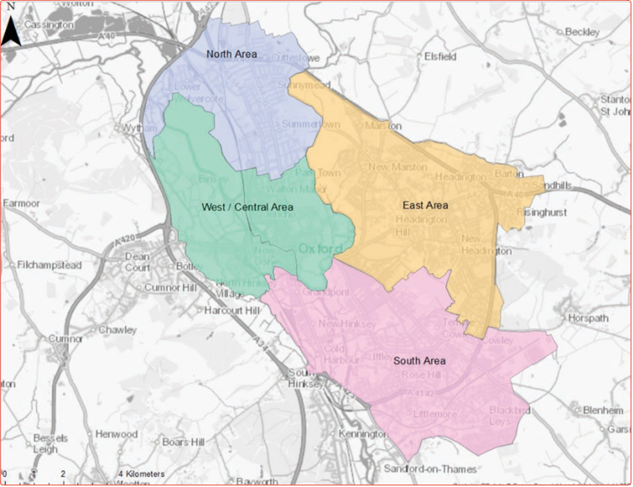
Figure 8.1 The four quadrants of the city for considering infrastructure, as set out in the IDP

Sites beyond the city boundary for Oxford’s unmet housing need

Chapter 2 of The Plan, A Healthy Inclusive City to Live In, explains Oxford’s urgent need for more homes, the constrained supply in Oxford, and why we have a capacity-based housing target. There are several sites around the edge of Oxford which are allocated for housing in the most recent adopted local plans of neighbouring districts, to help deliver the unmet housing needs for Oxford for the period up to 2036 (corresponding with the Oxford Local Plan 2036). Development has commenced on several of these sites and planning applications have been submitted for others.

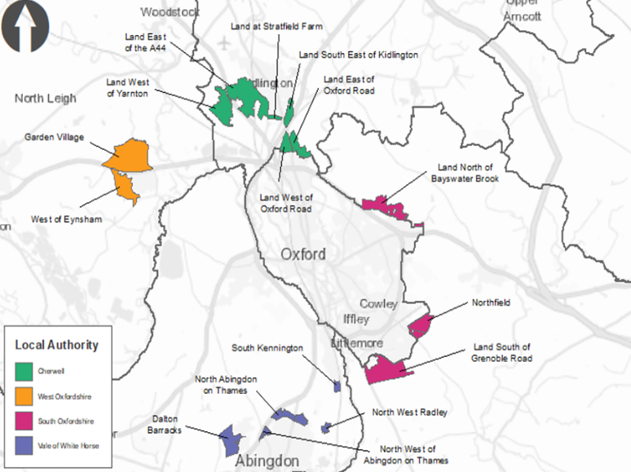
Figure 8.2 Allocated unmet need sites outside of Oxford boundary

This Plan covers the period to 2040 so there is an additional four years of unmet need to consider between 2036-2040. The HENA identifies the level of housing need for Oxford to 2040, whilst the HELAA assesses the capacity of Oxford: together these assessments indicate the level of need which cannot be met in Oxford – the unmet need. During the Plan’s preparation work has continued with neighbouring districts whereby discussions were held about how to accommodate the additional unmet need beyond that already agreed to 2036. In several instances the sites identified in Figure 8.2 above are already indicating a greater capacity than previously estimated, so it may be that the additional unmet need to 2040 can be met this way.

The City Council continues to work with the neighbouring districts about delivery of the housing sites on the edge of Oxford. Whilst each of the neighbouring authorities is responsible for the delivery of these sites, the City Council wishes to ensure that they are developed in a sustainable manner and that they are well-connected to Oxford because the unmet need is from people who need to access Oxford regularly for work, family, or other reasons. For example, in terms of infrastructure this means that they should be well connected into existing transport networks to optimise opportunities for active travel and public transport (such as dedicated pedestrian and cycle routes and public transport stops). The City Council is also working to agree nomination rights for the social rent homes on these sites.

Areas of Focus (AoF)

The Plan includes five Areas of Focus which have been identified as areas across the city where change by way of new development is likely to occur during the Plan period. The Areas of Focus contain some key policy principles which relate to all development that comes forward in that specific AofF. This aims to ensure the cumulative impacts are adequately considered to optimise opportunities for infrastructure delivery, high quality design and place making. The Areas of Focus also each include development site allocation policies.

The Areas of Focus (AoF) and how they relate to the IDP quadrants are as follows:
- North Infrastructure Area quadrant includes the Northern Edge of Oxford AoF, and North Area proposed development sites;
- South Infrastructure Area quadrant includes the Cowley Branch Line, Littlemore and Leys Area of Focus, and South Area proposed development sites;
- East Infrastructure Area quadrant includes the Marston Road and Old Road Area of Focus, and East Area proposed development sites; and
- West and Central Infrastructure Area quadrants containing the North of the City Centre Area of Focus, West End and Botley Road Area of Focus, and West and Central Area proposed development sites.

North Infrastructure Area (including Northern Edge of Oxford Area of Focus and site allocation policies)

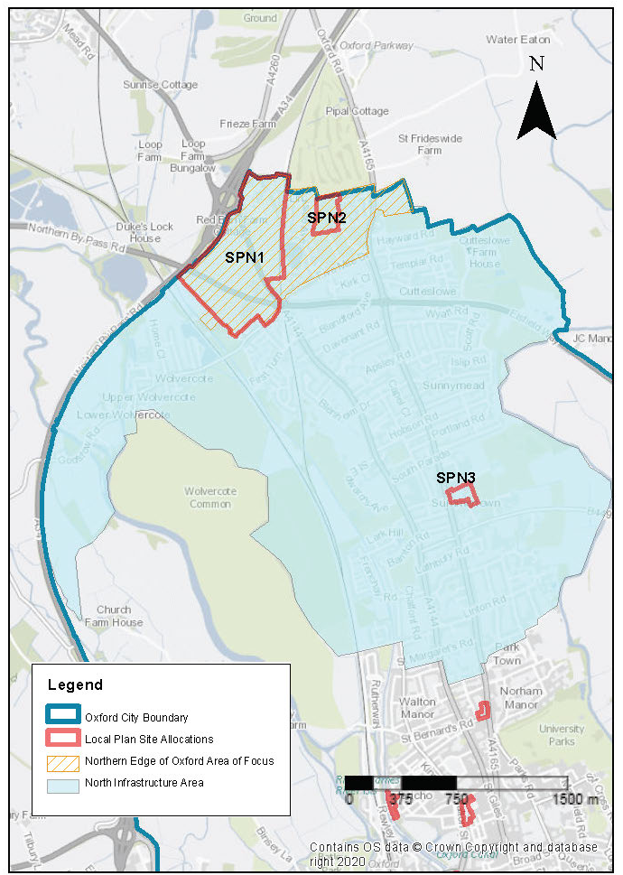
Figure 8.3 North Infrastructure Area, Northern Edge of Oxford Area of Focus and site allocation policies

The North Infrastructure Area includes development sites such as Northern Gateway, which are adjacent to the Cherwell District Council (CDC) development sites, PR6a – Land East of Oxford Road, PR6b – Land West of Oxford Road and PR6c Land at Frieze Farm, which is the reserved site for the replacement Golf Course extension areas within CDC. Good transport connectivity via public transport, walking and cycling is a key need for this area if people are to be able to move easily between these residential areas and the city. As the northern entrance to the city, it is also important to have high quality urban design and good place making and to ensure views into and out of the city are protected.
Key considerations for infrastructure and design common across the area are:
- Improvements to pedestrian and cycle routes, and public transport accessibility, including
  - safe crossing at desire lines across the major roads in the area
  - Ensure connectivity by foot and cycle to sites adjoining the city
  - Connectivity of local facilities and services (that may be in Cherwell) and communities
  - Connectivity to Oxford Parkway
- Increase public access to green spaces
- Reduce air pollution to protect the SSSIs/SAC at Port Meadow
- Retain the integrity of the Green Belt by careful design at its edges
- Wolvercote Neighbourhood Plan.

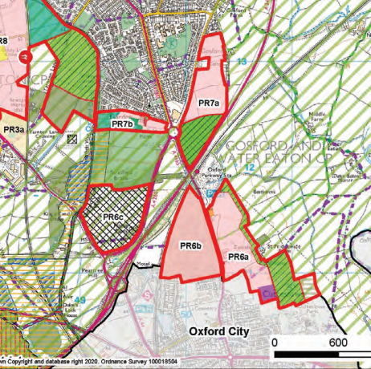
Figure 8.4 Location of the Cherwell site allocations for Oxford’s unmet need, near to Oxford’s boundary: PR6a, PR6b, PR7a, PR7b

Policy NEOAOF– Northern Edge of Oxford Area of Focus

Planning permission will be granted for new development within the Northern Edge of Oxford Area of Focus where it would ensure that opportunities are taken to deliver the following (as applicable):

- Pedestrian and cycling infrastructure improvements must be delivered in accordance with the requirements of the Oxfordshire Local Cycling and Walking Infrastructure Plan. All opportunities to optimise connectivity and permeability for people wishing to walk or cycle in the area to other parts of the city and/or to destinations in the neighbouring districts of Cherwell District Council and West Oxfordshire should be taken;
- Public transport provision enhancements;
- Good urban design and place making opportunities to be incorporated into new residential areas including enhancing both existing and the introduction of new public open space; and
- Enhanced landscape planting and increased tree cover.

Development proposals that exceed the height that the High Buildings TAN states may have an impact on the historic core will be required to provide extensive information so that the full impacts can be understood and assessed as listed in Policy HD9.

North Area site allocation policies within the Area of Focus
- Northern Gateway
- Oxford University Press Sports Ground
Northern Gateway

Site area: 45.2 hectares
Ward: Wolvercote
Landowner: St John’s College (Thomas White Oxford), Merton College, Oxford City Council
Current use: majority under construction plus existing park & ride, service station, hotel, greenfield/farmland, car showroom and petrol station.
Flood Zone: FZ1

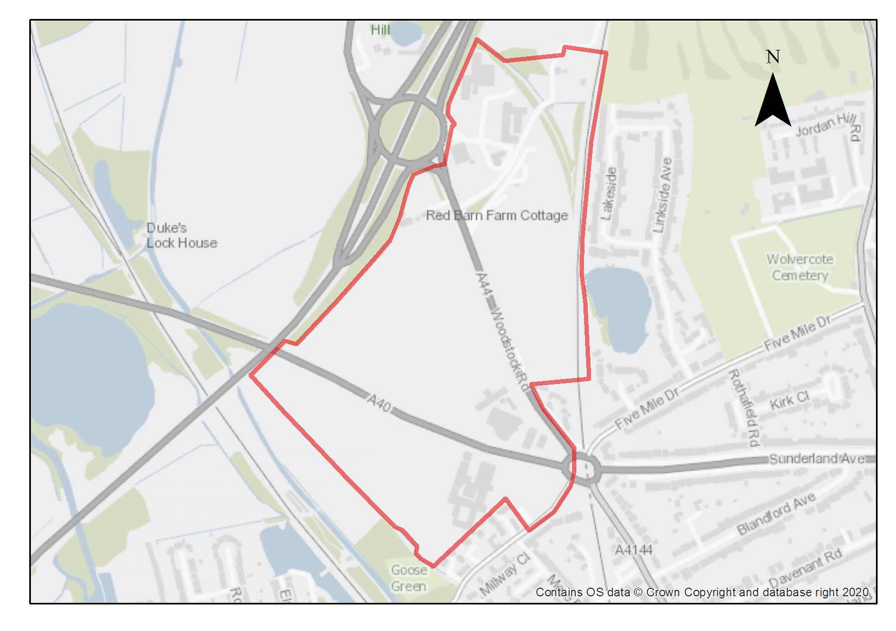

This is one of the largest sites for housing and employment growth in Oxford. Development here will have a significant positive impact on the supply of specialised employment floorspace and new homes, and it is crucial to ensure the optimum use is made of the area.

This site was the subject of the Northern Gateway Area Action Plan (NGAAP) and there is an extant planning permission for a significant part of the site (“Oxford North”). In addition, there is substantial further capacity for growth in the remaining parts of the site: around Red Barn Farm, Pear Tree Farm, and Land off Goose Green Close, as well as key infrastructure needed to unlock the area especially capacity of junctions in the area. In response to the City’s pressing need for housing, the main use for remaining areas at the Northern Gateway is residential alongside the Category 1 employment uses as defined by Policy E1.

The NGAAP is superseded by this site allocation policy reflecting the contextual changes that have occurred since the AAP was adopted in 2015 namely: the granting of planning permission for Oxford North, the allocation of unmet need housing sites in adjoining Cherwell district; delivery of highways/junctions improvements through Growth Deal and Housing Infrastructure Fund (HIF) funding; and the opening of Oxford Parkway railway station.

The planning permission for Oxford North covers a significant part of the site, and a comprehensive approach to the development of the remaining parcels of land is needed. This site allocation will help to ensure the efficient delivery of development across the area. Coordinated infrastructure delivery and protection of environmental assets are key to the success of the site, including protecting the SAC at Port Meadow, and prioritising good connectivity for pedestrians and cyclists and access to public transport from this area to the new residential developments on the unmet need housing sites in the adjoining Cherwell district.

Northern Gateway includes a Category 1 employment site which is delivering key innovation and research facilities and plays a role in the wider “Knowledge Spine” in Oxfordshire.

The Oxford North planning permission 18/02065/OUTFUL makes provision to deliver 480 homes and 87,300sqm (B1) employment, as well as a 180-room hotel, 2500sqm retail (A1 A2 A3 A4 A5), and 500sqm community uses. Construction has commenced on site for the first phases. The remaining areas of the Northern Gateway area (land at Pear Tree Farm, Pear Tree Services area, the Pear Tree Park & Ride facility, Land off Goose Green Close and Red Barn Farm) are yet to be developed/redeveloped. This policy seeks to make efficient use of the whole site subject to environmental constraints.

Pear Tree Farm is suitable for residential development (minimum number 122). Vehicle access to the site is a constraint as the current single-lane track would not be suitable for this development in its current form and an alternative access would be required. The layout and design of this area must also facilitate pedestrian and cycle access through the site, over the footbridge across the railway line to Oxford Parkway station.

The site is contained by the railway line and by a belt of trees, and there is substantial existing tree coverage of the site, so design will need to consider the potential impacts on biodiversity and urban greening factor. The quality of all existing trees should be assessed against the criteria in table 1 of BS5837:2012 (or its latest iteration). High quality trees must be retained unless there is a robust over-riding policy-based justification. Moderate and low-quality trees should be retained where it is feasible to do so. Opportunities exist to plant new trees to benefit public amenity in the area. Retaining trees along the railway line and A34 could also help act as a buffer with noise and screening. The parcel was formerly in the Green Belt so compensatory improvements should be made to surrounding areas of remaining Green Belt. The site is part of a larger field which is severed by the administrative boundary with Cherwell district, and the geometry of the part within Oxford means the design and layout of the site could benefit from being developed holistically with the rest of the field which lies within Cherwell (and all under the same landowner).

This site is of archaeological interest for potential prehistoric and Roman remains. This will require further investigation as part of any redevelopment. A part of the site to the west is in the Wolvercote Conservation Area.

The Pear Tree services area performs an important function at its location on the A34 Pear Tree interchange, however it makes inefficient use of land and forms a visually low-quality gateway to Oxford. There has been investment by the landowner in recent years so it is not anticipated that the area will change significantly in the earlier part of the plan period but may offer longer term opportunities for either redevelopment or refurbishment during the plan period and may offer access opportunities to Pear Tree Farm development. Proposals to further enhance the urban design of this strategic approach to the city will be supported.

Part of the site currently operates as Pear Tree Park & Ride facility, which is important in supporting modal shift and the zero-emission zone in the city centre and its future will also be influenced by the countywide Park and Ride strategy. However, the present layout with a large area of surface car parking does not make most efficient use of the site, nor does it contribute towards the urban design of the area. There is a lease on the site to operate the Park & Ride but if the whole or part of this site were to become available for development during the plan period due to the consolidation of the facility or making more efficient use of the site (eg introducing decked parking) it would be suitable for residential development. This would also have the potential to create capacity for other mobility hubs uses as set out in the County Council’s COTP.
Between the A34 and A44 is Red Barn Farm which is currently used by Oxfordshire Projects (TRAX) with office/workshop/classroom buildings and a motorcross track. This is an important community facility to support young people, so whilst the area is suitable for redevelopment, the loss of this community facility needs to be addressed as per Policy C3. The site is most suited for high quality employment uses due to the location adjoining the convergence point of the A34 and A44 and this would complement the adjoining employment uses in the Oxford North development. Vehicle access to this site needs to be addressed because the current access onto the A44 is unlikely to be suitable for any significant increase in traffic. There is the potential for access to Red Barn Farm through the Oxford North site around the balancing ponds, or low car development may be an option.

The Red Barn Farm parcel is at a prominent location of the Northern Gateway site, and a key entrance to the city, so design should be high quality whilst also considering the impact on views, particularly the view cone from Port Meadow. There is opportunity to orientate employment blocks towards the adjoining balancing ponds for more pleasant views for occupiers and to benefit from passive solar gain. There is substantial existing tree/hedgerow coverage along the edge adjoining the A34 which could help to provide screening and act as a buffer against noise and pollution from the A34.

The land to the north of Northern Gateway site lies in Cherwell district and is a site allocation for Oxford’s unmet need in the Cherwell Local Plan Partial Review for 1,360 homes (PR6a and PR6b). Development in this side of the Northern Gateway site should make provision for future connectivity with development of the site in Cherwell and onwards to Oxford Parkway Rail Station, with potential for vehicular, pedestrian and cycle links.

There is also remaining land in the southern part of the Northern Gateway site. This is mainly the Wolvercote services, car showroom, hotel area. This part of the site, next to the Wolvercote roundabout, has existing buildings in the form of a hotel, car showroom, petrol station and BT facility. There has been investment in those buildings in recent years and for that reason the area is unlikely to change significantly in the earlier part of the plan period but may offer longer term opportunities for either redevelopment or refurbishment during the plan period, and opportunity to enhance the contribution to urban design of this gateway site.

There is also a parcel of greenfield land by Goose Green Close which is suitable for residential use (minimum number 20 dwellings). The proximity of this site to the SAC means the potential recreation and dog-walking impacts will need to be addressed in any proposal, and the HRA may need to be revisited to satisfy the Habitat Regulations requirements. Appropriate levels of open space should be provided within the development as compensatory measures.

The southwest side of the Northern Gateway lies within 500m of the internationally protected Oxford Meadows Special Area of Conservation (SAC), so development must not affect the integrity of the SAC in terms of recreational pressure, hydrological regime, or air quality. The main risk to the SAC is from potential increased recreational pressure (including dog walking) from additional residents, and from potential increased air pollution from additional vehicle movements. As such, an increased level of open space provision should be made within residential developments to provide local alternative recreation areas in the southwest part of the site.

Residential development in the northern parts of the site at Pear Tree Farm or Pear Tree P&R is not anticipated to present the same risk to the SAC due to the distance to access to the SAC for recreation, so open space requirements would be as per Policy G2.

Vehicle movements related to the employment development at Red Barn Farm could also present a risk to the SAC in terms of air quality, so proposals will need to demonstrate that the Habitats Regulations have been satisfied, which may include limited parking provision within Red Barn Farm to within the limits already tested through Appropriate Assessment.

Preliminary analysis suggests that the presence of various green infrastructure features on the site at present means that parts of, or all of the site, are likely to score above the minimum thresholds for green surface cover as required by Policy G3; as such proposals will need to ensure that this score is retained (no net loss), demonstrated through submission of the Urban Greening Factor assessment. New development on the site will need to consider how existing green features, particularly higher scoring elements, can be retained. Sufficient replacements will need to be incorporated into the new design, or enhancement of existing green infrastructure that is being retained, to preserve the baseline UGF score as a minimum.

A coordinated and comprehensive package of transport measures is required to facilitate development at Northern Gateway so that Oxford remains accessible and well-connected for residents, visitors, and businesses. Since the AAP was adopted key infrastructure is being provided up front via HIF/Growth Deal funding, City Deal funding, and the Oxford North development including: bus lane and bus stop upgrades around Pear Tree; junction signal improvements on A44; pedestrian access and crossings improvements around Pear Tree; cycle lanes; junction improvements at Canalside and central parcels of Oxford North; cycle lane and bus lane improvements on A40; and pedestrian crossings and footpaths to connect the south of the site with Wolvercote.

Further infrastructure related to development at the Northern Gateway is likely to include:
- Improved bus services and facilities
- High quality cycle routes into Oxford
- Improved pedestrian and cycle links to Oxford Parkway rail station
- Potential expansion of Wolvercote Primary School*
- Further A44 works at southern end (beyond that already secured via Oxford North)
- SEN and disability provision in SEN schools serving the development
- Provision of an enhanced Pear Tree P&R facility with additional parking spaces, improved waiting facilities, and installation of a decked car park.

Because of the land use there are potential contamination risks near the farm area. Site investigations will be required, and remedial works are likely to be necessary.

*2023 pupils data indicates currently not needed but may change during plan period

Policy SPN1– Northern Gateway

Planning permission will be granted for development of the remaining areas at the Northern Gateway for the following uses:
- Residential development at: Pear Tree Farm (min 122 dwellings) and other complementary uses will be considered on their merits; Pear Tree Park & Ride; and Goose Green Close (min 20 dwellings); and
- Employment development and ancillary uses to support the employment at Red Barn Farm; and
- Redevelopment and/or refurbishment of Pear Tree Services, and Wolvercote services area.

Area-specific requirements
- Development at Pear Tree Farm must ensure pedestrian and cycle access through the site to encourage and support connections between Oxford Parkway Station and the wider Northern Gateway development. Development must also take into consideration the potential presence of prehistoric or Roman archaeological remains. Due to this potential, development should demonstrate compliance with Policy HD5.
- Red Barn Farm provides an important community function by providing education and training to disadvantaged and vulnerable young people, so any proposal will need to demonstrate that the facilities can be re-provided in accordance with policy C3, which may be outside of the city.
- Goose Green Close – the proximity of this parcel to the Oxford Meadows SAC means that any proposal for residential development will specifically need to address the impacts of potential increases in dog-walking and recreation use and will need to demonstrate that the Habitats Regulations requirements are satisfied.

As a Category 1 employment site it is important that employment development at Northern Gateway directly supports the knowledge economy of Oxford. At Red Barn Farm permission will only be granted for employment development where the intended uses directly relate to the knowledge economy of Oxford: science and technology, research, bio-technology, spin-off companies from the universities and hospitals, or other intended uses that make a measurable contribution to those sectors. Applicants will be required to demonstrate how their proposals contribute to the knowledge economy of Oxford. The City Council will ensure that these uses are maintained into the future, using legal agreements/conditions.

Open space, nature and flood risk
- The southwest part of the site (Canalside and Goose Green Close) lies less than 500m from the internationally protected Oxford Meadows Special Area of Conservation (SAC). To help protect this site from recreational pressure, a minimum of 15% publicly accessible green open space for the enjoyment and benefit of residents should be provided onsite as part of any residential development in this part of the Northern Gateway. Unless the proposal can demonstrate that the development is not likely to have a significant effect on the Oxford Meadows Special Area of Conservation, the application will be subjected to appropriate assessment under the Habitats Regulations and permission will be granted only if it is ascertained that the development will not adversely affect the integrity of that Special Area of Conservation.

Vehicle movements related to the employment development at Red Barn Farm could also present a risk to the SAC in terms of air quality, so proposals will need to demonstrate that the Habitats Regulations have been satisfied, which may include limited parking provision within Red Barn Farm to within the limits already tested through Appropriate Assessment.

Landscaping along streets and in public open space should help introduce high quality green features into the site, which will contribute to biodiversity net gain and achieving the required Urban Greening Factor score. Parts of the site which are currently fields/green open space will also need measures to retain permeability of surface water.

Compensatory improvements should be made to surrounding areas of remaining Green Belt in accordance with the Identification of Opportunities to Enhance the Beneficial Use of Green Belt Land Report (LUC, 2018).

The level of POS provision if not specifically stated must be delivered in compliance with Policy G2.

Urban design and heritage
The design of new development in this area must be accessible, permeable and legible to ensure easy access to and through the site for all users with priority for pedestrians and cyclists. Development proposals must be designed with consideration of their impacts on the significance of the Wolvercote Conservation Area (in accordance with HD1). Design of new development must respect the character of the natural features of the site and create a sense of place which has its own identity and with continuous and well-connected streets with well-defined building frontages. Development must ensure that there is a clear distinction between the public and private realms to ensure both private and public spaces are well designed and defined. Careful consideration must be given to the positioning of windows and lighting in this development to ensure there is good surveillance of the public realm.

Movement and access
Accessibility within the area must also be considered in the design and layout of any proposals, and where necessary included in legal agreements associated with planning permissions, so that the development of remaining land is not prejudiced.

The land to the north of Northern Gateway lies in Cherwell, part of which is site allocations for Oxford’s unmet need in the Cherwell Local Plan partial review (site allocations PR6a&b). Development should make provision for future connectivity with any development of the sites in Cherwell, which should give potential for vehicular, pedestrian and cycle links. This should include designing the development to ensure it shall not compromise the delivery of the pedestrian and cycle improvements or the potential future direct cycle link to Oxford Parkway. It is important that the unmet need sites are well-connected to Oxford, and development at Northern Gateway must facilitate access and integration for those communities with existing north Oxford communities.

A coordinated and comprehensive package of transport measures is required to facilitate development at Northern Gateway. Strategic developments within the Northern Gateway area will be expected to provide proportionate financial contributions directly related to the development, to secure necessary improvements to, and mitigations for, the highway network and to deliver necessary improvements to infrastructure and services for public transport. Where necessary the provision of land will be required to support the implementation of relevant schemes to enable the area to be developed comprehensively.

Further transport infrastructure for the Northern Gateway includes:
- Improved bus services and facilities
- Improved cycling routes into Oxford and to Oxford Parkway rail station and destinations in neighbouring districts of Cherwell and West Oxfordshire in accordance with the LCWIP.

Natural Resources
The site is in an air quality hot spot area. Development proposals must demonstrate compliance with policy R4 by ensuring that all necessary mitigation measures against poor air quality have been incorporated during the construction and operational phases and ensuring that any potential negative air quality impacts are adequately mitigated on an ongoing basis, within and surrounding the site. Adjustments and considerations at design stage may be helpful in reducing the ongoing impact of poor air quality. Potential options may include considering layout options that place habitable spaces and openings away from pollution sources such as busy roads, landscape buffers, and designing in walking and cycling options as integral part of schemes.

Owing to previous uses on the site there are some areas of potential contamination present on the site so site investigation will be required, and remedial works are likely to be necessary and must demonstrate compliance with Policy R5.

Development proposals must include an acoustic design statement in compliance with Policy R7 as this site is part of an area which is subject to significant environmental noise from adjacent roads including the A40 and A34.
Oxford University Press Sports Ground
Site area: 3.65 hectares
Ward: Wolvercote
Landowner: Oxford University Press
Current use: Private sports ground
Flood Zone: FZ1

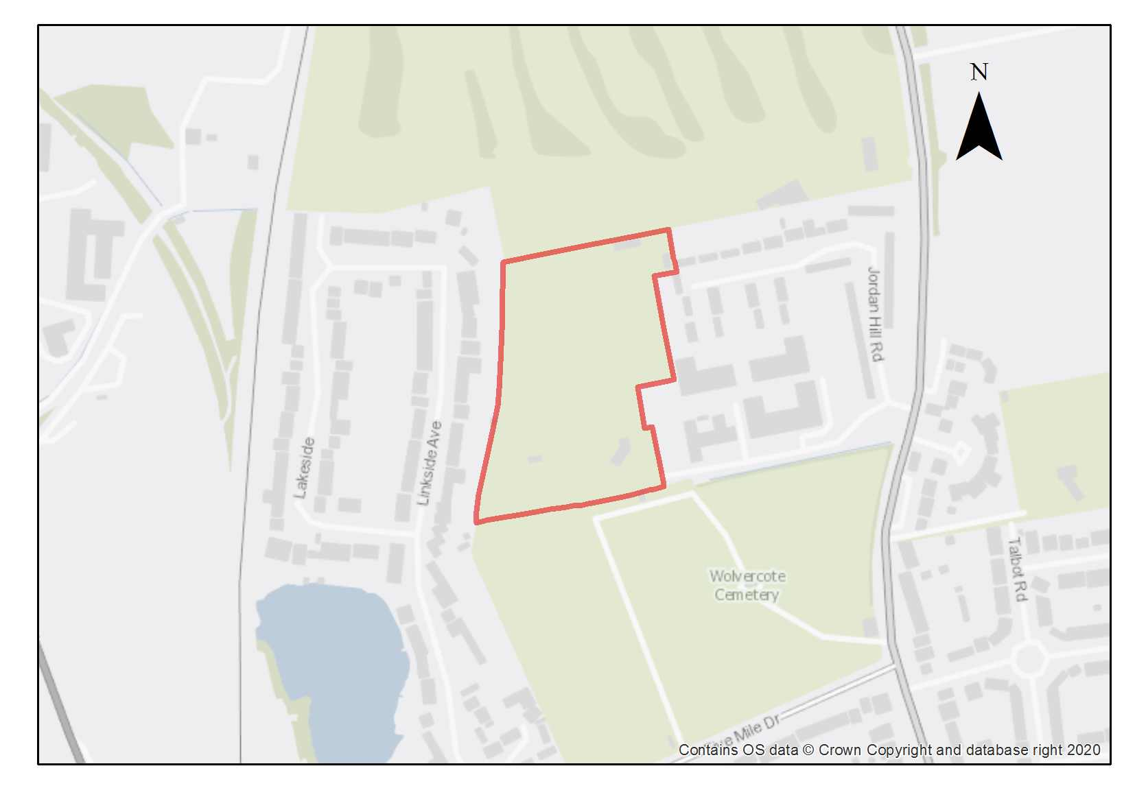

This site is currently open-air sports facilities for Oxford University Press and is adjacent to existing residential properties and Jordan Hill Business Park. Outside groups are able to use the pitches on an ad hoc basis. The pitches are in use and are not surplus sports pitches, so development that leads to any loss of pitches will need to demonstrate that the capacity will be replaced. The loss of the majority of the sports facility is considered justified due to the need for and benefits of new housing, and because there is scope within this large site to re-provide the sports provision at the same capacity but within a smaller space, leaving potential for development. Therefore, sports provision must be retained on the site unless an alternative provision is made, or contributions can be made to improving a local facility such that its capacity increase replaces what is lost. If an alternative site is found, then 10% of the site will be required for new public open space which should be sited to make existing residents feel welcome to use it.

Residential development would be an appropriate use on this site and some complementary employment uses may be suitable due to the site being adjacent to the Jordan Hill Business Park. However, given the strategy of the plan to prioritise residential use on new development sites, the site should be residential led.

The minimum housing number assumes the cricket pitch remains on the site, which will also need some buffering from residential development. A density varying from 50-60 dwellings per hectare has been assumed. If the cricket pitch is replaced with an alternative sports facility or off-site, then the minimum housing capacity will be higher. The City Council’s Active Communities team should be consulted about needs for different sports fields.

This site is within 1900m of the Oxford Meadows SAC. There should be access from the site to the Five Mile Drive Recreation Ground to help ensure minimal additional recreational pressure on the SAC.

Preliminary analysis suggests that the presence of various green infrastructure features on the site currently means it is likely to score above the minimum thresholds for green surface cover as required by Policy G3. As such, proposals will need to ensure that this score is maintained (no net loss) as a minimum, demonstrated through submission of the Urban Greening Factor assessment. To do this, new development on the site will need to consider how existing green features, particularly higher scoring elements, can be retained and enhanced where possible, such as the hedgerows at the boundary, as well as areas of the open green space. Sufficient replacements will also need to be incorporated into the new design, including as part of the new open space provision, to help mitigate features which are removed as part of development.

Policy SPN2: Oxford University Press Sports Ground

Planning permission will be granted for residential development and public open space at Oxford University Press Sports Grounds. The minimum number of homes to be delivered is 90 if the cricket pitch is retained on the site, rising to 130 if it is not. Some complementary employment use would also be suitable. Other complementary uses will be considered on their merits.

Open space, nature and flood risk
The capacity of the sports provision must be retained unless it can be demonstrated there is not demand for the facility (which is not the case at the current time) or the loss of the sports provision can be otherwise compensated for (Policy G1). If an alternative site is found, the City Council must be satisfied that it will be delivered and operational prior to the occupation of residential development on the site. The Active Communities team should be consulted about whether their cricket pitch needs to be retained or an alternative sporting use would better meet needs. In addition, the Oxford University Press Sports Ground site will still be expected to provide 10% new public open space as part of the residential development, if that is above the 1.5ha threshold set in Policy G2.

Policies G1 and G3 require protection of existing green infrastructure features and enhancement of greening on site through the urban greening factor. It is expected that those requirements can be met in the following ways. Opportunities should be taken to create wildlife corridors through the site by enhancing the biodiversity of the hedgerow to the west of the site and connecting it to existing mature trees in the corner of the Wolvercote cemetery. The southern part of the site should be retained as open green space, connecting to the existing recreation ground and maintaining the green setting of the Wolvercote Cemetery, which is the main asset of historic interest in the area. The surrounding area is characterised by wide streets and set-back buildings in large plots, which contributes to a high-quality public realm. Gardens and landscaping along streets should help introduce high quality green features into the site, which will contribute to biodiversity net gain and maintaining the Urban Greening Factor score.

Development should be designed to ensure that there is no adverse impact on the Port Meadow SSSI (Policy G6) and will be subject to appropriate traffic mitigation measures.

Urban design and heritage
Policy HD7 requires high quality design and the following sets out key considerations for achieving that on this site. Development should line and face the key streets and including greening features alongside such as verges, planting and swales would help achieve the urban greening factor. Development should encourage active frontages onto the new public open space. There is potential for higher density than the surroundings, with some flats set within grounds. To the west and the centre of the development near the business park and with a significant gap from the Wolvercote cemetery for open space and replacement facilities, will be most suitable for higher densities.

Movement and access
The relationship between development on this site and the neighbouring urban extension site in Cherwell District Council’s area must be carefully considered. The hedgerow that divides the sites adds important greening, but there should be high Policy HD7 requires high quality design and the following sets out key considerations for achieving that on this site. quality links through to the neighbouring development site for pedestrians and cyclists. This should provide a safe and clear linkage all the way through the site to the recreation ground, and through on to Jordan Hill, improving permeability through the area for pedestrians and cyclists.

Vehicular access to the site should be from Jordan Hill. This is likely to be the only exit and entrance so the road layout will need to allow easy circulation around the site. Any significant increase in traffic is likely to impact upon the nearby Wolvercote and Cutteslowe roundabouts, so appropriate mitigation measures will be required, and traffic generation should be limited, with low parking.

North Area site allocation policies outside of the Area of Focus
- Diamond Place and Ewert House
Diamond Place and Ewert House, Summertown

Site area: 1.73 hectares
Ward: St Margarets
Landowner: Oxford City Council and Oxford University
Current use: Public car parks, academic offices
Flood Zone: FZ1

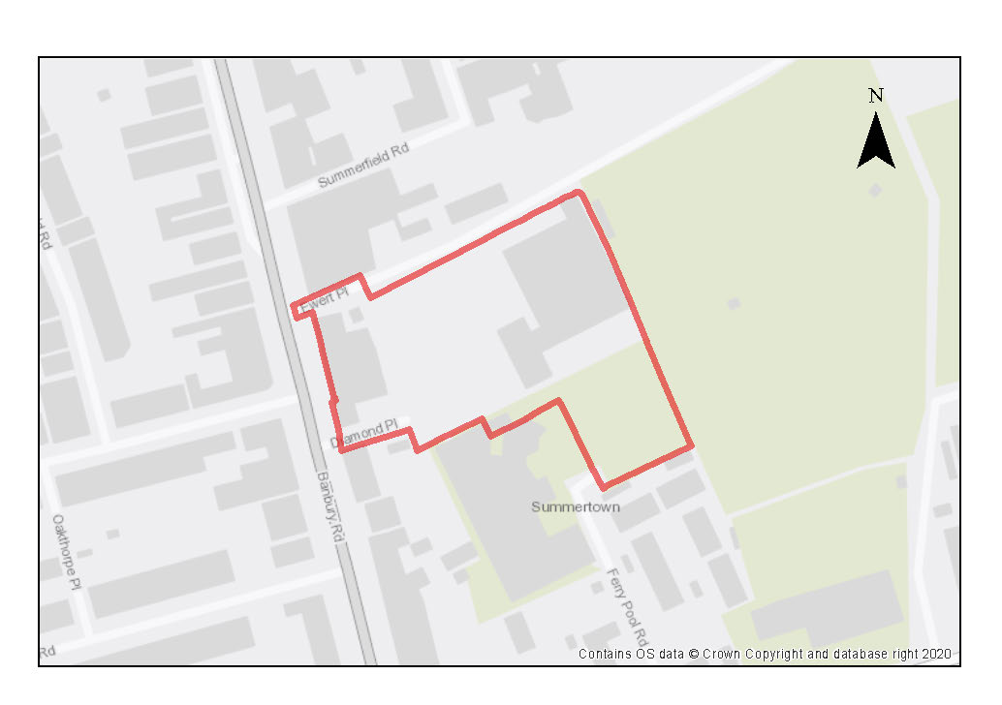

This site comprises car parks, offices and academic use. The University of Oxford propose to relocate the Examination Halls of Ewert House to an alternative site, and the City Council is seeking to make better and more efficient use of the car parks.

The site lies within the designation of the Summertown District Centre, so a mix of town centre uses should be provided. A comprehensive redevelopment of the site is required through a masterplan to make more efficient and effective use of this land, secure greater permeability and connectivity through the site, a high standard of design, achieve place-making and good public realm to maximise community benefits. The delivery of the approved development could however come forward in phases but should not compromise the operation of existing uses on this site.

The site lacks good quality urban design owing to the dominance of the open surface car parking. It slopes significantly from south to north, which offers design opportunities.

The City and County Council are seeking to promote sustainable travel and reduce public car parking within the city. There is however a recognition that some public parking on this site is important to serve the district centre, Community centre and the Ferry Pool leisure centre, but this should be reduced to meet only these requirements. The City Council will undertake this through a review of its current parking usage and in the context of public transport services. A safe and secure pedestrian and cycle route from north to south linking to Cherwell School and Ferry Pool Road is required to be provided.

New residential and student development could be designed in blocks to allow public spaces to flow through the site and areas of public realm created. There could be scope for some supporting uses such as retail, cafes, service uses to provide active frontages in the centre of the site, and alongside community centre and possible medical / health centre. The eastern boundary abuts Summerfield School playing fields, which affords attractive views to the east from the site. There is a hedgerow on the eastern boundary and some trees on the site, opportunities to retain these features and to enhance links where possible to the open fields beyond should be taken where deliverable.

Preliminary analysis suggests that the limited presence of green infrastructure features on the site currently means it is likely to score below the minimum thresholds for green surface cover as required by Policy G3. As such, proposals will need to ensure that an appropriate proportion of green features are incorporated into the design of development to meet the minimum targets set out in the policy, demonstrated through submission of the Urban Greening Factor assessment.

New green features could be incorporated as part of the public open space to be delivered on the site as part of the development proposal, which could be located in the centre of the scheme. Opportunities should be taken to link with existing green corridors adjacent to the scheme, as well as to deliver ecological enhancements through habitat creation linking through with the open playing fields to the east. The site contains existing trees which are important to public amenity and of value to the green ecosystem. The existing trees and those adjacent to the boundary will influence the developable area of the site and its potential capacity.

The potential for protected species on the site is likely to be limited to roosting bats in existing buildings.
This site is of archaeological interest as it is adjacent to an area of cropmarks of prehistoric or Roman era. This will require further investigation as part of any redevelopment.

Policy SPN3: Diamond Place & Ewert House

Planning permission will be granted for a mixed-use development and the minimum number of dwellings to be delivered is 180 dwellings. A minimum of 100 dwellings should be delivered on Diamond Place and 80 dwellings on Ewert House, of if delivered as non-self-contained student accommodation, the number of rooms that equate to this when the relevant ratio is applied.
A range of other uses would also be suitable, including the following:

- a replacement community centre, if existing one is demolished; and/or
- town centre supporting uses of an appropriate scale to a district centre, which could include additional shops / cafes / services / Class E uses to provide services for local people and new workers / residents / students; and/or
- other complementary uses such as a medical centre will be considered on their merits.

Open space, nature and flood risk
Policies G1 and G3 require protection of existing green infrastructure features and enhancement of greening on site through the urban greening factor. It is expected that those requirements can be met in the following ways. The hedgerows which connect the school playing fields to the wider landscape will be protected and opportunities for enhancements to the ecology should be promoted. An assessment of the condition of the existing trees should be undertaken and those of good quality retained where feasible and opportunities taken to plant new trees to benefit public amenity, support green infrastructure and enhance place making. The development must provide 10% open space.

Opportunities exist to reduce the overall amount of hard surfacing in favour of increased considered landscaping and green features such as bushes and hedgerows, or other forms of GI for ecological purposes.

Urban design and heritage
Development proposals must be designed with consideration of their impacts on the setting of the North Oxford Victorian Suburb conservation Area, the setting of the Grade II listed Diamond Place cottages and the character of the Summertown District Centre. Proposals must demonstrate compliance with polices HD1 and HD2.

Development must take into consideration the potential presence of prehistoric or Roman archaeological remains. Due to this potential, development should demonstrate compliance with Policy HD5.

Movement and access
Vehicular access to the development should be carefully considered and from Banbury Road (either Ewert Place or Diamond Place) and Ferry Pool Road. A new safe and secure pedestrian and cycle access should be provided through the site from the north to the south-east, connecting to Cherwell School and to Ferry Pool Road, together with pedestrian and cycle access safeguarded for any future development of the adjacent Summerfield School ground. The new route should explore the scope for potential improvements to the restricted width of the existing footpath/cycle way adjacent to the Bowls Club, which links to Cherwell School.

Residential development and student accommodation elements should be low car and the City Council will seek to minimise public car parking on the site to a level which is reasonable to serve the area bearing in mind the public transport connections and its location within a district centre.

Natural resources
Development proposals will be required to include an appropriate site contamination investigation and applications will be required to demonstrate how any contamination issues will be resolved in compliance with Policy R5.

South Infrastructure Area (including Cowley Branch Line and Littlemore Area of Focus)

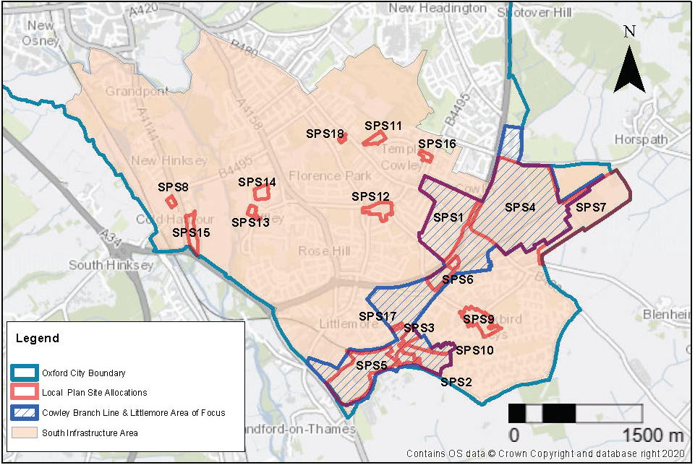
Figure 8.5 South Infrastructure Area, Southern Edge of Oxford Area of Focus and site allocation policies

The South Infrastructure Area includes development sites such as Kassam Stadium, which are adjacent to the South Oxfordshire development sites, Land South of Grenoble Road (Policy STRAT 11) and Land at Northfield (Policy STRAT 12)16. The area also includes large employment sites such as ARC Oxford and the Oxford Science Park. Enhanced public transport to these sites will be important as they grow, to provide a realistic alternative to car use for people travelling to the sites.
The opening up of passenger services along the Cowley Branch Line would provide a welcome public transport alternative for this area of the city. The branch line currently extends over three miles eastwards from Kennington Junction. The potential area of influence of the Cowley Branch Line, including where its passengers may come from, extends across this area. Two stations are proposed along the line at Littlemore/Oxford Science Park and in the vicinity of Oxford Business Park/Oxford Retail Park and Blackbird Leys and Cowley. Major new developments coming forward in this area will be expected to make financial contributions towards the delivery of the Cowley Branch Line to mitigate the impact of their development.
Good transport connectivity via public transport, walking and cycling is a key need for this area if people are to be able to move easily between bus stops, potential stations, residential and employment areas and other facilities. This area includes the significant centres of Blackbird Leys and Cowley, which have many facilities essential to their local communities. The vibrancy of these centres needs to be maintained so they can continue to be gathering places offering a range of facilities and services.
Oxfordshire County Council’s proposals to introduce an enhanced public transport service as part of the measures made possible through the proposed traffic filters will play an important contribution to this area.

Key considerations for infrastructure and design across the area are:
- Ensure good connectivity by foot and cycle and public transport across the area, including to the proposed locations of Cowley Branch Line stations
- Consider the connectivity of the urban extension area to the rest of the city and some sites in the city to the rest of the city.
- Enhanced public transport connectivity to help enable a reduction in car parking across the area
- Ensure land is safeguarded for stations and access for the proposed CBL.
- Increase public access to green spaces
- Ensure good urban design and place making opportunities are taken for the new residential areas to be brought forward
- Support the vibrancy of district and local centres in the area to ensure the facilities and services they include continue to be available
- Increase opportunities to enhance existing tree cover which is the lowest canopy cover across the city.
Cowley Branch Line and Littlemore Area of Focus
This Area of Focus includes the area around the Kassam Stadium and the proposed Cowley Branch Line (CBL) where several of the city’s key employment sites lie, including MINI Plant Oxford, Oxford Science and the ARC Business Park, which all employ large numbers of people. Key objectives for this area include improving and enhancing connectivity to this part of the city by modes other than by private car.
There is the potential for the re-instatement of passenger trains along the Cowley Branch Line (CBL) within the Plan period. The opening up of passenger services along the CBL would provide an additional public transport alternative for this area of the city. The branch line currently extends over three miles eastwards from Kennington Junction. Two stations are proposed along the line at Oxford Science Park and in the vicinity of ARC Business Park on the site of the Sandy Lane Recreation Ground to the rear of the Tesco Superstore.
The CBL would enable a wider catchment area of workers to be able to access important employment sites such as ARC Oxford and the Science Park by rail, which will help support the local, regional and national economy. There are secondary benefits of rail travel, such as the potential for reduced reliance on the private car, which brings with it the potential for improvements in air quality and reduced traffic congestion on the local highway network.
As well as delivering benefits for some of Oxford’s key employers, the delivery of the CBL has the potential to enrich the lives of residents by providing an accessible rail route into and out of the area. Any infrastructure delivery associated with the CBL must therefore be accessible for residents as well as workers who may be commuting into the city from across the county and region. This transformational infrastructure will require significant investment from a number of sources including developer contributions. Development sites within this Area of Focus will be expected to make financial contributions towards public transport, the delivery of the CBL including upgrading pedestrian and cycle access to the proposed stations to mitigate the impact of the developments.
In addition to changes resulting from the delivery of the CBL, the area will experience considerable transformation over the plan period as developments on the edge of the city in adjoining South Oxfordshire are built out as allocated strategic sites, particularly the Land South of Grenoble Road (Policy STRAT 11) and Land at Northfield (Policy STRAT 12). It is important that all opportunities are taken to ensure that these strategic developments on the city’s boundaries are well connected for both pedestrians and cyclists. In addition, these new developments must support existing public transport routes and the expansion of these routes where required to ensure people have the option to use public transport to move around the whole city not just routes that go to the city centre.
Oxford Stadium lies within this AoF, and Littlemore Conservation Area is near this AoF and must be properly considered in any development proposals that come forward. The height, scale and massing of new development in this AoF must be of a height, scale and mass that responds positively to the area. A degree of variation in height, scale and mass of any single proposal or its relationship to adjoining development is encouraged to promote an interesting and diverse townscape, provided it does not conflict with the surrounding context, appears incoherent, or leads to the fragmentation of townscape resulting in poor legibility.

Policy CBLLAOF: Cowley Branch Line and Littlemore Area of Focus

Planning permission will be granted for new development within this Area of Focus where it would ensure that opportunities are taken to deliver the following (where applicable):

- Pedestrian and cycling infrastructure improvements must be delivered in accordance with the requirements of the Oxfordshire Local Cycling and Walking Infrastructure Plan. Development proposals must take the opportunity to increase connectivity and permeability through developments so people can walk or cycle across the area and to other parts of the city including from the site allocations adjacent to the city which are in South Oxfordshire Local Plan 2035 (Strat 11 Land South of Grenoble Road and Strat 12 Northfield)
- Development sites coming across the area should seek to reduce car parking in line with Policy C8;
- New development must incorporate safeguarded land for pedestrian and cycle access to the proposed CBL railway stations as referenced in Policies SPS 5 Oxford Science Park and SPS6 Sandy Lane Recreation Ground and connections to bus stops;
- Enhancements to public transport both improving existing bus services and towards the proposed CBL. Improved accessibility in the southeast of the city is needed to support the anticipated intensification of existing employment use and to improve accessibility to new residential development. The CBL would enable a reduction in car use to this area, supporting this employment use. Financial contributions from trip-generating uses on all major sites within a 1,500m buffer zone of the proposed CBL stations will be expected in order to achieve these enhancements and mitigate the impact of their development. Figures 8.5 and 8.6 shows the extent of this buffer zone around both proposed railway stations and the site allocations that lie within it;
- Good urban design and place making opportunities are taken for new residential areas to be brought forward across the area of focus which would include delivering new residential development on redundant retail parks; and
- Enhanced landscape planting and opportunities taken to increase tree cover and enhance existing public open space and develop new ones across the area.

Due to the nature of sites in this area, it is expected that some larger scale development proposals are likely to come forward within this AoF. As such, careful consideration must be given to the design and height of new buildings to ensure that their impact does not have a detrimental upon views from the historic core, or on surrounding low-rise residential areas. Development proposals must be developed in accordance with Policy HD9 and the site-specific allocation where applicable. Development proposals that exceed the height that the High Buildings TAN states may have an impact on the historic core (which says skylining impacts from this area may be possible from 21m and above) will be required to provide extensive information so that the full impacts can be understood and assessed as listed in Policy HD9. When large scale buildings are proposed in the area, planning permission will only be granted where careful design mitigates the impacts of these large buildings upon the Oxford skyline and on existing neighbouring uses in terms of overbearing, overlooking and overshadowing, including:
- Setting back buildings away from the site boundaries and neighbouring residential areas/gardens boundaries; and
- Stepping back the upper storeys of proposals; and
- Ensuring windows in the proposal are angled away from the existing dwellings to reduce scope for overlooking into both houses and gardens; and
- Reinforcing or introducing landscape planting around the site boundaries to provide more screening and sense of separation between residential and non-residential uses; and
- Careful choice of materials including colour to mitigate glare and soften the visual impact of the proposal; and
- Varying the roofscape of the proposals to reduce scope for the merging of several taller buildings which prevent views across the city to the hills beyond; and
- Demonstrating consideration of the cumulative impacts of the proposal on views from the historic core area to the historic core area and across the historic core area.

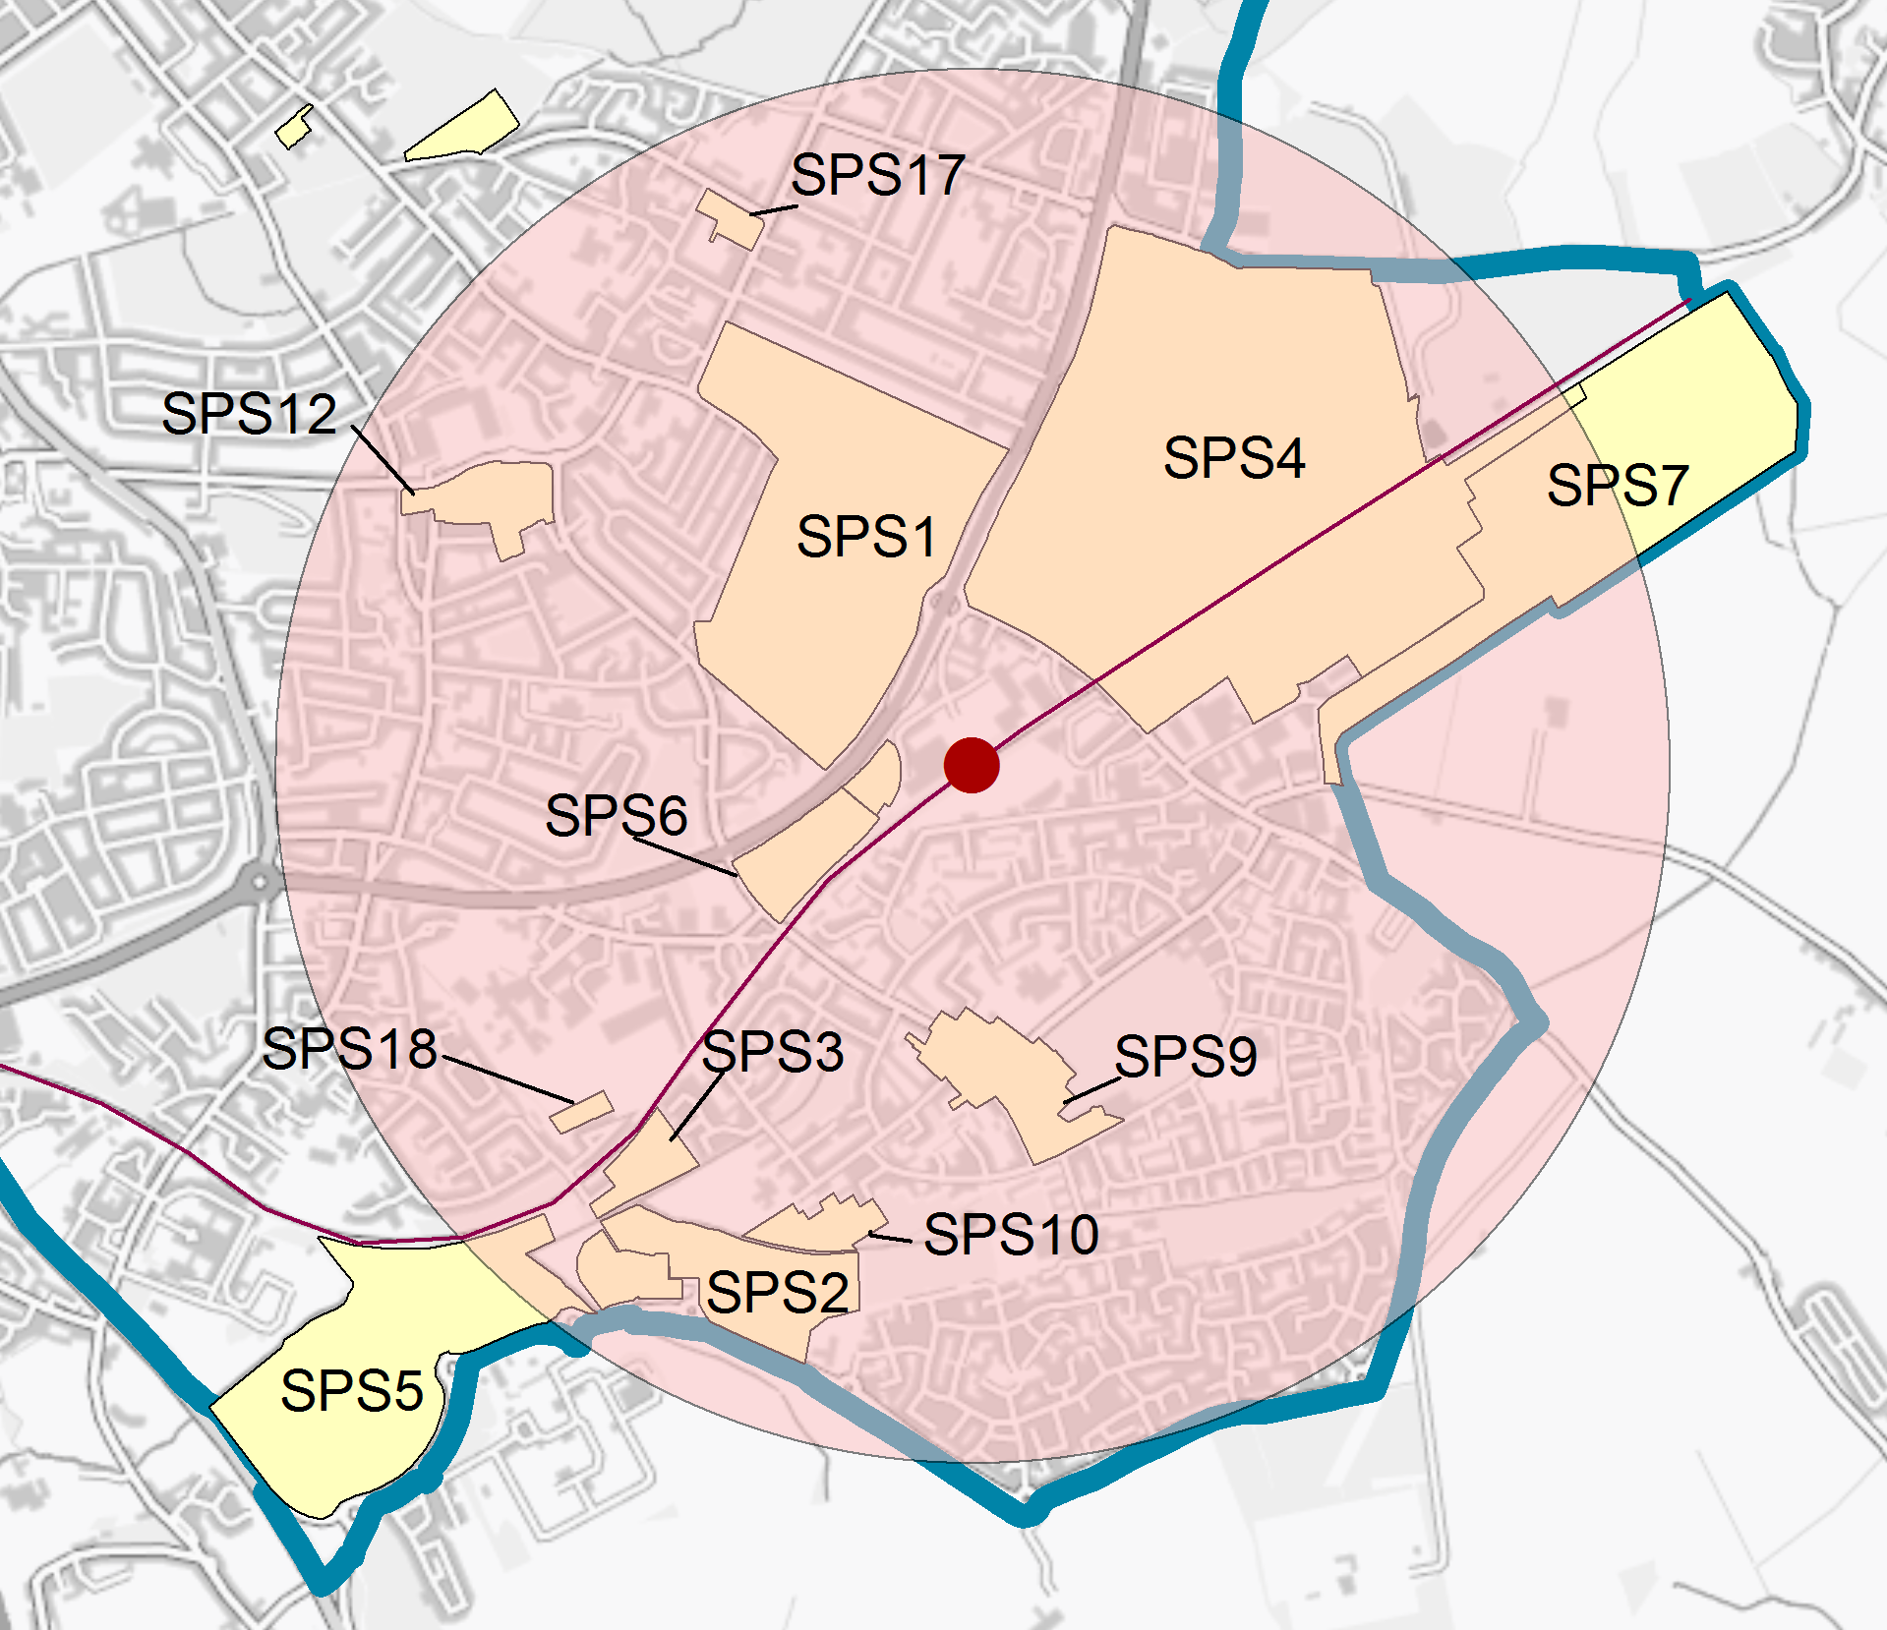
Figure 8.6 Site allocations within 1,500m buffer from proposed Oxford East station.
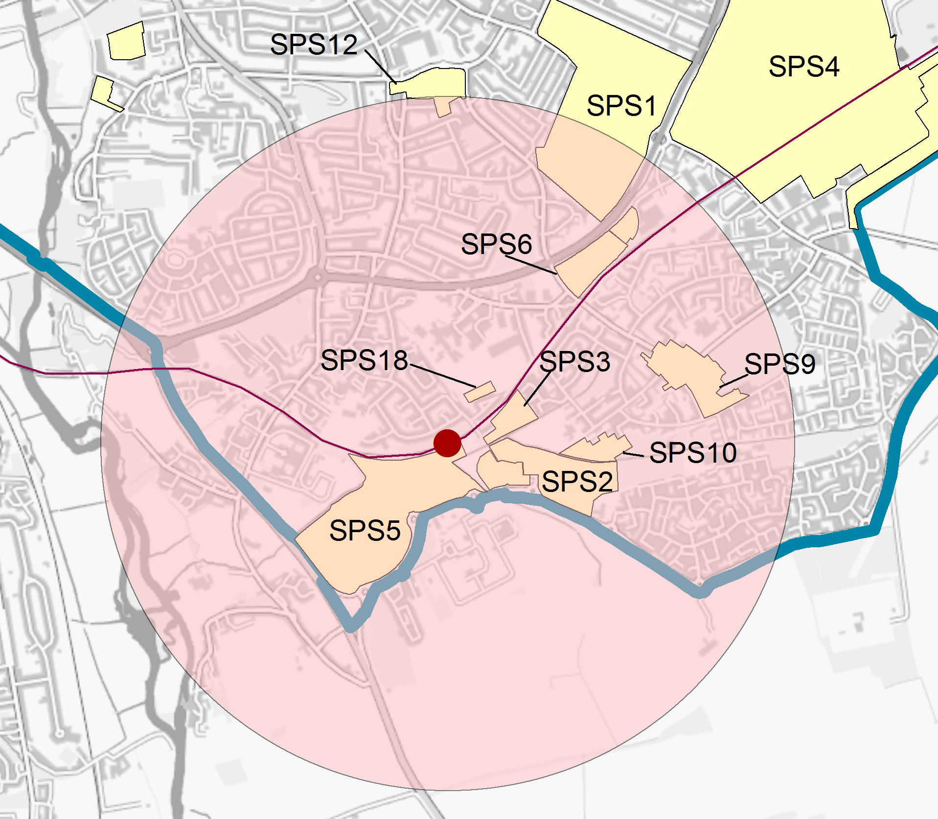
Figure 8.7 Site allocations within 1,500m buffer from proposed Oxford South station.

South Area site allocation policies within the Area of Focus
- ARC Business Park
- Kassam Stadium and Ozone Leisure Complex
- Overflow Car Park, Kassam Stadium
- MINI Plant Oxford
- Oxford Science Park
- Sandy Lane Recreation Ground
- Unipart Group
ARC Oxford

Site area: 35.4 hectares
Ward: Cowley
Landowner: ARC (majority)
Current use: Business Park
Flood Zone: FZ1

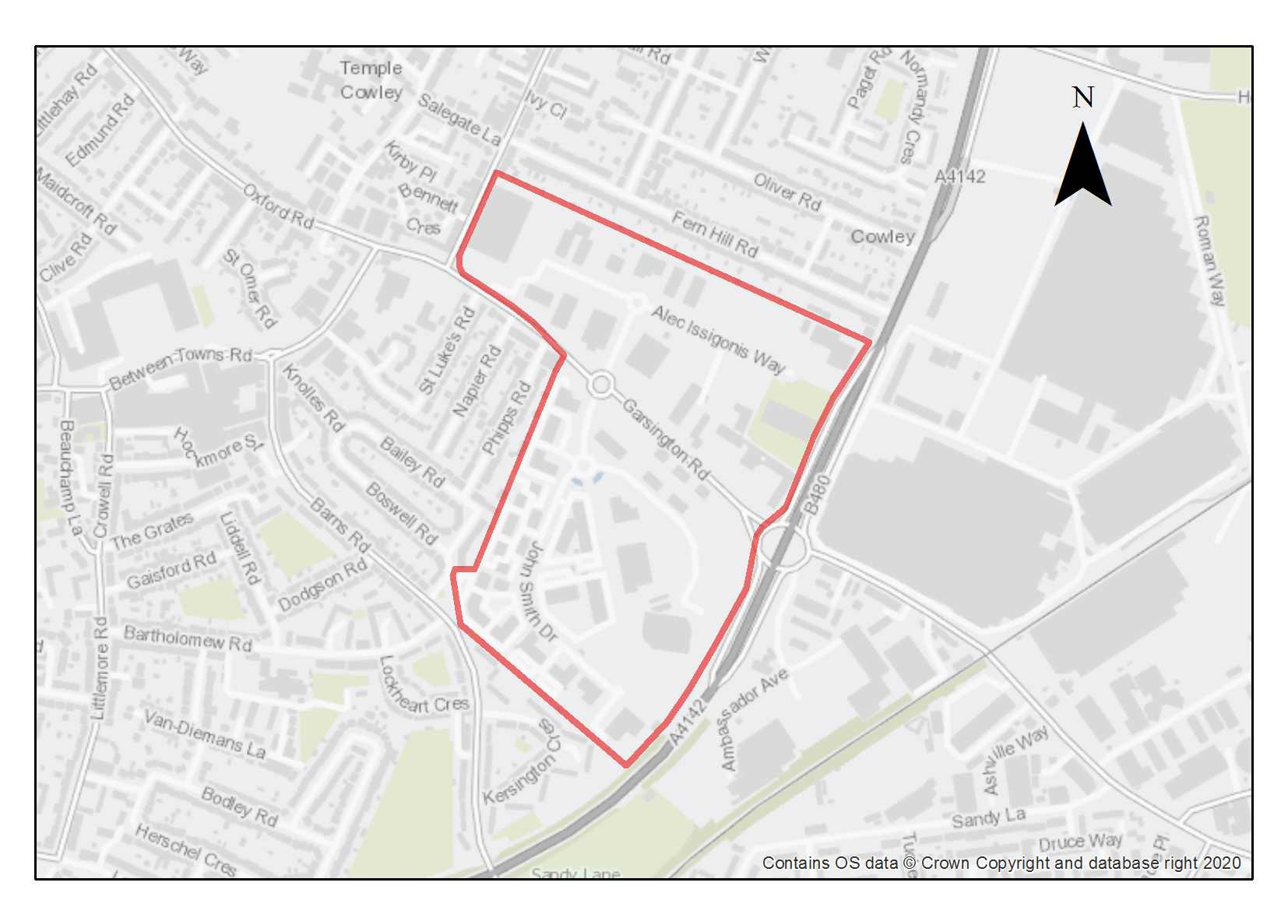

ARC Oxford is a Category 1 employment site home to a number of businesses and companies that make an important contribution to the regional and national economy (formerly known as Oxford Business Park). Several of these focus on science and innovation, individually and collectively contribute to building on Oxford’s key strengths in research and development, life sciences and the knowledge economy.

The Oxford City Employment Land Needs Assessment Report July 2023) identified the site as one of the best performing locations in the city for Class E (g) uses. Strong demand for research and development and laboratory space has prompted a shift from traditional offices to spin-out research and development, as well as several existing sites capable of intensification and modernisation to satisfy future employment needs of the city in these sectors.

Whilst there are few heritage assets in the area, the site does lie adjacent to Temple Cowley Conservation Area and Oxford Stadium Conservation Area, as well as a grade II listed building to the west (The Nuffield Press) and development proposals need to ensure they do not detrimentally impact upon these heritage assets.

The existing buildings are generally 2-3 storeys in height. The site lies within what has been identified as an Area of Greater Potential as referenced in the High Buildings TAN. These areas have scope for intensification of the land use with the introduction of more high buildings alongside new development on the remaining vacant plots The High Buildings TAN suggests that heights above 15 metres may have some level of impact on the skyline as viewed from the St Mary’s Church vantage point, a key sensitive viewpoint in the city. Other viewpoints across the city should also be considered when assessing proposals for high buildings on this site. While going beyond this threshold does not automatically preclude proposals from being acceptable, such schemes will be expected to strongly demonstrate that there has been an understanding of the context and the impact of the likely effects with regard to the High Buildings TAN.

Notwithstanding the increase in working from home, the office market remains strong in Oxford. Demand is being led by research and development and laboratory spaces, which has prompted a shift from traditional offices to spin-out research and development for life science companies. The ARC Oxford site has some plots of land available for future development and scope within the park to support intensification and modernisation of existing sites, and as such can help to meet some of the future employment needs of the city in these key sectors.

Preliminary analysis suggests that the limited presence of green infrastructure features on the site currently means it is likely to score below the minimum thresholds for green surface cover as required by Policy G3. As such, proposals will need to ensure that an appropriate proportion of green features are incorporated into the design of development to meet the minimum targets set out in the policy, demonstrated through submission of the Urban Greening Factor assessment. To help meet the UGF target, development proposals should seek a reduction in hard surfacing and car parks, which could release land for pocket parks, landscaping and SuDS. There is also the potential for wildlife corridors through the site.

The opening up of the Cowley Branch Line to passengers has the potential to deliver a sustainable transport solution, which will help to support the ARC Oxford and its opportunities for the future modernisation and intensification of this site. This will positively promote sustainable travel within this area and create better links to the city centre and to the wider area. ARC Oxford has already contributed to the detailed design phase of the CBL. It would be one of the most significant beneficiaries from a passenger service, it is expected to make a financial contribution towards the implementation of the CBL and its related infrastructure including pedestrian and cycling access to the proposed station and to support existing public transport services.

This site is of archaeological interest for potential Roman remains (although with some previous disturbance). This will require further investigation as part of any redevelopment.

Policy SPS1: ARC Oxford

Planning permission will be granted for new development, modernisation and intensification for research and development, offices and light industrial uses (Class E) and general industrial (Class B2) employment uses at ARC Oxford. Other complementary uses will be considered on their merits, such as amenity uses which support occupiers and the local area. An element of residential development within the defined threshold as specified in Policy E1 will also be supported.

Open space, nature and flood risk
Policies G1 and G3 require protection of existing green infrastructure features and enhancement of greening on site through the urban greening factor. Policy G5 requires onsite biodiversity enhancement, and Policy G2 requires new Green Infrastructure features and enhancement of existing features. It is expected that those requirements will be met in the following ways. Open space should be provided to contribute to green infrastructure and access for public use encouraged. Biodiversity on any vacant plots and between buildings should be improved. Proposals to develop vacant plots will be expected to be accompanied by a biodiversity survey to assess the biodiversity value of the site, and it should be demonstrated how harm will be avoided, mitigated or compensated. New developments should incorporate proposals for greening. An assessment should be undertaken of the quality and condition of existing trees and hedgerows with the aim to retain species of high-quality and medium / low wherever feasible and to introduce new planting in accordance with an agreed landscape and planting scheme.

Urban design and heritage
Policy HD7 requires high quality design and the following sets out key considerations for achieving that on this site. New development proposals should seek to improve both the place-making on this site, connectivity and the permeability and recognise its relationship to the wider area as part of a comprehensive master plan. Opportunities should be taken through the masterplan and as individual schemes come forward to enhance the external appearance of this site, its landscape setting and create new public open spaces for occupiers of the park and community use.

Development proposals that exceed the height that the High Buildings TAN states may have an impact on the historic core (which says skylining impacts may be possible from 15m and above) will be required to provide extensive information so that the full impacts can be understood and assessed as listed in Policy HD9.

Development must be designed with consideration of its impact on the adjoining Temple Cowley and Oxford Stadium Conservation Areas and nearby listed building (in accordance with Policies HD1 and HD2).

Development proposals must also take into consideration the potential presence of Roman archaeological remains. Due to this potential, development should demonstrate compliance with Policy HD5.
Movement and access
Pedestrian, cycle and bus links to and from the ARC Park and improved sustainable transport links should be promoted and supported, which may include the future re-opening of the Cowley Branch line to passengers. The implementation and wider use of the Cowley Branch Line, with a stop near ARC Oxford, would bring significant benefits and improve both sustainability and accessibility to this area of the city. As such, contributions will be required towards the provision of a pedestrian/cycle bridge over the railway if the opportunity for this to be delivered arises.

Natural resources
The site is in an air quality hot spot area. Development proposals must demonstrate compliance with policy R4 by ensuring that all necessary mitigation measures against poor air quality have been incorporated during the construction and operational phases and ensuring that any potential negative air quality impacts are adequately mitigated on an ongoing basis, within and surrounding the site. Adjustments and considerations at design stage may be helpful in reducing the ongoing impact of poor air quality. Potential options may include considering a layout that places habitable spaces and openings away from pollution sources such as busy roads, landscape buffers, and designing in walking and cycling options as integral part of schemes.

Development proposals will be required to include an appropriate site contamination investigation and applications will be required to demonstrate how contamination issues will be resolved in compliance with Policy R5.

Development proposals must include an acoustic design statement in compliance with Policy R7 as this site is part of an area which is subject to significant environmental noise from the surrounding roads including the Garsington Road and John Smith Drive.

Kassam Stadium and Ozone Leisure Park

Site area: 8.48 hectares
Ward: Littlemore
Landowner: Firoka Ltd
Current use: Football stadium, commercial, leisure, food and drink, retail and car parking
Flood Zone: FZ3b but FZ1 for sequential test

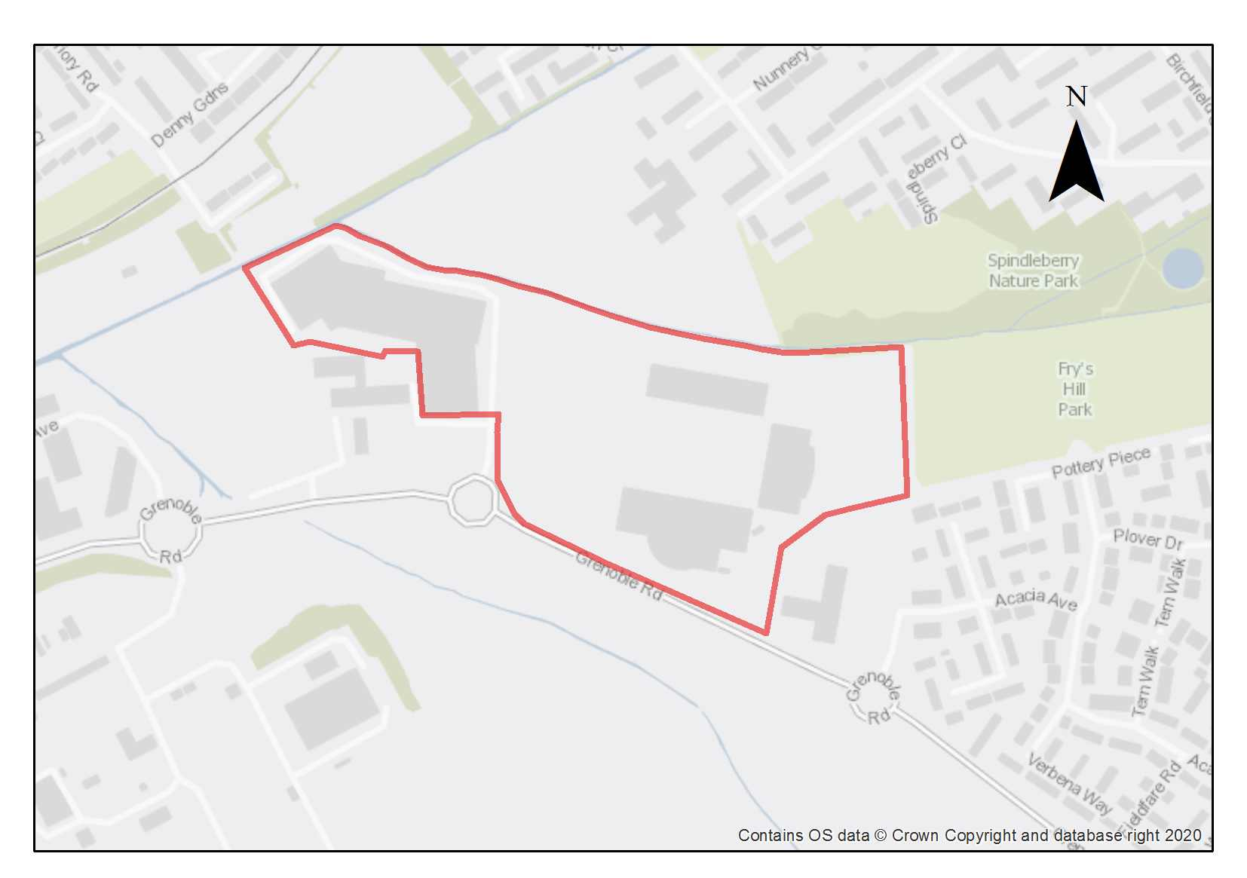

Northfield Brook runs along the northern edge of the site, and feeds into the Littlemore Brook in the northwest corner of the site. The fragments of the rural landscape that weave through the area are characteristic and make the area relatively sensitive to change. These should inform design choices. Grenoble Road is at the southern edge of one of the sites, and to the south of this a large new development site in South Oxfordshire is allocated in their Local Plan, which will change the character of the area, and which will need to be responded to in the design of development at the Kassam Stadium. Improvements to the road may also be needed because of developments on both sides. The site is largely flat, with few topography changes.

Currently access to the site is largely by car. The sustainability of the site at present is poor and enhancements for active travel modes as well as for public transport will be required.

The Ozone leisure facility is a dominating feature on the stadium site, which is a building of large mass, with the main active edge facing the Kassam stadium and Ozone car park, and blank faces on other sides. The three stands of the Kassam football stadium are also dominating. Hedges and trees line much of the site, especially alongside the Northfield Brook and the Littlemore Brook, which is adjacent to a short side of the Ozone Leisure Complex. A narrow strip of flood zone 3 lines the Northfield Brook and should be avoided by development. To the north east of the site is the Spindleberry Park Oxford City Wildlife Site, and any potential impacts of the development on this site should be considered.

The minimum housing number applies if the Kassam Stadium is moved to an alternative site and therefore frees up the area for alternative development, which should be residential development. The Ozone leisure facility is largely in Use Class E, so that is the lawful use of that part of the site. The assumed appropriate density is relatively high and around 70 dwellings per hectare on the Grenoble Road edge and Ozone and dropping to around 60 dwellings per hectare in the northern eastern corner. If residential development is enabled by the Kassam Stadium moving, this would be a large enough area if residential development to require 10% open space. A buffer around the watercourse has also been assumed.

Preliminary analysis suggests that the limited presence of green infrastructure features on the site currently means it is likely to score below the minimum thresholds for green surface cover as required by Policy G3. As such, proposals will need to ensure that an appropriate proportion of green features are incorporated into the design of development to meet the minimum targets set out in the policy, demonstrated through submission of the Urban Greening Factor assessment.

The EA has data/records on site investigation(s) adjacent to this site. Any proposal for development should make enquiries to understand the land quality issues and impacts on groundwater.

The mix of uses on this site, a small part of which is in Flood Zone 2, has been justified through the sequential test. A Level 2 Strategic Flood Risk Assessment was carried out for this site to examine part b) of the Exception Test (which relates to whether the development is safe). The Level 2 SFRA considered the proposed development was appropriate and additional mitigation and/ or analysis may be required to demonstrate compliance with the Exception Test at the planning application stage. This is to be undertaken through a site-specific FRA supporting the planning application. The site-specific flood risk assessment must demonstrate how the development will be safe otherwise planning permission will not be granted.

Both this site and the other Kassam site (SPS3) have potential for prehistoric, Roman and medieval archaeology. Both sites were evaluated in 1996 but the mitigation was never completed. The archaeology is dispersed and mostly focused around the fringes of the car park (peat with potential for prehistoric pollen sequences near northwestern corner of the Ozone, dispersed Roman pottery manufacturing activity, burials and other features east and north of the standing Nunnery dormitory range). This will need to be explored as part of any redevelopment.

Policy SPS2: Kassam Stadium and Ozone Leisure Park

Planning permission will be granted for residential development, public open space and replacement community and/or sport and leisure facilities, and for commercial uses within the existing area of the Ozone Leisure Park only, on the Kassam Stadium and Ozone Leisure Park site. The football stadium should remain (unless it has been replaced elsewhere in Oxford or in proximity to Oxford). If the Kassam Stadium is replaced elsewhere and that part of the site becomes available for development, the minimum number of homes to be delivered is 275. Other complementary uses will be considered on their merits.

Open space, nature and flood risk
Policies G1 and G3 require protection of existing green infrastructure features and enhancement of greening on site through the urban greening factor. Policy G5 requires onsite biodiversity enhancement, and Policy G2 requires new Green Infrastructure features and enhancement of existing features. It is expected that those requirements will be met in the following ways. The existing tree lined edges and green buffer along the Northfield Brook should be retained (with a minimum 10 metre width). There is an opportunity to enhance these features to create a strong wildlife network that connects to the wider countryside. A minimum of 10% of the site should be used for public open space, which should be accessible for existing residents of neighbouring areas. The opportunity should be taken to weave this green space through the site, creating a green corridor that links Fry’s Hill Park and Spindleberry Nature Reserve and the surrounding landscape, with enhanced walking, cycling links and pocket parks along the green corridor. The development should be designed to ensure active frontages face onto the open space. Development should not have an adverse impact upon the Oxford City Wildlife Site.

Proposals will be expected to provide additional protective and enhancement measures for Northfield Brook, with wetland restoration and an ecological buffer zone (min 10m from bank top). Any development should also assess and take account of hydrological and connectivity issues that could be impacted by work in the corridor of the main river and avoid any new crossing structures on the Northfield Brook.

A sequential approach should be taken to locating development on the site, with more vulnerable uses away from the highest flood risk. A drainage strategy will be required to manage run-off and may need a raised floor level for some of the site, to be informed by the FRA.

Urban design and heritage
Policy HD7 requires high quality design and the following sets out key considerations for achieving that on this site. Within the proximity of the Ozone Leisure Park, larger plot sizes would be appropriate to ensure they are not dominated. Closer to the Northfield Brook and existing low-rise development of Greater Leys, development will need to be lower to avoid dominating this and to reflect the rural landscape fragments. In these locations, a smaller plot size will also be more appropriate.

The form and layout of development should respond to the South Oxfordshire allocated development site to the south. A set-back may be necessary to minimise noise and air quality impacts from Grenoble Road, but there should be an opportunity to face and address the road, with relatively high-density development. More vulnerable development will be expected to be directed away from the small area of Flood Zone 3.

The 15th Century (remodelled around 1600) Grade II* listed Minchery Farmhouse adjoins the site in the southwest corner by the edge of the Ozone complex (within the Science Park, Policy SPS5). Development proposals must be designed with consideration of their impact on the listed building and its setting and demonstrate compliance with policy HD2.

Development must take into consideration the potential presence of prehistoric, Roman and medieval archaeological remains. Due to this potential, development should demonstrate compliance with Policy HD5.

Movement and access
Publicly accessible footpaths wrap around the North (Northfield Brook) and East of the Stadium site, linking up with Minchery Lane to the West and Littlemore/Blackbird Leys to the north. Development of the site must be designed to allow easy pedestrian and cycle movement east to west and north to south across the site and into the surrounding areas. There are frequent bus services from Pegasus Road, and the pedestrian access to these via the public footpaths should be enhanced to support new commercial and residential uses. Public transport enhancements will be required to ensure that the site does not remain car-dependent. The vehicular access will continue to be in the same location from Grenoble Road.

Natural resources

The site includes areas of filled ground which may be unsuitable for housing without protection measures. A land contamination survey must be submitted in compliance with Policy R5.

Potential effects of odour from the nearby wastewater treatment works along Grenoble Road will need to be assessed and mitigated in compliance with Policy R7

Development proposals must include an acoustic design statement submitted in accordance with Policy R7 as this site is part of an area which is subject to significant environmental noise from surrounding roads including Grenoble Road.
Overflow Car Park at Kassam Stadium site

Site area: 2.29 hectares
Ward: Littlemore
Landowner: Firoka Ltd
Current use: Car parking
Flood Zone: FZ3b but FZ1 for sequential test

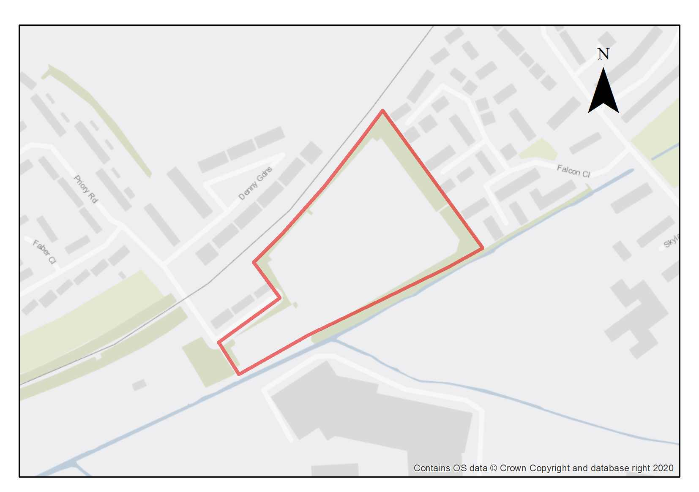

Hedges and trees line most of site, currently in use as an overflow car park for the Kassam Stadium on match days, with rarely more than a handful of cars parked at other times. Littlemore Brook runs along the southern edge of the site. To the east of the site is the Spindleberry Park Oxford City Wildlife Site, and any potential impacts of the development on this site should be considered. The steep railway embankment of the Cowley Branch line runs along the long northern edge of the site and creates a significant boundary/barrier. The surfacing is a mix of tarmac and gravelled areas, with some low hedges breaking up the parking spaces. The site is largely flat, with few topography changes.

The site is suitable for residential development. The minimum housing number given assumes minimum appropriate suburban densities of 50-60 dwellings per hectare, higher density being most appropriate to the north and in the centre of the site. The far southwestern part of the site is at higher flood risk, and the assumption has been made that built development will not take place on this part of the site. The assumption is also made that 10% of the site will need to be delivered as public open space, according to Policy G2. The public open space could be distributed across the site, with green links and pocket parks, and planting and types of space that appeal to a range of senses, a range of ages, including children and provide corridors for wildlife that link existing features.

There are limited access points because of the brooks and the railway embankment. There is currently informal pedestrian access from Falcon Close into the site, but this is via a muddy bank under trees.

Preliminary analysis suggests that the limited presence of green infrastructure features on the site currently means it is likely to score below the minimum thresholds for green surface cover as required by Policy G3. As such, proposals will need to ensure that an appropriate proportion of green features are incorporated into the design of development to meet the minimum targets set out in the policy, demonstrated through submission of the Urban Greening Factor assessment.

Residential use on this site, a very small part of which is in Flood Zone 3b, has been justified through the sequential test. A Level 2 Strategic Flood Risk Assessment was carried out for this site to examine part b) of the Exception Test (which relates to whether the development is safe). The Level 2 SFRA considered the proposed development was appropriate and additional mitigation and/ or analysis may be required to demonstrate compliance with the Exception Test at the planning application stage. This is to be undertaken through a site-specific FRA supporting the planning application. The site-specific flood risk assessment must demonstrate how the development will be safe otherwise planning permission will not be granted.

Both this site and the other Kassam site (SPS2) have potential for prehistoric, Roman and medieval archaeology. Both sites were evaluated in 1996 but the mitigation was never completed. The archaeology is dispersed and mostly focused around the fringes of the car park (peat with potential for prehistoric pollen sequences near the Bingo Hall, dispersed Roman pottery manufacturing activity, burials and other features east and north of the standing Nunnery dormitory range). This will need to be explored as part of any redevelopment.

Policy SPS3: Overflow Car Park, Kassam Stadium

Planning permission will be granted for residential-led development and public open space on the Overflow Car Park, Kassam Stadium site. The minimum number of homes to be delivered is 77. Other complementary uses will be considered on their merits.

Open space, nature and flood risk
Policies G1 and G3 require protection of existing green infrastructure features and enhancement of greening on site through the urban greening factor. Policy G5 requires onsite biodiversity enhancement, and Policy G2 requires new Green Infrastructure features and enhancement of existing features. It is expected that those requirements will be met in the following ways. A minimum of 10% of the site should be used for public open space, which should be accessible for existing residents of neighbouring areas. The opportunity should be taken to weave this green space through the site, creating a green corridor that links Fry’s Hill Park and Spindleberry Nature Reserve and the surrounding landscape, with enhanced walking and cycling links and pocket parks along the green corridor. The development should be designed to ensure active frontages face onto the open space.

Development should not have an adverse impact upon the Oxford City Wildlife Site. A buffer should be retained along the railway corridor to allow for the movement of protected species such as slow worms. The fragments of the rural landscape that weave through the area are characteristic and make the area relatively sensitive to change. The existing treed edges and green buffer along the watercourses should be retained. There is opportunity to enhance these features to create a strong wildlife network that connects to the wider countryside. A minimum 10m buffer should be left alongside the watercourse.

A sequential approach should be taken to locating development on the site. More vulnerable development will be expected to be located away from the small area of Flood Zone 3 alongside the brook and in the southwestern corner. A drainage strategy will be required to manage run-off and may need a raised floor level for some of the site, to be informed by the FRA.

Urban design and heritage
Policy HD7 requires high quality design and the following sets out key considerations for achieving that on this site. Closer to the Littlemore Brook and Falcon Close, terraced housing with front and rear gardens will be most appropriate, with an opportunity for larger plots to bookend rows, at road junctions, or facing buildings of similar size adjacent to the site. There is some potential for higher and larger plot buildings in front of the railway embankment, building in height from the other edges towards the centre and north of the site. The western part of the site near the access to Littlemore is too narrow for a row of two terraces in a block, and this also includes the area of Flood Zone 3, which built development should avoid. There should be a clear route through this corner, connecting to the path. There is potential for variations in roofscape as there is no predominant roofscape type in the area and it is not a defining characteristic.

Plot boundaries within Littlemore and Blackbird Leys are varied and include hedges, low walls and railings. The proximity of the brooks and existing hedgerows create an opportunity for green connections, and to run this through the site, so green plot boundary treatments with low trees and hedges are the most appropriate plot boundary treatments.

Development must take into consideration the potential presence of prehistoric, Roman and medieval archaeological remains. Due to this potential, development should demonstrate compliance with Policy HD5.

Movement and access
There are frequent bus services from Pegasus Road, which are within 800m from the site, and pedestrian routes to access this need to be enhanced. Opportunities to enhance the informal pedestrian access from Falcon Close should be investigated to create a more attractive pedestrian and cycle link to the surrounding area and nearby bus stops. Pedestrian and cycle access should also be retained from the western corner of the site towards Littlemore, via Priory Road; the potential for a restricted access from this location for servicing and emergency vehicles could be considered. The main vehicular access will remain as the bridge over the Littlemore Brook from the Ozone complex and Grenoble Road.

To eliminate any risk to railway operations and to ensure the safe operation of the railway, applicants must demonstrate that the design of development considers guidance provided by Network Rail.

Natural resources
Because of the use as a car park, some areas of potential contamination are present on the site so site investigation will be required, and remedial works are likely to be necessary in compliance with Policy R5.

Potential effects of odour from the nearby wastewater treatment works along Grenoble Road will need to be assessed and mitigated in compliance with Policy R7.

Development proposals must include an acoustic design statement to be submitted in compliance with Policy R7 as this site is part of an area which is subject to significant environmental noise from surrounding roads.

MINI Plant Oxford

Site area: 82.13 hectares
Ward: Lye Valley
Landowner: BMW Mini
Current use: Car Plant
Flood Zone: FZ1

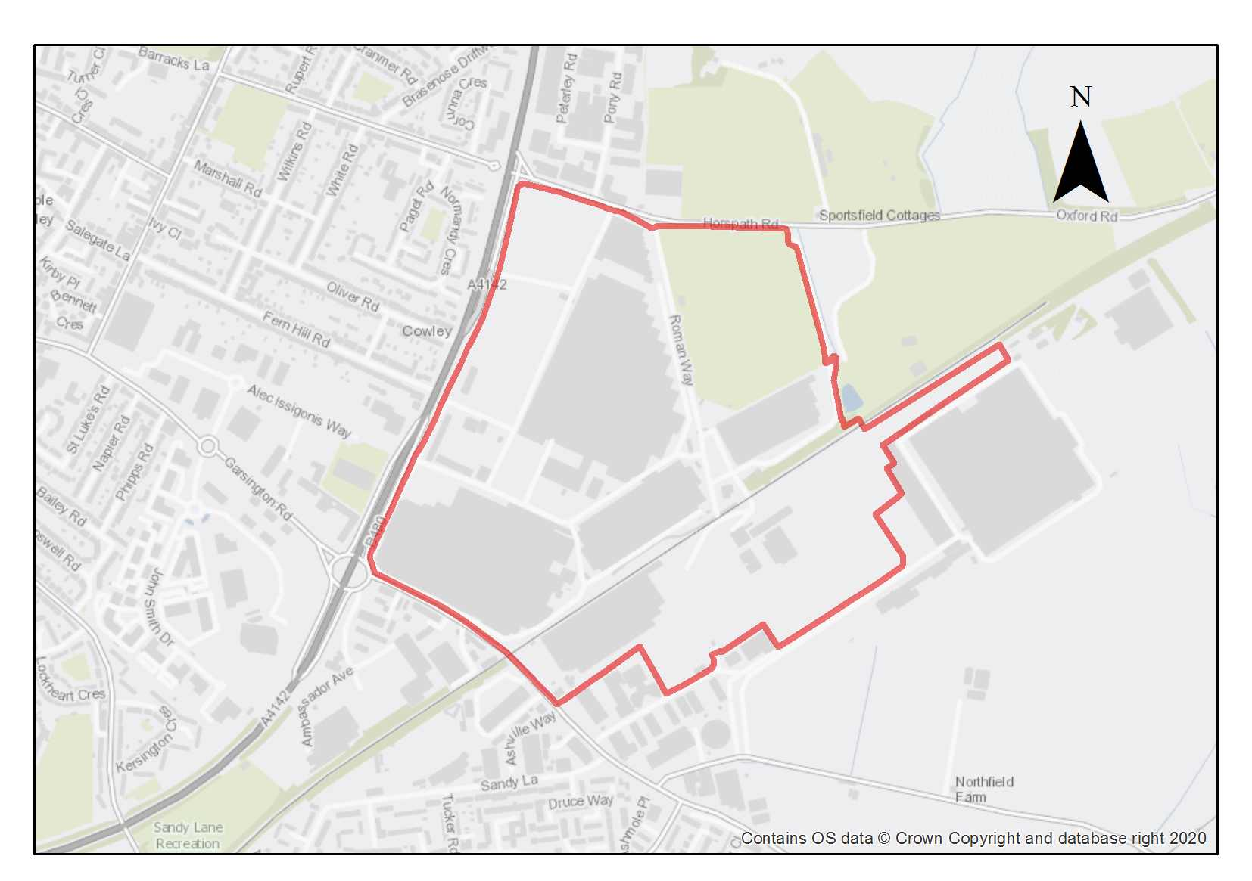

The Mini Plant Oxford lies in a ‘gateway’ location on the corner of the eastern by-pass and the Garsington Road, to the immediate south-east of the ARC Oxford business park. The Mini Plant is a major employer in the city and forms an important part of a wider range of industrial and office developments in this area.

This site is identified as a Category 1 employment site, being significant to both the regional and national economy. The future development of this site needs to reflect the ambition of the Oxford Economic Growth Strategy together with the aims and objectives to support economic growth and the importance of this site to the national economy. In these circumstances the modernisation and intensification of this site is supported to make the best and most efficient use of land and promote sustainable development.

The site is served by the Cowley Branch Line, the railway line that transports freight to and from the Mini Plant. The proposals to open-up the Cowley Branch Line to passenger traffic would provide improved accessibility and sustainable travel options to both this site and the surrounding developments including ARC Oxford and the Oxford Science Park.

Preliminary analysis suggests that the limited presence of green infrastructure features on the site currently means it is likely to score below the minimum thresholds for green surface cover as required by Policy G3. As such, proposals will need to ensure that an appropriate proportion of green features are incorporated into the design of development to meet the minimum targets set out in the policy, demonstrated through submission of the Urban Greening Factor assessment.

This site is of archaeological interest as the Dorchester- Alchester Roman Road runs through the site and there is potential for roadside settlement. Archaeological remains from the Bronze Age and Roman remains have also previously been recorded.

Policy SPS4: MINI Plant Oxford

Planning permission will be granted for the intensification and modernisation of the MINI Plant Oxford site to make the most efficient and effective use of the land in accordance with Policy E1 and in recognition of its importance as a Category 1 employment site.

Development and/or changes of use of buildings to Class B2 (general industrial), Class E (offices and light industrial) together with Class B8 warehousing uses or other complementary uses will be supported in principle, even though they may result in a loss of jobs, where these uses are shown to be important to the successful operation of the MINI Plant.

An element of residential development within the defined threshold as specified in Policy E1 will be supported.

Open space, nature and flood risk
Policies G1 and G3 require protection of existing green infrastructure features and enhancement of greening on site through the urban greening factor. It is expected that those requirements will be met in the following ways. New development should include some landscaping proposals to reflect the 'Gateway’ location of the public frontages of this site. Opportunities for greening on this site should be explored as part of future development proposals.

Urban Design and heritage
Policy HD7 requires high quality design and the following sets out key considerations for achieving that on this site. The MINI Plant Oxford site represents a ‘gateway’ location and therefore new development should positively respond to its setting and its relationship to key frontages adjacent to the Eastern By-Pass, Garsington Road and Horspath Road. There is scope to maximise the use of this site, with few constraints and an opportunity for new buildings to be of a modern innovative design that positively responds to its ‘Gateway’ location.

Adjustments and considerations at design stage may be helpful in reducing the ongoing impact of poor air quality. Potential options may include considering layout options that place habitable spaces and openings away from pollution sources such as busy roads, landscape buffers, and designing in walking and cycling options as integral part of schemes.

Development proposals that exceed the height that the High Buildings TAN states may have an impact on the historic core (which says skylining impacts may be possible from 15m and above) will be required to provide extensive information so that the full impacts can be understood and assessed as listed in Policy HD9.

Development must take into consideration the potential presence of Bronze Age and Roman archaeological remains. Due to this potential, development should demonstrate compliance with Policy HD5.
Movement and access
This site is located within the geographical area of the Eastern Arc. This is an area where it has been identified that future travel demand will be focused. Opportunities should be taken through the development of this site to support sustainable travel by providing greater public transport links and services, including the re-opening of the Cowley Branch Line to passengers. Support should be provided for improved pedestrian and cycle links and enhancements to the existing network including key junctions and provide better connections to both existing and planned major developments in the area.

Natural resources
The site is in an air quality hot spot area. Development proposals must demonstrate compliance with policy R4 by ensuring that all necessary mitigation measures against poor air quality have been incorporated during the construction and operational phases and ensuring that any potential negative air quality impacts are adequately mitigated on an ongoing basis, within and surrounding the site.

Because of the use of the site, some areas of potential contamination are present, so site investigation will be required, and remedial works may be necessary in compliance with Policy R5.

Development proposals must include an acoustic design statement to be submitted in compliance with Policy R7 as this site is part of an area which is subject to significant environmental noise from traffic using surrounding roads and existing operations.

Oxford Science Park

Site area: 27.1 hectares
Ward: Littlemore
Landowner: Magdalen College and Oxford City Council
Current use: Science Park and Vacant
Flood Zone: FZ3b but FZ2 for sequential test

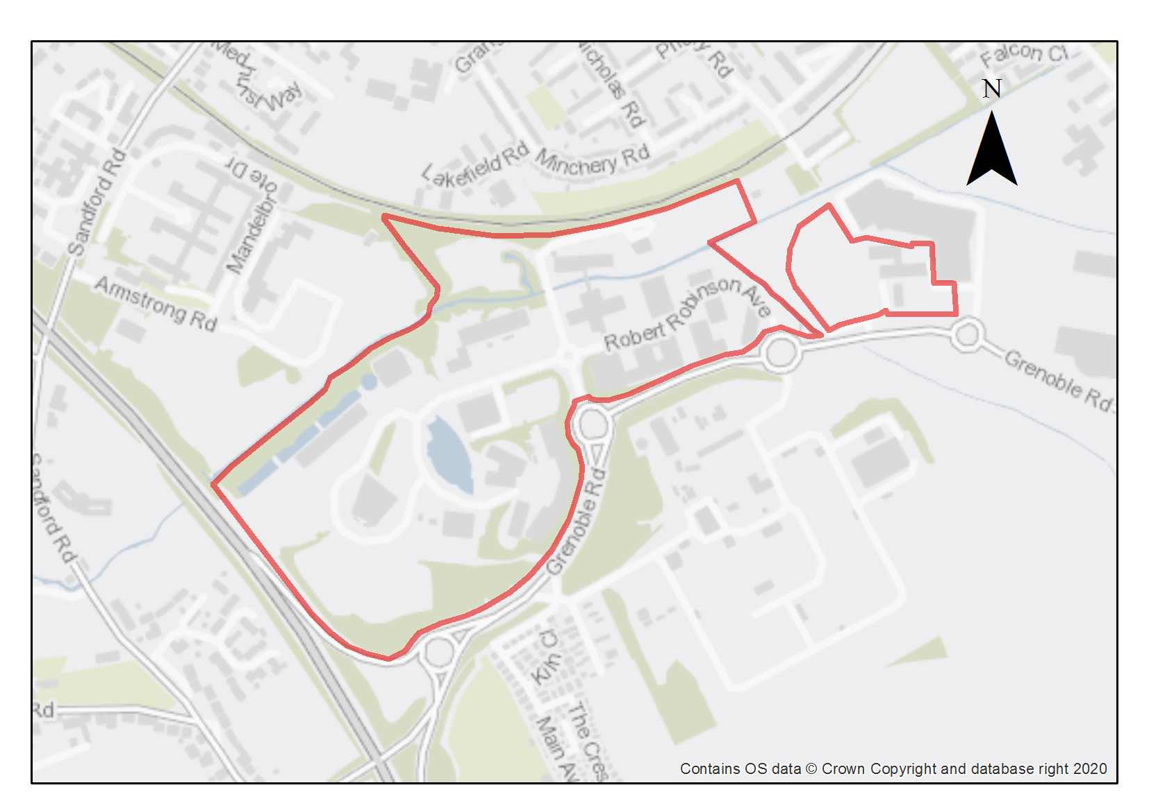

The Oxford Science Park is identified as a Category 1 employment site being of regional, national and global importance. It is one of the most influential science, technology, and business environments in Europe with 100 science and technology businesses employing some 3,200 people. These companies are often world leading and are having a significant impact on advanced science and research to improve human health. The companies range in size from small start-ups to large international firms.

The Oxford Science Park has six undeveloped plots with planning permission for 20,000 sqm, together with some master planning currently being undertaken for the remainder of the site to accommodate an additional estimated 25,000 sqm. This would provide for additional laboratories and offices, building on the city’s key economic strengths in the field of science, technology and life science research.

The opening up of the Cowley Branch Line to passengers has the potential to deliver a sustainable transport solution, which will help to support the Science Park and its opportunities for the future modernisation and intensification of this site. This will create better transport links to the city centre and wider area.

The land at Grenoble Road which lies at the southern edge of this site is a major new development site in South Oxfordshire, allocated in their Local Plan as an extension to the Science Park and for housing. This will significantly change the character of the area, and will need to be responded to both in the design of the new development at the Science Park, its connectivity and permeability and the links to future transport infrastructure provision.

The site lies within an identified potential growth area in the city, where there is scope for intensification of use with more higher buildings. Previous assessments and modelling have determined a threshold height of 21 metres beyond which built form will have some level of impact on the skyline as viewed from the St Mary’s Church vantage point, a key sensitive viewpoint in the city. While going beyond this threshold does not automatically preclude proposals from being acceptable, such schemes will be expected to strongly demonstrate that there has been an understanding of the context and the impact of the likely effects.

The site lies adjacent to the Oxford City Wildlife Site (Littlemore Brook) which also passes through the site. There are records of peat deposits that follow the line of the Littlemore Brook, which runs through the northern part of the site and the potential for additional unrecorded deposits in the area which will need to be considered and avoided.

Preliminary analysis suggests that the limited presence of green infrastructure features on the site currently means it is likely to score below the minimum thresholds for green surface cover as required by Policy G3. As such, proposals will need to ensure that an appropriate proportion of green features are incorporated into the design of development to meet the minimum targets set out in the policy, demonstrated through submission of the Urban Greening Factor assessment.

The employment use of this site, a small part of which, near the brook, is in Flood Zone 3b, has been justified through the sequential test. A Level 2 Strategic Flood Risk Assessment was carried out for this site to examine part b) of the Exception Test (which relates to whether the development is safe). The Level 2 SFRA considered the proposed development was appropriate and additional mitigation and/ or analysis may be required to demonstrate compliance with the Exception Test at the planning application stage. This is to be undertaken through a site-specific FRA supporting the planning application. The site-specific flood risk assessment must demonstrate how the development will be safe otherwise planning permission will not be granted.

The 15th Century (remodelled around 1600) Grade II* listed Minchery Farmhouse is within the site and any development should be sympathetic to the setting of this heritage asset. The site is of archaeological interest as medieval and Roman remains have been recorded previously and there is high potential for further prehistoric, Roman and early Saxon archaeology. The remaining priory structures (above and below ground) and related features and burials should be preserved in situ.

Policy SPS5: Oxford Science Park

Planning permission will be granted for new development and modernisation for research and development and office employment uses (Class E) that directly relate to Oxford’s key sectors of research-led employment at The Oxford Science Park. Other complementary uses will be considered on their merits.

An element of residential development within the defined threshold as specified in Policy E1 will be supported.

Open space, nature and flood risk
Policies G1 and G3 require protection of existing green infrastructure features and enhancement of greening on site through the urban greening factor. Policy G5 requires onsite biodiversity enhancement, and Policy G2 requires new Green Infrastructure features and enhancement of existing features. It is expected that those requirements will be met in the following ways. Adjacent to Oxford City Wildlife Site (Littlemore Brook) which also passes through the site. The site and its perimeter contain significant existing trees, hedgerows and woodland which form the structural landscaping of the Science Park that are important to public amenity in the area and will provide valuable ecosystem services. A 10-metre buffer to the watercourse should be maintained.

An assessment of the trees and hedgerows is required to assess their quality and condition. High quality trees must be retained unless there is a robust over-riding policy-based justification. Moderate and low-quality trees should be retained where it is feasible to do so. Opportunities should be taken to both retain and plant new trees to benefit public amenity in the area as part of a landscaping scheme.

Development should not have an adverse impact upon the wildlife corridor. Opportunities should be taken to improve biodiversity and provide links through the site. New development should incorporate proposals for additional greening as part of new landscaping schemes. A buffer should be retained along the railway corridor to allow for the movement of the protected species.

A site-specific FRA will be required. A sequential approach should be taken to locating development on the site, with more vulnerable uses away from the highest flood risk. A drainage strategy will be required to manage run-off and may need a raised floor level for some of the site, to be informed by the FRA.

Urban design and heritage
Policy HD7 requires high quality design and the following sets out key considerations for achieving that on this site. New development proposals should seek to improve the place-making on this site and the permeability and recognise its relationship to the wider area as part of a comprehensive master plan. Opportunities should be taken to enhance the external appearance of the science park, enhance the landscape and create new public open spaces for occupiers of the park. The site would benefit from more areas of public realm between large buildings and a clear delineation between cyclists and vehicles which share the road space.

Development proposals that exceed the height that the High Buildings TAN states may have an impact on the historic core (which from this area says skylining impacts may be possible from 21m and above) will be required to provide extensive information so that the full impacts can be understood and assessed as listed in Policy HD9. Development proposals will be expected to mitigate impacts to the sensitive skyline and surrounding area by avoiding built forms with excessively overbearing scale and massing, and avoiding roofscapes that are excessively uniform.

Development proposals must be designed with consideration of their impact on the setting of the Grade II* listed Minchery Farmhouse and demonstrate compliance with policy HD2.

Development proposals must take into consideration the potential presence of Medieval and Roman archaeological remains and preserve the setting of the nearby listed building. Due to this potential, development should demonstrate compliance with Policy HD5 and there should be no adverse impact on the buried remains of Littlemore Priory.
Movement and access
This site is located within the geographical area of the eastern arc. This is an area where it has been identified that future travel demand will be focused. Opportunities should be taken through the development of this site to support sustainable travel by providing greater public transport links and services, including the re-opening of the Cowley Branch Line to passengers. The Park strongly supports improvements to public transport provision in the eastern arc. Improved pedestrian and cycle links and enhancements to the existing network are required together with better connections to both existing and planned major developments in the area.
Proposals to reduce car parking will be supported.

Natural resources
Due to the site’s proximity to recorded peat reserves along Littlemore Brook and the potential for further deposits in the area, any development on currently undeveloped parts of the site will only be permitted where it can be demonstrated that there will be no harm or loss of peat deposits in accordance with the requirements of policy R6. This may mean that where there is the potential for causing removal of peat, site layout has been designed accordingly to protect and mitigate any harm to identified peat deposits onsite.

Development proposals will be required to include an appropriate site contamination investigation and applications will be required to demonstrate how any contamination issues will be resolved in compliance with Policy R5.

Development proposals must include an acoustic design statement to be submitted in compliance with Policy R7 as this site is part of an area which is subject to environmental noise from traffic using surrounding roads.

Sandy Lane Recreation Ground

Site area: 5.15 hectares
Ward: Blackbird Leys
Landowner: Oxford City Council
Current use: Green open space with sports pitches; vacant car parking area off Ambassador Avenue currently used by a motorcycle training company.
Flood Zone: FZ1

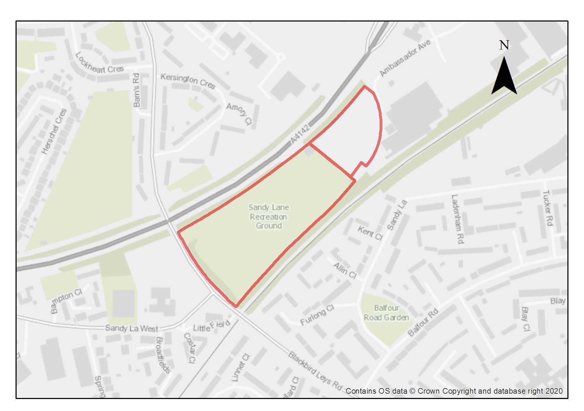

The site includes a recreation space consisting of two adult and one junior grass surface football pitches. There is also a small pavilion on the site which incorporates changing facilities. There is an area of hardstanding (1.1 ha) in the northeastern corner which was once used for storage of cars from the production line and in 1995 permission was granted for use of the site as a car park for Rover employees. This part of the site is currently used by a motorcycle training company operating under a temporary permission.

The Eastern Bypass Road forms the northern/northeastern boundary and the Cowley Branch line (CBL) runs along the southeastern boundary. Access to the southwest onto Blackbird Leys Road is via a ramp. The Cowley Retail Park lies to the easterly end of the site. There is no vehicular access from the site onto Ambassador Avenue which runs through the retail park and leads onto the Garsington Road. The hardstanding area is accessed through the retail park. The site has a raised bank on the southeastern boundary covered in scrub.

Beyond the CBL to the southeast is an area of low density and low height development (2 storey) which is part of the Blackbird Leys estate. However, beyond the bypass to the northeast is an area of higher density and height in Kersington Crescent and at the ARC Business Park. Development proposals for this site must be sensitively designed to strike the right balance in terms of density and height of new development on this site, although the site is in an area identified in the High Buildings Study as being in an area of greater potential for height.

The proposed reopening of the CBL to passenger use offers a great opportunity for sustainable transport options. An important element of the CBL project is the delivery of a station at this location. Although the proposed station will be located on land in the ownership of Network Rail, the land for access routes to and from the station must be safeguarded within this site to ensure there are access routes for pedestrians and cyclists to ensure future passengers have suitable access to the branch line. The station and other developments in the area may result in the opportunity for a pedestrian/cycle bridge over the railway line, and contributions towards delivery of this will be required. This site is very close to the ARC Business Park and could act as a gateway and important connection, especially if a station is present.

The minimum number of dwellings stated in the policy assumes that pitches remain on the site but are re-configured. A density of 60+ dwellings per hectare has been assumed for the site as it lies in this suburban area of the city where there is some potential for height. If pitches are relocated, then the minimum housing capacity will be higher, and a number has been included in the policy to reflect this too. In the event the pitches are to be relocated, the City Council’s Active Communities team should be consulted to provide advice about the needs for sports fields in the area local to this site and should be satisfied with the proposed reprovision to ensure that the facilities are not lost to the local community.

Preliminary analysis suggests that the presence of various green infrastructure features on the site at present means it is likely to score above the minimum thresholds for green surface cover as required by Policy G3. Proposals will need to ensure that this score is retained (no net loss) and demonstrated through submission of the Urban Greening Factor assessment. New development on the site will need to consider how existing green features, particularly higher scoring elements, can be retained including the semi mature trees along the boundary with the Eastern Bypass. There is the opportunity to plant a range of native species trees and shrubs along the bank to support biodiversity in providing habitats for birds and insects.

As the site consists of made up ground and potential fill it is likely that land contamination will be an issue on the site, as such, site investigations will be required to be undertaken as part of any development proposals.

Policy SPS6: Sandy Lane Recreation Ground

Planning permission will be granted for residential development and public open space at the Sandy Lane Recreation Ground. The minimum number of dwellings to be delivered is 120 dwellings although this would be expected to be higher if the outdoor sports facilities were relocated off site within the local area with a minimum number of dwellings of 300 dwellings. Land should be safeguarded on the site to allow for future access by pedestrians and cyclists to the passenger station for the Cowley Branch Line (CBL). Other complementary uses will be considered on their merits.

Open space, nature and flood risk
Policies G1 and G3 require protection of existing green infrastructure features and enhancement of greening on site through the urban greening factor. Policy G5 requires onsite biodiversity enhancement, and Policy G2 requires new Green Infrastructure features and enhancement of existing features. It is expected that those requirements will be met in the following ways. The site has limited biodiversity value as currently laid out to football pitches; the redevelopment of this site offers the opportunity to introduce more diversity in terms of the design of the public open space and enhancing the planting and natural vegetation across the site particularly along the southeastern boundary. The trees planted on the northwestern boundary should be retained and maintained within any scheme as this will help to provide a buffer against noise and pollution arising from the eastern by-pass. The trees along the northwestern boundary should be retained and regularly maintained to ensure this tree screen is protected and incorporated as part of the development.

Enhanced outdoor sports facilities should be provided in line with the requirements of Policy G1. The City Council’s Active Communities Team must be consulted and in agreement with any relocation of these sports facilities.

Public open space provision must be integrated into the scheme and ensure good permeability on foot or by bicycle for all users of the site both residents and users of the proposed CBL station

Urban design and heritage

Policy HD7 requires high quality design and the following sets out key considerations for achieving that on this site. Development proposals will be expected to mitigate impacts to the sensitive skyline and surrounding area by avoiding built forms with excessively overbearing scale and massing, and avoiding roofscapes that are excessively uniform. Development proposals that exceed the height that the High Buildings TAN states may have an impact on the historic core (which from this area says skylining impacts may be possible from 21m and above) will be required to provide extensive information so that the full impacts can be understood and assessed as listed in Policy HD9.

Adjustments and considerations at design stage may be helpful in reducing the ongoing impact of poor air quality. Potential options may include considering layout options that place habitable spaces and openings away from pollution sources such as busy roads, landscape buffers, and designing in walking and cycling options as integral part of schemes.

Movement and access
The site will be accessed from the Blackbird Leys Road although a pedestrian and cycle access should be provided from Ambassador Avenue to ensure good connectivity to the proposed station for the Cowley Branch Line. Access by pedestrians and cyclists to the station must be incorporated into any development proposals for the site. Contributions will be required towards provision of a pedestrian/cycle bridge over the railway if the opportunity for this to be delivered arises.

Natural resources
The site is in an air quality hot spot area. Development proposals must demonstrate compliance with policy R4 by ensuring that all necessary mitigation measures against poor air quality have been incorporated during the construction and operational phases and ensuring that any potential negative air quality impacts are adequately mitigated on an ongoing basis, within and surrounding the site.

Development proposals will be required to include an appropriate site contamination investigation and applications will be required to demonstrate how contamination issues will be resolved in compliance with Policy R5.

Development proposals must include an acoustic design statement in compliance with Policy R7 as this site is part of an area which is subject to significant environmental noise from the railway line and traffic on the Eastern bypass.

Unipart

Site area: 30.63 hectares
Ward: Lye Valley
Landowner: Logicor Europe
Current use: Warehousing, industrial uses, offices
Flood Zone: FZ1

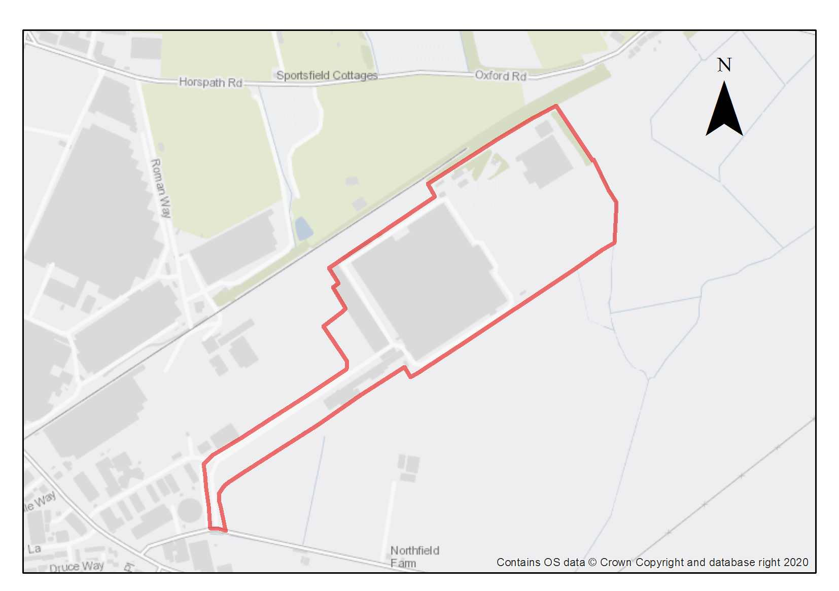

This site is identified as a Category 1 employment site, occupied by a significant employer in the city and comprises a large area of industrial land which makes an important contribution to the city’s employment land supply and can help to deliver the objectives of the Local Plan 2040.

The site comprises principally warehouses and industrial uses together with some office space but does not make efficient and effective use of the land. It has a principal access from Transport Way to the south-east and includes significant areas of car parking with impermeable hard surfaces, which restricts opportunities for ecology and biodiversity. There are very limited opportunities for wildlife to move across the site via wildlife corridors. The site has a low-landscape value and poor accessibility through the site for walking and cycling. Although public transport is available services are limited and the site is heavily car dominated.

The site is largely comprised of brownfield developed land, but there is a small area of grassland, scrub and woodland in the north-east of the site that is likely to be of the greatest value ecologically. Consideration should be given to whether Open Mosaic Habitat is present (a range of diverse plant communities and substrates in close proximity to one another). Hollow Brook runs along the north-eastern boundary. Potential protected species constraints are likely to include breeding birds, foraging and commuting bats, reptiles, badgers, and water vole and otters (associated with Hollow Brook). Development proposals would offer an opportunity to protect (Policy G4) and enhance any biodiversity (Policy G5) on the site and provide potential links and green corridors to the surrounding grassland areas.

The potential redevelopment of this site offers significant opportunities for modernisation and intensification, through a comprehensive master plan, that could make more efficient and effective use of this land in a way that promotes sustainable development and introduces more opportunities for green infrastructure. Sustainable travel should be positively encouraged including public transport, walking and cycling improvements. The re-opening of the Cowley Branch Line to passenger traffic could make a significant difference to travel options to and from the site to the city centre.

The land at Northfield which lies at the southern edge of this site is a large new development site in South Oxfordshire, allocated in their Local Plan. This will significantly change the character of the area and will need to be responded to both in the design of the new development at Unipart and the links to future transport infrastructure provision.

Preliminary analysis suggests that the limited presence of green infrastructure features on the site currently means it is likely to score below the minimum thresholds for green surface cover as required by Policy G3. As such, proposals will need to ensure that an appropriate proportion of green features are incorporated into the design of development to meet the minimum targets set out in the policy, demonstrated through submission of the Urban Greening Factor assessment.

This site is of archaeological interest as part of the access road is on the line of the Dorchester-Alchester Roman Road and there is high potential for roadside settlement. There is also high potential for other prehistoric and Roman remains (sites are recorded to the north & south of the plot). This will require further investigation as part of any redevelopment.

Policy SPS7: Unipart

Planning permission will be granted for new development, modernisation and intensification of office (Class E), warehousing (Class B8) and general industrial (Class B2) employment uses. New development needs to make the most efficient and effective use of the land in accordance with Policy E1 (employment sites) and in recognition of its importance as a Category 1 employment site. Other complementary uses will be considered on their merits. An element of residential development within the defined threshold as specified in Policy E1 will be supported.

Open space, nature and flood risk
Policies G1 and G3 require protection of existing green infrastructure features and enhancement of greening on site through the urban greening factor. Policy G5 requires onsite biodiversity enhancement, and Policy G2 requires new Green Infrastructure features and enhancement of existing features. It is expected that those requirements will be met in the following ways. The new development should provide greening opportunities to contribute to the biodiversity on this site, which will be best determined and explained with a landscaping scheme. The use of large roofscapes for solar panels or green roofs will be encouraged. Planting of native trees to screen buildings and or the use of green walls to soften the industrial activity would be supported and help to reduce the sensitivity of the site’s borders.

An assessment should be undertaken of the quality and condition of existing trees and hedgerows on the site with the aim of retaining high-quality trees and medium or low-quality trees wherever feasible. Opportunities should be taken to plant new trees to contribute to public amenity, good design and to improve connectivity within the green infrastructure network.

Surveys will be required to determine any species or habitats of value around the edges of the site and within the area of scrub to the north-east in advance of any redevelopment. Opportunities for wildlife corridors along the railway line and within the site that link to open areas within the industrial area should be fully considered and provided where feasible.

There should be a reduction in hard surfacing and car parks on this site which could release land for landscaping. This provides an opportunity to implement a SuDs programme to reduce surface water run-off and improve climate resilience.

A undeveloped buffer zone of at least 10m width should be left alongside the watercourse in accordance with Policy G2.

Urban design and heritage
Policy HD7 requires high quality design and the following sets out key considerations for achieving that on this site. The site would benefit from a comprehensive masterplan to co-ordinate its development and provide a framework for the future modernisation and intensification of this site and should positively promote sustainable development. The future development of this site needs to consider its relationship to the new major housing development at Northfield and the treatment of sensitive boundaries and take account of potential linkages with the `proposed infrastructure provision in the area.

Development must take into consideration the potential presence of prehistoric and Roman archaeological remains. Due to this potential, development should demonstrate compliance with Policy HD5.
Movement and access
This site is located within the geographical area of the Eastern Arc. This is an area where it has been identified that future travel demand will be focused. Opportunities should be taken through the development of this site to support sustainable travel by providing greater public transport links and services, including the re-opening of the Cowley Branch Line to passengers. Support should be provided for improved pedestrian and cycle links and enhancements to the existing network and better connections to both existing and planned major developments in the area.

Natural resources
Because of the existing use of the site, some areas of potential contamination are present on the site, so site investigation will be required, and remedial works are likely to be necessary in compliance with Policy R5.

Development proposals must include an acoustic design statement to be submitted in compliance with Policy R7 as this site is part of an area which is subject to significant environmental noise from traffic using the surrounding roads.

South area site allocation policies outside of the Area of Focus
- Bertie Place
- Blackbird Leys Central Area
- Knights Road
- Cowley Marsh Depot
- Cowley Centre and Templars Square
- Land at Meadow Lane
- Former Iffley Mead Playing Fields
- Redbridge Paddock
- Crescent Hall
- Oxford Academy Edge of Playing Fields
- 474 Cowley Road
Bertie Place Recreation Ground

Site area: 0.67 hectares
Ward: Hinksey Park
Landowner: Oxford City Council
Current use: Recreation Ground
Flood Zone: FZ3b but FZ2 for sequential test

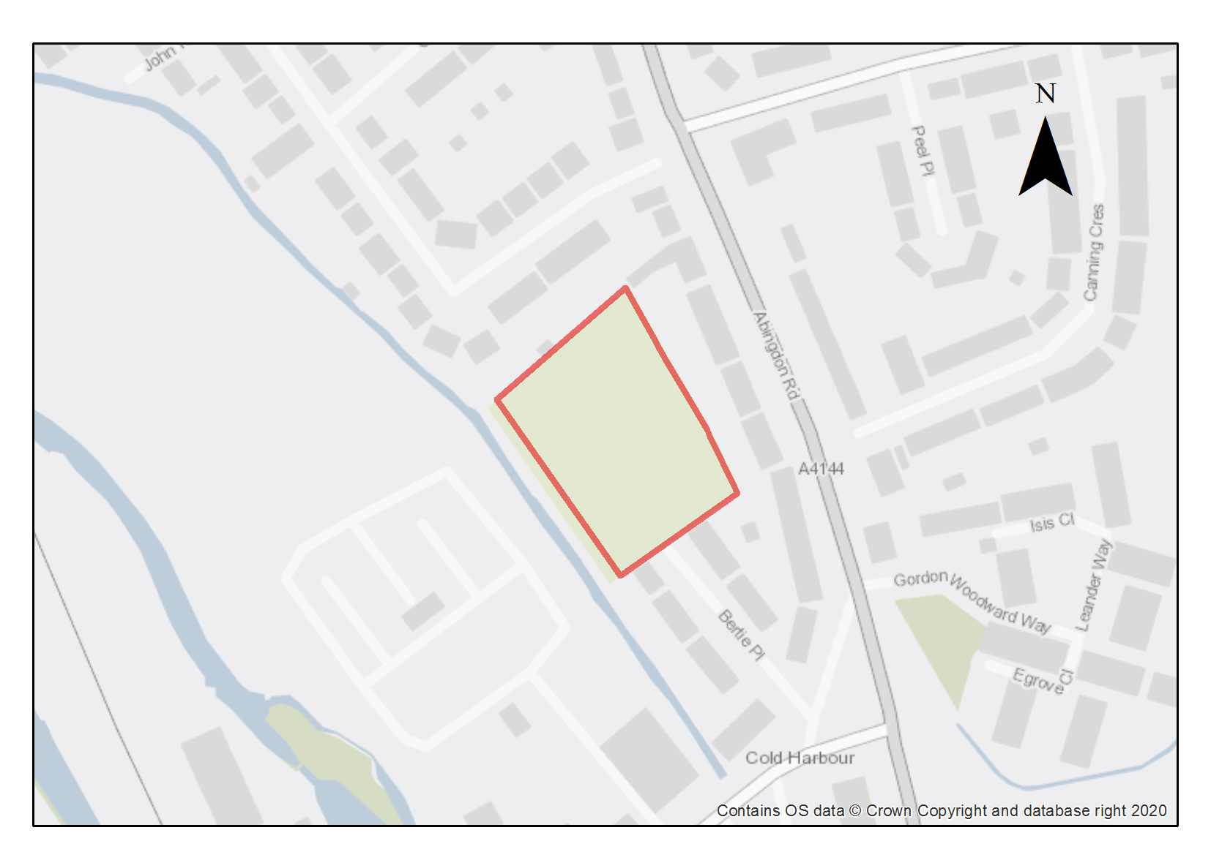

The site is currently a public recreation ground. It is considered suitable for residential development because there is potential for the landowner (the City Council) to replace the function of the site partially within the site and partially elsewhere in the local area.

Preliminary analysis suggests that the presence of various green infrastructure features on the site at present means it is likely to score above the minimum thresholds for green surface cover as required by Policy G3; as such proposals will need to ensure that this score is retained (no net loss), demonstrated through submission of the Urban Greening Factor assessment. New development on the site will need to consider how existing green features, particularly higher scoring elements, can be retained including the treed/ small wooded areas to the east, south and west of the site. Where green elements are proposed to be removed, sufficient replacements will need to be incorporated into the new design, or enhancement of existing green infrastructure that is being retained, in order to preserve the baseline UGF score as a minimum. Retention of trees around the edge of the site, in addition to greater use of permeable surfaces and additional high-quality planting as part of the landscaping through the site, will help ensure the requirements are achieved.

This site is within the catchment of the Iffley Meadows SSSI, which is sensitive to changes in the flows and quality of water in the two arms of the River Thames due to being in its floodplain. As such it can be impacted by contamination through surface water runoffs.

Residential development at this site in Flood Zone 3a has been justified through the sequential test. A Level 2 Strategic Flood Risk Assessment was carried out for this site to examine part b) of the Exception Test (which relates to whether the development is safe). The Level 2 SFRA considered the proposed development was appropriate and additional mitigation and/ or analysis may be required to demonstrate compliance with the Exception Test at the planning application stage. This is to be undertaken through a site-specific FRA supporting the planning application. The site-specific flood risk assessment must demonstrate how the development will be safe otherwise planning permission will not be granted.

The minimum housing number uses a density assumption of 50 dwellings per hectare, and assumes a replacement playground will be provided, potentially using part of the small area of the site within high risk flood zones. The capacity assessment also assumes existing trees along the boundary retained.

Policy SPS8: Bertie Place Recreation Ground

Planning permission will be granted for residential development. The minimum number of homes to be delivered is 30. Other complementary uses will be considered on their merits.

Open space, nature and flood risk
Policies G1 and G3 require protection of existing green infrastructure features and enhancement of greening on site through the urban greening factor. Policy G5 requires onsite biodiversity enhancement, and Policy G2 requires new Green Infrastructure features and enhancement of existing features. The following sets out the key considerations for achieving these requirements on this site.

There must be adequate re-provision of the current recreation facilities to meet the needs of those who currently use the facilities (and the new residents). The playground should be re-provided within the site. Replacement of the Multi Use Games Area could be with an alternative type of facility or by improvements to the capacity of an existing one, provided the re-provision is in the neighbourhood and meets the recreation needs of teenagers. The nature area to the west of Wytham street provides an opportunity in close proximity to the site, if accessibility and useability of that area is enhanced.

The trees at the edges of the site should be retained as far as possible or replaced where necessary and in accordance with Policy G1. High quality planting in landscaping features and use of permeable surfaces will be important to help achieve the requirements of Policy G3. A green buffer should be retained alongside the stream to the west of the site.

Planning permission will only be granted if it can be demonstrated that there would be no adverse impacts on the integrity of the Iffley Meadows SSSI. To minimise the impact upon the Iffley Meadows SSSI development proposals will be expected to incorporate SuDS and, depending on the details of the proposals, may be required to be accompanied by a groundwater study.

A site-specific FRA will be required. A sequential approach should be taken to locating development on the site, with more vulnerable uses away from the highest flood risk. A drainage strategy will be required to manage run-off and may need a raised floor level for some of the site, to be informed by the FRA.

A undeveloped buffer zone of at least 10m width should be left alongside the watercourse in accordance with Policy G2.

Urban design and heritage
Policy HD7 requires high quality design and the following sets out key considerations for achieving that on this site. The site is surrounded by low-rise residential development and a green corridor. It is a constrained site and suitable for low-rise development of a typical suburban density. The surrounding streets are terraces and semi-detached houses. The position of the site amongst these homes and next to the green corridor means that buildings should be kept relatively low, otherwise it would be difficult to avoid overshadowing, overbearing and overlooking of neighbouring properties.

Movement and access
Vehicular access should be taken via Bertie Place, and a suitable turning head will need to be provided within the development. Pedestrian access to the site should be provided from Bertie Place, from the pathway at the northern end of the site off Wytham Street, and from the alleyway between 378 and 380 Abingdon Road. The National Cycle Network Route 5 currently passes through the site and development proposals should either provide for its retention or replacement by a suitable alternative route.

Because the vehicular access will need to be on a no-through-road that allows circulation around the site, development should line and face this this so that it works well as a street and so that gardens are back-to-back with the existing gardens that back on to the site, and continuing as far as possible the street line of Bertie Place. The playground should be sited so that it is well overlooked by the new development.

Natural resources
Development proposals will be required to include an appropriate site contamination investigation and applications will be required to demonstrate how contamination issues will be resolved in compliance with Policy R5.

Development proposals must include an acoustic design statement in compliance with Policy R7 as this site is part of an area which is subject to significant environmental noise from traffic using the surrounding roads.

Blackbird Leys Central Area

Site area: 6.54 hectares
Ward: Blackbird Leys
Landowner: Various including Oxford City Council, Oxfordshire Council and Oxford and Cherwell Valley College
Current use: Mixed use
Flood Zone: FZ1

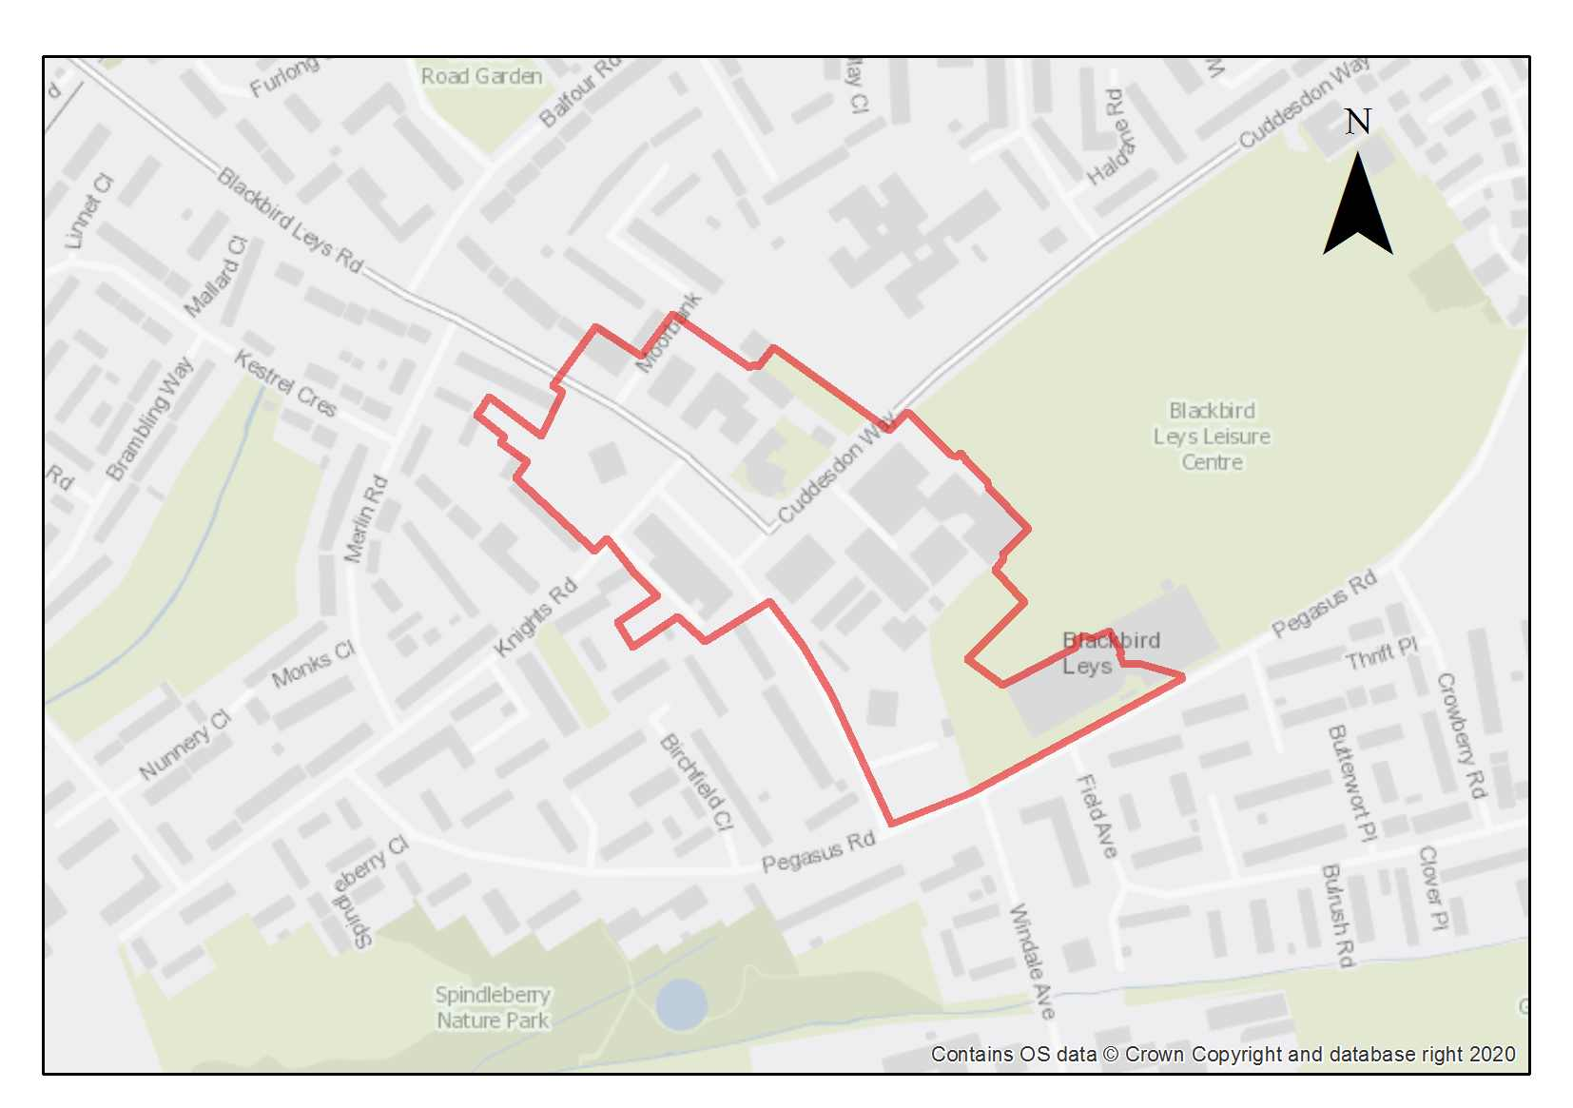

Blackbird Leys District Centre is located to the south of the city in the heart of Blackbird Leys. It is well served by public transport to and from the Cowley Centre and Oxford city centre, as well as by local cycle and pedestrian routes. It is important for the Blackbird Leys community and includes facilities such as the community centre, library and leisure centre. Blackbird Leys is one of Oxford’s district centres and a regeneration area, improved local facilities, shops, new housing, educational and employment opportunities are appropriate and supported in this location.

To ensure that the development makes the best use of the site, delivers the policy requirements and is well designed, it is expected that the site will be developed as part of a comprehensive regeneration plan for the area. With a number of different landowners within the site this would help delivery and ensure that piecemeal development does not prejudice the overall aim of a comprehensive regeneration of the site.

The site includes the tower block sites where there may be potential to develop residential on the land around the base of the towers.

The site includes the Grade II listed Church of the Holy Family, and consideration should be given to the impacts of development on the significance of this building. Consideration should be given to potential impacts on the Oxford Stadium Conservation Area and views out from St Mary’s Tower.

Preliminary analysis suggests that the limited presence of green infrastructure features on the site currently means it is likely to score below the minimum thresholds for green surface cover as required by Policy G3. As such, proposals will need to ensure that an appropriate proportion of green features are incorporated into the design of development to meet the minimum targets set out in the policy, demonstrated through submission of the Urban Greening Factor assessment.

Policy SPS9: Blackbird Leys Central Area

Planning permission will be granted for a mixed-use development that includes town centre uses, start-up employment units, residential development and community and educational facilities at the Blackbird Leys Central Area site. The minimum number of homes to be delivered is 200. Other complementary uses will be considered on their merits.

Planning permission will not be granted for development that prejudices the comprehensive development of the whole site. Regard should be had for any regeneration plan for the Blackbird Leys area.

Open space, nature and flood risk
Policies G1 and G3 require protection of existing green infrastructure features and enhancement of greening on site through the urban greening factor. Policy G5 requires onsite biodiversity enhancement, and Policy G2 requires new Green Infrastructure features and enhancement of existing features. It is expected that those requirements will be met in the following ways. Development proposals should seek to incorporate new green features throughout the site, including establishing new green corridors through street tree planting and hedges. If existing trees are to be removed, new trees should be planted to fully mitigate the impact on tree canopy cover and to support the introduction of more of green infrastructure on this site.

There is an opportunity to incorporate a network of pocket parks and green spaces through the site as part of the open space provision. These spaces should include areas of more natural planting to support biodiversity as well as opportunities for new play facilities for younger people.

Urban design and heritage
Development proposals must be designed with consideration of their impact on the setting of the Oxford Stadium conservation area and the Grade II listed Church of the Holy Family, and demonstrate compliance with policy HD1 and HD2.

Opportunities should be sought to enhance the quality of open space across the site which could include public realm enhancements such as a public square, tree and landscape planting, public seating and pocket parks.

Development proposals that exceed the height that the High Buildings TAN states may have an impact on the historic core, (which from this area says skylining impacts may be possible from 15m and above) will be required to provide extensive information so that the full impacts can be understood and assessed as listed in Policy HD9. Development proposals will be expected to mitigate impacts to the sensitive skyline and surrounding area by avoiding built forms with excessively overbearing scale and massing, and avoiding roofscapes that are excessively uniform.

Movement and access
The site is well served by public transport, and this should be complemented by ensuring that improvements to pedestrian and cycling links are designed in the development and implemented.

Natural resources
Development proposals will be required to include an appropriate site contamination investigation and applications will be required to demonstrate how contamination issues will be resolved in compliance with Policy R5.

Knights Road

Site area: 2.25 hectares
Ward: Northfield Brook
Landowner: Oxford City Council
Current use: Open space
Flood Zone: FZ3b but FZ1 for sequential test

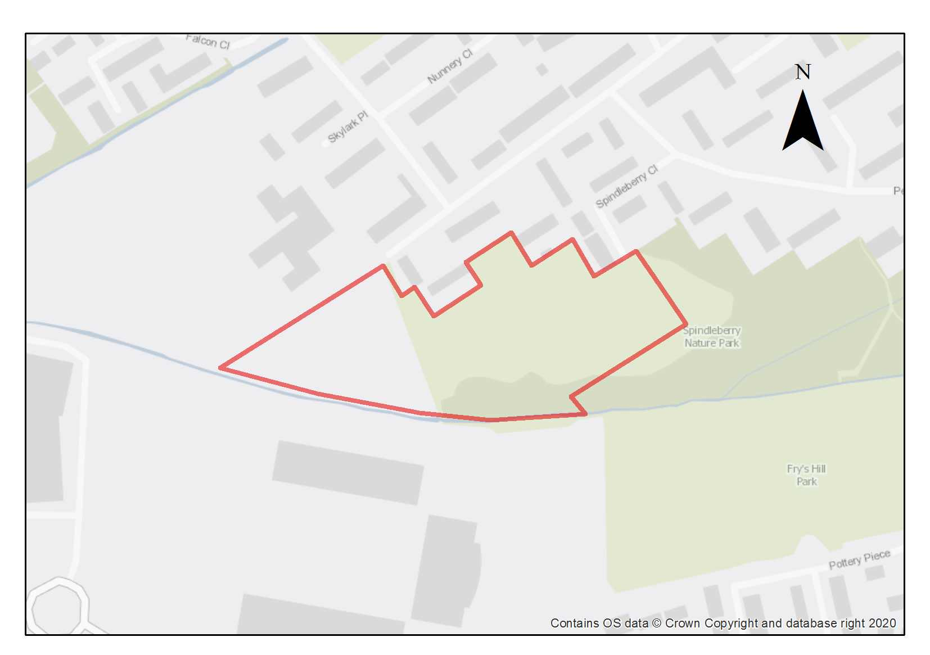

This site comprises a mix of informal playing fields and scrubland with self-seeded trees and ground made up mainly from spoil from the construction of the Kassam stadium. The site lies on the southwestern edge of the Blackbird Leys estate and is adjacent to the Spindleberry Nature Park, an Oxford City Wildlife Site, which wraps around the southern/southeastern boundary of the site. The Kassam Stadium lies to the southwestern corner of the site across the Northfield Brook.

The western side of site is covered with some scrubby woodland and abuts against the boundary of Orion Academy special school. A public footpath runs north/south along the edge of this area of scrub/woodland and connects to and from the Kassam stadium.

The majority of the site is at low risk of flooding, but the site’s boundary includes the Northfield Brook and small areas of Flood Zone 2 and an almost negligible area in Flood Zone 3b. Any proposal should therefore include a flood risk assessment and design the development to avoid the areas at flood risk.

Preliminary analysis suggests that the presence of various green infrastructure features on the site at present means it is likely to score above the minimum thresholds for green surface cover as required by Policy G3; as such proposals will need to ensure that this score is retained (no net loss), demonstrated through submission of the Urban Greening Factor assessment. The site is likely to be able to accommodate a considerable amount of new native tree planting to compensate for the loss of those trees removed. Sufficient replacements will need to be incorporated into the new design, or enhancement of existing green infrastructure that is being retained, to preserve the baseline UGF score as a minimum.

The site is suitable for residential use and the density assumptions for the site are based upon suburban typology of 50-60dph. New development should enhance the quality and safety of the area in that the design should relate well to the existing development along Knights Road, ensure that it does not conflict with the adjacent school uses and ensure footpaths are well lit and overlooked to provide informal surveillance. In addition, new development should provide good access opportunities to Spindleberry Park.

There is evidence of badger activaity on the site. As such any proposed development on the site will require a detailed assessment as to how badgers use the site and surrounding land, to inform a package of mitigation and compensation measures that ensures that there are no residual impacts on the protected species.

There are records of peat deposits that follow the line of the Northfield Brook, and the potential for additional unrecorded deposits in the area, which will need to be assessed and avoided.

Policy SPS10: Knights Road

Planning permission will be granted for residential-led development and public open space. The minimum number of homes to be delivered is 80. Other complementary uses will be considered on their merits.

Open space, nature and flood risk
Policies G1 and G3 require protection of existing green infrastructure features and enhancement of greening on site through the urban greening factor. Policy G5 requires onsite biodiversity enhancement, and Policy G2 requires new Green Infrastructure features and enhancement of existing features. It is expected that those requirements will be met in the following ways. A biodiversity survey will be expected to assess the biodiversity value of the site and it should be demonstrated how harm will be avoided, mitigated or compensated. Any proposed development on the site will require a detailed assessment as to how badgers use the site and surrounding land, to inform a package of mitigation and compensation measures that ensures that there are no residual impacts on the protected species.

The opportunity to enhance the vegetation across the site with enhanced planting, screening and landscaping should be taken. Native hedgerows and trees could be planted to help to ensure that there is no decrease from the baseline level of the Urban Greening Factor.

A Flood Risk Assessment will be required.

Opportunities should be taken to protect and enhance the Northfield Brook and a 10 m buffer should be retained between the edge of the watercourse and the built development.
Urban Design and Heritage
Policy HD7 requires high quality design and the following sets out key considerations for achieving that on this site. Development proposals must ensure the design enhances the area and should seek to integrate well into the existing residential area. Development should not overlook the Orion Academy and good permeability through the site should be retained to ensure pedestrians can reach the Kassam Stadium and the surrounding area.

Movement and access
Opportunities should be taken to develop and link into existing pedestrian and cycling ways to and through the development.

Natural resources
Due to the site’s proximity to recorded peat reserves along Northfield Brook and the potential for further deposits in the area, any development on currently undeveloped parts of the site will only be permitted where it can be demonstrated that there will be no harm or loss of peat deposits in accordance with the requirements of policy R6. This may mean that where there is the potential for causing removal of peat, site layout has been designed accordingly to protect and mitigate any harm to identified peat deposits onsite.
Areas of potential contamination are likely to be present on the site, so site investigation will be required, and remedial works are likely to be necessary in compliance with Policy R5.
Development proposals must include an acoustic design statement in compliance with Policy R7 as this site is part of an area which is subject to environmental noise from traffic using surrounding roads.

Cowley Marsh Depot

Site area: 1.7 hectares
Ward: Temple Cowley
Landowner: Oxford City Council
Current use: City works depot
Flood Zone: FZ2 but FZ1 for sequential test

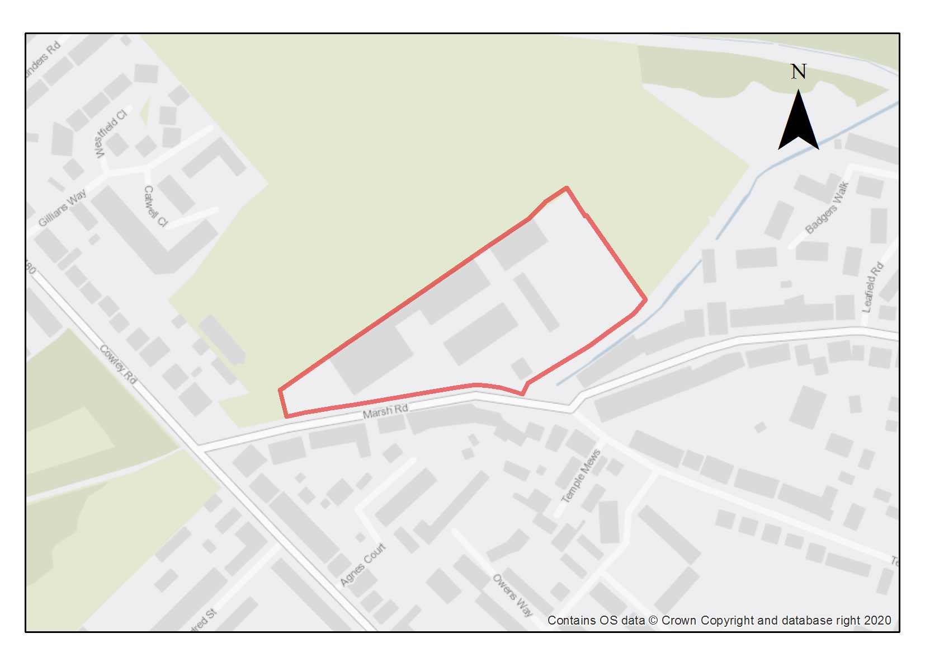

The site is currently in use as a depot by the City Council, which is expected to relocate during the Plan period. The site is located in a residential area, adjoining the Cowley Marsh Recreation Ground green open space, with good links to transport and facilities on Cowley Road as well as the Sustrans route along Boundary Brook.

The site is suitable for residential development of similar density and form to the surrounding residential area. Redevelopment would present opportunities to improve the permeability of the site and provide biodiversity enhancements.

There are two residential properties within the site, at the corner between Marsh Road and the single track adjacent to the southern boundary, which are within the same landownership. If the landowner chooses to retain these then the design of this corner will need a sensitive edge, or they could alternatively be redeveloped within a comprehensive scheme.

The site’s boundary includes the Boundary Brook and small areas of Flood Zone 2, so any proposal should include a site Flood Risk Assessment and design the development to avoid the areas at flood risk. This should also consider the site’s access from Marsh Lane, part of which lies in Flood Zone 3b. For ecology, protective and enhancement measures should be incorporated for river and wetland restoration, as well as ecological buffer zones (minimum of 10m from bank top) for the Boundary Brook.

Preliminary analysis suggests that the limited presence of green infrastructure features on the site currently means it is likely to score below the minimum thresholds for green surface cover as required by Policy G3. As such, proposals will need to ensure that an appropriate proportion of green features are incorporated into the design of development to meet the minimum targets set out in the policy, demonstrated through submission of the Urban Greening Factor assessment.

The site is likely to require site investigation as potentially contaminated land owing to its existing use as a council depot.

Policy SPS11: Cowley Marsh Depot

Planning permission will be granted for residential development and public open space at Cowley Marsh Depot. The minimum number of dwellings to be delivered is 80 homes. Other complementary uses will be considered on their merits.

Prior to the development of the site the City Council depot use must be relocated. The City Council also owns the two residential properties within the site, which could potentially be incorporated into a comprehensive redevelopment of the site.

Open space, nature and flood risk
Policies G1 and G3 require protection of existing green infrastructure features and enhancement of greening on site through the urban greening factor. Policy G5 requires onsite biodiversity enhancement, and Policy G2 requires new Green Infrastructure features and enhancement of existing features. It is expected that those requirements will be met in the following ways. The development proposals should include opportunities to support and enhance biodiversity and connect with the adjoining playing fields and Cowley Marsh Nature Reserve/Boundary Brook/Barracks Lane. If existing trees are to be removed new trees should be planted to fully mitigate the impact on tree canopy cover and to support the introduction of more of green infrastructure on this site.

Opportunities should be taken to protect and enhance the Boundary Brook and a 10 m buffer should be retained between the edge of the watercourse and the built development.
A Flood Risk Assessment will be required and this should consider a flood warning system because the flood risk on the access road.

Urban design and heritage
Policy HD7 requires high quality design and the following sets out key considerations for achieving that on this site. Heights should be compatible with surrounding residential streets and should avoid negatively impacting on the view cone. Opportunities should be taken to increase permeability of the site for residents and the access to the adjoining recreation ground and footpaths across it and the nearby sustrans route along Boundary Brook; as well as improving wildlife corridor connections for biodiversity; improving active frontage along Marsh Road; and improving permeable surfaces on the site.

Movement and access
Opportunities should be taken to develop and link into existing pedestrian and cycling ways.

Natural resources
Because of the current use as a depot with a fuel station some areas of potential contamination are present on the site, so site investigation will be required, and remedial works are likely to be necessary in compliance with Policy R5.

Templars Square

Site area: 3.65 hectares
Ward: Cowley
Landowner: Oxford Re Value Investments Ltd.
Current use: Mixed use including retail, residential and car parks
Flood Zone: FZ1

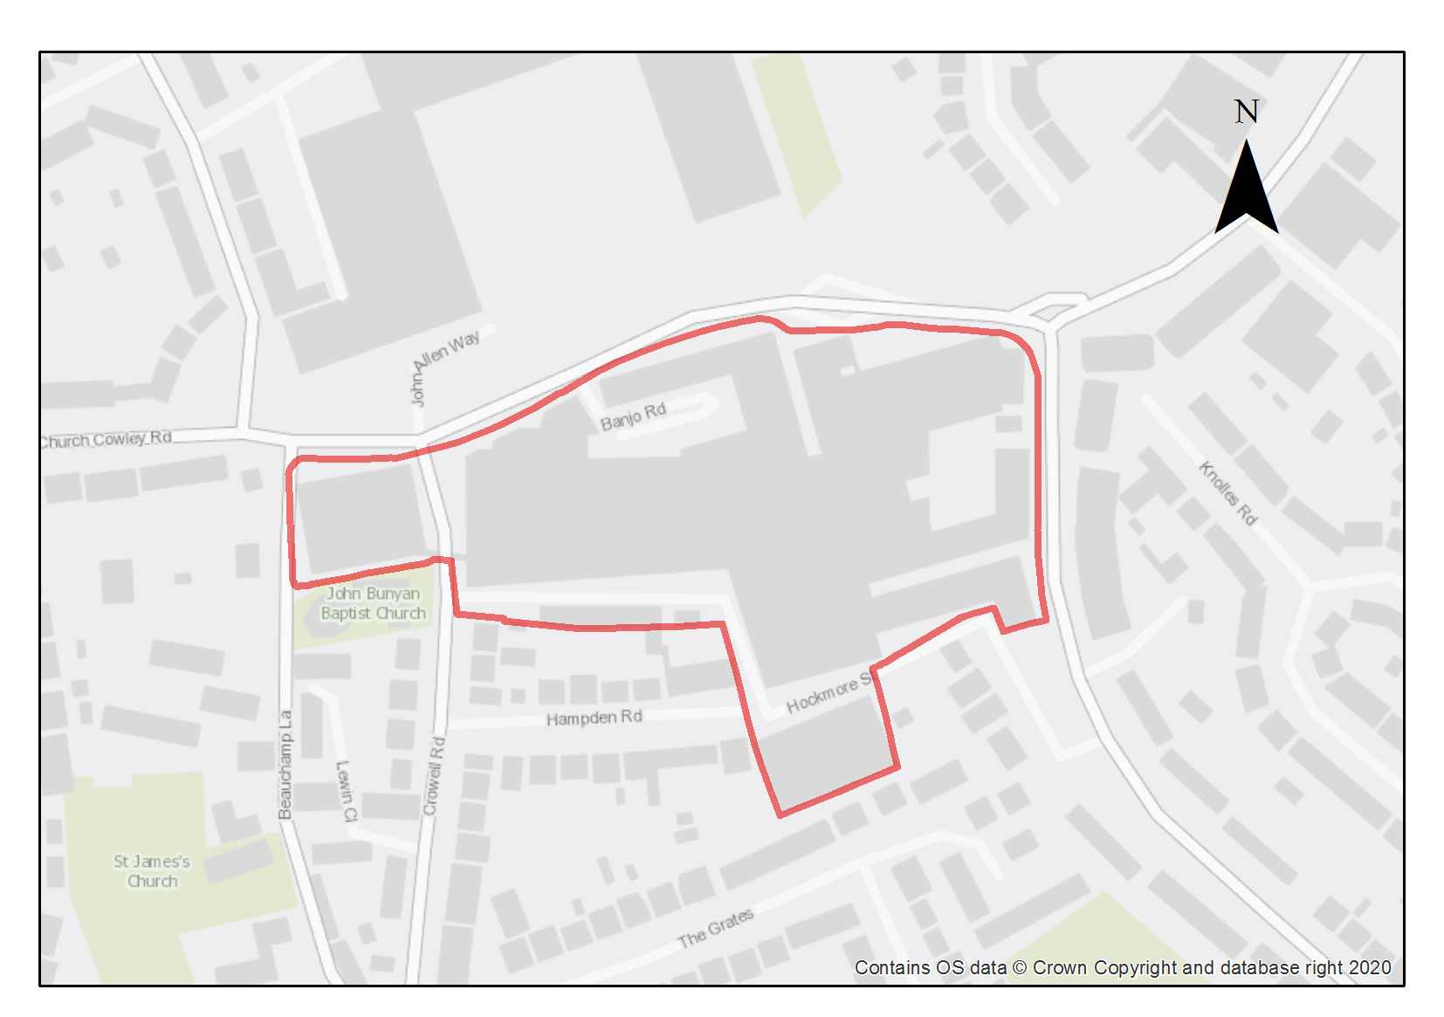

Templars Square is within the Cowley Centre primary district centre and provides a varied retail and commercial offer which serves a local and wider catchment area. Residential apartments are also provided across the site, including at Hockmore Tower. Templars Square plays an important role in serving the local and wider community.

Across the road from Templars Square is the Templars Shopping Park. The sites are both part of the Cowley district centre but have different roles and characters: Templars Square in particular is used by local communities in the Cowley and Blackbird Leys areas especially, for day-to-day goods and services, as well as being an alternative to the City Centre, whilst the Templars Shopping Park comprising larger-scale national retailers and free car parking also attracts shoppers from a wider area. The sites are split by the busy Between Towns Road, which the District Centre extends along to the east.

Templars Square (including its three multi-storey car parks, one of which is closed) is reaching the end of its functional lifespan, does not make the most efficient use of this highly sustainable site, restricts permeability, and provides no landscaping/biodiversity. There are opportunities for pedestrian, cycle, and public realm improvements within and directly around the site.

Users of Templars Square predominantly access the site by foot, cycle, and public transport. A parking strategy should be prepared to review the approach to parking in and around the site including consolidation of the three public car parks to support sustainable modes of transport.

In 2021 planning permission was granted for a large-scale redevelopment of part of the Templars Square site, on part of the site that fronts Between Towns Road, but not including the main enclosed shopping centre. The approved scheme provides 226 residential units, a 71-bed hotel, and 2 new commercial units, and proposes significant investment in the quality of the buildings and public realm and a strengthening of the range and quantity of facilities provided. This permission has not been implemented, however, and the site has since been sold. The new landowner is reviewing development options, including comprehensive redevelopment for a larger residential-led mixed use scheme across the whole site reflecting the site’s district centre status whilst responding to changing retail patterns. The minimum housing number in the policy considers the planning permission plus the wider site so it is expected that a greater number of residential units can be delivered as part of a mixed-use scheme.

The site is on the edge of an area visible from the historic core, including from St Mary’s tower, and it is on the edge of an area where tall buildings may create a skylining effect. This means that tall buildings on the site could be in the backdrop of views of the spires from the other side of the central core, which may harm appreciation of those views. As well as any obstruction of a view, which can be reduced by minimising the width of any higher buildings, higher buildings may create visual competition in the view in the foreground and in this case most likely background of views. The heritage asset that is Oxford’s central core is appreciated in long-range views, and the impact on views into and across the historic core should help to inform heights for this site. In addition, the impact on views from the historic core, particularly St Mary’s tower, which are part of the significance and understanding of the heritage asset of the historic core, must be considered carefully and fully explained and evidenced.

Also important in terms of design choices, including height and massing, is the adjacent Beauchamp Conservation Area, which includes the Grade II* listed 12th Century Church of St. James and Grade II listed cottage at 1 Beauchamp Lane. The significance of this heritage asset needs to be fully considered and taller buildings on the site should preserve or enhance the architectural interest of the asset and enable the conservation area to be appreciated; matters of visual competition and incongruous design should be avoided. However, there is also potential for enhancement of the appreciation of the asset, because current buildings detract from it.

Though the area is built up, the site is of potential archaeological interest being located in the historic core of Church Cowley and at the western end of a Roman pottery manufacturing compound. This will require further investigation as part of any redevelopment.

Preliminary analysis suggests that the limited presence of green infrastructure features on the site currently means it is likely to score below the minimum thresholds for green surface cover as required by Policy G3. As such, proposals will need to ensure that an appropriate proportion of green features are incorporated into the design of development to meet the minimum targets set out in the policy, demonstrated through submission of the Urban Greening Factor assessment.

Contamination risks are potentially present. Site investigations and remedial works are likely to be necessary.

Policy SPS12: Templars Square

Planning permission will be granted for a mixed-use development at Templars Square that supports its ongoing role as a key part of the district centre.

Development should include residential and retail development, and could also include a range of town centre uses, including the following:
- commercial leisure;
- financial and professional services;
- learning and educational uses (e.g. Use Class F.1);
- evening economy uses such as cafes, restaurants and pubs;
- community facilities (e.g. Use Class D.1, Use Class F.2);
- Other employment such as offices and small workshops

The minimum number of dwellings to be delivered is 350 (net gain).

In any development, the active frontages at ground floor level in Use Class E should be re-provided along the identified principal route/s. The routes are to be situated to draw people into and through the shopping centre from the surrounding areas.

A mix of town centre and community uses are encouraged on this site to retain a vibrant town centre with a mix of uses for local communities, especially those in the east of the city. The City Council will encourage schemes which make more efficient use of the site and strengthen and diversify the range of services and facilities on offer to the local community and its wider catchment area, alongside the provision of new homes.

Open space, nature and flood risk
Policies G1 and G3 require protection of existing green infrastructure features and enhancement of greening on site through the urban greening factor. Policy G5 requires onsite biodiversity enhancement, and Policy G2 requires new Green Infrastructure features and enhancement of existing features. It is expected that those requirements will be met in the following ways. Greening features will be necessary to achieve the required urban greening factor score. Most appropriate to the urban context of this site will be high-quality planting and landscaping along any public realm and integrating green features into the built form.

Urban design and heritage

Policy HD7 requires high quality design and the following sets out key considerations for achieving that on this site. A masterplan should be in place to help guide development, which would help to organise services, access, movement routes, landscape, public realm, and acceptable heights through the site, and to ensure that piecemeal development does not prejudice the overall aim of a comprehensive regeneration of the area.

Development proposals must be designed with consideration of their impact on the setting of the adjoining Beauchamp Conservation Area and the setting of the Grade II* listed Church of St James and Grade II listed cottage at 1 Beauchamp Lane. Proposals must demonstrate compliance with policies HD1 and HD2.

Because of the elevated position of this site relative to the city core, there is potential for development on the site to alter views from and to the historic core (both in the foreground and background of views). Therefore, the townscape and visual impact of any development on views to and across the historic core area, as well as from the historic core area’s key spires and tower, must be thoroughly explained and the impacts evidenced with thorough townscape/landscape VIAs, in compliance with Policy HD9, in particular from St Mary’s Tower, but also from more than one point in the historic core to give different viewing angles.

Development proposals must also take into consideration the potential presence of archaeological remains. Due to this potential, development should demonstrate compliance with Policy HD5.

Movement and access
Development should seek to significantly improve the public realm to accommodate improved pedestrian connectivity across Between Towns Road and an improved pedestrian and cycle experience, whilst supporting the important public interchange hub located at Between Towns Road. Development should take opportunities to consolidate public car parking, improve bus stopping areas, signage and facilities, and the taxi ranks.

Natural Resources
Development proposals will be required to include an appropriate site contamination investigation and applications will be required to demonstrate how any contamination issues will be resolved in compliance with Policy R5.

Development proposals must include an acoustic design statement in compliance with Policy R7 as this site is part of an area which is subject to environmental noise from surrounding roads
Land at Meadow Lane

Site area: 0.99 hectares
Ward: Iffley Fields
Landowner: Oxford City Council
Current use: Grassland/pony paddock
Flood Zone: FZ3b but FZ1 for sequential test

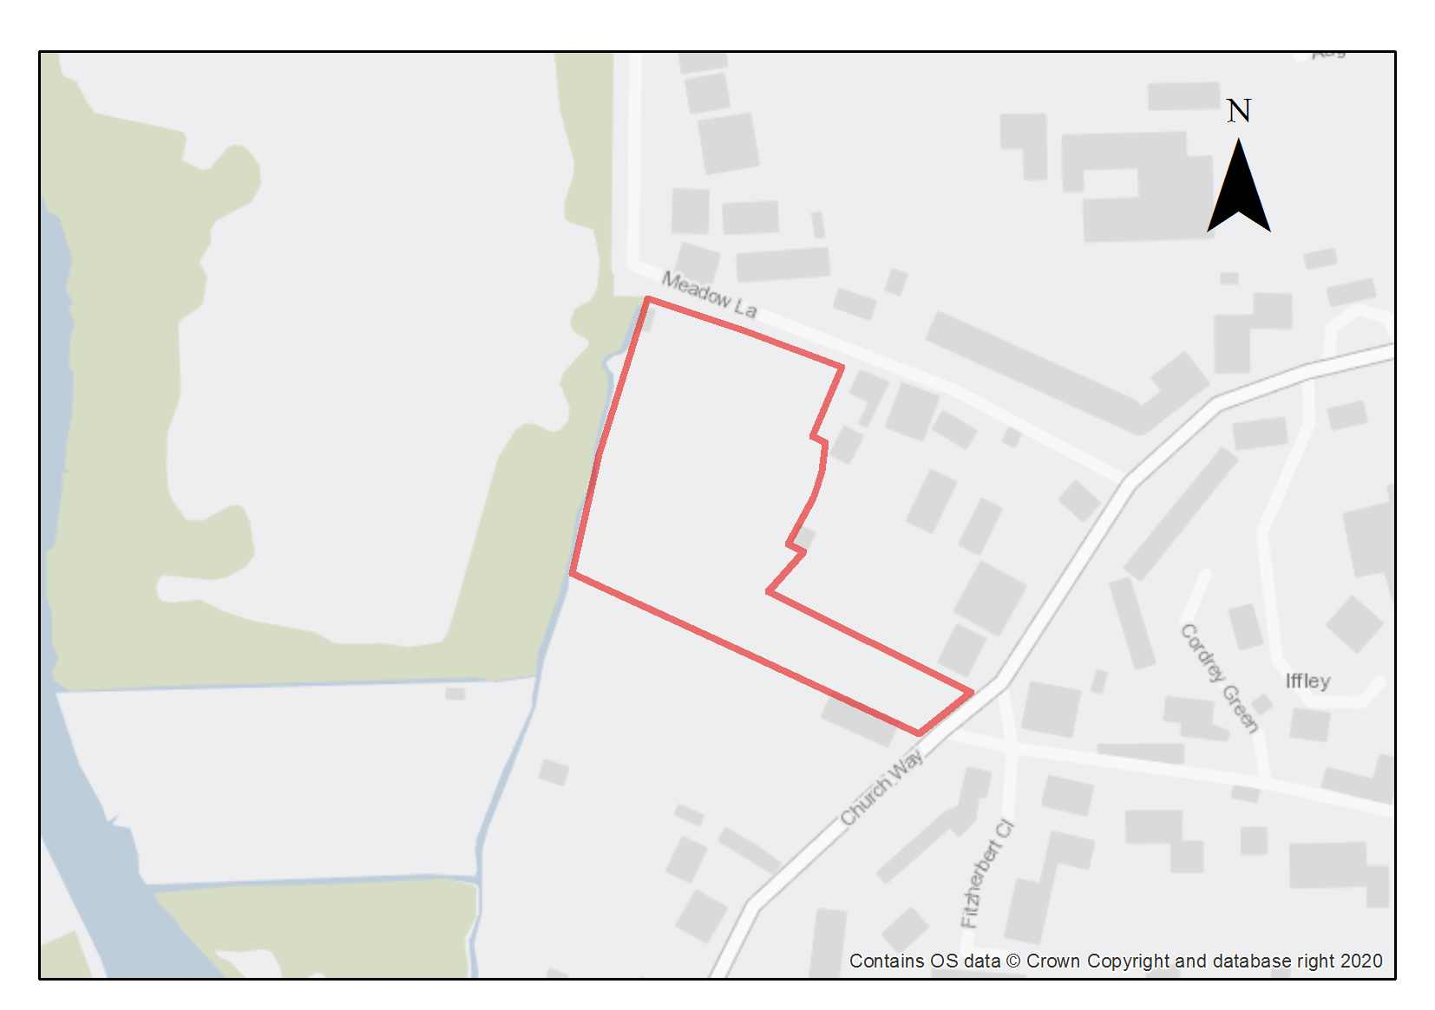

The site comprises land used for horse grazing, with some trees and shrubs. The site sits within the Iffley village envelope and has potential for some sensitive housing infill. Any development proposals would be expected to conserve and enhance the unique characteristics of the Iffley Conservation Area. The site is also partly within a view cone.

The site is of archaeological interest as it is located within the historic core of a medieval village and there is potential for Iron Age and Roman remains. This will require further investigation as part of any redevelopment.
The building line should be followed on the frontage of Meadow Lane and the semi-rural frontage on Church Way should be retained, as well as the stone wall boundary and trees, particularly at Church Way. Development should be relatively low- density and two-storey with front and rear gardens and stone-walled boundaries. The impact of development on views through the riverside edge landscape of the Cherwell meadows to the west, and views back to Iffley from the west should be considered.

Access to the site can be achieved from Church Way or Meadow Lane. There is an existing field gate access to the site from Church Way.

Ecological assessments undertaken in 2023 have found the site to be of County value for invertebrates. There is also evidence of badger activity. Development on the site will require a detailed assessment as to how invertebrates and badgers use the site and surrounding land, to inform a package of mitigation and compensation measures that ensures that there are no residual impacts on either interest.

The majority of the site is at low risk of flooding, but a small part of the site is in Flood Zone 2, and a very small part in Flood Zone 3b. Residential development at this site in Flood Zone 3a has been justified through the sequential test. A Level 2 Strategic Flood Risk Assessment was carried out for this site to examine part b) of the Exception Test (which relates to whether the development is safe). The Level 2 SFRA considered the proposed development was appropriate and additional mitigation and/ or analysis may be required to demonstrate compliance with the Exception Test at the planning application stage. This is to be undertaken through a site-specific FRA supporting the planning application. The site-specific flood risk assessment must demonstrate how the development will be safe otherwise planning permission will not be granted.

Preliminary analysis suggests that the presence of various green infrastructure features on the site at present means it is likely to score above the minimum thresholds for green surface cover as required by Policy G3; as such proposals will need to ensure that this score is retained (no net loss), demonstrated through submission of the Urban Greening Factor assessment. New development on the site will need to consider how existing green features, particularly higher scoring elements, can be retained including the retention of mature trees and hedgerows on the site. Where green elements are proposed to be removed, sufficient replacements will need to be incorporated into the new design, or enhancement of existing green infrastructure that is being retained, to preserve the baseline UGF score as a minimum. The site is likely to be able to accommodate the lines of trees and the hedgerows around the boundary of the site.

This site is within the catchment of the Iffley Meadows SSSI, which is sensitive to changes in the flows and quality of water in the two arms of the River Thames due to being in its floodplain. As such it can be impacted by contamination through surface water runoffs.

Policy SPS13: Land at Meadow Lane

Planning permission will be granted for residential development at Land at Meadow Lane with the minimum number of dwellings to be delivered is 29 units. Other complementary uses will be considered on their merits.

Open space, nature and flood risk
Policies G1 and G3 require protection of existing green infrastructure features and enhancement of greening on site through the urban greening factor. Policy G5 requires onsite biodiversity enhancement, and Policy G2 requires new Green Infrastructure features and enhancement of existing features. It is expected that those requirements will be met in the following ways. Planning permission will only be granted if it can be demonstrated that there would be no adverse impacts on the integrity of the Iffley Meadows SSSI. To minimise the impact upon the Iffley Meadows SSSI development proposals will be expected to incorporate SuDS and, depending on the details of the proposals, may be required to be accompanied by a groundwater study.

A detailed assessment of the site's value for invertebrates and the impacts of the proposed development will be required, with mitigation and compensation measures delivered that fully offset these impacts and functionally support notable species and the assemblage as a whole.

Any proposed development on the site will require a detailed assessment as to how badgers use the site and surrounding land, to inform a package of mitigation and compensation measures that ensures that there are no residual impacts on the protected species.

The existing vegetation on the site should be retained where possible including the strong belt of vegetation on the southern boundary of the site.

A site-specific FRA will be required. A sequential approach should be taken to locating development on the site, with more vulnerable uses away from the highest flood risk. A drainage strategy will be required to manage run-off and may need a raised floor level for some of the site, to be informed by the FRA.

Urban design and heritage
Development proposals must be designed with consideration of their impact on the setting of the Iffley Conservation Area and demonstrate compliance with policy HD1. The building line should be followed on the frontage and the semi-rural frontage on Church Way should be retained as well as the stone wall boundary and trees. Heights should be compatible with surrounding residential streets and should avoid negatively impacting on the view cone in accordance with policy HD9.

Development must take into consideration the potential presence of Iron Age and Roman archaeological remains. Due to this potential, development should demonstrate compliance with Policy HD5.
Movement and access
Opportunities to improve walking and cycling links should be taken to link into existing networks.
Natural Resources
Development proposals will be required to include an appropriate site contamination investigation and applications will be required to demonstrate how any contamination issues will be resolved in compliance with Policy R5.

Former Iffley Mead Playing Field

Site area: 2.04 hectares
Ward: Rose Hill and Iffley
Landowner: Oxfordshire County Council
Current use: Fenced off grassed areas with scrub (no permitted right of access)
Flood Zone: FZ1

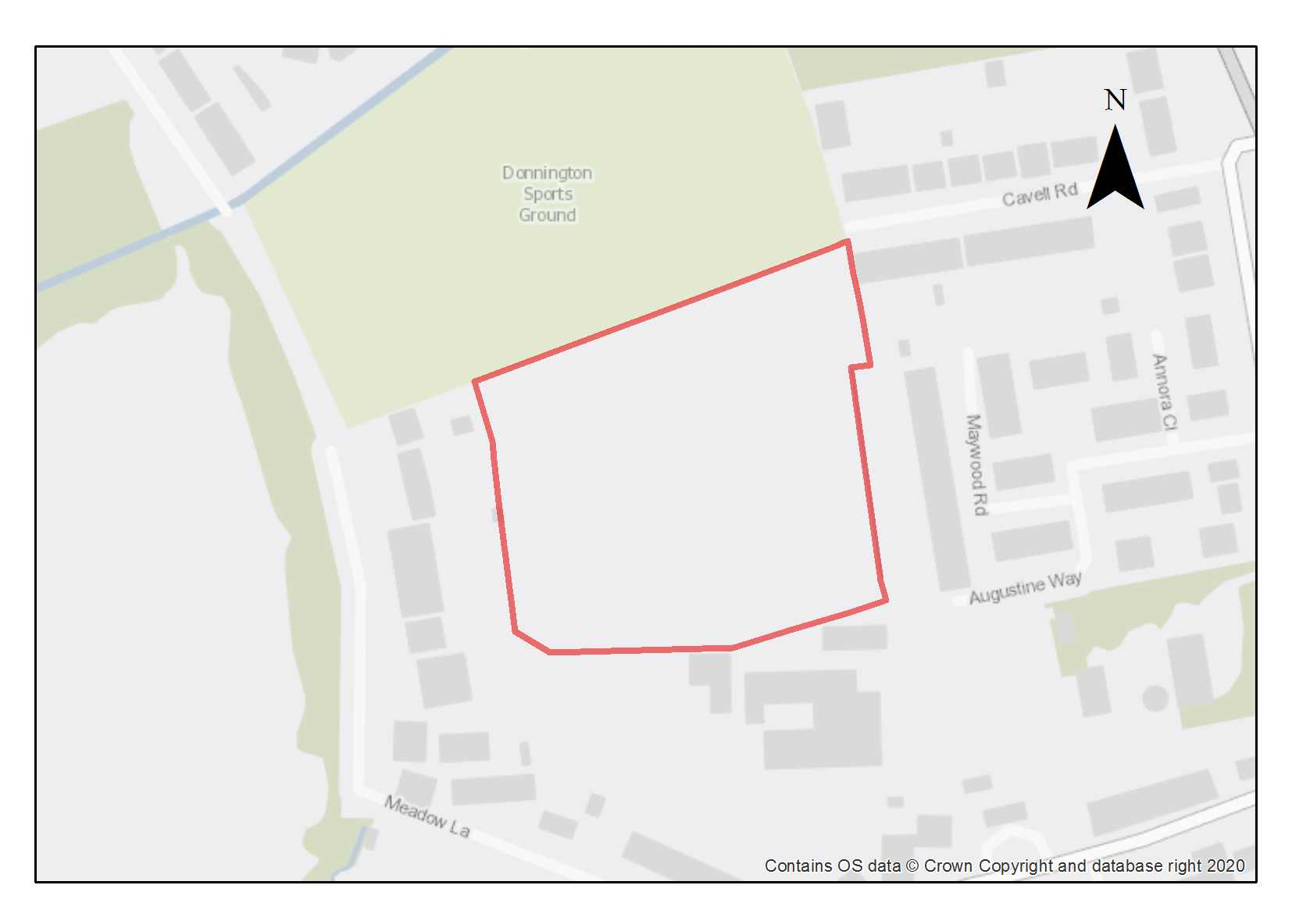

The Former Iffley Mead Playing Field was once part of the St Augustine School which closed in 2003. Most of the St Augustine School site was redeveloped for housing, but the playing field was retained for use by the adjacent Iffley Mead School. Iffley Mead School is now the Iffley Academy and uses their adjacent playing field not the former playing field which has been fenced off and is increasingly covered in scrub and brambles. The site is bounded to the north by the Donnington recreation ground, to the east and west by residential areas and to the south by The Iffley Academy. The site is adjacent to the Iffley Village Conservation Area and is close to the Rose Hill view cone. The site should be designed in such a way as to capture the village character of the conservation area, including small scale development plots, irregular building lines and the use of brick and stone materials, especially for the edges of the development. The design of the development should take opportunities to look out on the views over the recreation ground to the north of the site.

Preliminary analysis suggests that the presence of various green infrastructure features on the site at present means it is likely to score above the minimum thresholds for green surface cover as required by Policy G3; as such proposals will need to ensure that this score is retained (no net loss), demonstrated through submission of the Urban Greening Factor (UGF) assessment. The site should also be assessed to determine its value to invertebrates. New development on the site will need to consider how existing green features such as mature trees, hedgerows and grassland can be retained. Depending on the existing distinctiveness and condition of the existing grassland, there may be opportunities to enhance this. Where green elements are proposed to be removed, sufficient replacements will need to be incorporated into the new design, or enhancement of existing green infrastructure that is being retained, to preserve the baseline UGF score as a minimum. The site is likely to be able to accommodate areas of public open space including space for children’s play.

This site is within the catchment of the Iffley Meadows SSSI, which is sensitive to changes in the flows and quality of water in the two arms of the River Thames due to being in its floodplain. As such it can be impacted by contamination through surface water runoffs.

This site is of archaeological interest as it is located 70 metres from a Neolithic pit circle and there is potential for further remains. This will require further investigation as part of any redevelopment.

The site is well located to nearby bus stops on Iffley Road and Henley Avenue providing access to both the city centre and Rose Hill. Meadow Lane connects to Donnington Bridge Road, which also has bus stops providing access to the city centre and cycle infrastructure.

Policy SPS14: Former Iffley Mead Playing Field

Planning permission will be granted for residential development and public open space at the Former Iffley Mead Playing Field site. The minimum number of dwellings to be delivered is 84. Other complementary uses will be considered on their merits.

Open Space, nature and flood risk
Policies G1 and G3 require protection of existing green infrastructure features and enhancement of greening on site through the urban greening factor. Policy G5 requires onsite biodiversity enhancement, and Policy G2 requires new Green Infrastructure features and enhancement of existing features. It is expected that those requirements will be met in the following ways. Planning permission will only be granted if it can be demonstrated that there would be no adverse impacts on the integrity of the Iffley Meadows SSSI. To minimise the impact upon the Iffley Meadows SSSI development proposals will be expected to incorporate SuDS and, depending on the details of the proposals, may be required to be accompanied by a groundwater study.

The site would be expected to provide for 10% new public open space which could incorporate a well-designed secure children’s play area alongside some Sustainable Urban Drainage System (SuDS).

Urban design and heritage
Policy HD7 requires high quality design and the following sets out key considerations for achieving that on this site. The design should consider active frontages and how to optimise links to new and existing public open space. Existing trees and hedgerows within and surrounding the site should be retained to give privacy within the site and for neighbouring properties in addition to retaining habitats/ wildlife corridors within and across the site. The site needs to give careful attention to the relationship with the adjacent school to ensure visual impacts on both developments can be mitigated.

Development proposals must be designed with consideration of their impact on the setting of the Iffley Village Conservation Area and on views, particularly from the Rose Hill view cone, and demonstrate compliance with policies HD1 and HD9.

Development must take into consideration the potential presence of Neolithic archaeological remains. Due to this potential, development should demonstrate compliance with Policy HD5.

Movement and access
Vehicular access to the site can be achieved via Augustine Way, which connects into Iffley Turn. As this access is the primary route to the adjacent Iffley Academy school, vehicular access to the site should be minimised to not be detrimental to the school site. A low car development would be supported, ensuring parking provision is made available for blue badge holders and servicing and delivery vehicles. Ensuring access links through to local bus stops must be sought as part of the development

Opportunities to access the site for pedestrians and cyclists from Cavill Road and through the adjacent recreation ground to the north should be explored. This would improve permeability within the site and provide a connection with existing pedestrian and cycle infrastructure across the recreation ground between Cavill Road and Meadow Lane.

Redbridge Paddock

Site area: 3.64 hectares
Ward: Hinksey Park
Landowner: Oxford City Council
Current use: Agricultural land
Flood zone: FZ3b but FZ1 for sequential test

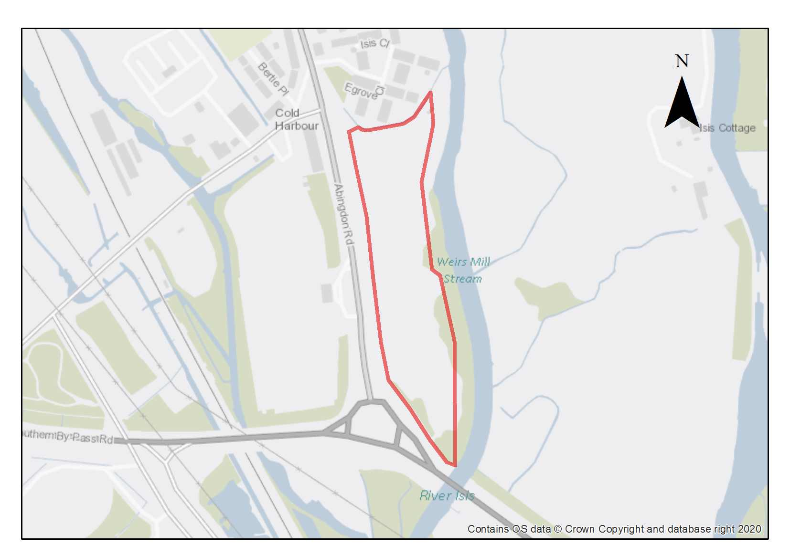

Redbridge Paddock is a former landfill site that is currently used for rough grazing. Weirs Mill Stream forms the eastern boundary beyond which lies the Iffley Meadows SSSI. A cycle track and footpath form the western boundary alongside Abingdon Road with Redbridge Park and Ride beyond. The site was formerly Green Belt land but was removed from the Green Belt in the Oxford Local Plan 2036. Green Belt land lies along eastern edges of the site. The busy Eastern Bypass Road forms the southern boundary of the site which has noise and air pollution implications for the site.

There are views into and out of the site from the Iffley Village Conservation Area which need to be properly considered and assessed in any design proposals for the site. The site is also of archaeological interest for potential remains of a historic routeway (potentially Norman/medieval) and related fording points but has been subject to landfill so archaeological implications would be subject to the scale and character of development/remediation.
The site has good access to the city onto the Abingdon Road and benefits from good sustainable transport links in terms of segregated pedestrian and cycle routes and is on an important bus route with regular buses serving the Park and Ride travelling into and out of the city centre.

The majority of the site is at low risk of flooding, but there is an almost negligible area in Flood Zone 3b. Any proposal should therefore include a flood risk assessment and design the development to avoid the area at flood risk.

Preliminary analysis suggests that the presence of various green infrastructure features on the site at present means it is likely to score above the minimum thresholds for green surface cover as required by Policy G3; as such proposals will need to ensure that this score is retained (no net loss), demonstrated through submission of the Urban Greening Factor assessment. New development on the site will need to consider how existing green features, particularly higher scoring elements, can be retained, which could include maintaining the vegetation and trees along the river edge and introducing screen planting around the site to act as a buffer from the roads around the site.

Weirs Mill Stream is one of the few locations in the city with potential for new residential moorings. These should be provided as part of the development with access through the site to the bankside and necessary servicing provided.

Adjustments and considerations at design stage may be helpful in reducing the ongoing impact of poor air quality. Potential options may include considering layout options that place habitable spaces and openings away from pollution sources such as busy roads, landscape buffers, and designing in walking and cycling options as integral part of schemes.

Policy SPS15: Redbridge Paddock

Planning permission will be granted for residential development and public open space at Redbridge Paddock. Proposals should include residential moorings and associated servicing facilities. The design of the proposals should include a minimum of 200 dwellings.

Open space, nature and flood risk
Policies G1 and G3 require protection of existing green infrastructure features and enhancement of greening on site through the urban greening factor. Policy G5 requires onsite biodiversity enhancement, and Policy G2 requires new Green Infrastructure features and enhancement of existing features. It is expected that those requirements will be met in the following ways. Planning permission will only be granted if it can be demonstrated that there would be no adverse impacts on the integrity of the Iffley Meadows SSSI. To minimise the impact upon the Iffley Meadows SSSI development proposals will be expected to incorporate SuDS and, depending on the details of the proposals, may be required to be accompanied by a groundwater study.

The design for the proposals should consider and respond to the natural setting of the site with the river and pastoral floodplain landscape character and the sensitive SSSI adjacent. A 10m buffer measured from the edge of the riverbank, must be retained between the river and the built development to protect and enhance the watercourse.

There are opportunities to create attractive riverside open spaces and the mature trees along the banks should be retained where they enhance the design of the proposal. A biodiversity survey will be required to assess the biodiversity value of the site. The survey must set out how any harm to biodiversity on the site will be avoided, mitigated or compensated.

A lighting strategy should be submitted in support of any planning application setting out the internal and external lighting associated with the proposed development. This is because the River Thames is likely to be an important foraging and commuting resource for bats and should not be subject to any artificial illumination as a result of the proposed development.

A flood risk assessment will be required as a very small part of the site is in Flood Zone 3b.

Compensatory improvements should be made to the surrounding areas of remaining Green Belt in accordance with the identification of Opportunities to Enhance the Beneficial Use of Green Belt Land Report (LUC 2018).

Urban design and heritage
Policy HD7 requires high quality design and the following sets out key considerations for achieving that on this site. It is important that this “gateway site” into the city is given a clear identity/sense of place, in terms of its design and layout. It must be well designed to enhance the area currently dominated by the Redbridge Park and Ride and Travelodge hotel.

Development proposals must be designed with consideration of their impacts on the broader landscape setting and the views from and into the Iffley Village Conservation Area and must demonstrate compliance with policy HD1.
Development must also take into consideration the potential presence of Norman/ medieval archaeological remains. Due to this potential, development should demonstrate compliance with Policy HD5.

Movement and access
The site is well located to existing pedestrian and cycle links as well as good public transport service into the city centre and to locations outside of the city. Development proposals should seek to enhance these links.

Vehicular access to the site would be from Abingdon Road and must be delivered to the satisfaction of the transport authority.

Natural resources
Development proposals will be required to include an appropriate site contamination investigation and applications will be required to demonstrate how contamination issues will be resolved in compliance with Policy R5.

The site is in an air quality hot spot area. Development proposals must demonstrate compliance with Policy R4 by ensuring that all necessary mitigation measures against poor air quality have been incorporated during the construction and operational phases and ensuring that any potential negative air quality impacts are adequately mitigated on an ongoing basis, within and surrounding the site.

Development proposals must include an acoustic design statement in compliance with Policy R7 as this site is part of an area which is subject to significant environmental noise from traffic on the surrounding roads.

Crescent Hall
…
Site area: 0.96 hectares
Ward: Temple Cowley
Landowner: Oxford Brookes University and Oxford City Council (the MUGA)
Current use: Student accommodation
Flood zone: FZ1

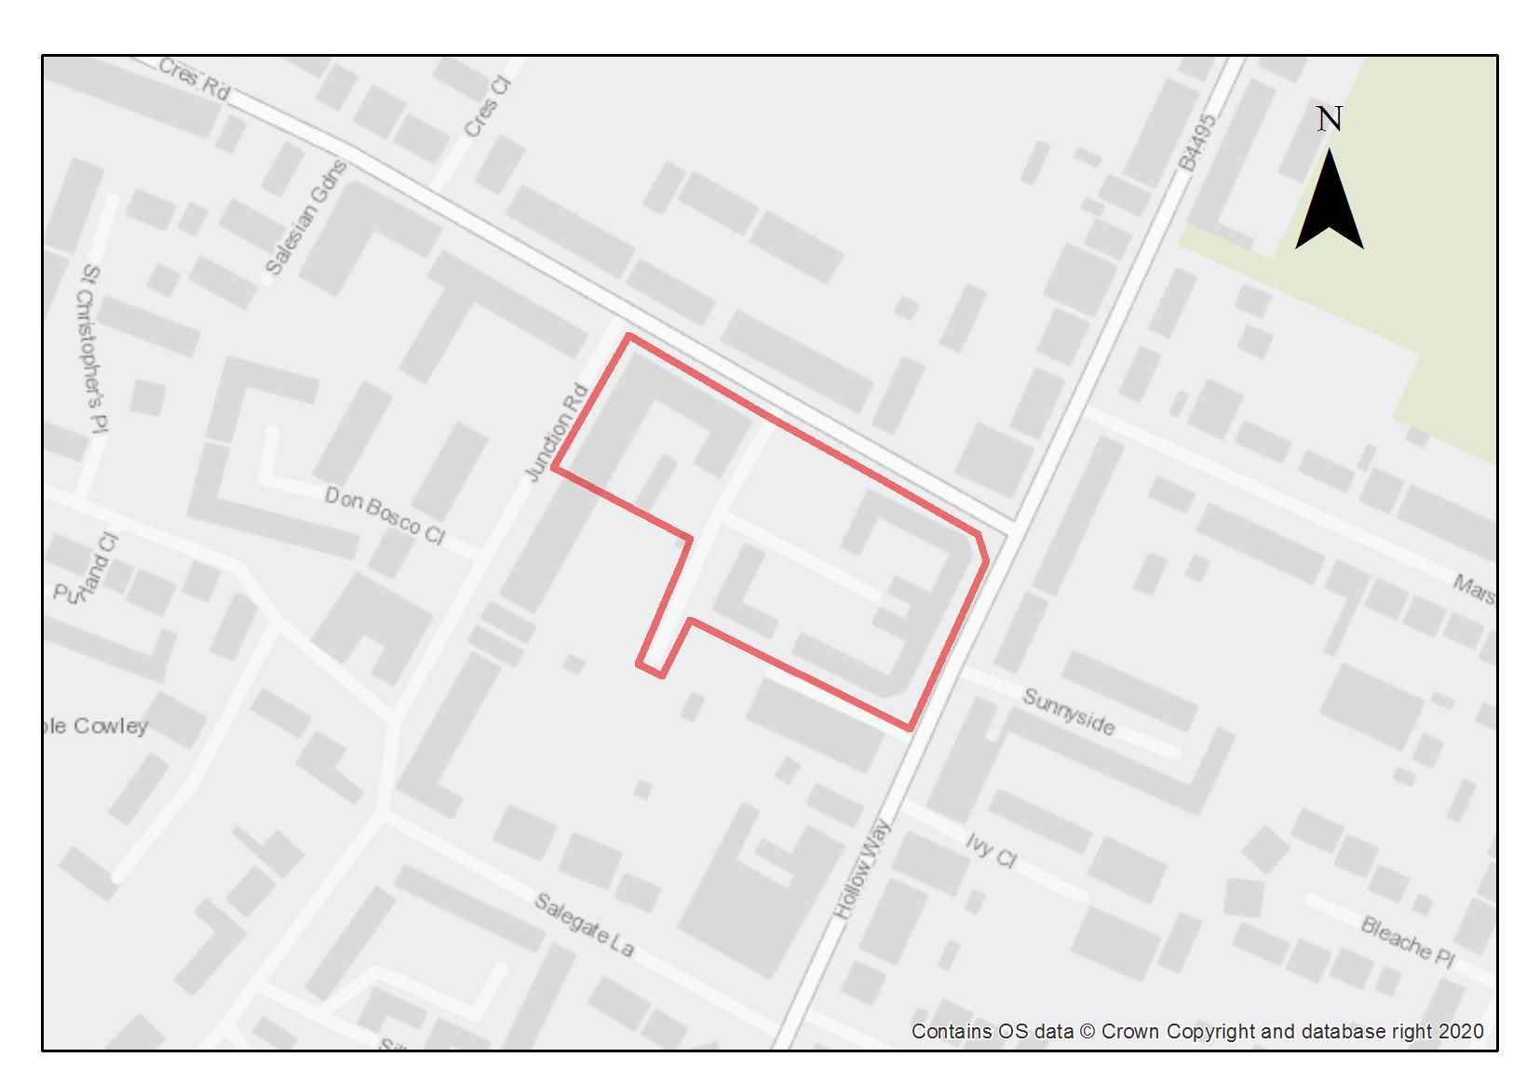

The site is fully built out and is currently in use as student accommodation, with the capacity of about 300 bedspaces. The development is made up of two separate blocks that largely follow the perimeter of the site, with openings to allow access.

The surrounding context is predominantly residential and is in proximity to the Cowley district centre with good access to transport options, including bus routes and dedicated cycle paths along Hollow Way and Garsington Road. As the site also lies within a CPZ, the site will be appropriate for car free or low car development.

The site is directly adjacent to the Temple Cowley conservation area with the shared boundary along the Hollow Way. Most of the buildings are at a height of 3 stories and hipped roofs in varying configurations, which is generally in keeping with the surrounding context. There is also a characterful low limestone wall along the perimeter of the site, which mirrors a similar wall along the frontage on the opposite of Junction Road. There is a council owned MUGA within the site boundary and it is expected that this would be retained or integrated within any development schemes unless it is deemed surplus to requirements.

The site contains significant existing trees and other forms of planting along the Crescent Road, Junction Road and Hollow Way frontages, which provide visual interest in the street scene. However, within the site curtilage there is no other landscaping of note other than some amenity grass within the enclosures formed by the blocks.

Preliminary analysis suggests that the limited presence of green infrastructure features on the site currently means it is likely to score below the minimum thresholds for green surface cover as required by Policy G3. As such, proposals will need to ensure that an appropriate proportion of green features are incorporated into the design of development to meet the minimum targets set out in the policy, demonstrated through submission of the Urban Greening Factor assessment.

Policy SPS16: Crescent Hall

Planning permission will be granted for residential development and/or student accommodation on the site. The minimum number of dwellings to be delivered on the site is 29 (or, if delivered as student rooms, the number of rooms that equate to this when the relevant ratio is applied).

Open space, nature and flood risk
Policies G1 and G3 require protection of existing green infrastructure features and enhancement of greening on site through the urban greening factor. Policy G5 requires onsite biodiversity enhancement, and Policy G2 requires new Green Infrastructure features and enhancement of existing features. The following is expected to help meet these requirements. There are opportunities to incorporate high-quality green infrastructure on the site. Existing mature trees should be retained as far as possible, especially those on the edge of the site and those that screen the site from the adjoining conservation area. Replacement and additional planting of trees and other mixed high-quality planting will be required. There should be permeable surfacing across the site and more natural landscaping.
Development schemes will be expected to retain and integrate the existing MUGA, unless the loss of the sports provision can be otherwise compensated for in accordance with the requirements of Policy G5. If an alternative site is found, the City Council must be satisfied that it will be delivered.

Urban design and heritage
Policy HD7 requires high quality design and the following sets out key considerations for achieving that on this site. There is scope for intensification on the site, including additional height; however development proposals are expected to have regard for the character of the adjoining conservation area (in accordance with policy HD1), particularly in terms of heights, massing, roofscape and impacts on street scene and local character.

Movement and access
The scheme should seek to prioritise walking and cycling owing to its proximity to the district centre and location within a CPZ. The most suitable access to the site is likely to be from Crescent Road, as the existing access is. Designing and locating circulation areas and servicing areas so that vehicle circulation around the site is minimised will be important due to the limited access opportunities for this relatively large site.

Edge of Playing Fields, Oxford Academy
…
Site area: 0.58 hectares
Ward: Littlemore
Landowner: Oxfordshire County Council (Freehold Owner), River Learning Trust (leaseholder)
Current use: School playing field
Flood zone: FZ1

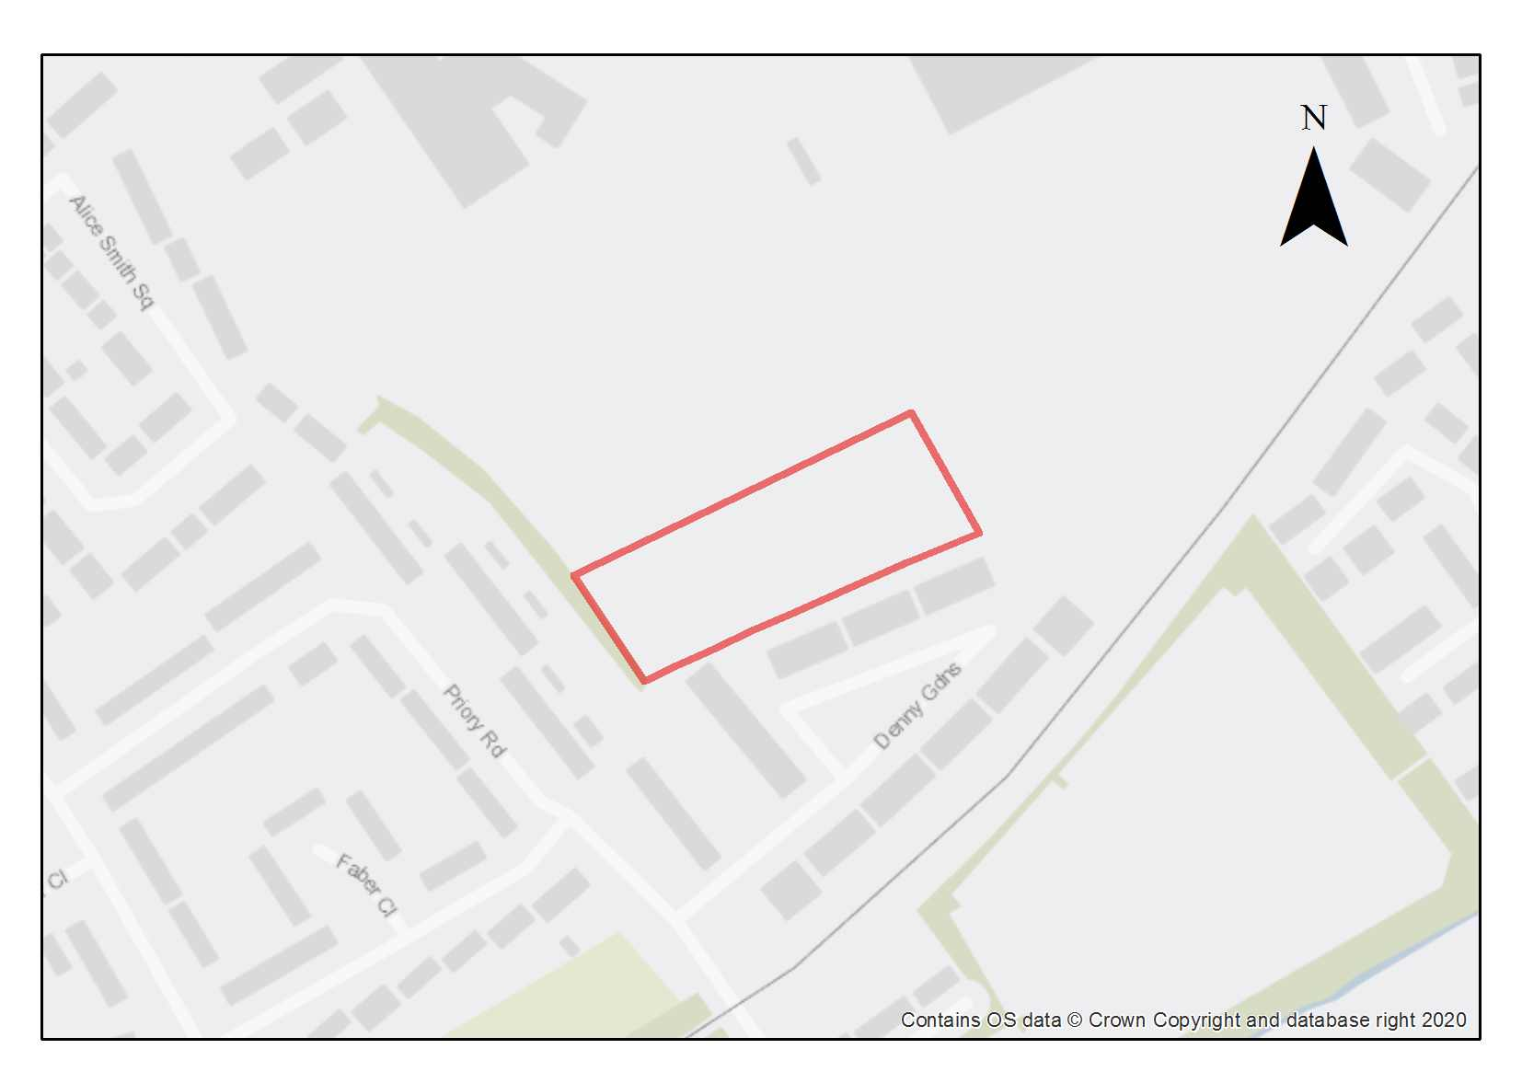

This site comprises spare land at the edge of the playing fields at the Oxford Academy School. It is at a lower level than the rest of the playing fields, and not an intrinsic or well-used part of the outdoor sport offer. The site is adjacent to Denny Gardens and there is potential to access the site through Denny Gardens. The site is suitable for residential development, which is employer-linked housing provided for employees of the academy trust.

Preliminary analysis suggests that the presence of various green infrastructure features on the site at present means it is likely to score above the minimum thresholds for green surface cover as required by Policy G3; as such proposals will need to ensure that this score is retained (no net loss), demonstrated through submission of the Urban Greening Factor assessment. New development on the site will need to consider how existing green features, particularly higher scoring elements, can be retained. The site is likely to be able to accommodate more planting along the boundaries of the site to provide both screening for the development and enhanced quality of vegetation surrounding the site.

Adjustments and considerations at design stage may be helpful in reducing the ongoing impact of poor air quality. Potential options may include considering layout options that place habitable spaces and openings away from pollution sources such as busy roads, landscape buffers, and designing in walking and cycling options as integral part of schemes

Policy SPS17: Edge of Playing Fields, Oxford Academy

Planning permission will be granted for employer linked housing in accordance with Policy H5. The minimum number of dwellings to be delivered is 20. Other complementary uses will be considered on their merits.

The site to be developed is the playing field only and must not encroach upon the other playing pitches on the school site. The loss of part of the playing field will require qualitative improvements to be undertaken to the City Council’s satisfaction to the remaining playing field.

Open space, nature and flood risk
Policies G1 and G3 require protection of existing green infrastructure features and enhancement of greening on site through the urban greening factor. It is expected that those requirements will be met in the following ways. The planting on the southern edge of the site should be encouraged and reinforced to provide both screening to the neighbouring properties and to enhance the biodiversity value of the hedgerow. Planting should be introduced on the northeastern boundary of the site to screen the sports pitch from the proposal.

Urban design and heritage
Policy HD7 requires high quality design and the following sets out key considerations for achieving that on this site. The residential development must be designed to ensure sufficient space for a turning head to allow waste services, emergency vehicles access and egress of the site. The site would be better suited to a flatted scheme to optimise the use of amenity space and create attractive public realm. Careful consideration must be given to the positioning of windows and lighting in this development to ensure there is good surveillance of the public realm.

Movement and access
Opportunities should be taken to connect the development proposal into the existing pedestrian and cycling network and to improve it where opportunities arise. Access could be taken from Denny Gardens.

Natural resources
The site is in an air quality hot spot area. Development proposals must demonstrate compliance with Policy R4 by ensuring that all necessary mitigation measures against poor air quality have been incorporated during the construction and operational phases and ensuring that any potential negative air quality impacts are adequately mitigated on an ongoing basis, within and surrounding the site.

474 Cowley Road (Former Powells’ Timber Yard)

Site area: 0.34 hectares
Ward: Donnington
Landowner: The Orders of St John Care Trust
Current use: Former timber yard, currently not in use
Flood Zone: FZ2

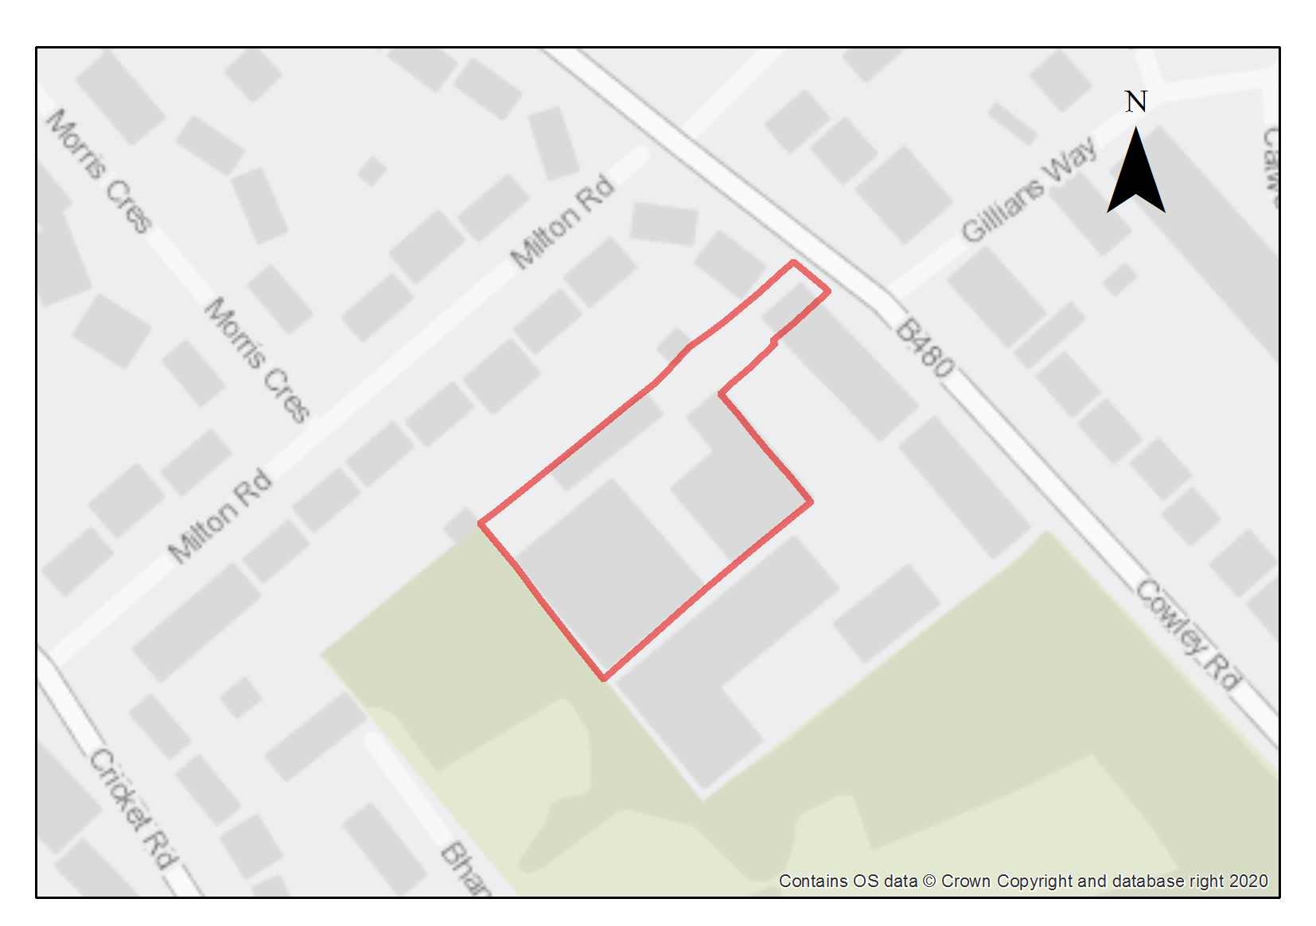

This site was previously in employment use, today all buildings have been demolished and the site cleared. It is tightly bounded by two-storey terraced residential uses on two sides, allotments and a car repair business. The design and layout of development will therefore need to be sensitive to these neighbouring uses.

The site has previously benefitted from planning permission for a care home and although the former industrial buildings on the site were demolished, the permission was not fully implemented and has expired. A care home or residential C3 would be suitable for this site.

Access to the site is via a single-width passage between two residential properties onto Cowley Road. The site has good access to public transport and to cycle and pedestrian infrastructure along Cowley Road. The site is situated within the Cowley Marsh Controlled Parking Zone (CPZ) and would be appropriate for car free or a low car development.

As a former timber yard, the site has potential contamination risks. Site investigations and risk assessment works are required to be undertaken and necessary remediation works carried out.

Preliminary analysis suggests that the limited presence of green infrastructure features on the site currently means it is likely to score below the minimum thresholds for green surface cover as required by Policy G3. As such, proposals will need to ensure that an appropriate proportion of green features are incorporated into the design of development to meet the minimum targets set out in the policy, demonstrated through submission of the Urban Greening Factor assessment.

Policy SPS18: 474 Cowley Road (Former Powells Timber Yard)

Planning permission will be granted for residential development, which could be in the form of care home. The minimum number of dwellings to be delivered is 20.

Open space, nature and flood risk
Policies G1 and G3 require protection of existing green infrastructure features and enhancement of greening on site through the urban greening factor. Policy G5 requires onsite biodiversity enhancement, and Policy G2 requires new Green Infrastructure features and enhancement of existing features. It is expected that those requirements will be met in the following ways. There are opportunities to incorporate high-quality green infrastructure on the site, to enhance the existing green infrastructure in the neighbouring allotments creating an opportunity for wildlife corridors to extend within the site. Existing trees and hedgerows on the site boundary should be retained and new planting introduced where necessary to provide screening both within the site and to the neighbouring properties and adjacent employment site. Equally, applicants are encouraged to deliver improvements to permeable surfacing across the site which would establish opportunities for more natural landscaping and SuDS features.

A site-specific flood risk assessment should also be submitted as part of any planning application (Policy G7). This should set out any mitigation measures.

Urban design and heritage
Policy HD7 requires high quality design and the following sets out key considerations for achieving that on this site. The built form should be sympathetic to the surrounding area and careful attention should be given to the relationship with the neighbouring employment use. The site should be designed to give privacy within the site and for neighbouring properties.

Movement and access
Opportunities to improve access to the site for pedestrians and cyclists should be explored to provide a connection with existing pedestrian and cycle infrastructure along Cowley Road.

Natural resources
Because of the current use some areas of potential contamination are present on the site, so site investigation will be required, and remedial works are likely to be necessary (Policy R5).

East Infrastructure Area (including Marston and Old Road Area of Focus) and Site Allocation Policies

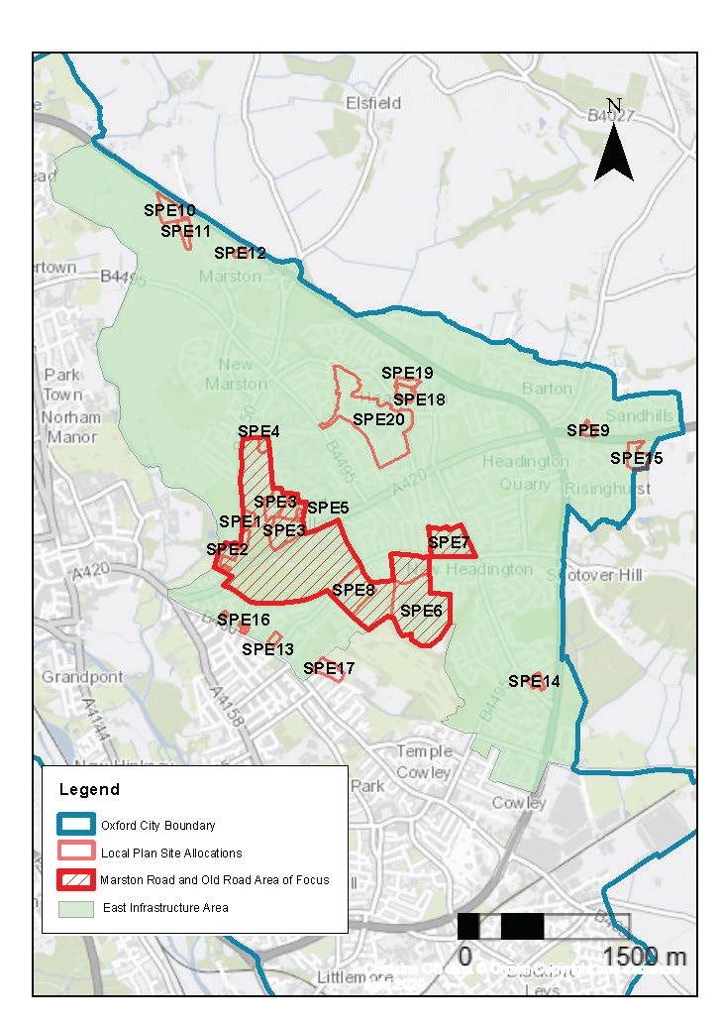
Figure 8.8 East Infrastructure Area, Marston and Old Road Area of Focus and site allocation policies
This area includes a number of sites with a range of uses including education, residential, research and the medical hospitals. As a result of people needing to get to the sites, particularly the hospitals, there is significant traffic congestion in the area. Improving accessibility, especially to the hospitals, by means other than the car is a key aim for this area.
The area includes many significant green spaces, including the Lye Valley SSSI, South Park and Bury Knowle Park.
Key considerations for infrastructure and design across the area are:
- Ensure good connectivity by foot and cycle and public transport across the area, e.g., with safe, attractive routes
- Seek to manage/reduce the levels of car parking on the hospital sites.
- Ensure protection of New Marston SSSI and Lye Valley SSSI
- Seek opportunities to increase active frontages along the southern end of the Marston Road
- Maintain the rural character of Cuckoo Lane whilst taking opportunities to enhance its function as a walking and cycling route

Marston and Old Road Area of Focus

This Area of Focus extends from the southwest part of Marston Road, incorporating Oxford Brookes and Old Road Campus and the hospital sites. The area around this part of the Marston Road includes some underutilised sites with development potential. It is also a sensitive area because of proximity to important parks Headington Hill and South Park, to the River Cherwell and several listed buildings. The area has an attractive and important natural setting and there are important views both into and out of the historic core of Oxford that must be protected. There are also some significant archaeological sites within this area including Civil War defences and the Fairfax siege line.
A design workshop was held in March 2023 with the aim of gathering knowledge, experience and aspirations from residents of the Marston area to support the drafting of development policies for three sites located on Marston Road. These sites are Government Buildings and Harcourt House, Land Surrounding St Clement’s Church, and Oxford Brookes University Marston Road Campus. Design principles developed during the workshop have informed the design considerations contained within the policy for this Area of Focus, along with the specific policies for these sites.

Policy MRORAOF: Marston Road and Old Road Area of Focus

Planning permission will be granted for new development within this Area of Focus where it would ensure that opportunities are taken to deliver the following (where applicable):

- Pedestrian and cycling infrastructure improvements must be delivered in accordance with the requirements of the Oxfordshire Local Cycling and Walking Infrastructure Plan. All opportunities to optimise connectivity and permeability for people wishing to walk or cycle in the area to other parts of the city and/or to destinations in South Oxfordshire;
- Positive contributions and enhancements to the character and setting of conservation areas and other heritage assets;
- Making the best use of good urban design and place making opportunities with the redevelopment of Clive Booth Hall and Headington Hill Hall;
- Building heights that are appropriate for their setting and that do not negatively impact on key views or historic skylines;
- The consolidation and reduction of excess car parking across the hospital sites;
- Increased active frontages and natural surveillance along the southern end of Marston Road;
- Maintaining the frontage of St Clement’s Church, and ensuring that the setting is not compromised;
- Maintaining the verdant and rural character of the areas around Cuckoo Lane;
- Ensuring the protection of New Marston SSSI and Lye Valley SSSI, and other sites of ecological and biodiversity importance; and
- Mitigation of potential negative air quality impacts that arise during the construction and operational phases.

East Area site allocation policies within the Area of Focus
- Government Buildings and Harcourt House
- Land Surrounding St Clement’s Church
- Headington Hill Hall and Clive Booth Student Village
- Oxford Brookes University Marston Road Campus
- 1 Pullens Lane
- Churchill Hospital
- Nuffield Orthopaedic Centre (NOC)
- Warneford Hospital
Government Buildings and Harcourt House

Site area: 2.37 hectares
Ward: Headington Hill and Northway
Landowner: Oxford Centre for Islamic Studies
Current use: Car park, offices and cadet accommodation
Flood Zone: FZ1

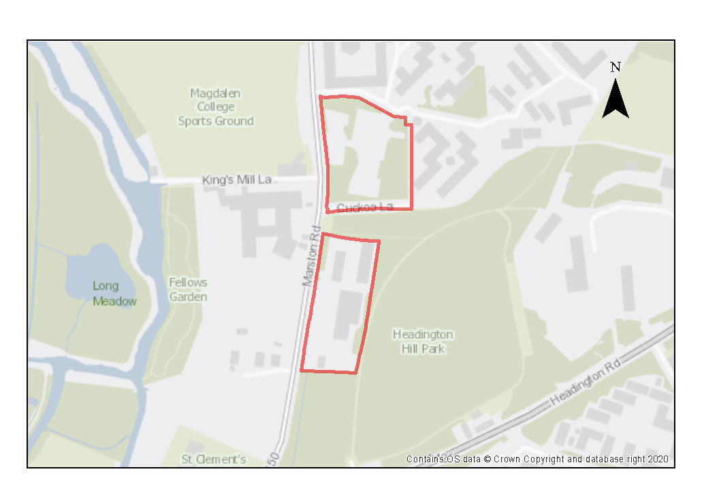

This site is on the Marston Road with good public transport links to the city centre and hospitals. The site is divided into two distinct parcels, the northern parcel is a car park surrounded by Clive Booth Student Village on two sides, Marston Road and Headington Hill Park. The southern parcel is separated from the northern parcel by Headington Hill Park and the historic Cuckoo Lane (with access to the park), is a small business estate and cadet accommodation consisting of 1-3 storey buildings.

The site context needs to consider heritage and natural environment sensitivities, which will need to be responded to through careful design, as set out in the policy. The northern parcel is adjacent to the Headington Hill Conservation Area and southern parcel is within it. There are no listed buildings on the sites but the Grade II* Headington Hall sits within the park and St. Clements Church is nearby. The Headington Hill view cone passes through the northern parcel and South Park view cone passes to the south of the southern parcel. Significant view lines are indicated in the conservation area documents from Headington Hill Hall towards the site and along the paths at the back of the southern parcel. As such buildings should generally be higher facing the road and lower adjacent to the park as site topography slopes up where particular care should be given to view sensitivity from the park. Roofscape should be varied in terms of height and arrangement to add visual interest. Combining different typologies would help give variation to the blocks and give opportunity to incorporate active frontages into the design.

Building material selection that features a palette of robust materials like high quality brick or stone would sit comfortably with the park setting and the institutional buildings nearby, at the Oxford Centre for Islamic studies. Maintaining rural character boundaries would reinforce the rural character of the area. Opportunities should be sought to reflect local vernacular features in boundary areas like stone walls – many from stone quarried locally – as well as making use of hedges and trees to give character to proposals.

There is the potential for archaeological remains on the site, with the Civil War Parliamentarian siege line having been identified in Headington Hill Park, suggesting that it runs through the northern part of the two plots. This will require further investigation as part of any redevelopment.

The site is a short distance away from the Long Meadow, a designated Local Wildlife Site, and the New Marston Meadows SSSI. Parts of the site include priority habitat in the form of open mosaic habitat (on the northern parcel) and woodland (on the southern parcel) and there is potential of the presence of various protected species including foraging and commuting bats, roosting bats (trees and buildings), badgers, and nesting birds. A high hedge separates the northern parcel from the Marston Road and low trees and shrub define back edge; large mature trees define the north and south edges of the parcel including a number of TPOs which are also within the site. Equally, mature trees define the boundaries of the southern parcel which are protected as part of the conservation area, with additional high hedging separating it from Headington Hill Park and a low stone wall facing the road.

Preliminary analysis suggests that the presence of various green infrastructure features on the site at present means it is likely to score above the minimum thresholds for green surface cover as required by Policy G3; and as such proposals will need to ensure that this score is retained (no net loss),demonstrated through submission of the Urban Greening Factor assessment. New development on the site will need to consider how existing green features, particularly higher scoring elements such as the mature trees (including those protected by TPOs) and established boundary features like hedges, can be retained. Sufficient replacements will need to be incorporated into the new design, or enhancement of existing green infrastructure that is being retained, to preserve the baseline UGF score as a minimum. The park setting, and existing green features gives ample opportunity to blend new development into the verdant surroundings with rich planting characteristic of the Headington Hill Conservation Area.

Policy SPE1: Government Buildings and Harcourt House

Planning permission will be granted for residential development and public open space including student accommodation, as well as other academic institutional uses (subject to Policy H10). The minimum of dwellings to be delivered is 70 (or, if delivered as student rooms, the number of rooms that equate to this when the relevant ratio is applied). Other complementary uses will be considered on their merits.

Open space, nature and flood risk
Policies G1 and G3 require protection of existing green infrastructure features and enhancement of greening on site through the urban greening factor. Policy G5 requires onsite biodiversity enhancement, and Policy G2 requires new Green Infrastructure features and enhancement of existing features. It is expected that those requirements will be met in the following ways. There are a number of high-quality green features on the site, including mature trees, trees protected by TPOs, and hedges which should be retained wherever possible in order to help define a natural setting for proposals in line with the landscape and townscape character of the area, and help ensure no decrease in the Urban Greening Factor baseline score. External areas should work with existing green infrastructure such as the existing trees on the site and establish green linkages through the site, incorporating existing features as well as new planting and small green spaces. In particular, the existing green infrastructure and proximity of the site to Headington Hill Park creates an opportunity for wildlife corridors around the edge of, and through the site, which should be enhanced through the site as part of the green infrastructure provision.

A biodiversity survey may be required to assess the biodiversity value of the site and where appropriate it should be demonstrated how harm will be avoided, mitigated or compensated.

Opportunities to incorporate green features in the design of any new buildings should be maximised, such as green roofs, which are a feature of neighbouring buildings in Clive Booth Student Village. Development proposals should seek to reduce the impermeable surfaces across the site and introduce more natural landscaping and SuDS features.

Planning permission will only be granted if it can be proven that there would be no adverse impact on the New Marston Meadows SSSI. Development proposals should reduce surface water runoff in the area and should be accompanied by an assessment of groundwater and surface water flows. Development proposals must incorporate sustainable drainage with an acceptable management plan.

Urban design and heritage
Policy HD7 requires high quality design and the following sets out key considerations for achieving that on this site. The most efficient arrangement for the site is likely to be blocks parallel to the road to create a consistent building line within the setting of the trees. Building heights should be designed in a way that avoids interrupting or disrupting existing views across the site, particularly where their location is sited within the protected view cones.

Adjustments and considerations at design stage may be helpful in reducing the ongoing impact of poor air quality. Potential options may include considering layout options that place habitable spaces and openings away from pollution sources such as busy roads, landscape buffers, and designing in walking and cycling options as integral part of schemes.

Secure by Design Principles should be incorporated into design of external areas including clear, well-lit pedestrian, cycle and vehicular access from the Marston Road, well surveyed from the proposed buildings and sensitive to the Headington Hill and St Clements Conservation Areas.

Development proposals must have consideration of their impacts on the setting of the Headington Hill Conservation Area, particularly for development of the southern parcel; as well as the setting of the nearby listed buildings Headington Hall and St. Clement’s Church. Proposals must demonstrate compliance with policies HD1 and HD2. Design of development blocks and choice of materials should be sensitive to the special historic qualities and character of the area and ideally seek to enhance this.

Development proposals must take into consideration the potential presence of archaeological remains related to the Civil War Parliamentarian Siege line. Due to this potential, development should demonstrate compliance with Policy HD5.

Movement and access
Proposals should seek to improve upon accessibility to the site for pedestrians and cyclists. The southern parcel requires either a new pedestrian access behind the tree line or new crossings to be accessible from Marston Road. There is the potential for pedestrian linkage between the sites, where Cuckoo Lane and the park meet the road. Linkages with the adjacent park should be explored to open access for occupants to this green space, however, care should be taken in how entrances are placed to reduce impacts on the green character of the eastern boundary or the setting of the park.

Natural resources
The green boundaries to the west of the site should be retained and enhanced to mitigate impacts from air pollution and general traffic impacts from Marston Road.

The site is in an air quality hot spot area. Development proposals must demonstrate compliance with Policy R4 by ensuring that all necessary mitigation measures against poor air quality have been incorporated during the construction and operational phases and ensuring that any potential negative air quality impacts are adequately mitigated on an ongoing basis, within and surrounding the site.

Development proposals will be required to include an appropriate site contamination investigation and applications will be required to demonstrate how any contamination issues will be resolved in compliance with Policy R5.

Development proposals must include an acoustic design statement to be submitted in compliance with Policy R7 as this site is part of an area which is subject to significant environmental noise from the traffic on the surrounding roads.

Land surrounding St Clement’s Church

Site area: 2.31 hectares
Ward: St Clement’s
Landowner: Magdalen College
Current use: Greenfield, green open space, two bungalows, plant nursery
Flood Zone: FZ3b but FZ1 for sequential test

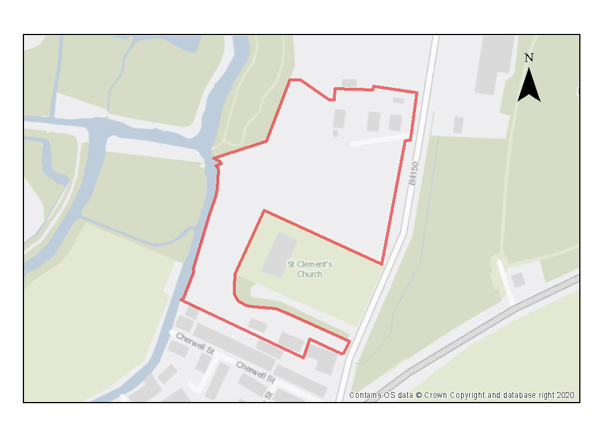

The site surrounds the Grade II* listed St. Clement’s Church and its cemetery, the St Clement’s and Iffley Road Conservation Area, and the setting of the Headington Hill Conservation Area. Careful design will be required to accommodate development whilst conserving and enhancing the conservation area and the setting of the Church. The conservation area appraisal identifies the open character of this part of Marston Road and the way in which St Clement’s church is set within a green enclave as key features. To conserve this character, development should be set back from Marston Road, and protection of key green infrastructure and maintenance of a green feel will be important. There is a still a clear visual relationship between the river and its meadows, the church and the green slope of Headington Hill, with views from the church across the Cherwell and towards Magdalen College, which should be referenced in new development. The southern part of the site lies within the South Park view cone and the impact of development on views of the historic core should be carefully considered.

The site also contains Air Training Corps huts on the southern side. The ATC huts are a public amenity. With careful design, scope exists for residential development that improves access, permeability, and experience of the site. A small area of the western part of the site lies in flood zone 3b and 2. The New Marston Meadows SSSI is a short distance away from the site and is sensitive to changes in the flows and quality of water in the river Cherwell due to being in its floodplain.

There have been issues previously with sewage leakages, therefore the network capacity needs to be considered.

The site is suitable for residential development and complementary uses, with some potential to help meet some of the needs of the college within this, in particular with a nursery and potential small-scale sports pavilion. The pavilion could be suitable on a part of the site that is more challenging for residential development and its associated servicing needs. The minimum housing number given assumes minimum appropriate suburban densities of around 30 dwellings per hectare, with allowances for buffers and no assumption built in for the western and southern part of the site because the suitability of these for residential development has not been tested through a detailed design processes and they are highly sensitive. The assumption is also made that 10% of the site will need to be delivered as public open space, according to Policy G2. The public open space could be distributed across the site, with green links and pocket parks, and planting and types of space that appeal to a range of senses, a range of ages, including children and provide corridors for wildlife that link existing features should all be aims of the public open space.

Preliminary analysis suggests that the presence of various green infrastructure features on the site at present means it is likely to score above the minimum thresholds for green surface cover as required by Policy G3; as such proposals will need to ensure that this score is retained (no net loss), demonstrated through submission of the Urban Greening Factor assessment. New development on the site will need to consider how existing green features, particularly higher scoring elements, can be retained including the hedgerows and trees on the site’s boundaries and around the church. Sufficient replacements will need to be incorporated into the new design, or enhancement of existing green infrastructure that is being retained, in order to preserve the baseline UGF score as a minimum. A very small part of the site, near to the river, is in Flood Zone 3b, and this should be kept free of development and include biodiversity enhancements.

Policy SPE2: Land Surrounding St Clement’s Church

Planning permission will be granted for residential development and/ or student accommodation at the Land surrounding St Clement’s Church site. The minimum number of dwellings to be delivered is 40 (or, if delivered as student rooms, the number of rooms that equate to this when the relevant ratio is applied).
Planning permission will also be granted for a children’s nursery and a pavilion as complementary uses, and other complementary uses will be considered on their merits.

Open space, nature and flood risk
Policies G1 and G3 require protection of existing green infrastructure features and enhancement of greening on site through the urban greening factor. Policy G5 requires onsite biodiversity enhancement, and Policy G2 requires new Green Infrastructure features and enhancement of existing features. It is expected that those requirements will be met in the following ways. Habitats should be preserved and enhanced, retaining existing hedgerows and mature trees where possible. Mature trees to the west and north of the church and the natural vegetation along the river should be maintained. At least a 10 metre buffer should be left between built development and the river Cherwell that adjoins the site. The tree and hedge-lines along the Marston Road and to the south of the church are important to the character of the area and to screen the site and the church. The green, treed character of these should be maintained.

Gardens with rich planting along boundaries should allow more diverse routes through the site for wildlife, connecting the river with neighbouring sites. Native hedgerow planting alongside the new homes should connect the river to west and the mature trees alongside the Marston Road to the east. Natural and diverse planting may form the main element of public open space on the site. 10% of the residential area of the site will be required to be public open space. These measures will be important in achieving no decrease in the Urban Greening Factor baseline score.

Planning permission will only be granted if it can be proven that there would be no adverse impact upon surface and groundwater flow to the New Marston SSSI. Development proposals should reduce surface water runoff in the area and should be accompanied by an assessment of groundwater and surface water. Development proposals must incorporate sustainable drainage with an acceptable management plan.

A site-specific flood risk assessment should also be submitted as part of any planning application (Policy G7). This should set out any mitigation measures.
A lighting strategy should be submitted in support of any planning application setting out the internal and external lighting associated with the proposed development. This is because the River Cherwell is likely to be an important foraging and commuting resource for bats and should not be subject to any artificial illumination as a result of the proposed development.

Urban design and heritage
Policy HD7 requires high quality design and the following sets out key considerations for achieving that on this site. Development proposals must be designed with consideration of their impacts on the significance of heritage assets, which are the Grade II* listed church, the St Clement’s and Iffley Road Conservation Area, the setting of the Headington Hill Conservation Area and the View Cone. Proposals must demonstrate compliance with policies HD1, HD2 and HD9. The conservation area appraisal identifies the open character of this part of Marston Road and the way in which St Clement’s church is set within a green enclave, as key features, and these should be retained. There is a clear visual relationship between the river and its meadows, the church and the green slope of Headington Hill, with views from the church across the Cherwell and towards Magdalen College, which should be referenced in new development. The southern part of the site lies within the South Park view cone and the impact of development on views of the historic core should be carefully considered.

Buildings should be arranged in a way that maintains the openness of the riverside setting, that does not compete with the Grade II* listed St. Clement’s Church, and that maintains the hedge and treeline on the Marston Road.

The built form needs to be highly sympathetic to the sensitive setting, which will mean buildings should reflect the semi-rural character of the site and be relatively limited in height and massing so as not to dominate the church and in response to the surrounding character. For example, terraced or semi-detached housing with pitched roofs would reflect the local vernacular in the character area and should provide a sympathetic setting for the Church. There would be an opportunity for larger plots to bookend rows or at junctions, giving variety to the roofscape.

Potentially the most challenging part of the site to develop will be the narrow strip to the south of the church. This will need bespoke design and there are a number of key considerations. Heights will need to drop towards the Cherwell, to be sympathetic to the relatively rural setting of the river. The impacts on the adjoining homes to the south will need to be considered carefully, avoiding direct over-looking into windows. Main outdoor amenity space may work best if shared. It will be important that the built development and new access road are not sited so close to the church that they would be too harmful to the setting of this heritage asset. The western part of the site, alongside the Cherwell and behind the church, is narrow and should maintain a more rural character and is most suitable for the location of a pavilion if that is to be within the mix of uses on the site. To the north of the church more than a single row of units is possible, potentially fronting the access road. The ATC huts could be relocated to the northernmost part of the site, near the current plant nursery.

Movement and access
Main access to the site from Marston Road should be towards the north of the site, avoiding the more sensitive area nearer the church. The existing access to the bungalows could become this main access. One main entrance would allow a highways compliant design while minimising the loss of hedgerow on Marston Road. There is a network of paths and bridges at the North-West corner of the site, however these are in the private ownership of Magdalen College. Opportunities to open these up for public access should be considered. A separate vehicle entrance to the south, where there is existing access to the ATC huts, is likely to be needed to service any development in this southern part of the site, but the impact on the setting of the church must be considered. The shorter, further south and more rural in character the access is the less likely it is to detract from the setting. Pedestrian and cycle connections within the site should link to the northern part of the site.

Parking should be kept in the public realm where possible and could be located close to the Marston Road, allowing the development of a masterplan more focused on walking and cycling within the site.

Natural resources
Development proposals must include an acoustic design statement to be submitted in compliance with Policy R7 as this site is part of an area which is subject to significant environmental noise from traffic on the surrounding roads.

Headington Hill Hall and Clive Booth Student Village

Site area: 10.05 hectares
Ward: Headington Hill and Northway
Landowner: Oxford Brookes University
Current use: Academic Institutional and student accommodation
Flood Zone: FZ1

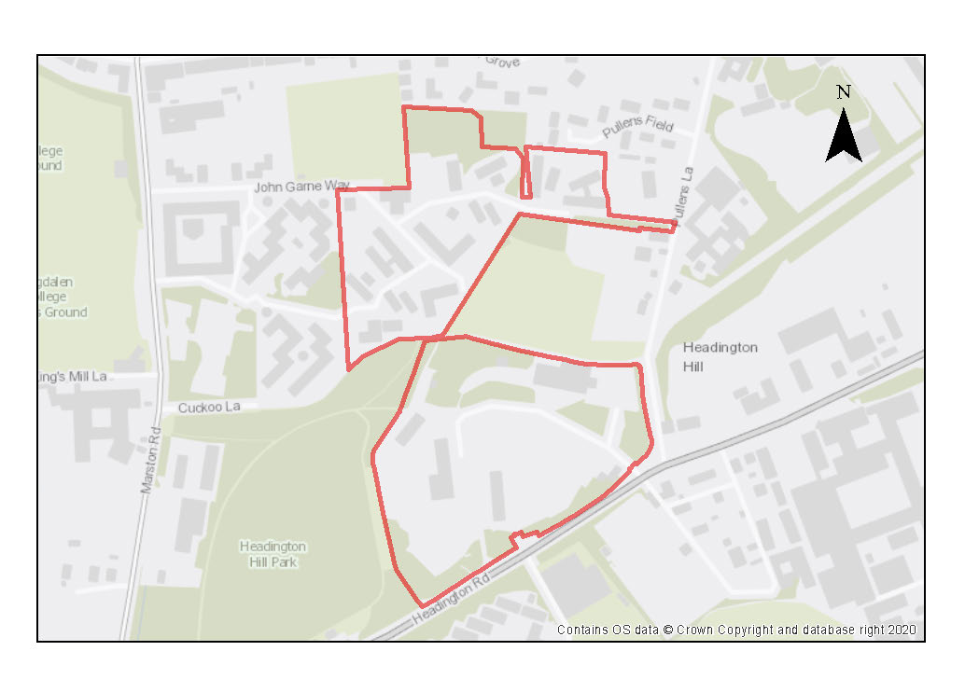

This site is home to academic and teaching facilities of Oxford Brookes and student accommodation. The entrance to the Headington Hill Hall site is from Headington Hill, opposite Oxford Brookes’ main teaching and academic centre at Gipsy Lane. The Clive Booth student village stretches down to Marston Road. The student village site is currently undergoing redevelopment following the approval of a scheme comprising of new student accommodation, associated social and leisure facilities for students, staff and the wider community. As well as enabling Oxford Brookes to relocate from their Wheatley campus, it will also contribute to their aim of reducing the number of students living outside of university-managed accommodation.

Headington Hill Hall and Lodge House are both listed buildings and much of the site falls within the Headington Hill Conservation Area. The well-treed slopes of the hill are important to the setting of the City Centre Conservation Area in views from the west, making an important contribution as the green backdrop in the famous views of the city of ‘dreaming spires’ and providing a number of features of historic or architectural interest in these views. Enhancing the landscape setting of the site will therefore be particularly important for any development proposals.

The New Marston Meadows SSSI is a short distance away from the site and is sensitive to changes in the flows and quality of water in the river Cherwell due to it being in floodplain. Due to the sensitivity of the SSSI opportunities to integrate SuDS into development proposals should be explored.

Preliminary analysis suggests that the presence of various green infrastructure features on the site at present means it is likely to score above the minimum thresholds for green surface cover as required by Policy G3; as such proposals will need to ensure that this score is retained (no net loss), demonstrated through submission of the Urban Greening Factor assessment. New development on the site will need to consider how existing green features, particularly higher scoring elements, can be retained including the mature trees. Sufficient replacements will need to be incorporated into the new design, or enhancement of existing green infrastructure that is being retained, to preserve the baseline UGF score as a minimum.

There is the potential for archaeological remains on the site, with the Civil War Parliamentarian siege line having been identified in close proximity at Headington Hill Park. This will require further investigation as part of any redevelopment.

The redevelopment of Clive Booth Student Village (21/01185/FUL) approved February 2022 will result in a total of 1213 student bedrooms on the campus (a net gain of 573 student rooms).

Policy SPE3: Headington Hill Hall and Clive Booth Student Village

Planning permission will be granted for:
- additional academic and teaching facilities on the Headington Hill Hall site (subject to Policy H10), with associated sport, social and leisure facilities subject to other relevant Local Plan policies;
- residential development on the Clive Booth Student Village site, including student accommodation or employer-linked affordable housing at a minimum quantum of 229 residential units (or, if delivered as student rooms, the number of rooms that equate to this when the relevant ratio is applied).

Other complementary uses will be considered on their merits.

Open space, nature and flood risk
Policies G1 and G3 require protection of existing green infrastructure features and enhancement of greening on site through the urban greening factor. Policy G5 requires onsite biodiversity enhancement, and Policy G2 requires new Green Infrastructure features and enhancement of existing features. It is expected that those requirements will be met in the following ways. Habitats should be preserved and enhanced, retaining existing green features where possible, particularly where these are identified as important for supporting the setting of the conservation areas and views across the site. In particular, there are a number of significant mature trees and some important tree groups, many of which will need to be preserved, and there must be no long-term overall loss of tree canopy cover across the site. New planting should be incorporated to enhance the landscape setting or to improve linkages between the adjacent green spaces.

Planning permission will only be granted if it can be proven that there would be no adverse impact upon surface and groundwater flow to the New Marston SSSI (Policy G6). Development proposals should reduce surface water runoff in the area and should be accompanied by an assessment of groundwater and surface water flows and development proposals must incorporate sustainable drainage with an acceptable management plan (Policies G7 and G8).

Urban design and heritage
Policy HD7 requires high quality design and the following sets out key considerations for achieving that on this site. Development proposals must be designed with consideration of their impacts on the setting of the listed buildings, the character of the conservation area, and on views, particularly from the historic core. Proposals must demonstrate compliance with policies HD1, HD2 and HD9. Development should have a positive impact on the relationship between buildings and the landscape setting. Development that rises above the treeline will need to be very carefully considered and justified.

Adjustments and considerations at design stage may be helpful in reducing the ongoing impact of poor air quality. Potential options may include considering layout options that place habitable spaces and openings away from pollution sources such as busy roads, landscape buffers, and designing in walking and cycling options as integral part of schemes

Development proposals must take into consideration the potential presence of archaeological remains related to the Civil War Parliamentarian Siege line. Due to this potential, development should demonstrate compliance with Policy HD5.

Movement and access
Development proposals should improve the pedestrian and cycle connectivity around the site, following desire lines between different parts of the site and from Gipsy Lane.

The development will be expected to minimise car parking spaces on site, and there should be no increase. Applicants will be expected to demonstrate how the development mitigates against traffic impacts and maximises access by alternative means of transport. Pedestrian and cycle access should be enhanced across the whole site, following desire lines from the Gipsy Lane campus and between different parts of the site.

Natural resources
The site is located in an air quality hot spot area. Development proposals must demonstrate compliance with policy R4 by ensuring that all necessary mitigation measures against poor air quality have been incorporated during the construction and operational phases and ensuring that any potential negative air quality impacts are adequately mitigated on an ongoing basis, within and surrounding the site.

Development proposals will be required to include an appropriate site contamination investigation and applications will be required to demonstrate how any contamination issues will be resolved in compliance with Policy R5.

Oxford Brookes University Marston Road Campus

Site area: 1.18 hectares
Ward: Headington Hill and Northway
Landowner: Oxford Brookes University
Current use: Educational facilities
Flood Zone: FZ1

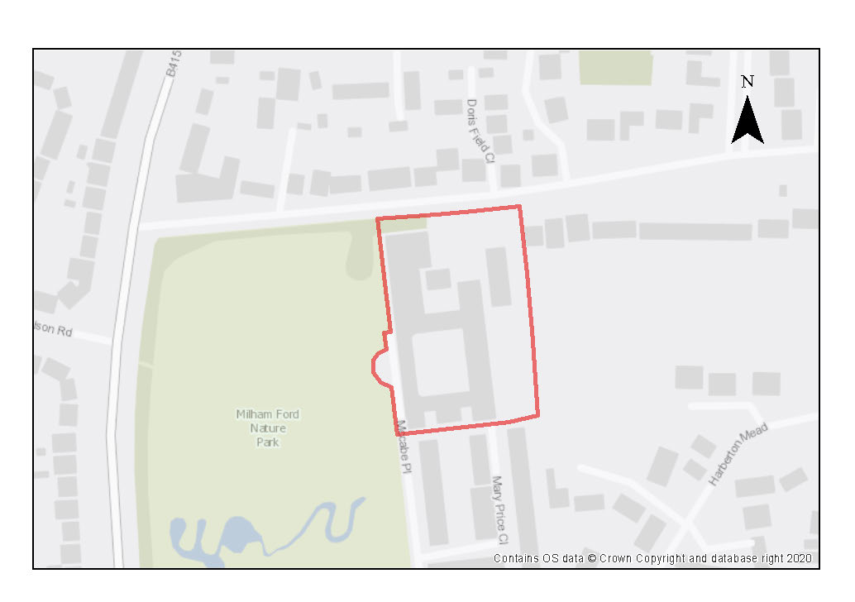

The site comprises the former Milham Ford School, which closed in 2003 and is currently in use as the Oxford Brookes Marston Road Campus. The former school building, built between the late 1930s and early 1940s is an imposing building, built in a neo-Georgian style. The school building is distinctive and there is an opportunity for it to be preserved as a landmark building within the site with the added benefit of embodied carbon savings. The site is adjacent to the Headington Hill Conservation Area and it has an important relationship to the setting of the conservation area.

The Oxford landscape assessment report records that Milham Ford School grounds contains important areas of lowland meadow grassland, a nationally important habitat, and is a good example of how recreation and wildlife can be accommodated side by side. The area is also designated as a Local Wildlife Site, as is the internal quad within the centre of the former School. The site is adjacent to the Milham Ford Nature Park, on the site of the former school playing fields and creates a landscape setting that has a strong relationship to the buildings. The Nature Park includes areas of formal play and a diverse mix of habitats. The tree and hedge lined boundaries along Jack Straws Lane and Harberton Mead are important features of the character of the area. The New Marston Meadows SSSI is a short distance away, and is sensitive to changes in the flows and quality of water in the river Cherwell due to being in its floodplain. Due to the sensitivity of the SSSI, development proposals should make the most of opportunities to integrate SuDS and make use of the natural features, such as the natural slope of the site, as part of drainage plans for the site.

The developable area considers the internal quad as well as allowances for vegetation on the eastern boundary which currently acts as a form of buffer to the adjoining residential dwellings on Jack Straw’s Lane.

Preliminary analysis suggests that the limited presence of green infrastructure features on the site currently means it is likely to score below the minimum thresholds for green surface cover as required by Policy G3. As such, proposals will need to ensure that an appropriate proportion of green features are incorporated into the design of development to meet the minimum targets set out in the policy, demonstrated through submission of the Urban Greening Factor assessment.

Currently vehicle access is limited to only the north and south of the site. Access can be achieved via Jack Straw’s Lane, McCabe Place and Mary Price Close.

The nearest bus stops are located on Marston Road to the west of the site and are within a suitable walking distance to support low car development. The site is also within the Marston South Controlled Parking Zone of the city. Therefore, the site should be a low car development or uses which would not increase vehicle movement (e.g., student accommodation).

Policy SPE4: Oxford Brookes University Marston Road Campus

Planning permission will be granted for further academic, research and related uses (subject to Policy H10), potentially with linked student accommodation or employer-linked housing, subject to other relevant Local Plan policies.

Other complementary uses will be considered on their merits.

Open space, nature and flood risk
Policies G1 and G3 require protection of existing green infrastructure features and enhancement of greening on site through the urban greening factor. Policy G5 requires onsite biodiversity enhancement, and Policy G2 requires new Green Infrastructure features and enhancement of existing features. It is expected that those requirements will be met in the following ways. Development should not result in adverse impacts on the Milham Ford Nature Park or the inner quad, which is designated as a local wildlife site.

Green links could be incorporated through the site connecting from the nature park, these should include green SuDS features, rain gardens etc. to facilitate sustainable drainage. Hard, non-permeable surfaces should be kept to a minimum. There are a few medium sized trees on the site which should be retained in first instance, opportunities to incorporate additional trees and hedges would help to replicate the character of the wider area and have various benefits.

Planning permission will only be granted if it can be proven that there would be no adverse impact upon surface and groundwater flow to the New Marston SSSI. Development proposals should reduce surface water runoff in the area and should be accompanied by an assessment of groundwater and surface water flows. Development proposals must incorporate sustainable drainage with an acceptable management plan.

Boundary treatments could continue the natural style present on the site, e.g. retain and make use of existing hedges and trees as much as possible. The existing row of hedges and trees form a natural border along the western boundary as well as to the north of the site (which are characteristic of the length of Jack Straw’s Lane) and should be retained in any development proposals. Public realm improvements should incorporate ample amounts of green features designed to function aesthetically, but also as important resources for biodiversity, cooling, noise, and flood resilience. Particular attention should be paid to new lighting and its impacts on biodiversity, particularly on the western side of the site adjacent to the nature park, efforts should also be made to minimise negative impacts of noise and poor air quality.

Urban Design and Heritage
It is expected that the form, materiality and significance of the existing school buildings are assessed and responded to appropriately in development proposals. Attention should also be paid to the materiality of the adjacent conservation area, and Policy HD7 requires high quality design and the following sets out key considerations for achieving that on this site. materials selected that are sensitive to this and enhance it.

Development proposals must be designed with consideration of their impact on the overall landscape setting and character of the adjoining conservation area, demonstrating compliance with policy HD1.

Movement and access
The existing accesses allow good permeability through the site and are likely to remain the best locations for accessing the site in future.

Natural resources
Development proposals will be required to include an appropriate site contamination investigation and applications will be required to demonstrate how any contamination issues will be resolved in compliance with Policy R5.

1 Pullens Lane

Site area: 0.4 hectares
Ward: Headington Hill & Northway
Landowner: Oxford Brookes University
Current use: Residential
Flood Zone: FZ1

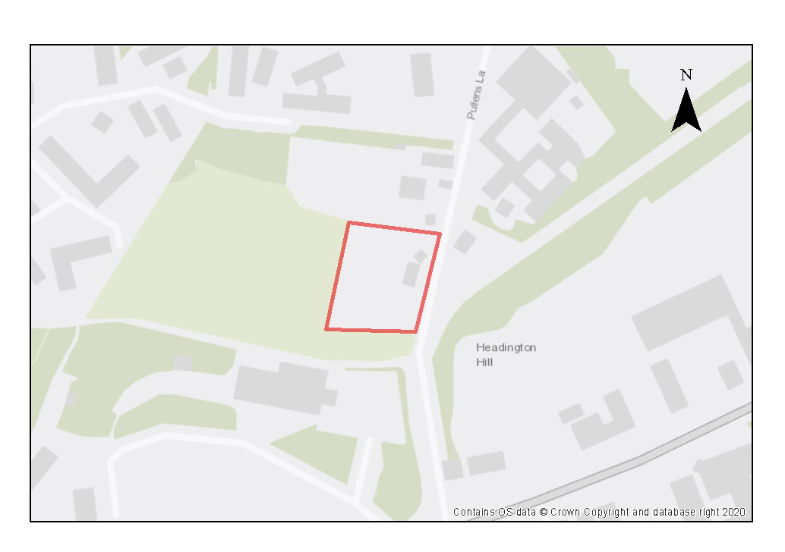

The site contains a single detached dwelling dating from the 1960s set within a large plot. The site is in the Headington Hill Conservation Area although the existing house itself is not of design or heritage interest. The buildings of the historic Pullen’s Gate farmhouse occupy the adjoining northern plot. The density of the area is low, characterised by large plots within which are set detached dwellings of varying size and individual educational buildings.

The site directly adjoins a large allotment site (St Clement’s at Pullens Lane). The presence of the allotments, the extensive mature planting within and around the site, strong hedgerows on both sides of Pullens Road for much of its length, and the generous gaps between detached buildings in the surroundings creates a green backdrop. The Conservation Area Appraisal notes the dominance of greenery on Pullens Lane in providing enclosure which contributes to the rural or sylvan character of the area.

Pullen’s Lane is a private narrow single lane road that branches off London Road and is occasionally closed to vehicular access traffic. Access is retained from Harberton Mead and Jack Straw’s Lane at the other end. There are no designated footpaths for much of its length, and mature planting lining both sides can make it difficult for pedestrians and cyclists when they are faced with passing vehicles. It is also possible to connect to Headley Way via Cuckoo Lane, which is an unlit cycleway/footway that runs behind Headington Girls school.

The site is likely to have a high biodiversity value, and already contributes greatly to the verdant character of the street scene, particularly on the front boundary where hedgerows are in place. Preliminary analysis suggests that the presence of various green infrastructure features on the site at present means it is likely to score above the minimum thresholds for green surface cover as required by Policy G3; as such proposals will need to ensure that this score is retained (no net loss), demonstrated through submission of the Urban Greening Factor assessment.

New development on the site will need to consider how existing green features, particularly higher scoring elements, can be retained, particularly the hedgerows along Pullens Lane and the shared boundaries, as well as the larger mature trees along the site boundaries and towards the rear of the site. Sufficient replacements will need to be incorporated into the new design, or enhancement of existing green infrastructure that is being retained, to preserve the baseline UGF score as a minimum.

Policy SPE5: 1 Pullens Lane

Planning permission will be granted for residential development, student accommodation, elderly accommodation or specialist or supported accommodation. The minimum number of dwellings to be delivered on the site is 11 dwellings (or, if delivered as student rooms, the number of rooms that equate to this when the relevant ratio is applied).

Open Space, Nature and Flood Risk
Policies G1 and G3 require protection of existing green infrastructure features and enhancement of greening on site through the urban greening factor. Policy G5 requires onsite biodiversity enhancement, and Policy G2 requires new Green Infrastructure features and enhancement of existing features. It is expected that those requirements will be met in the following ways. Development proposals must be accompanied by a site-specific biodiversity survey and any harm avoided, mitigated or compensated for.

Consideration should be given to integrating as many of the existing natural features into design schemes as possible, particularly the hedgerows along Pullens Lane and the shared boundaries, and the larger mature trees along the site boundaries and towards the rear of the site. In addition to landscaping of outdoor spaces, consideration should be given where practicable to integrating features such as green roofs or walls to retain as much of the verdant character as possible.

A lighting strategy should be submitted in support of any planning application setting out the internal and external lighting associated with the proposed development. This is because the surrounding habitat is likely to be an important foraging and commuting resource for bats and should not be subject to any artificial illumination as a result of the proposed development.

Urban Design and Heritage
Development proposals must be designed with consideration of their impact
on the conservation area setting and must demonstrate compliance with policy HD1.

The local setting is one of a green backdrop sand it is expected that any development will retain this character, with features such as screening and planting of a range of vegetation and trees, some degree of setback and screening from Pullen’s Lane and the boundaries with adjoining plots, and a medium scale that is in keeping with the surroundings. There is potential for development to make more efficient use of the land, subject to consideration of the conservation area setting, and bring about a better standard of building.

Movement and Access
The existing access is likely to remain as the most suitable location for accessing the site. The location of parking, servicing and circulation routes around the site will need to be carefully considered to avoid conflicts between pedestrians, cyclists and vehciles that may arise when there is only one main access.

Churchill Hospital

Site area: 22.73 hectares
Ward: Churchill
Landowner: Oxford City Council
Current use: Hospital
Flood Zone: FZ1

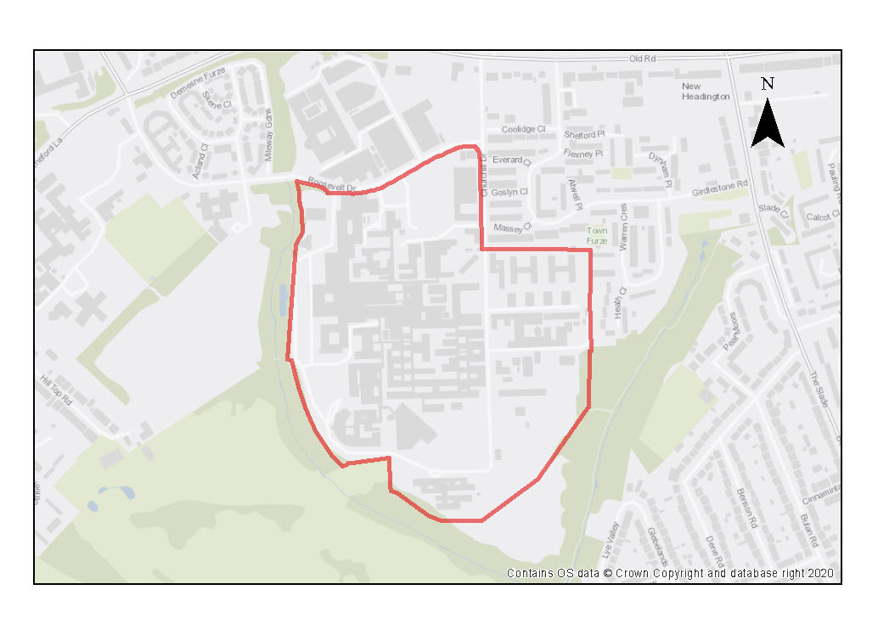

The Churchill Hospital is a teaching hospital specialising in cancer care, managed by the Oxford University Hospitals NHS Foundation Trust. The site is fully developed with well-established medical and related uses, including research and institutional buildings, as well as residential accommodation – some of which is currently under construction. The main site access is from Old Road, via Churchill Drive and Roosevelt Drive. Further development for the hospital function or employment uses which have a particular need to be located close to the hospital, such as medical research, would be suitable. Residential development, student accommodation, employer linked housing would also be appropriate uses.

The highest density of built development is focussed on the hilltop in the north-east corner of the site. The large complex is formed of interconnected buildings, with Churchill Drive forming an encircling access road connecting multiple car parks. Pavements along Churchill Drive are not continuous or limited to one side at a time, and there are minimal legible pedestrian routes through the site. Further work should be carried out to assess if the level of car parking can be reduced and the land repurposed for other uses.

The central part of the site comprises of the historical temporary hospital buildings, around which wider complex has grown, including various cabins., The buildings themselves are rarely higher than two storeys and several of the older structures are in a poor state of repair. There is scope for densification and increased heights to consolidate uses and make more efficient use of land. The site is of archaeological interest due to an important Roman pottery manufacturing site and there is the potential for further Roman remains.

The site only has marginal areas of green space which are isolated from each other. Hardstanding is extensive throughout the site, which might have implications for environmental impacts such as excessive surface water runoffs. There is potential to integrate more green features that could improve the site’s visual appearance, spatial quality and ecological amenity.

The site directly adjoins a number of designated ecological sites and parts of the green infrastructure network. Significant development has the potential to impact hydrologically sensitive sites, including Boundary Brook along the western and southern boundaries, and the Lye Valley along the eastern boundary. Lye Valley is particularly sensitive because of its important peat deposits. Churchill Hospital field lies on the southern boundary and a near continuous line of mature trees along entire western edge of site. The overall effect creates a green backdrop to the site, although this is not always perceptible from within the site.

Preliminary analysis suggests that the limited presence of green infrastructure features on the site currently means it is likely to score below the minimum thresholds for green surface cover as required by Policy G3. As such, proposals will need to ensure that an appropriate proportion of green features are incorporated into the design of development to meet the minimum targets set out in the policy, demonstrated through submission of the Urban Greening Factor assessment.

Policy SPE6: Churchill Hospital

Planning permission will be granted for:
- further hospital related uses, including the redevelopment of existing buildings to provide improved facilities on the Churchill Hospital Site.
- Other suitable uses which must have an operational and research link to the hospital could include:
• employment;
• patient hotel;
• primary health care;
• education;
• academic institutional and research;
• extra care accommodation, including elderly persons accommodation;
• small scale retail units, provided that they are ancillary to the hospital;
• employer-linked affordable housing;
• student accommodation.

Other complementary uses will be considered on their merits.

Development of the site should be undertaken as part of a masterplan to ensure all landuse issues including parking are considered in a comprehensive way to make the most efficient use of land.

Open space, nature and flood risk
Policies G1 and G3 require protection of existing green infrastructure features and enhancement of greening on site through the urban greening factor. Policy G5 requires onsite biodiversity enhancement, and Policy G2 requires new Green Infrastructure features and enhancement of existing features. It is expected that those requirements will be met in the following ways. Planning permission will only be granted if it can be demonstrated that there would be no adverse impact upon surface and groundwater flow to the Lye Valley SSSI.

Development proposals should reduce surface water runoff in the area and should be accompanied by an assessment of groundwater and surface water. Development proposals must incorporate sustainable drainage with an acceptable management
plan. Important trees should be retained.

A buffer zone should be provided during the construction period to avoid disturbance to the adjacent SSSI.

Any planning applications near the Boundary Brook or Lye Valley will also need to assess the potential for additional indirect impacts on the flora and fauna of those areas, including (but not limited to) potential impacts from lighting, noise, and dust, and provide adequate buffers and deliver ecological enhancements as required.

Additional protective and enhancement measures for river and wetland restoration as required around the watercourse and ecological buffers zones (minimum 10metres from bank top) should form part of development proposals.

Opportunities should be sought to repurpose the existing hard surfaces for other uses including GI and amenity uses, or to create connections between the site and landscape beyond, or green corridors/routes through the site.

Urban design and heritage
Policy HD7 requires high quality design and the following sets out key considerations for achieving that on this site. Redevelopment or consolidation of buildings is likely to be the most appropriate approach to achieve more effective use of land and free up land for further development and for landscaping and the creation of amenity areas. Rationalisation and consolidation of parking provision where possible will free up more land for more effective uses. New buildings should be designed to create active frontages and avoid creating large areas of inactive frontage. Design should draw inspiration from the non- designated heritage assets, drawing inspiration from them to inspire and enrich the identity, character and quality of new development on the site.

New development must preserve the Roman pottery manufacturing site and should take into consideration the potential for further Roman archaeological remains. Due to this potential, development should demonstrate compliance with Policy HD5.

Movement and access
Applicants will be expected to demonstrate how the development mitigates against traffic impacts and maximises access by alternative means of transport. Mitigation measures will be required to ensure that proposals do not lead to increased parking pressure on nearby residential streets. Improvements to pedestrian and cycle links to and across the site, and good public transport access will be required. Development proposals must not prejudice current bus access through the site.

Natural resources
Due to the site’s proximity to recorded peat reserves, and the potential for further deposits in the area, any development on currently undeveloped parts of the site will only be permitted where it can be demonstrated that there will be no harm or loss of peat deposits in accordance with the requirements of policy R6. This may mean that where there is the potential for causing removal of peat, site layout has been designed accordingly to protect and mitigate any harm to identified peat deposits onsite.

Because of the use as a hospital some areas of potential contamination are present on the site, so site investigation will be required, and remedial works are likely to be necessary (Policy R5).

Nuffield Orthopaedic Centre (NOC)

Site area: 8.37 hectares
Ward: Headington
Landowner: Oxford University Hospitals NHS Trust
Current use: Hospital, medical research
Flood Zone: FZ1

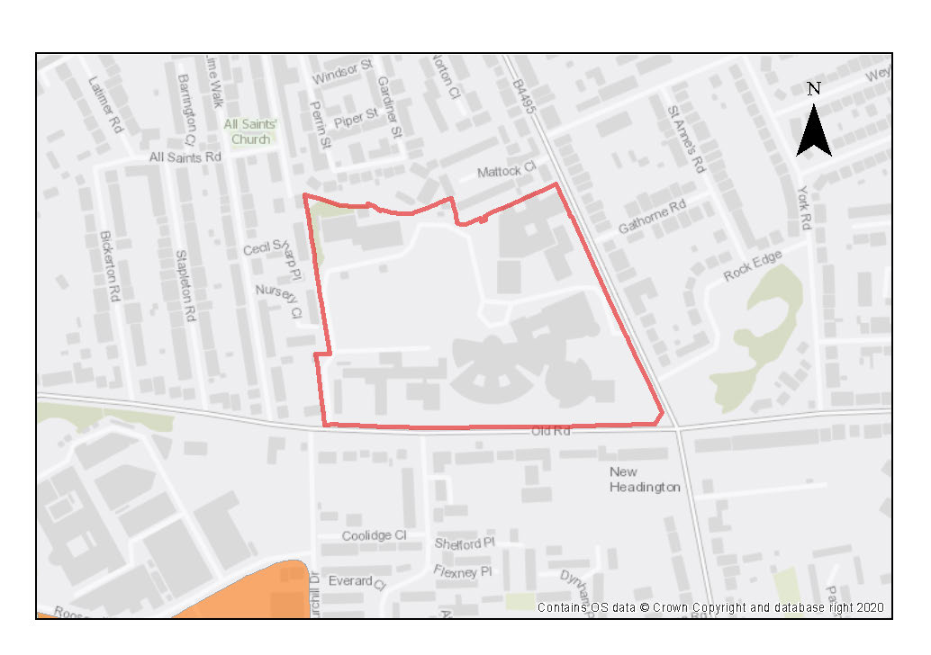

The Nuffield Orthopaedic Centre is a modern hospital and medical research site that forms part of the Oxford University Hospitals NHS Foundation Trust. It has significant roads on two sides (Old Road and Windmill Road) and adjacent residential development to the north and west. Large institutional frontages are set back from the roads, with open space mainly in the centre of the site.

There are opportunities for suitable intensification of use and rationalisation of car parking surfaces can contribute to a more efficient use of buildings and spaces. It would be beneficial to develop a masterplan to arrange different uses onsite including hospital, research and potentially Employer Linked Housing and respond holistically to the unusual plan form of the main buildings.

The site bordered by trees and hedging with good cover along Old Road and the East of the site, with more variable coverage around the remainder. Surface level parking dominates the external areas and there is a minimal level of landscaping. Improvements could include reinforcing treeline and hedging at the sensitive site boundaries to improve privacy and reduce overlooking. The site may be within the catchment area of Lye Valley SSSI, which contains important peat deposits and as a result is particularly sensitive to impacts to groundwater flows and other changes to hydrology. The site is also directly opposite the Rock Edge SSSI, however as it is a geological site there are no direct impacts expected from development on this site.

Preliminary analysis suggests that the limited presence of green infrastructure features on the site currently means it is likely to score below the minimum thresholds for green surface cover as required by Policy G3. As such, proposals will need to ensure that an appropriate proportion of green features are incorporated into the design of development to meet the minimum targets set out in the policy, demonstrated through submission of the Urban Greening Factor assessment.

The site is well served by several sustainable and active travel options, including bus routes along Windmill Road, segregated cycle ways and wide pavements. The site is however dominated by car parking. Movement within the site prioritises the car above other modes and is not best suited for those with mobility issues using the bus stop on Windmill Road. Currently the main access is via Windmill Road, with secondary access on Old Road to access research buildings and back of house servicing. Low density development means buildings are spread across the site and there are few direct through routes across the site.

If level of need for car parking is assessed to be not as high as the amount of provision, the car parking could be repurposed for other uses including GI for biodiversity and amenity purposes, SuDS or green corridors/routes through the site.

The site is of archaeological interest as Roman remains have been recorded previously.

Policy SPE7: Nuffield Orthopaedic Centre (NOC)

Planning permission will be granted for further healthcare facilities and medical research including staff and patient facilities at the Nuffield Orthopaedic Centre. Planning permission will also be granted for residential development and extra care accommodation, employer linked affordable housing that supports the main use of the site.

Open Space, Nature and Flood Risk

Policies G1 and G3 require protection of existing green infrastructure features and enhancement of greening on site through the urban greening factor. Policy G5 requires onsite biodiversity enhancement, and Policy G2 requires new Green Infrastructure features and enhancement of existing features. It is expected that those requirements will be met in the following ways. Planning permission will only be granted if it can be demonstrated that there would be no adverse impact upon surface and groundwater flow to the Lye Valley SSSI.

Development proposals should reduce surface water runoff in the area and should be accompanied by an assessment of groundwater and surface water and development proposals must incorporate sustainable drainage with an acceptable management plan (Policies G7 and G8).

Urban Design and Heritage
Policy HD7 requires high quality design and the following sets out key considerations for achieving that on this site. There may be potential for infill development of repurposed surface level parking areas and redevelopment of low-density buildings in the South–Western part of the site. The use of pitched roofs can also help in the transition down in scale from institutional buildings to the residential edge.
Development must take into consideration the potential presence of Roman archaeological remains. Due to this potential, development should demonstrate compliance with Policy HD5.

Movement and Access
Along with the potential for consolidating car parking areas, there may also be opportunities to reduce the overall amount of hard surfacing in favour of increased considered landscaping and amenity spaces such as pocket parks, or other forms of GI for ecological purposes.
Natural Resources
Due to the site’s proximity to recorded peat reserves, and the potential for further deposits in the area, any development on currently undeveloped parts of the site will only be permitted where it can be demonstrated that there will be no harm or loss of peat deposits in accordance with the requirements of policy R6. This may mean that where there is the potential for causing removal of peat, site layout has been designed accordingly to protect and mitigate any harm to identified peat deposits onsite.
Because of the use as a hospital some areas of potential contamination are present on the site, so site investigation will be required, and remedial works are likely to be necessary (Policy R5).

Warneford Hospital

Site area: 8.78 hectares
Ward: Churchill
Landowner: Oxford Health NHS Foundation Trust
Current use: Hospital, research, playing fields
Flood Zone: FZ1

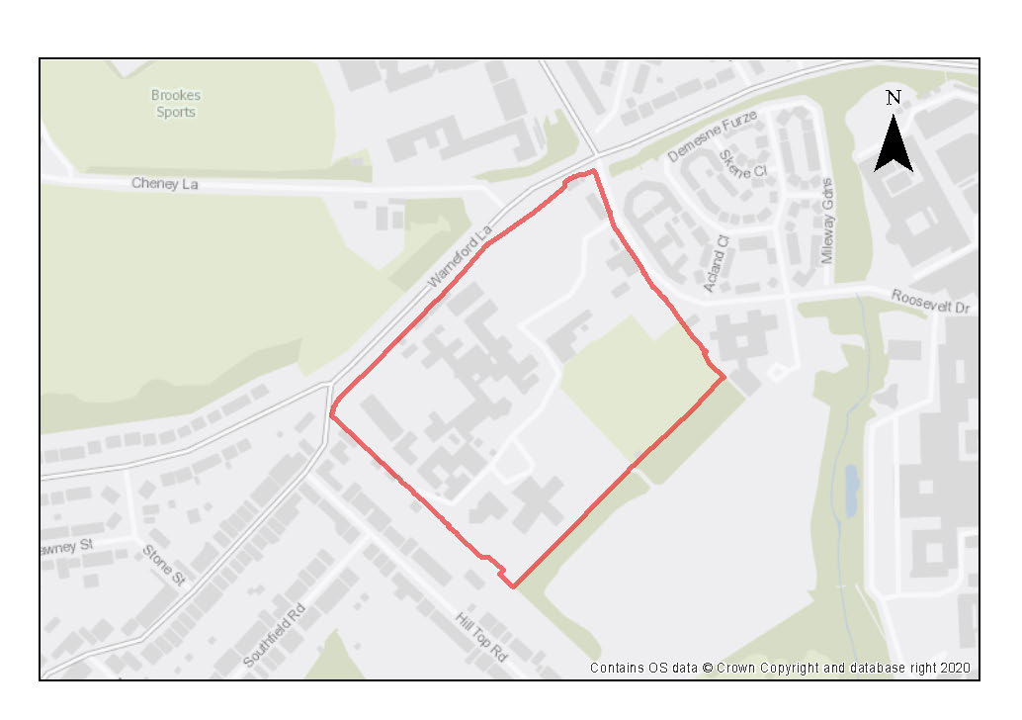

The hospital is run by the Oxford Health NHS Trust and provides mental health services. The main hospital building from the late 19th century was built in the style of a country house set in parkland. Over time, various annexes and self-contained buildings accommodating specialist units and research facilities have been built, making up the complex. The site location lies adjacent to the Headington Hill CA. A masterplan holistic approach to redevelopment would help address the complexities of this site.

Stone boundary walls are features of the public realm, enclosing private spaces. 6 structures on the site are Grade II listed, with the main hospital building, ancillary annexes (mortuary, nurse’s home, and chapel), front garden wall including lodge and piers, being included within the listing. Building heights are relatively low across the site, around 2 to 3 storeys, including the later additions.

Roosevelt Drive is main access route into the site. Warneford Lane runs along northern boundary but there is no access from it. The boundary wall and piers are at least partially covered by the listing so creating additional access points will be difficult to deliver. Generally, car movement is prioritised through the site with areas dedicated to car parking, however, the site is accessible by sustainable and active travel options. There is therefore potential to rethink the layout of the grounds to enhance non-vehicular movement through the site by introducing measures such as dedicated foot and cycle paths and connections, and reducing the priority given to cars and other vehicles.

The site sits between two green corridors and comprises of open fields within which the buildings are set, with several mature trees, lawns and hedges, and a sizable playing field. The overall effect is that of a green backdrop and open character than blends the site into the surrounding landscape. The hospital directly adjoins a number of designated ecological sites and parts of the green infrastructure network, including the Warneford Meadows. Proposals should include an assessment of what connectivity the site provides to protected species and seek to preserve and enhance existing permeability through the site. The site lies within the catchment area of Lye Valley SSSI, which contains important peat deposits and as a result is particularly sensitive to impacts to groundwater flows and other changes to hydrology.

Preliminary analysis suggests that the presence of various green infrastructure features on the site at present means it is likely to score above the minimum thresholds for green surface cover as required by Policy G3; as such proposals will need to ensure that this score is retained (no net loss), demonstrated through submission of the Urban Greening Factor assessment. New development on the site will need to consider how existing green features, particularly higher scoring elements, can be retained such as the mature trees. Sufficient replacements will need to be incorporated into the new design, or enhancement of existing green infrastructure that is being retained, in order to preserve the baseline UGF score as a minimum.

The site is of archaeological interest for potential Roman remains. This will require further investigation as part of any redevelopment.

Policy SPE8: Warneford Hospital

Planning permission will be granted for healthcare facilities and related uses at Warneford Hospital, any of the following complementary uses:
- extra care accommodation
- residential development, including employer-linked affordable housing and student accommodation,
- employment uses that have an operational link to the hospital;
- additional academic institutional and education uses subject to compliance with relevant local plan policies.

Other complementary uses will be considered on their merits.

Open space, nature and flood risk

Policies G1 and G3 require protection of existing green infrastructure features and enhancement of greening on site through the urban greening factor. Policy G5 requires onsite biodiversity enhancement, and Policy G2 requires new Green Infrastructure features and enhancement of existing features. It is expected that those requirements will be met in the following ways. Planning permission will only be granted if it can be demonstrated that there would be no adverse impact upon surface and groundwater flow to the Lye Valley SSSI.

Development proposals should reduce surface water runoff in the area and should be accompanied by an assessment of groundwater and surface water. Development proposals must incorporate sustainable drainage with an acceptable management
plan.

The existing trees and green boundaries are important features that should be retained. Opportunities should be explored for more considered landscaping with a greater variation of planting and natural surface covers to bring ecological enhancements onto the site and to make the most of the green setting. The creation of more amenity spaces that make use of the green setting and are easy to access on foot would be a positive addition. Proposals should also integrate SuDS to mitigate surface water flows and impacts on nearby ecological sites.

Development proposals affecting the playing fields will be expected to mitigate any harm or loss in accordance with the requirements of Local Plan Policy G1.

Urban design and heritage
Policy HD7 requires high quality design and the following sets out key considerations for achieving that on this site. Developers are encouraged to follow a coordinated masterplan approach for the site to encourage holistic development and avoid a situation where proposals coming forward in a piecemeal way.
The open, green character of the site, and setting of listed structures should inform the design of proposals. A generous setback from the rear of properties on Hill Top Road must be retained. To minimise loss of openness on the site, further development could be focussed in the first instance towards the rear of the hospital block with redevelopment of non-listed poorer quality buildings. The most appropriate approach will incorporate green gaps between buildings of relatively low height and limited scale. Development proposals must retain the listed buildings and be designed with consideration of their impact on the setting of the listed buildings, the broader landscape and the adjoining Headington Hill Conservation Area. Proposals must demonstrate compliance with policies HD1 and HD2.
Development proposals must also take into consideration the potential presence of Roman archaeological remains. Due to this potential, development should demonstrate compliance with Policy HD5.

Movement and access
If the current levels of car parking are assessed as not being required, there may be opportunities for some consolidation and any freed-up site area may be repurposed for considered landscaping and more space for pedestrian use, or development. Applicants will be expected to demonstrate how the development mitigates against traffic impacts and maximises access by alternative means of transport.

Natural resources
Due to the site’s proximity to recorded peat reserves associated with the Lye Valley, and the potential for further deposits in the area, any development on currently undeveloped parts of the site will only be permitted where it can be demonstrated that there will be no harm or loss of peat deposits in accordance with the requirements of policy R6. This may mean that where there is the potential for causing removal of peat, site layout has been designed accordingly to protect and mitigate any harm to identified peat deposits onsite.

Because of the use as a hospital some areas of potential contamination are present on the site, so site investigation will be required, and remedial works are likely to be necessary (Policy R5).
Development proposals should be accompanied by an assessment of groundwater and surface water and must incorporate sustainable drainage with an acceptable management plan (Policy G8).

East Area site allocation policies outside the Area of Focus
- Bayards Hill Primary School Part Playing Fields
- Hill View Farm
- Land West of Mill Lane
- Marston Paddock
- Manzil Way Resource Centre
- Slade House
- Thornhill Park
- Union Street Car Park
- Jesus and Lincoln College Sports Grounds
- Ruskin College Campus
- Ruskin Field
- John Radcliffe Hospital
- Rectory Centre
Bayards Hill Primary School Part Playing Fields

Site area: 1.04 hectares
Ward: Barton & Sandhills
Landowner: Oxfordshire County Council (Freehold), River Learning Trust (leaseholder)
Current use: School playing field
Flood zone: FZ1

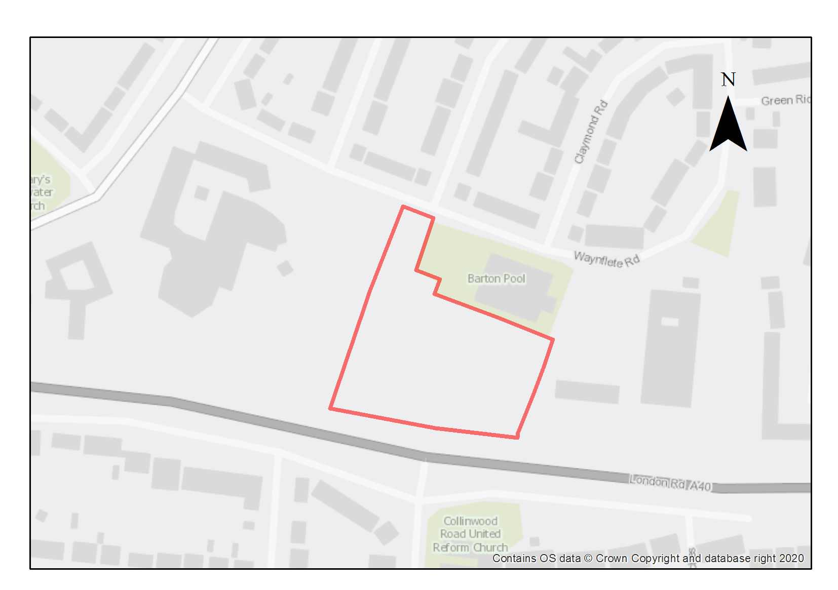

This site is currently used as a school playing field. The eastern part of the playing field adjacent to the Barton Leisure Centre will be released for employer linked housing to be occupied by staff working for the school academy trust. This loss of playing field (excluding the playing pitches) is justified owing to the need for and benefits of providing some employer-linked housing for the employees of the school academy trust though mitigation will need to be provided in line with the requirements of policy G1.

Preliminary analysis suggests that the presence of various green infrastructure features on the site at present means it is likely to score above the minimum thresholds for green surface cover as required by Policy G3; as such proposals will need to ensure that this score is retained (no net loss), demonstrated through submission of the Urban Greening Factor assessment. New development on the site will need to consider how existing green features, particularly higher scoring elements, can be retained and in particular how to introduce an effective landscape screen to differentiate the residential area from the school use. Sufficient replacements will need to be incorporated into the new design, or enhancement of existing green infrastructure that is being retained, in order to preserve the baseline UGF score as a minimum.

This site is of archaeological interest as part of the access road is on the line of the Dorchester-Alchester Roman Road and there is potential for roadside settlement. This will require further investigation as part of any redevelopment.

Site investigation required although significant contamination not considered likely.

Adjustments and considerations at design stage may be helpful in reducing the ongoing impact of poor air quality. Potential options may include considering layout options that place habitable spaces and openings away from pollution sources such as busy roads, landscape buffers, and designing in walking and cycling options as integral part of schemes.

Policy SPE9: Bayards Hill Primary School Part Playing Fields

Planning permission will be granted for employer-linked affordable housing. The minimum number of homes to be delivered is 30. Other complementary uses will be considered on their merits.

The site to be developed at Bayards Hill Primary School is to be a part of the field only and must not encroach upon the playing pitches.

Open space, nature and flood risk
Policies G1 and G3 require protection of existing green infrastructure features and enhancement of greening on site through the urban greening factor. Policy G5 requires onsite biodiversity enhancement, and Policy G2 requires new Green Infrastructure features and enhancement of existing features. It is expected that those requirements will be met in the following ways. The loss of part of the playing field will require reprovision in accordance with Policy G1. Qualitative improvements to remaining areas of greenspace such as enhanced planting should be incorporated in order to maintain baseline UGF score (policy G3). In addition, a landscape scheme must be approved and implemented to show how an effective planting belt can be introduced on to the site to differentiate the residential area from school use.

Urban design and heritage
Development should be sympathetic to the school, providing clear separation and limited overlooking and overbearing. New development must take into consideration the potential presence of Roman archaeological remains. Due to this potential, development should demonstrate compliance with Policy HD5.

Movement and access
Use of the existing access from Waynflete Road into the Barton Leisure Centre Car Park would avoid conflicts with the school use and avoid the need for additional accesses onto surrounding streets. Applicants will be expected to demonstrate how the development enables access by alternative means of transport including improving connectivity to support active travel such as walking and cycling.

Natural resources
The site is in an air quality hot spot area. Development proposals must demonstrate compliance with policy R4 by ensuring that all necessary mitigation measures against poor air quality have been incorporated during the construction and operational phases and ensuring that any potential negative air quality impacts are adequately mitigated on an ongoing basis, within and surrounding the site.

Development proposals must include an acoustic design statement in compliance with Policy R7 as this site is part of an area which is subject to significant environmental noise from traffic on the surrounding roads.

Hill View Farm

Site area: 3.52 hectares
Ward: Marston
Landowner: M K Dogar Limited
Current use: Green field with agricultural buildings
Flood Zone: FZ1

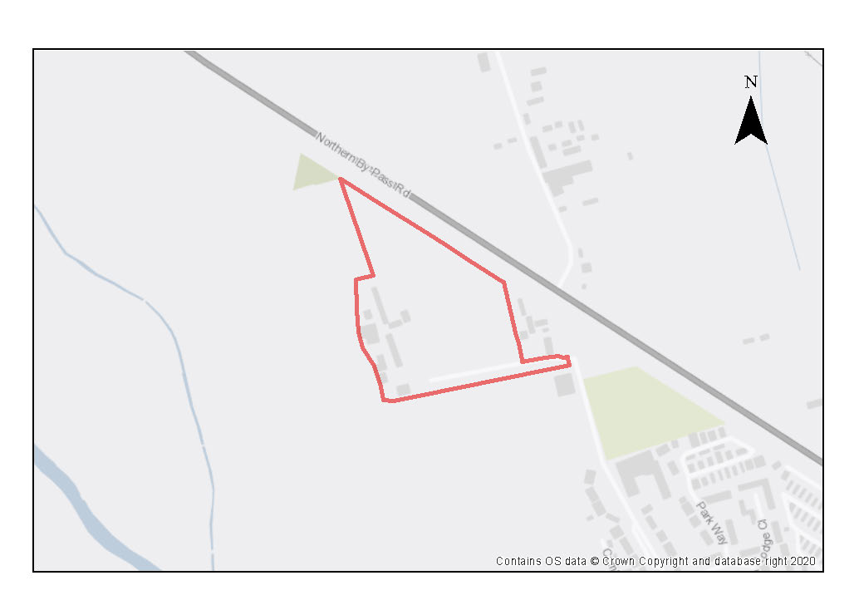

The site is comprised of hedged farmland and riverside meadow with some farm buildings, trees and shrubs and some mown areas. The site adjoins the defined urban edge at its south-eastern corner, on Mill Lane, next to Hill View Farmhouse and an associated property, which are in the Green Belt but outside of the site. The A40 Northern Bypass defines the northeastern edge of the site.

The site was formerly in the Green Belt. There is a slight detachment between the site and the existing urban settlement edge, as allotments form the northern tip of the defined urban area. Site policy SPE11 which adjoins with the southern boundary connects this site with the residential areas to the west of Mill Lane. The openness of the Cherwell Valley, penetrating the heart of Oxford, makes an important contribution to the City’s historic setting and special character, but this parcel is peripheral within that area. The river itself meanders westwards along the edge of Sunnymead, so the parcel is some distance from the valley floor floodplain, but the north-south orientation of the river to the south means that high buildings would still encroach on the perceived openness of the valley.

The site is near to the Old Marston Conservation Area. Careful design will be needed in order to ensure that the setting of the conservation area is conserved and enhanced. Development must be sensitive to both the Green Belt and the character of the Old Marston Conservation Area. Relatively low-density and low height residential development will be required.

The site does not have any biodiversity protections, but the ecological value of the site must be assessed as part of a planning application and any harm avoided, mitigated or compensated for. The hedgerows should be retained as part of the design where possible. 10% of the site will be required for new public open space which should be sited to make existing residents feel welcome to use it.

Preliminary analysis suggests that the presence of various green infrastructure features on the site at present means it is likely to score above the minimum thresholds for green surface cover as required by Policy G3; as such proposals will need to ensure that this score is retained (no net loss), demonstrated through submission of the Urban Greening Factor assessment. New development on the site will need to consider how existing green features, particularly higher scoring elements, can be retained including the mature hedgerows that define the north, north-western and southern edges of the site. Where green elements are proposed to be removed, sufficient replacements will need to be incorporated into the new design, or enhancement of existing green infrastructure that is being retained, in order to preserve the baseline UGF score as a minimum. The site is likely to be able to accommodate the planting of native hedgerows to strengthen the existing boundary treatment and provide enhanced screening of the development. Several trees already exist within the site that should be retained, and where possible additional trees should be planted. Any public open space provided on site should incorporate new trees within its design and link to the existing hedgerows to enable wildlife movement.

Adjustments and considerations at design stage may be helpful in reducing the ongoing impact of poor air quality. Potential options may include considering layout options that place habitable spaces and openings away from pollution sources such as busy roads, landscape buffers, and designing in walking and cycling options as integral part of schemes.

Access to the site will need to be taken from Mill Lane and localised improvements will be required to demonstrate that two vehicles can pass each other along the duration of Mill Lane.

Policy SPE10: Hill View Farm

Planning permission will be granted for residential development at the Hill View Farm site. The minimum number of homes to be delivered is 159. Other complementary uses will be considered on their merits.

Open space, nature and flood risk
A minimum of 10% of the site should be for public open space, which must be sited to also be welcoming to existing communities. Development proposals should encourage active frontages to the new public open space. Gardens with rich planting along boundaries should allow more diverse routes through the site for wildlife, connecting to those existing hedgerows which are to be retained that define the boundary of the site. These measures will be important in achieving no decrease in the Urban Greening Factor baseline score. Compensatory improvements should be made to surrounding areas of remaining Green Belt in accordance with the Identification of Opportunities to Enhance the Beneficial Use of Green Belt Land Report (LUC, 2018).

Urban design and heritage
Development proposals must be designed with consideration of their impact
on the character of the adjoining Conservation Area and the landscape setting and must demonstrate compliance with policy HD1. Development heights must be designed to minimise the effect of encroachment on the perceived openness of the Cherwell Valley.

Movement and access
Access to the site will need to be taken from Mill Lane and localised improvements will be required in order to demonstrate that two vehicles can pass each other along the duration of Mill Lane. Applicants will be expected to demonstrate how the development enables access by alternative means of transport including improving connectivity to support active travel such as walking and cycling.

Natural Resources
The site is located in an air quality hot spot area. Development proposals must demonstrate compliance with policy R4 by ensuring that all necessary mitigation measures against poor air quality have been incorporated during the construction and operational phases and ensuring that any potential negative air quality impacts are adequately mitigated on an ongoing basis, within and surrounding the site.

Development proposals will be required to include an appropriate site contamination investigation and applications will be required to demonstrate how any contamination issues will be resolved (Policy R5).

Development proposals must include an acoustic design statement in compliance with Policy R7 as this site is part of an area which is subject to significant environmental noise from traffic on the A40.

Land West of Mill Lane

Site area: 1.99 hectares
Ward: Marston
Landowner: Oxford City Council
Current use: Agricultural land
Flood Zone: FZ1

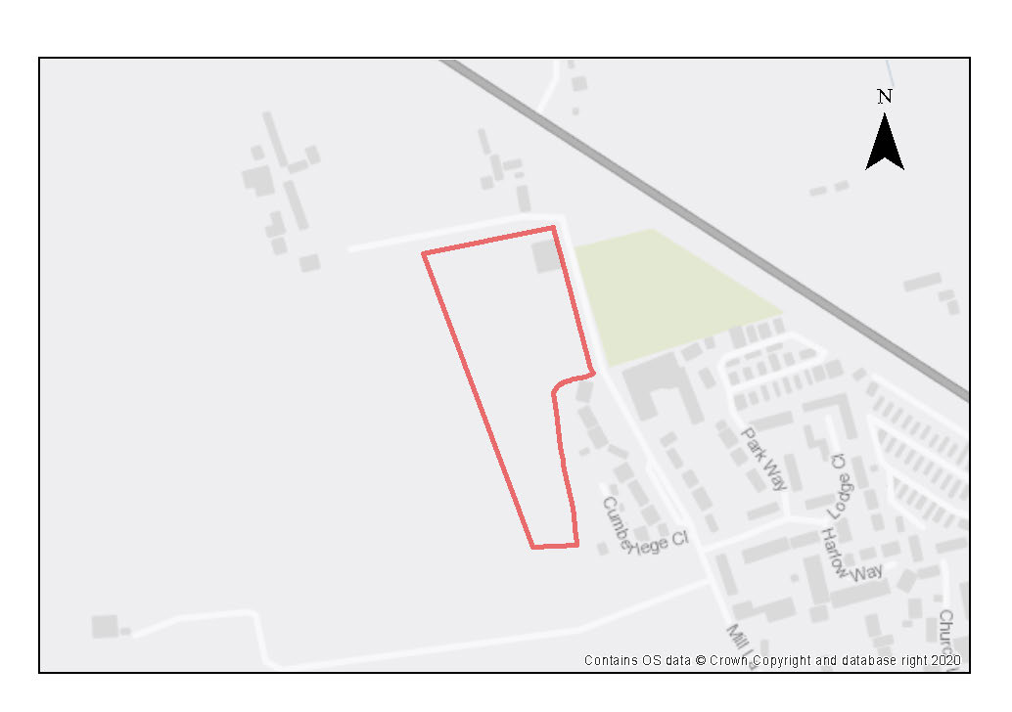

This flat agricultural site is surrounded by mature hedgerows. It adjoins site policy SPE10 to the north and forms part of the rural edge to Old Marston, in close proximity to the Old Marston Conservation Area. Development proposals should have consideration in their design to the setting of the village. The site was formerly within the Green Belt and compensatory improvements should be made to surrounding areas of remaining Green Belt.

The site does not have any biodiversity protections, but the ecological value of the site must be assessed as part of a planning application and any harm avoided or compensated for. The hedgerows should be retained as part of the design where possible. 10% of the site will be required for new public open space which should be sited to make existing residents feel welcome to use it.

Preliminary analysis suggests that the presence of various green infrastructure features on the site at present means it is likely to score above the minimum thresholds for green surface cover as required by Policy G3; as such proposals will need to ensure that this score is retained (no net loss) and demonstrated through submission of the Urban Greening Factor (UGF) assessment. New development on the site will need to consider how existing green features, particularly higher scoring elements, can be retained including the edges of the site. Where green elements are proposed to be removed, sufficient replacements will need to be incorporated into the new design, or enhancement of existing green infrastructure that is being retained, in order to preserve the baseline UGF score as a minimum. The site is likely to be able to accommodate the planting of native hedgerows to strengthen the existing boundary treatment to the western edge of the site and provide enhanced screening of the development. A balancing pond could be provided to the north of this space which could also assist with the SuDS strategy for the site. Substantial new tree planting between the public open space and the frontage of the built form would also be suitable and once mature, would further assist in screening the development in views from the west. Any hedgerows removed to facilitate access to the site should be kept to a minimum and where possible, incorporated elsewhere within the development.

Adjustments and considerations at design stage may be helpful in reducing the ongoing impact of poor air quality. Potential options may include considering layout options that place habitable spaces and openings away from pollution sources such as busy roads, landscape buffers, and designing in walking and cycling options as integral part of schemes.

Localised improvements are likely to be required to Mill Lane in order to demonstrate that two vehicles can pass each other along the duration of Mill Lane. Access improvements will also be required from Mill Lane into the site which is currently only suitable for agricultural vehicles.

Policy SPE11: Land West of Mill Lane

Planning permission will be granted for residential development on the Land West of Mill Lane site. The minimum number of homes to be delivered is 80. Other complementary uses will be considered on their merits.

Open space, nature and flood risk
Policies G1 and G3 require protection of existing green infrastructure features and enhancement of greening on site through the urban greening factor. Policy G5 requires onsite biodiversity enhancement, and Policy G2 requires new Green Infrastructure features and enhancement of existing features. It is expected that those requirements will be met in the following ways. A minimum of 10% of the site should be for public open space which should be accessible for existing residents of Marston. The development should be designed to ensure active frontages face onto the open space. Gardens with rich planting along boundaries should allow more diverse routes through the site for wildlife, connecting to those existing hedgerows which are to be retained that define the boundary of the site. Native tree planting could also be incorporated within the open space as these measures will be important in achieving no decrease in the Urban Greening Factor baseline score. Compensatory improvements should be made to surrounding areas of remaining Green Belt in accordance with the Identification of Opportunities to Enhance the Beneficial Use of Green Belt Land Report (LUC, 2018).

Urban design and heritage
Development proposals must be designed with consideration of their impact
on the character of the adjoining Conservation Area and the landscape setting and must demonstrate compliance with policy HD1. Development heights must be designed to minimise the effect of encroachment on the perceived openness of the Cherwell Valley.

Movement and access
Access to the site will be from Mill Lane and localised improvements will be required in order to demonstrate that two vehicles can pass each other along the duration of Mill Lane. Applicants will be expected to demonstrate how the development enables access by alternative means of transport including improving connectivity to support active travel such as walking and cycling.

Natural resources
The site is located in an air quality hot spot area. Development proposals must demonstrate compliance with policy R4 by ensuring that all necessary mitigation measures against poor air quality have been incorporated during the construction and operational phases and ensuring that any potential negative air quality impacts are adequately mitigated on an ongoing basis, within and surrounding the site.

Development proposals must include an acoustic design statement in compliance with Policy R7 as this site is part of an area which is subject to significant environmental noise from traffic on the A40.

Development proposals will be required to include an appropriate site contamination investigation and applications will be required to demonstrate how any contamination issues will be resolved (Policy R5).

Marston Paddock

Site area: 0.78 hectares
Ward: Marston
Landowner: Aubrey-Fletcher
Current use: Paddock land
Flood Zone: FZ1

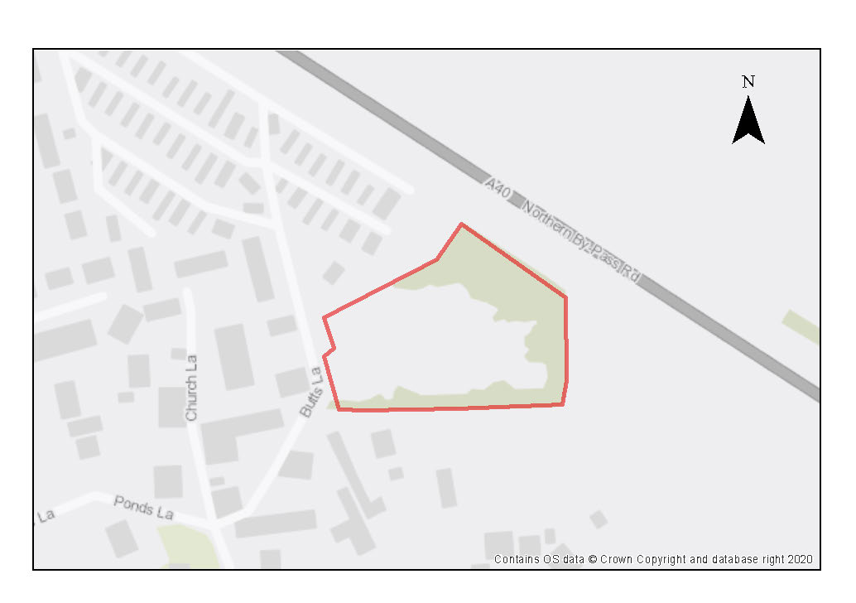

The site is comprised of a single pasture field with several trees and shrubs and well-treed hedgerows to the east and north. The current urban edge is defined by the residential park home site to the north. The site is a contained flat site with a small area of woodland containing mature trees and hedgerows located in the northeast corner of the site. The site was formerly Green Belt land.

The site is on the edge of Marston village adjacent to existing residential properties and the Old Marston Conservation Area. Low density residential development is possible without harm to the conservation area. Careful design will be needed in order to ensure that the setting of the conservation area is conserved and enhanced. 10% of the site will be required for new public open space which should be sited to make existing residents feel welcome to use it.

Preliminary analysis suggests that the presence of various green infrastructure features on the site at present means it is likely to score above the minimum thresholds for green surface cover as required by Policy G3; as such proposals will need to ensure that this score is retained (no net loss), demonstrated through submission of the Urban Greening Factor assessment. New development on the site will need to consider how existing green features, particularly higher scoring elements, can be retained including the small, wooded area to the northeast of the site. Where green elements are proposed to be removed, sufficient replacements will need to be incorporated into the new design, or enhancement of existing green infrastructure that is being retained, in order to preserve the baseline UGF score as a minimum. The site is likely to be able to accommodate a considerable amount of new native tree planting to compensate for the loss of those trees removed and the wooded area to the northeast can be further strengthened through additional tree planting which would also enable wildlife movement.

Adjustments and considerations at design stage may be helpful in reducing the ongoing impact of poor air quality. Potential options may include considering layout options that place habitable spaces and openings away from pollution sources such as busy roads, landscape buffers, and designing in walking and cycling options as integral part of schemes.

Access to the site is via Butts Lane and Church Lane, which are of single carriageway width. Proposals for the development of this site would need to demonstrate that access arrangements would not be detrimental to highway safety.

Policy SPE12: Marston Paddock

Planning permission will be granted for residential development at the Marston Paddock site. The minimum number of homes to be delivered is 40. Other complementary uses will be considered on their merits.

Open space, nature and flood risk
Policies G1 and G3 require protection of existing green infrastructure features and enhancement of greening on site through the urban greening factor. Policy G5 requires onsite biodiversity enhancement, and Policy G2 requires new Green Infrastructure features and enhancement of existing features. It is expected that those requirements will be met in the following ways. A minimum of 10% of the site should be for public open space, which should be accessible for existing residents of Marston. The development should be designed to ensure active frontages face onto the open space. Gardens with rich planting along boundaries should allow more diverse routes through the site for wildlife, connecting to the wooded area to the northeast of the site to the new open space. Native tree planting could also be incorporated within the open space and existing wooded area, as these measures will be important in achieving no decrease in the Urban Greening Factor baseline score. Compensatory improvements should be made to surrounding areas of remaining Green Belt in accordance with the Identification of Opportunities to Enhance the Beneficial Use of Green Belt Land Report (LUC, 2018).

Urban design and heritage
Development proposals must be designed with consideration of their impacts on the landscape setting and the character of the Old Marston Conservation Area and must demonstrate compliance with policy HD1.

Movement and access
Development proposals for this site must demonstrate that access arrangements would not be detrimental to highway safety. Applicants will be expected to demonstrate how the development enables access by alternative means of transport including improving connectivity to support active travel such as walking and cycling.

Natural resources
Development proposals will be required to include an appropriate site contamination investigation and applications will be required to demonstrate how contamination issues will be resolved (Policy R5).

The site is in an air quality hot spot area. Development proposals must demonstrate compliance with policy R4 by ensuring that all necessary mitigation measures against poor air quality have been incorporated during the construction and operational phases and ensuring that any potential negative air quality impacts are adequately mitigated on an ongoing basis, within and surrounding the site.

Development proposals must include an acoustic design statement in compliance with Policy R7 as this site is part of an area which is subject to significant environmental noise from the traffic using the A40.

Manzil Way Resource Centre

Site area: 0.75 hectares
Ward: St Clement’s
Landowner: Oxford City Council
Current use: Healthcare, offices, flats
Flood Zone: FZ1

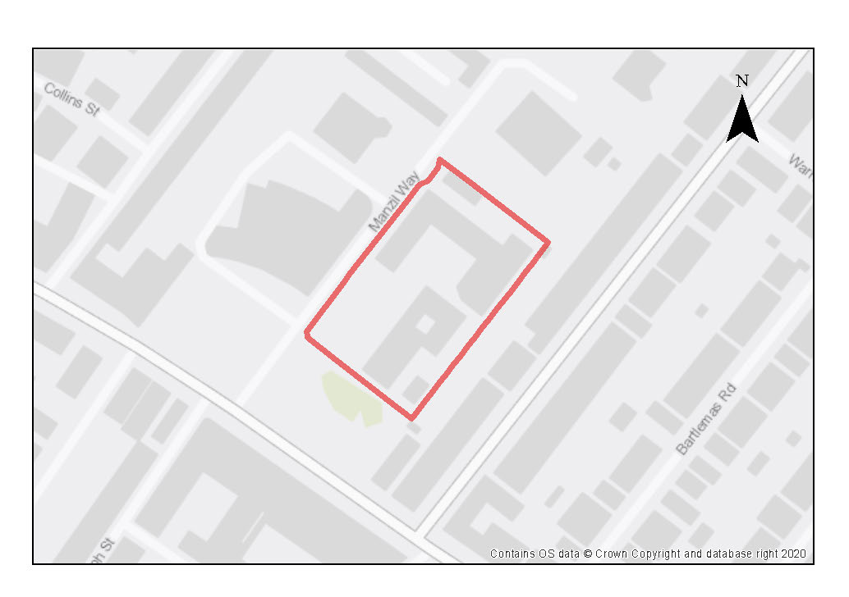

The site is located within Cowley Road district centre with very good access to shops, services, and bus routes. It comprises health centre, offices, and nurses’ accommodation, with car parking and small areas of grass and trees.

This site is a suitable site for a healthcare facility or for residential development. As one of only a few sites owned by the Oxford Health NHS Foundation Trust, it is also an opportunity for them to develop employer-linked affordable housing on the site.

There is potential for the existing buildings, which are fairly modern, to be converted to residential use, or if the site is redeveloped more comprehensively, then the proximity of existing surrounding residential uses will require considerate design of heights and orientation of plots to avoid overlooking or overbearing or impacts on the View Cone.

Given the location in the district centre and within a CPZ any additional residential development could be car free.

Any redevelopment should respond to the opportunities of the adjoining Manzil Gardens public open space, and also support enhancements to Manzil Way to become a high-quality spine from which numerous community-focussed buildings are accessed (the health centre, Mosque and Asian Culture Centre, and the community garden cafe).

Preliminary analysis suggests that the limited presence of green infrastructure features on the site currently means it is likely to score below the minimum thresholds for green surface cover as required by Policy G3. As such, proposals will need to ensure that an appropriate proportion of green features are incorporated into the design of development to meet the minimum targets set out in the policy, demonstrated through submission of the Urban Greening Factor assessment.

Policy SPE13: Manzil Way Resource Centre

Planning permission will be granted for improved health-care facilities, associated administration and/or residential development, including employer-linked affordable housing, at the Manzil Way Resource Centre site.

Other complementary uses will be considered on their merits.

Open space, nature and flood risk
Development proposals should include urban greening on the site and opportunities to introduce more tree and shrub planting.

Urban design and heritage
Development should respond to the opportunities of the adjoining Manzil Gardens public open space, and support enhancements to Manzil Way to become a high-quality spine from which numerous community-focussed buildings are accessed (the health centre, Mosque and Asian Culture Centre, and the community garden cafe). Development proposals must be designed with consideration of their impacts on the protected view in accordance with policy HD9.

Movement and access
Access should continue to be from Manzil Way. The site is small so circulation around it to allow safe turning for vehicles that does not conflict with pedestrian and cycle use will need careful consideration. Applicants will be expected to demonstrate how the development enables access by alternative means of transport including improving connectivity to support active travel such as walking and cycling.

Nature and resources
Because of the previous use of the site some potential contamination may be present on the site, so site investigation will be required, and remedial works are likely to be necessary in compliance with Policy R5.

Slade House

Site area: 1.68 hectares
Ward: Churchill
Landowner: Oxford Health NHS Foundation Trust
Current use: Offices, training, and adult day care
Flood Zone: FZ1

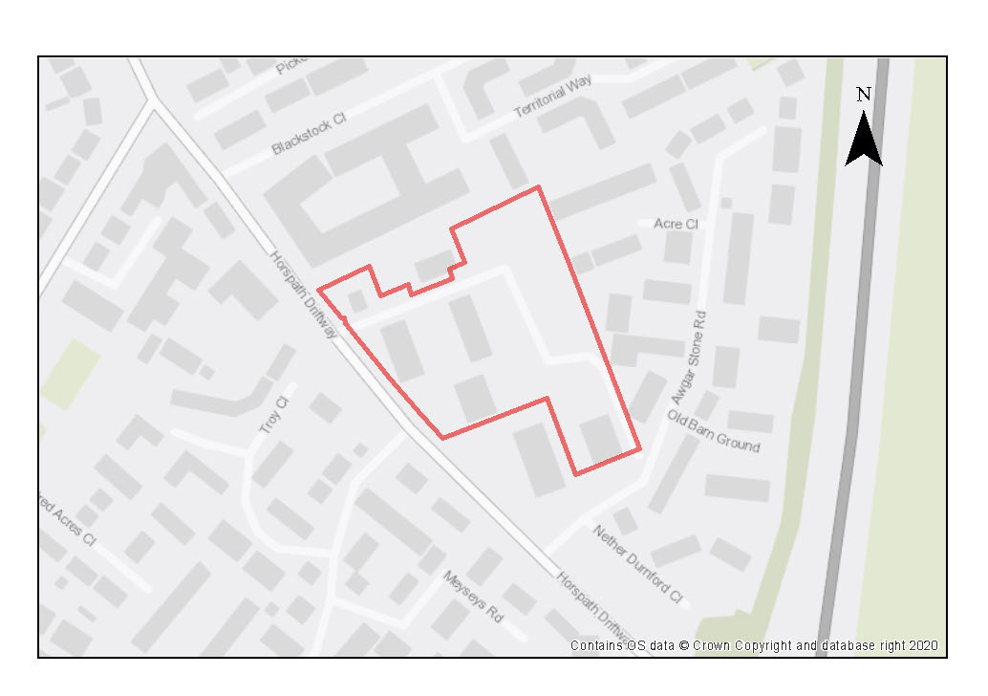

The site contains multiple healthcare-related buildings (including Slade House, Abell House and Maple House, and an adult day care centre) plus staff training and office accommodation, and several parking areas. A number of buildings on the site are currently vacant.

Site is suitable for healthcare facilities or for residential development: As this site is one of only a few sites owned by the Oxford Health NHS Foundation Trust, it also presents an opportunity for them to develop employer-linked housing on the site.

There are a number of biodiversity constraints affecting the site: The site is in close proximity to the Shotover and Brasenose Wood SSSI, which is sensitive to recreational pressure, so proposals will need to demonstrate no adverse impact from recreational pressure or groundwater/surface water flows to the SSSI. It is also in the vicinity of the Lye Valley SSSI, which contains important peat deposits and as a result is particularly sensitive to impacts to groundwater flows and other changes to hydrology. This would need to be established as part of the planning application process

A TPO applies across the whole site, which protects the mature trees across the site and around the boundaries so the plots and layout will need to respond to this. There are also opportunities from the mature trees and hedgerows on the north, west and southern boundaries to help wildlife corridors, provide privacy for occupiers, and ameliorate noise/pollution from the ring road.

Preliminary analysis suggests that the limited presence of green infrastructure features on the site currently means it is likely to score below the minimum thresholds for green surface cover as required by Policy G3. There are several parcels of existing green space on the site as well as other green features like mature trees and hedges which any new development ought to accommodate into the design. Play space and pockets of biodiverse planting could be included to enhance the setting and help achieve the minimum UGF target. The green spaces to the east/centre of site could be enhanced to accommodate more biodiverse species/wild areas or potentially some play equipment. Hedges and other natural features should be incorporated wherever possible, particularly where new boundaries/fencing is considered. Opportunities to introduce pockets of wilder/biodiverse patches would enhance the natural feel of the site.

Reduction in hard surfacing could be used for communal amenity space and SuDS could be incorporated into the site to help reduce the risk of surface water flooding and further enhance the natural character of the site.

Buildings on the site are 1-3 storeys and are residential in scale and character, having been used primarily for mental health residential care. There is potential to retain the larger 3-storey buildings on the site and convert them to residential use, alongside new development on the site to make more efficient use of the site.

Access to the site is from Horspath Driftway then First Avenue. There are good sustainable transport links by bus and cycle, with potential to bring cycle routes through the site. In addition, there is potential for additional access via Awgar Stone Road which could be explored.

Adjustments and considerations at design stage may be helpful in reducing the ongoing impact of poor air quality. Potential options may include considering layout options that place habitable spaces and openings away from pollution sources such as busy roads, landscape buffers, and designing in walking and cycling options as integral part of schemes.

Policy SPE14: Slade House

Planning permission will be granted at the Slade House site for improved health-care facilities, associated administration, and/or residential development, including employer-linked affordable housing.

Other complementary uses will be considered on their merits.

Open space, nature and flood risk
Policies G1 and G3 require protection of existing green infrastructure features and enhancement of greening on site through the urban greening factor. Policy G5 requires onsite biodiversity enhancement, and Policy G2 requires new Green Infrastructure features and enhancement of existing features. It is expected that those requirements will be met in the following ways. Planning permission will only be granted if it can be demonstrated that there would be no adverse impact upon surface and groundwater flow to the Lye Valley SSSI.

Development proposals should reduce surface water runoff in the area and should be accompanied by an assessment of groundwater and surface water. Development proposals must incorporate sustainable drainage with an acceptable management
plan.

Planning permission will only be granted if it can be demonstrated that there would be no adverse impact on the integrity of the Brasenose and Shotover Park SSSI.

Development proposals must be accompanied by an assessment of potential recreational pressure on the SSSI that may arise from increased numbers of visitors, along with plans to mitigate this impact as necessary.

Proposals will need to ensure that an appropriate proportion of green features are incorporated into the design of development to meet the minimum targets set out in the Policy G3.

A Tree Protection order applies across the whole site, meaning all trees on site must protected in any redevelopment of the site. The design of any redevelopment should be led by the presence of the trees on the site and be prepared in a way that these would be retained.

Movement and access
Active travel should be promoted in this site and opportunities taken to improve connectivity both to and through the site for pedestrians and cyclists.

Natural resources
The site is in an air quality hot spot area. Development proposals must demonstrate compliance with policy R4 by ensuring that all necessary mitigation measures against poor air quality have been incorporated during the construction and operational phases and ensuring that any potential negative air quality impacts are adequately mitigated on an ongoing basis, within and surrounding the site.

Development proposals will be required to include an appropriate site contamination investigation and applications will be required to demonstrate how any contamination issues will be resolved in compliance with Policy R5.

Due to the site’s proximity to recorded peat reserves associated with the Lye Valley, and the potential for further deposits in the area, any development on currently undeveloped parts of the site will only be permitted where it can be demonstrated that there will be no harm or loss of peat deposits in accordance with the requirements of policy R6. This may mean that where there is the potential for causing removal of peat, site layout has been designed accordingly to protect and mitigate any harm to identified peat deposits onsite.

Development proposals must include an acoustic design statement in compliance with Policy R7 as this site is part of an area which is subject to significant environmental noise from traffic using the Oxford ring road/Eastern bypass.

Thornhill Park

Site area: 3.39 hectares
Ward: Barton and Sandhills
Landowner: Shaviram Group
Current use: Residential, car parking and a sports ground.
Flood Zone: FZ1

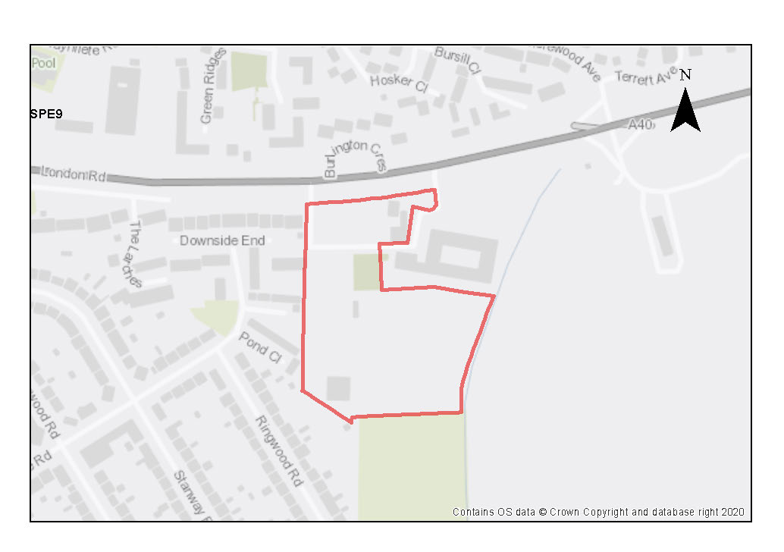

This site lies on the south-side of the A40 London Road in Headington, next to the predominantly residential areas of Risinghurst and Sandhills. The site is well served by local bus services and cycle routes that lead into the city centre. The Thornhill Park and Ride is situated to the east of this site. The site is accessed from the London Road.

The site was formerly in employment use occupied by A C Nielsen. The main office buildings fronting London Road have since benefited from a prior approval for conversion from offices to residential, which has now been completed and comprises 134 residential units. There are some ancillary buildings on the site associated with the former use, together with a car parking area and a sports ground. This site allocation is for the remaining wider site and excludes the former office building as that development has already completed.

A planning application (21/01695/FUL) was submitted in July 2021 for the erection of 402 apartments (Class C3), 133 bed hotel (Class C1) and employment provision in the form of offices, café and restaurant (Class E), which was approved in principle in December 2022 subject to a section 106 legal agreement.

A previous study has shown that the site is of particular value to wildlife and contains great crested newts and multiple bat roosts. Although this site is not designated it lies close to the CS Lewis Nature Reserve, and as such, recreational impacts from new development will need to be assessed and appropriate mitigation measures implemented where necessary to preserve the nature reserve.
Preliminary analysis suggests that the presence of various green infrastructure features on the site at present means it is likely to score above the minimum thresholds for green surface cover as required by Policy G3; as such proposals will need to ensure that this score is retained (no net loss), demonstrated through submission of the Urban Greening Factor assessment. New development on the site will need to consider how existing green features, particularly higher scoring elements can be retained, such as the larger mature trees, particularly those along the boundaries of the A40 which will also help with buffering the site. Sufficient replacements will need to be incorporated into the new design, or enhancement of existing green infrastructure that is being retained, including reducing artificial surface cover in order to preserve the baseline UGF score as a minimum.

There is the potential for land contamination on the site due to previous uses and as such proposals will need to be informed by appropriate assessment to identify risks and any required remediation. The site is also located in an air quality hotspot area and as such, proposals will need to consider the impacts of air pollution on occupants, as well as potential for worsening air quality, and incorporate sufficient mitigation measures in line with policy R4.

Adjustments and considerations at design stage may be helpful in reducing the ongoing impact of poor air quality. Potential options may include considering layout options that place habitable spaces and openings away from pollution sources such as busy roads, landscape buffers, and designing in walking and cycling options as integral part of schemes.

Policy SPE15: Thornhill Park

Planning permission will be granted for a residential-led mixed use redevelopment on the remainder of the Thornhill Park site, which should include some employment use (offices Class E). Other complementary uses could include a café, restaurant, gym, hotel. The minimum number of new homes to be delivered is 402.

Open space, nature and flood risk
Policies G1 and G3 require protection of existing green infrastructure features and enhancement of greening on site through the urban greening factor. Policy G5 requires onsite biodiversity enhancement, and Policy G2 requires new Green Infrastructure features and enhancement of existing features. It is expected that those requirements will be met in the following ways. The existing playing field must be retained unless its loss can be otherwise compensated for in line with policy requirements. If an alternative site is found the City Council must be satisfied that it will be delivered.

Proposals for development will need to be informed by an updated ecological assessment to confirm previous findings in relation to biodiversity and consider potential for known species of interest (great crested newts and bats) as well as other species including reptiles, nesting birds and badgers. Recreational impacts on the CS Lewis Nature Reserve should be assessed and mitigation measures included, if necessary.

Opportunities exist to reduce the overall amount of hard surfacing in favour of increased natural landscaping. Existing mature trees should be retained where possible as with other high-quality GI in order to preserve the base line UGF score. Layout should incorporate a network of amenity spaces such as pocket parks, or other forms of GI that provide linear connections across the site particularly where this can assist with movement of wildlife.
Urban design and heritage
Development proposals that exceed the height that the High Buildings TAN states may have an impact on the historic core will be required to provide extensive information so that the full impacts can be understood and assessed as listed in Policy HD9. New development should respect design sensitivities particularly in the southern part of the site which is likely to have a visual impact on the countryside (Policy HD1).

Movement and access
Active travel should be promoted in this site and opportunities taken to improve connectivity both to and within the site for pedestrians and cyclists and to connect through to neighbouring areas.

Natural resources

The site is in an air quality hot spot area. Development proposals must demonstrate compliance with policy R4 by ensuring that all necessary mitigation measures against poor air quality have been incorporated during the construction and operational phases and ensuring that any potential negative air quality impacts are adequately mitigated on an ongoing basis, within and surrounding the site.

Extensive site investigation works have been completed over parts of the site already, however a contamination investigation would be required in other areas due to its previous use and potential contamination risks, and an application must demonstrate how contamination issues will be resolved (Policy R5).

Development proposals must include an acoustic design statement in compliance with Policy R7 as this site is part of an area which is subject to significant environmental noise from the traffic on the A40.

Union Street Car Park and 159-161 Cowley Road

Site area: 0.47 hectares
Ward: St Clement’s
Landowner: Oxford City Council
Current use: Car park
Flood Zone: FZ1

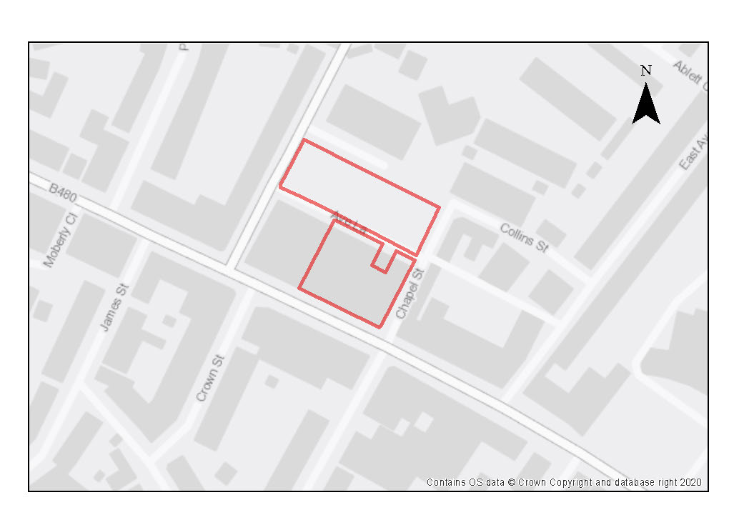

This site is within the busy Cowley Road District Centre which has a variety of uses including those with active frontages such as retail, cafés and restaurants, as well as residential and student accommodation. Part of the site includes the Tesco Express (159-161 Cowley Road) which has been redeveloped for student accommodation and the reconfiguration of the supermarket which remains on the ground floor. This provides active retail frontage on the Cowley Road.

There is further capacity on the site but any proposed scheme would need to consider design owing to the proximity of surrounding buildings and future car parking needs in the district centre as well impact on the protected View Cone across the site. Sufficient car parking spaces should be retained at a level at which the City Council considers is reasonable to serve and safeguard the vitality of the local area bearing in mind the quality of public transport to the area and the current level of usage of the car park. Supporting information justifying the proposed level of car parking spaces should accompany any application. The retained car parking could be in a different form such as beneath ground level (undercroft), decking or surface level with buildings above.

Preliminary analysis suggests that the limited presence of green infrastructure features on the site currently means it is likely to score below the minimum thresholds for green surface cover as required by Policy G3. As such, proposals will need to ensure that an appropriate proportion of green features are incorporated into the design of development to meet the minimum targets set out in the policy, demonstrated through submission of the Urban Greening Factor assessment.

Whilst overall proportion of green infrastructure on the site does not currently meet the target score required in policy G3, this site contains significant existing trees along the northern (row of mature lime trees) and southern boundaries (an over- mature cherry and several young trees) of the car park which are important to public amenity in the area and will provide valuable ecosystem services. Existing trees will influence the developable area of site and its capacity. The quality of all existing trees should be assessed against the criteria in table 1 of BS5837:2012 (or its latest iteration). High quality trees must be retained unless there is a robust over-riding policy-based justification. Moderate and low-quality trees should be retained where it is feasible to do so. Opportunities exist to plant new trees along the Union Street and Chapel Street frontages to benefit the quality of the street scenes.

This site is of archaeological interest as is within the general area of a poorly understood Civil War parliamentary siege line. There is also potential for prehistoric, Roman and medieval archaeology. These will require further investigation as part of any redevelopment.

Policy SPE16: Union Street Car Park and 159 –161 Cowley Road

Planning permission will be granted for residential development or student accommodation, and car parking at Union Street Car Park and 159-161 Cowley Road. The minimum number of residential homes to be delivered is 20 (or, if delivered as student accommodation, the number of rooms that equate to this when the relevant ratio is applied). Other complementary uses will be considered on their merits.

Open space, nature and flood risk
Policies G1 and G3 require protection of existing green infrastructure features and enhancement of greening on site through the urban greening factor. Policy G5 requires onsite biodiversity enhancement, and Policy G2 requires new Green Infrastructure features and enhancement of existing features. It is expected that those requirements will be met in the following ways. Opportunities should be sought to reduce the overall amount of hard surfacing in favour of increased natural landscaping. Existing mature trees along the northern and southern boundaries should be retained where possible. There is an opportunity to plant new trees as part of any new development along the Union Street and Chapel Street frontages to benefit the quality of the street scenes.
Urban design and heritage
It is expected that the requirements for high quality design set out in Policy HD1 will be met in the following ways. Development proposals must consider the proximity of surrounding building and the car parking provision to ensure a comprehensive scheme is achieved and in balance with the redevelopment above the existing supermarket fronting the Cowley Road. Development proposals must also be designed with consideration of their impacts on the protected view in accordance with policy HD9.

Development proposals must take into consideration the potential presence of archaeological remains related to the Civil War Parliamentarian Siege line and also potential prehistoric, Roman or medieval archaeological remains. Due to this potential, development should demonstrate compliance with Policy HD5.
Movement and access
Any residential development/student accommodation delivered on this site should be low car. The City Council will seek to minimise public car parking on the site to a level which is reasonable to serve the area bearing in mind the public transport connections and its location within a District centre. Applicants will be expected to demonstrate how the development enables access by alternative means of transport including improving connectivity to support active travel such as walking and cycling.

Natural resources
Because of the use as a car park, potential contamination is present on the site, so site investigation will be required, and remedial works are likely to be necessary (Policy R5).

Jesus and Lincoln College Sports Grounds

Site area: 5.42 hectares
Ward: Donnington
Landowner: Lincoln College & Jesus College
Current use: Open air sports facility
Flood Zone: FZ1

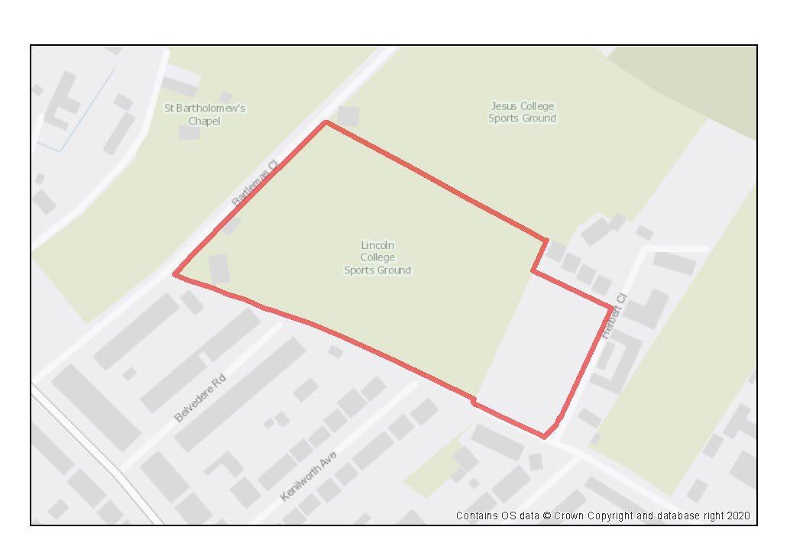

The site is situated to the north-eastern side of Cowley Road, to the north of Barracks Lane and currently consists of two adjoining private open-air sports facilities (for Lincoln College and Jesus College). Access to both Jesus College’s and Lincoln College’s sports facility is taken from Bartlemas Road whilst Jesus College’s existing graduate accommodation and grass tennis courts is accessed from Herbert Close.

There is potential for residential development on the site whilst retaining the sports pitches, on the land around the existing graduate accommodation at Herbert Close and along the eastern edge of the adjacent open-air sports facilities. The potential for residential development on the larger part of the site would depend on the potential to re-provide the sports facilities. This could potential be done on-site through pitch-sharing if the capacity could be re-provided on a smaller area of shared pitch. If the capacity of both pitches could be re-provided elsewhere in the local area this could potentially provide an even larger area, although this would still be significantly constrained because of the need to retain a green setting to Bartlemas and the need to retain a green edge to the wildlife corridor on the northern edge.

The southern part of the site is adjacent to the Bartlemas CA and is within its setting., and also within the setting of the Grade I listed St Bartholomew’s Chapel and Bartlemas House and the Grade II* listed Bartlemas Farmhouse (all located on the eastern side of Bartlemas Close). The southern part of the site also lies partially within the Crescent Road view cone.

Preliminary analysis suggests that the presence of various green infrastructure features on the site at present means it is likely to score above the minimum thresholds for green surface cover as required by Policy G3; as such proposals will need to ensure that this score is retained (no net loss), demonstrated through submission of the Urban Greening Factor (UGF) assessment. New development on the site will need to consider how existing green features, particularly higher scoring elements, can be retained, including the hedgerows and trees on the sites’ boundaries, some of which are protected by Tree Preservation Orders. There is an existing mobile phone mast disguised as a conifer tree within the site that it is likely will need to be retained. Existing trees should be assessed against the criteria in Table 1 of BS5837:2012 (or its latest iteration). Where green elements are proposed to be removed, there must be a robust policy-based justification. Sufficient replacements will need to be incorporated into the new design, or enhancement of existing green infrastructure that is being retained, to preserve the baseline UGF score as a minimum. The site is likely to be able to accommodate enhanced planting and landscape screening along with Sustainable Urban Drainage System features (SuDS).

Policy SPE17: Jesus and Lincoln College Sports Grounds

Planning permission will be granted for residential development (including graduate accommodation) at Jesus College Sports Ground (Playing Field off Bartlemas Close, and Herbert Close sites) and Lincoln College Sports Ground. The minimum number of dwellings to be delivered is 52, which may come forward individually as a minimum of 26 dwellings each on land in the Jesus College and Lincoln College ownerships (or, if delivered as non-self-contained student accommodation, the number of rooms that equate to this when the relevant ratio is applied). Other complementary uses will be considered on their merits.

Open space, nature and flood risk
Policies G1 and G3 require protection of existing green infrastructure features and enhancement of greening on site through the urban greening factor. Policy G5 requires onsite biodiversity enhancement, and Policy G2 requires new Green Infrastructure features and enhancement of existing features. It is expected that those requirements will be met in the following ways. Landscape design should be a fundamental consideration at the earliest design stage, to enhance the contribution that existing trees and hedgerows make to the rural setting of the Bartlemas settlement, listed buildings, and the Bartlemas Conservation Area (CA). Development should result in enhancement of the hedgerow along the southern side of the site and existing trees should be retained as much as possible. The opportunity to enhance existing wildlife corridors and ecological habitats with enhanced planting, screening and landscaping should be taken. SuDS features could be incorporated within the landscaping. This will help to ensure that there is no decrease from the baseline level of the UGF.

Sports provision must be retained. Contributions could be made to improving a local facility such that its capacity increase replaces what is lost at the site; however, no opportunities are evident currently, and in addition a large portion of the site needs to be kept as green open space to maintain a green corridor and the setting of the conservation area. Potentially, if pitches can be shared on the site and still provide the same capacity to meet playing pitch needs, then a larger area of the site could be developed. If all pitch capacity is re-provided off-site, a green area at least the size of one of the existing pitches must be retained on the site to keep its green character and fit with the rural character of the Bartlemas CA and green corridor.

Built development is most suitable adjacent to the existing graduate student accommodation located on Herbert Close and belonging to Jesus College. There should be a significant area of green space left alongside Bartlemas Close to minimise impacts on the Bartlemas CA, and any replacement shared sports facilities should remain alongside Bartlemas Close. In addition, a green corridor needs to be retained in the north of the site to maintain the continuous green network alongside the golf course and towards the Oriel College Sports Ground.

Development should be designed to ensure that there is no adverse impact on the Lye Valley SSSI.

Urban design and heritage
Policy HD7 requires high quality design and the following sets out key considerations for achieving that on this site. Development proposals must be designed with consideration of their impact on views, the rural setting of the Bartlemas settlement, listed buildings and the Bartlemas Conservation Area. Proposals must demonstrate compliance with policies HD1, HD2 and HD9.

The character and materiality of the Bartlemas CA and the Edwardian and Victorian residential streets on the southern side of Barracks Lane should influence the design of new development. This is likely to mean development should be relatively small-scale buildings, irregular building lines and utilise brick and stone materials, especially for boundary treatments. Any development should be designed with buildings of form, massing (roof profiles) height and façade materials that allow the built forms to recede in the backdrop to the view from and across Bartlemas. A graduation of height, lower on the south-western edge and highest in the north-eastern, would respond to the context of the Crescent Road view cone.

Movement and access
The most suitable area of the site for development is around the existing graduate accommodation accessed from Herbert Close and this is the most suitable location for vehicular access, which should be shared with pedestrians and cyclists. Beyond this point, Barracks Lane is only suitable for pedestrians and cyclists. If the playing pitches are shared and more development happens to the northwest, vehicle access may be required from Bartlemas Close, in which case the existing service vehicle access from Bartlemas Close would be most suitable as this would minimise intrusion into the existing treeline along Bartlemas Close. There is also opportunity to increase design options by designing a low or car free scheme. If graduate accommodation comes forward, then parking should only be available for servicing and disabled.

Ruskin College Campus

Site area: 1.86 hectares
Ward: Headington
Landowner: University of West London
Current use: Educational Facilities
Flood Zone: FZ1

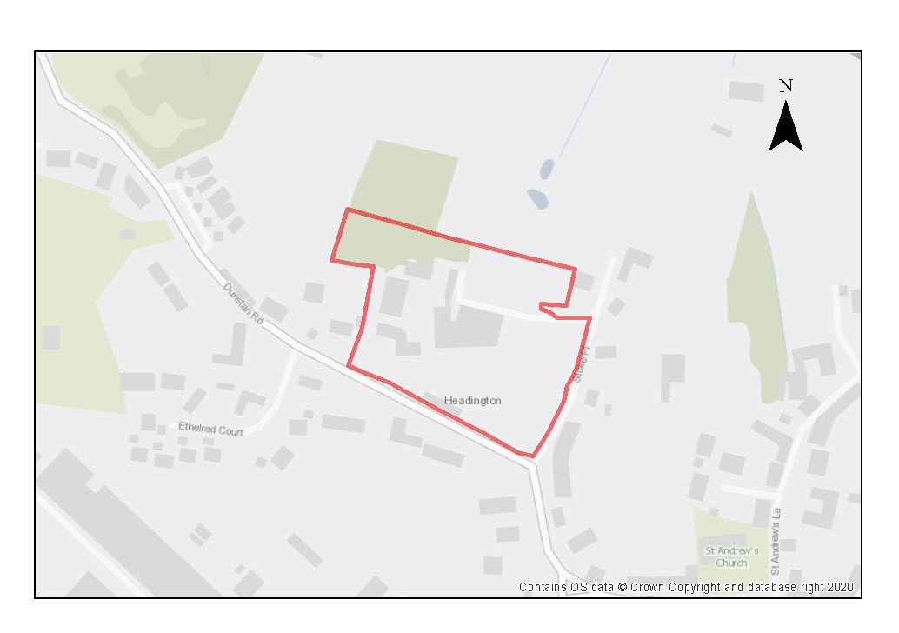

Ruskin College Campus off Dunstan Road(and the associated field – see Policy SPE19) has been bought by the University of West London and is now operating as a campus site of that university. The buildings are used for academic purposes, student accommodation, student facilities and administration.

There are nine buildings on site, including the listed Rookery and wall, set within landscaped grounds with some large trees. Any development would need to ensure that there was no adverse impact upon the setting of the listed buildings, wall or on Old Headington Conservation Area, and therefore should demonstrate compliance with Policy HD1 and HD2. The site is suitable for further academic uses, residential development including student accommodation linked to the academic uses on the site, public open space and sports facilities.

The site contains significant existing trees and hedgerows scattered across the site, which are important to public amenity in the area and that will provide valuable ecosystem services. Trees will be protected by their location within the Old Headington Conservation Area and the most valuable and high-quality trees will need to be retained. There are tennis courts within the site boundary.

Preliminary analysis suggests that the presence of various green infrastructure features on the site at present means it is likely to score above the minimum thresholds for green surface cover as required by Policy G3; as such proposals will need to ensure that this score is retained (no net loss), demonstrated through submission of the Urban Greening Factor assessment. New development on the site will need to consider how existing green features, particularly higher scoring elements, can be retained including the existing tree and hedgerows. Sufficient replacements will need to be incorporated into the new design, as well as enhancement of existing green infrastructure that is being retained, in order to preserve the baseline UGF score as a minimum.

The site is of archaeological interest with Iron Age activity and Roman pottery production having been recorded previously. In addition, the site has potential for peat deposits as these have been recorded at Dunstan Park to the west.

Policy SPE18: Ruskin College Campus

Planning permission will be granted for academic institutional uses (subject to Policy H10), student accommodation and residential development, including student accommodation and residential development at Ruskin College Campus. The minimum number of dwellings (net gain) to be delivered on the site is 28 (or, if delivered as student rooms, the number of rooms that equate to this when the relevant ratio is applied). Development could include open space, sports facilities and allotments. Other complementary uses will be considered on their merits.

Open space, nature and flood risk
Policies G1 and G3 require protection of existing green infrastructure features and enhancement of greening on site through the urban greening factor. It is expected that those requirements will be met in the following ways. Trees and hedgerows at the edges of the site maintain a rural character; these should be retained, with loss of other trees compensated for within the development in accordance with Policy G1, and new landscaping encouraging connectivity of green networks.

Urban design and heritage
Policy HD7 requires high quality design and the following sets out key considerations for achieving that on this site. Development proposals must be designed with consideration of their impact on the Old Headington Conservation Area and the setting of the listed buildings within the site and demonstrate compliance with policies HD1 and HD2. Development should respond positively to the rural setting of the Old Headington Conservation Area. Views through to the remaining undeveloped areas should be retained.

Evidence of Iron Age activity and Roman pottery production has been recorded from this site, so it has significant archaeological potential. Due to this potential, development should demonstrate compliance with Policy HD5.

Movement and access
Access to the site exists currently from Dunstan Road and should remain in the same location. Pedestrian and cycle links to the site and circulation around the site should be enhanced.

Natural resources
Due to the site’s proximity to recorded peat reserves at Dunstan Park and the potential for further deposits in the area, any development on currently undeveloped parts of the site will only be permitted where it can be demonstrated that there will be no harm or loss of peat deposits in accordance with the requirements of policy R6. This may mean that where there is the potential for causing removal of peat, site layout has been designed accordingly to protect and mitigate any harm to identified peat deposits onsite.

Ruskin Field

Site area: 1.19 hectares
Ward: Headington
Landowner: University of West London
Current use: Field
Flood Zone: FZ1

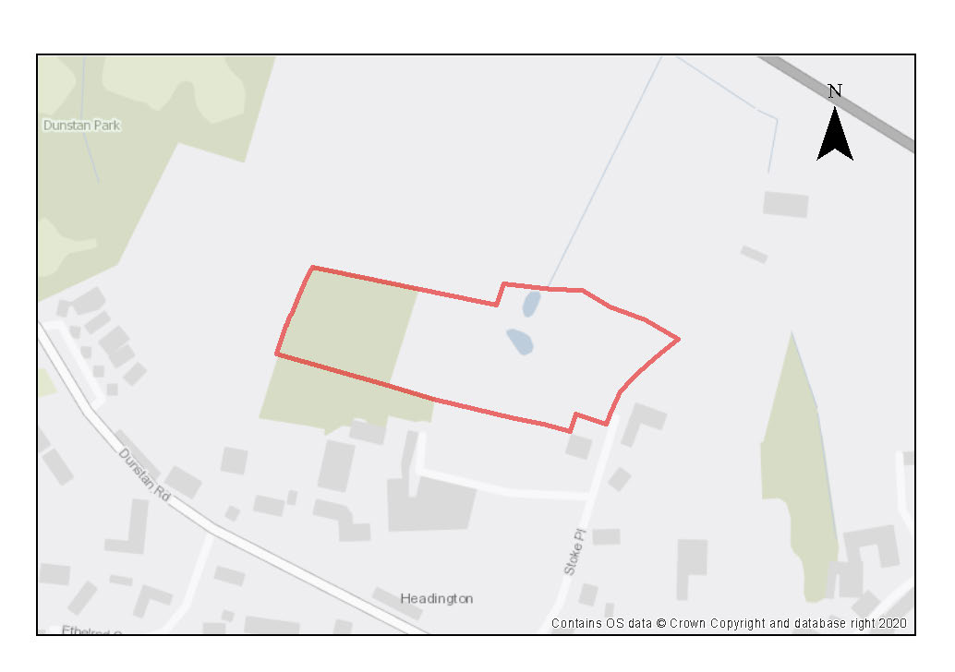

The site is owned by the University of West London and is part of a private field behind the college. It has some thick vegetation and is not accessible to members of the public or members of Ruskin College for recreational purposes. The site lies to the north of Stoke Place, a historic lane and private road, which forms part of the public right of way network (Byway Open to All Traffic (BOAT) and bridleway) and lies within the Old Headington Conservation Area (CA). The adjacent Ruskin College campus (Policy SPE18) includes the listed Rookery and wall, set within landscaped grounds with some large trees.

Old Headington has a clear village development envelope and distinct character from surrounding, later developments. The fields form part of the former rural setting of the village, allowing for a degree of visual separation with development to the north, helping to keep the historic character and settlement pattern of the village. The view from Stoke Place across Ruskin Fields to Elsfield is one of the most sensitive across and out of the conservation area. There is also potential for archaeological remains as well as potential for peat deposits which are recorded at Dunstan Park to the west. This will require further investigation as part of any development.

Preliminary analysis suggests that the presence of various green infrastructure features on the site at present means it is likely to score above the minimum thresholds for green surface cover. As such, proposals will need to ensure that this score is retained (no net loss), to be demonstrated through submission of the Urban Greening Factor (UGF) assessment as required by Policy G3. New development on the site will need to consider how existing green features, particularly higher scoring elements, can be retained including the mature trees, the pond and the hedgerow along Stoke Place. Where green elements are proposed to be removed, sufficient high-quality replacements will need to be incorporated into the new design, and/or existing green infrastructure that is being retained will need to be enhanced, to preserve the baseline UGF score as a minimum. The site is likely to be able to accommodate additional native hedgerow planting to create nature corridors, diverse planting in landscaping and gardens, new areas of tree planting and enhancements of existing features that are to be retained. This type of planting will also aid in achieving biodiversity net gain. The policy sets out requirements for green infrastructure on the site.

Any vehicular access would need to be through the college. There are opportunities to improve pedestrian and cycle access to the site via the BOAT/ bridleway along Stoke Place which could include contributions towards improvements to the existing surfacing of both the BOAT and bridleway.

The site is in an air quality hot spot area. Adjustments and considerations at design stage may be helpful in reducing the ongoing impact of poor air quality. Potential options may include considering layout options that place habitable spaces and openings away from pollution sources such as busy roads, landscape buffers, and designing in walking and cycling options as integral part of schemes.

Due to the heritage sensitivity of the site, the design of the scheme will need to be low in height and include gaps between buildings to retain views and a rural setting. The minimum housing requirement has assumed a density of 30 dwellings per hectare, which provides for retention of the most valuable planting, with high quality green infrastructure integrated into the design.

Policy SPE19: Ruskin Field

Planning permission will be granted for expansion of the adjoining academic institutional use (subject to Policy H10) and/or residential development use, which may include employer linked affordable housing or student accommodation. Other complementary uses will be considered on their merits. The minimum number of dwellings to be delivered is 20 (or, if delivered as student rooms, the number of rooms that equate to this when the relevant ratio is applied).

Open space, nature and flood risk
Policies G1 and G3 require protection of existing green infrastructure features and enhancement of greening on site through the urban greening factor. Policy G5 requires onsite biodiversity enhancement, and Policy G2 requires new Green Infrastructure features and enhancement of existing features. It is expected that those requirements will be met in the following ways. Development proposals must be designed with consideration of their impact on the setting of the Old Headington Conservation Area and demonstrate compliance with policy HD1. The site has a rural character due to surrounding trees and hedgerows, which is part of the distinctive character of the Old Headington Conservation Area. To minimise the impact of development on the sense of rural identity and support biodiversity interest, the most valuable green infrastructure should be retained, including trees that are part of the setting of the listed buildings and that frame Stoke Place. New native hedge and tree planting should connect existing trees and hedgerows. The potential to enhance the value of the ponds should be considered. Gardens and amenity spaces will need to have rich planting along boundaries to allow more diverse networks through the site for wildlife. Natural and diverse planting should be the basis of landscaping. These measures will be important in achieving no decrease in the UGF baseline score.

Urban design and heritage
Policy HD7 requires high quality design and the following sets out key considerations for achieving that on this site. Development must be well related to the college and carefully and sensitively designed to preserve and enhance the setting of the listed buildings and character and appearance of the conservation area (in accordance with HD1 and HD2). The potential impact on views from the north should inform the choice of siting, height, form and appearance of new buildings, as will the listed buildings, wall, hedges and pond. The view from Stoke Place across Ruskin Fields to Elsfield is one of the most sensitive across and out of the conservation area, and this should inform the choice of layout and built form. Built development should be low-density with several gaps to retain views through and to the north from the buildings on the Ruskin Campus, and views through the site from the north.

New development must take into consideration the potential presence of archaeological remains. Due to this potential, development should demonstrate compliance with Policy HD5.
Movement and access
The creation of a secondary pedestrian/ cycle access into the site from Stoke Place would be possible. Vehicular access to the site is not possible via Stoke Place or from the A40, and would therefore need to be through the college (as well as the primary pedestrian and cycle access). This means the site is most suitable for expansion of the college or employer-linked housing or student accommodation relating to the college, although the college could provide an access road for general housing.

Natural resources
Due to the site’s proximity to recorded peat reserves at Dunstan Park and the potential for further deposits in the area, any development on currently undeveloped parts of the site will only be permitted where it can be demonstrated that there will be no harm or loss of peat deposits in accordance with the requirements of policy R6. This may mean that where there is the potential for causing removal of peat, site layout has been designed accordingly to protect and mitigate any harm to identified peat deposits onsite.

The site is located in an air quality hot spot area. Development proposals must demonstrate compliance with policy R4 by ensuring that all necessary mitigation measures against poor air quality have been incorporated during the construction and operational phases and ensuring that any potential negative air quality impacts are adequately mitigated on an ongoing basis, within and surrounding the site.

John Radcliffe Hospital

Site area: 27.75 hectares
Ward: Headington
Landowner: Oxford University Hospitals NHS Foundation Trust
Current use: Hospital
Flood Zone: FZ1
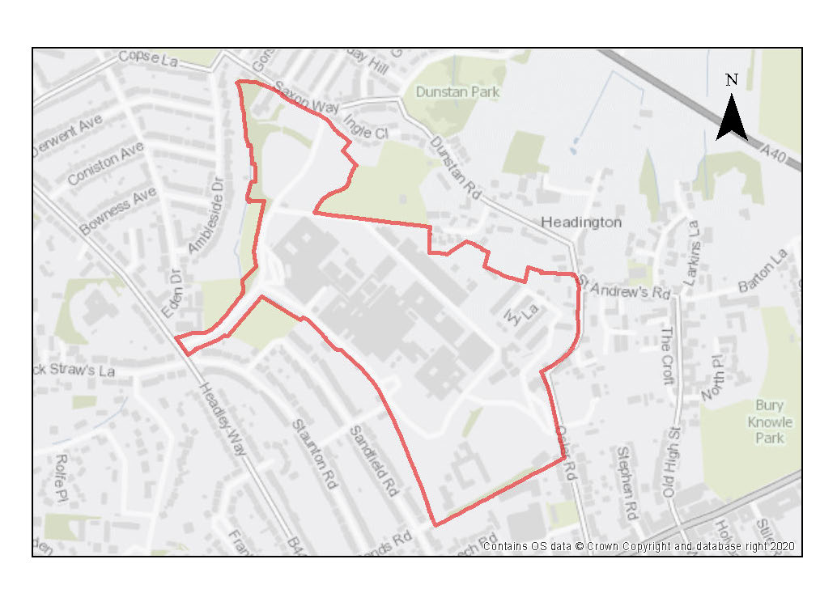

The John Radcliffe Hospital is a large tertiary teaching hospital that forms part of the Oxford University Hospitals NHS Foundation Trust. The hospital complex occupies the hilltop that was formerly the Headington Manor House Estate with views over the city which results in the site being very prominent in views across Oxford. There is scope for intensification of use on this site, including the use of higher buildings. Previous assessments and modelling have determined that sky-lining will occur in the St. Mary’s view out of the city for buildings over 21m, change of character will occur in the Boars Hill View Cone for buildings over 18m and competition will occur in the Elsfield view cone for buildings over 18m. The urban character of the site is large scale institutional buildings, often of modern style that contrasts with the semi-detached houses of New Headington and the historic village structure of the adjacent Old Headington Conservation Area.

To the north, the site is defined by mature trees and car parks adjacent to Headington Cemetery. To the east, tree cover and hedging is dense but with some breaks, buffering the site from Old Headington Conservation Area. To the south, tree cover on Cuckoo Lane separates the neighbouring residential apartment blocks. Back gardens of two storey semi-detached dwellings form the western boundary to the site. The site includes on its outer edge designated heritage assets in the form of Grade II listed Manor House and boundary wall.

Pedestrians can access the site on a non-segregated pavement from Headley Way, Woodlands Road, Saxon Way and Ostler Way. On Ostler Way, foot and cycle paths have been successfully integrated into the landscaping. A private road gives pedestrian access from Sandford Way. However, once inside the site, it is dominated by vehicles, with large areas of surface level car parking, loading bays and turning areas to navigate. Footpaths are fragmented, causing tension between vehicles and pedestrians.

Cyclists can access via the same entrances with dedicated cycle lanes at the main entrance on Headley Way and Ostler Way leading to cycle parking. However, it is much harder to cycle within the site as cyclists share the road with cars, ambulances and service vehicles.

Cars can access the site at the main entrance, Ostler Way, from Woodlands Road and a second entrance on Ostler Way near the site of the approved Ivy Lane Key worker housing scheme. The entrance on Saxon Way is for buses only. Congestion at the site entrance has been identified as an issue as has the demand for parking which is accommodated across the site at surface level. There is a helipad on the parkland grounds behind Headington Manor House and another adjacent to the Eye Hospital.

Preliminary analysis suggests that the limited presence of green infrastructure features on the site currently means it is likely to score below the minimum thresholds for green surface cover as required by Policy G3. As such, proposals will need to ensure that an appropriate proportion of green features are incorporated into the design of development to meet the minimum targets set out in the policy, demonstrated through submission of the Urban Greening Factor assessment.

Given the current use of the site as a hospital and a Category 1 employment site, it is expected that most buildings onsite are in use and would be retained. However, there may be scope for intensification and improved use of space, including infill development, the erection of new buildings and rationalisation of car parking to provide space for new development and mitigating the impact of vehicular journeys into the site.

It would be beneficial for the hospital if the site was developed for uses where the proximity of being adjacent to the hospital is important. Employment uses which have a particular need to be located close to the hospital, such as pharmaceutical companies needing access to patients for research purposes, would be suitable. It would also be beneficial to locate primary healthcare and a patient hotel on the site. Employer-linked housing that supports the main uses of the site will also be supported. Complementary uses which would also be suitable, but which should not dominate the new development on the site are general residential and student accommodation.

Policy SPE20: John Radcliffe Hospital

Planning permission will be granted for:

- further hospital related uses, including the redevelopment of existing buildings to provide improved facilities on the John Radcliffe Hospital Site.
- Other suitable uses which must have an operational link to the hospital and are:
- employment uses;
- patient hotel;
- extra care accommodation, including elderly persons accommodation;
- primary health care;
- education;
- academic institutional
- small scale retail units ancillary to the hospital
- employer-linked affordable housing;
- student accommodation.

Other complementary uses will be considered on their merits.

Development of the site should be undertaken as part of a masterplan to ensure all land use issues including parking are considered in a comprehensive way to make the most efficient use of land.

Open space, nature and flood risk
Policies G1 and G3 require protection of existing green infrastructure features and enhancement of greening on site through the urban greening factor. Policy G5 requires onsite biodiversity enhancement, and Policy G2 requires new Green Infrastructure features and enhancement of existing features. It is expected that those requirements will be met in the following ways. This site is within an area where development could exacerbate surface and/or foul water flooding. There is an opportunity to address excess of runoff at the John Radcliffe Hospital site by ensuring that any development at the site reduces rather than maintains existing levels. This could take the form of ponds, wetlands or an on-site attenuation feature. A drainage strategy will also need to be produced by the developer in liaison with the City Council, Thames Water and the Environment Agency, to establish the appropriate drainage mitigation measures for any development. Planning permission will only be granted if sufficient drainage mitigation measures are incorporated into the design of proposals.

Existing drainage features such as the brook separating northern car parks should be maintained, enhanced and integrated into the landscape scheme, potentially creating wildlife corridors through the site.

Surface level parking dominates the site. Consolidating and rationalising the level of car parking on the site could free up land for redevelopment, as well as present opportunities for providing improved landscaping and GI, improved pedestrian/cycle paths, and SuDS for managing surface water run-off.

Urban design and heritage
Policy HD7 requires high quality design and the following sets out key considerations for achieving that on this site. Development proposals must be designed with consideration of their impact on the adjoining Old Headington Conservation Area and views, particularly from the Boars Hill and Elsfield view cones, as well as on the listed buildings. As such, proposals must demonstrate compliance with policies HD1, HD2 and HD9.

For development of new hospital buildings, materials should be consistent with townscape character and be modern in style and materials. Whilst a more contextual approach should be considered for development of residential, student residential or key worker housing which would soften the impact of any new development and take inspiration from neighbouring areas. Material choice should not exacerbate the prominence of the hospital in views across the city or the view cones. Flat roofs onsite could accommodate solar panels.

Movement and access
Improvements to public transport, walking and cycling access through the site will be required. These measures should be set out within a transport assessment or travel plan and reflected in an agreed masterplan. Development proposals must not prejudice bus access through the site, and new routes that effectively separate walking and cycling from visitor or servicing traffic, will be encouraged. Additional access points to non-vehicular traffic onto the site will also be beneficial.

Rationalisation of the existing parking must be undertaken as part of development proposals coming forward on the site to ensure the most efficient use of land is made.

Natural resources
Site investigation works would be required in the event of redevelopment due to current and historic uses of the land and must demonstrate compliance with Policy R5.

Rectory Centre

Site area: 0.21 hectares
Ward: St Clement’s
Landowner: Oxford Health NHS Foundation Trust
Current use: Healthcare
Flood Zone: FZ1

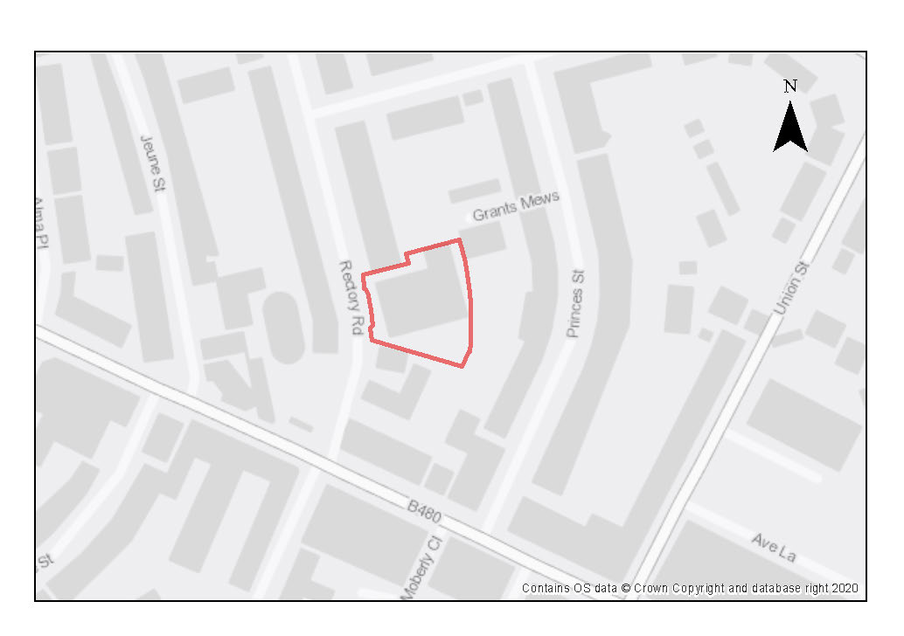

This site is within East Oxford and within the vibrant Cowley Road District Centre which has a variety of uses including retail, cafes/restaurants, residential and student accommodation, as well as frequent bus services towards the City Centre and eastwards towards Cowley and access to cycle routes. The site is located at the end of Rectory Road which is predominately a residential street, with some student accommodation/hostel accommodation of 2-3 storeys. As such, residential development on this site would be appropriate.

The site is comprised of a cluster of buildings used as an NHS health clinic where the majority of appointments must be pre-arranged which limits the number of walk-in visitors to the site.

This site has a flat topography, constrained by Rectory Road running to the west of the site, but adjoins residential plots along much of the site boundary. There is limited natural vegetation on the site as it is mainly a developed area, though there is a single established tree within the site boundary, which is adjacent to a cluster of trees to the east. Any redevelopment of the site should consider how this tree can be retained as part of the design. Most of the site is made up of hard surfaces either from tarmac or building roofs with little vegetation or permeable surfaces present so there is an opportunity to increase the amount of green infrastructure on site.

Preliminary analysis suggests that the limited presence of green infrastructure features on the site currently means it is likely to score below the minimum thresholds for green surface cover as required by Policy G3. As such, proposals will need to ensure that an appropriate proportion of green features are incorporated into the design of development to meet the minimum targets set out in the policy, demonstrated through submission of the Urban Greening Factor assessment.

The site is in an air quality hot spot area. Adjustments and considerations at design stage may be helpful in reducing the ongoing impact of poor air quality. Potential options may include considering layout options that place habitable spaces and openings away from pollution sources such as busy roads, landscape buffers, and designing in walking and cycling options as integral part of schemes.

The site is in line with the Crescent Road View Cone which should be considered in the consideration of building heights when developing the site in future. The rich and varied roofscape of this view cone should also be respected.

Policy SPE21: Rectory Centre

Planning permission will be granted for residential development on this site. The minimum number of residential homes to be delivered is 21.

Development of this site would lead to the loss of community healthcare facilities, so these should be re-provided elsewhere, in accordance with Policy C3, which may be through consolidation onto other healthcare sites.

Open space, nature and flood risk
Elements of green infrastructure on the site are currently lacking. Although the site is small and constrained the implementation of green walls and roofs on parts of the site should be considered. Further to this, elements of smaller and individual green features as part of gardens, as well as around boundaries, should be implemented to compliment any residential development which will in turn create a more pleasant living environment for residents.

Urban design and heritage
Policy HD7 requires high quality design and the following sets out key considerations for achieving that on this site. Development proposals must be designed with consideration of their impact on views, particularly from the Crescent Road view cone, and demonstrate compliance with policy HD9.

Any development should respond to both the character of the of the East Oxford Victorian Suburb and and the vibrant Cowley Road District Centre. The existing residential streetscape of Rectory Road should be considered to enhance the area’s existing colour and pattern of brickwork. The existing building height should also be respected and adhered to.

Movement and access
The constrained nature of the site means that the site is only accessible via Rectory Road from the west. The site should be easily navigable for residents both on foot and travelling on a bike, although applicants will be expected to demonstrate how the development improves connectivity to support active travel such as walking and cycling.

Natural resources
The site has potential contamination so a site investigation will be required, and remedial works are likely to be necessary to be undertaken in compliance with Policy R5.

The site is located in an air quality hot spot area. Development proposals must demonstrate compliance with policy R4 by ensuring that all necessary mitigation measures against poor air quality have been incorporated during the construction and operational phases and ensuring that any potential negative air quality impacts are adequately mitigated on an ongoing basis, within and surrounding the site.

Central and West Oxford Infrastructure Area (including North of the City Centre Area of Focus and West End and Botley Area of Focus
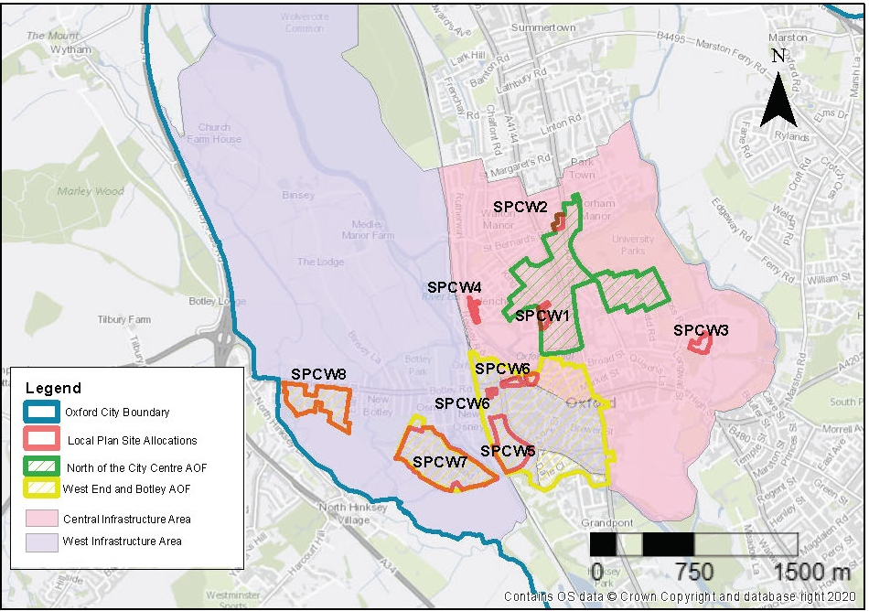
Figure 8.9 North of the City and West End and Botley Road Area of Focus and site allocation policies
This area contains a wide variety of buildings and uses. It is a key area of public transport provision for rail and bus, and includes the Oxford railway station, Gloucester Green coach station (the stopping point for most buses to and around the city) and Seacourt Park & Ride. It contains most of the Oxford colleges and most of the faculties of the University of Oxford. In addition, it is the retail heart of the region and contains venues that attract people from a wide area, including cinemas, theatres, live music venues and the ice rink. The large numbers of people visiting and interchanging on public transport can create congestion and conflict in the public realm, and high quality, thoughtfully designed public realm is key to the success of the area.
Some parts of the area are at high flood risk and so may be unsuitable for residential development. Flood mitigation measures, including new areas of flood storage and SuDS, integrated into green infrastructure enhancements, are likely to be necessary in the southern and western parts of the area.
Key considerations for infrastructure and design across the area are:
- Create high-density urban living with good provision and access to public open space
- Maintain a vibrant mix of uses
- Contribute to the knowledge economy
- Integrate flood risk mitigations into the public realm and green infrastructure
- Provision of a pedestrian and cycle bridge over the Thames to Oxpens
- Enhance accessibility and permeability of the area through good pedestrian and cycle links and enhanced public realm
- Support the redevelopment of Oxford railway station to create an easy and attractive transport interchange between rail, bus and active travel
North of the City Centre Area of Focus

The area to the north of the city centre is dominated by University of Oxford buildings of a wide range of styles, ages and sizes. The University would like to develop many of its buildings and plots within the area to improve the quality of the academic facilities and add some new floorspace. Development will be considered against any masterplan for the sites, which would help ensure that development occurs as part of a comprehensive plan for the area.
Across the area there is a lack of definition between public and private spaces and a lack of clear signalling of public routes. The area can feel closed off to the public and is dominated by hard landscaping, ill-defined and multiple small areas of parking and servicing features such as extractors and chemical storage tanks. Opportunities need to be taken to improve the permeability of the area, enhance the public realm and landscaping and clearly define public areas. The use of some of the institutional buildings at ground level for communal uses to bring a wider range of people into the area is encouraged. Development in the area should seek to add character and have regard to the listed buildings and conservation area. As these sites are controlled by one landowner there is more scope to ensure that new development and redeveloped buildings relate well to one another to optimise the opportunities to enhance the public realm. The Science Area & Keble Road triangle, the Radcliffe Observatory Quarter (ROQ) and the Banbury Road University sites all part of this Area of Focus, no site-specific policies required, but development in these areas will be expected to meet the requirements of Policy NCCAOF.

The AOF is largely within the Central (City and University) Conservation Area(CCA) part of the ROQ is within the North Oxford Victorian Suburb Conservation Area and it adjoins and is in the setting of the Jericho and Walton Manor Conservation Areas. Although the Banbury Road Triangle site is outside of any conservation area, although it is in the setting of several.

The impact of views out and into the Central Conservation Area from the Cherwell Valley, and longer-range views to and from the elevated viewpoints around surrounding landscape, are all sensitive to increases of height in this area. There is potential for visual competition with the city centre skyline in all views towards the city and competition and obstruction in elevated views from the city centre, particularly at heights above 15 metres. Short-range views to and from the Cherwell Meadows contribute to the significance of the North Oxford Victorian Suburb Conservation Area, and consideration of the impact of these will be important, particularly in relation to the Science Area. The backdrop to views from University Parks is also sensitive.

There are many listed buildings within the AOF and in addition, this area forms the setting of other listed buildings in the vicinity. Listed Buildings and their settings within the AOF include the Radcliffe Observatory, the Dyson Perrins Chemistry Laboratory, the Inorganic Chemistry Building, Reuben College, Ratcliffe Science Library, Museum Lodge and the Townshend building and the Grade I University and Pitt Rivers Museum.

Policy NCCAOF: North of the City Centre Area of Focus

Planning permission will be granted for new development within this Area of Focus where it would ensure that opportunities are taken to deliver the following (where applicable):

- community and public uses of some institutional buildings, especially at ground floor level e.g., example cafes and exhibition spaces;
- integration of servicing infrastructure into the built form;
- enhanced landscaping, including tree planting and enhanced biodiversity and green corridors and SuDs;
- improved demarcation and legibility of public routes through the area, using urban design and wayfinding;
- additional tree planting, green features and wayfinding in areas other than key routes;
- building heights and roofscapes that are appropriate for their setting and that do not negatively impact on historic skylines, roofscapes or key views, particularly from University Parks, to and from the Cherwell Valley and to and from the historic towers and spires of the city centre;
- creation of a strong and well-defined building line along the streets;
- mitigation of potential negative air quality impacts that arise during the construction and operational phases;
- new development should be designed to ensure that there is no adverse impact on the New Marston Meadows SSSI (part of the area is in proximity to the SSSI) ; and
- any design should balance the existing historic buildings onsite coupled with the celebration of cutting-edge science.

Central & West Area site allocation policies within the North of the City Centre and the Area of Focus
- West Wellington Square
- Land at Winchester Road, Banbury Road and Bevington Road, Oxford

West Wellington Square

Site area: 0.88 hectares
Ward: Carfax
Landowner: University of Oxford
Current use: Academic institutional uses
Flood Zone: FZ1

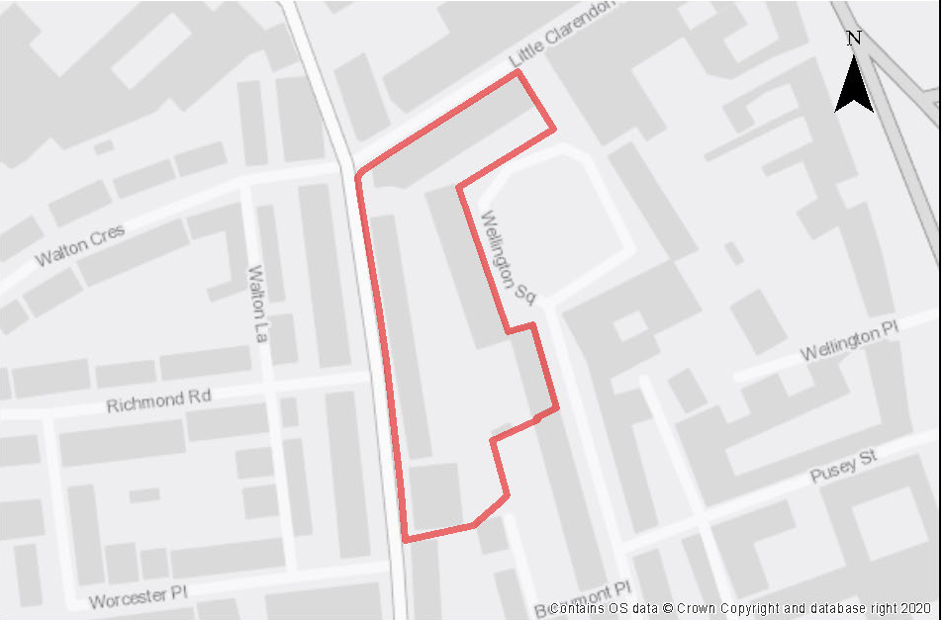

The site lies within the Central (City and University) Conservation Area to which a number of these buildings, particularly those ones fronting Walton Street, make a positive contribution and is adjacent to a grade II listed building. The area has a high potential for archaeological interest as it is the site of the Wellington Workhouse and a line of Civil War defences. Part of the site lies within the Walton Street and Little Clarendon Street Local Centre.

Opportunities should be taken to enhance pedestrian and cycle links between Walton Street and Wellington Square.

The site could contribute towards the University’s need to provide additional graduate accommodation and staff housing. In addition, the site would be suitable to provide employer-linked housing for staff at the University. The site will continue to accommodate some academic functions for the University although these are likely to be relocated to the Radcliffe Observatory Quarter over the plan period.

Preliminary analysis suggests that the limited presence of green infrastructure features on the site currently means it is likely to score below the minimum thresholds for green surface cover as required by Policy G3. As such, proposals will need to ensure that an appropriate proportion of green features are incorporated into the design of development to meet the minimum targets set out in the policy, demonstrated through submission of the Urban Greening Factor assessment.

Policy SPCW1: West Wellington Square

Planning permission will be granted for academic, institutional, student accommodation and residential development including employer linked housing in accordance with Policy H5. The minimum number of homes to be delivered is 18 dwellings (or, if delivered as student rooms, the number of rooms that equate to this when the relevant ratio is applied). Appropriate uses to the local centre of Little Clarendon Street and Walton Street as set out in Policy C1 will be permitted.

Open space, nature and flood risk
Development of the site must seek to ensure that the mature and semi mature gardens in the rear gardens of the property are retained and incorporated into any redevelopment scheme.

Urban design and heritage
Development proposals must be designed with consideration of their impact on the setting of the Central Conservation Area and adjacent listed buildings demonstrating compliance with policy HD1 and HD2. The site is in an area of high archaeological interest and new development must also take into consideration the potential presence of archaeological remains. Due to this potential, development should demonstrate compliance with Policy HD5.

Movement and access
Access is limited to the site and as such the development should be low car and not generate any material increase in traffic movements above the existing ones that service the current occupiers.
The opportunity exists to enhance pedestrian links between Walton Street and Wellington Square

Land at Winchester Road, Banbury Road and Bevington Road Oxford

Site area: 0.52 hectares
Ward: Walton Manor
Landowner: University of Oxford
Current use: Academic uses
Flood Zone: FZ1

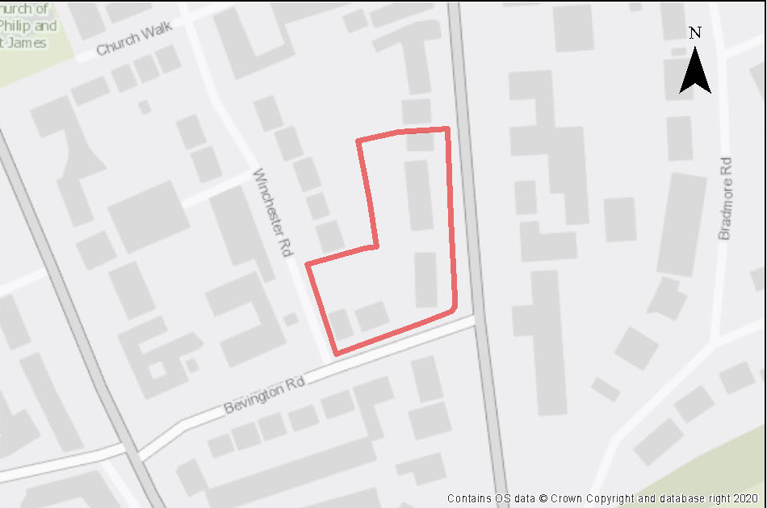

The site lies within the boundary of the North Oxford Victorian Suburb Conservation Area (NOVSCA) and consists of a triangular area of land that lies between Banbury Road to the east and Winchester Road to the west. The land is bounded by Bevington Road to the south and the rear boundaries of the properties lying on the south side of North Parade, which is a narrow street of small-scale buildings. There are two listed buildings adjacent to the site, 59 Banbury Road, a Grade II listed detached villa completed in 1859. Gees Restaurant is a Grade II listed building in use as a restaurant, it’s a surviving glasshouse from the former market garden that occupied the site.

The site’s contribution to the significance of the Conservation Area is its strong plot character, with large residential Victorian and Edwardian villas set in generous plots and the perception of verdant tranquil back gardens from the surrounding streets. The buildings are currently used by a number of academic departments of the university.

Development proposals must consider the impact of any development on the New Marston SSSI. A drainage and flood risk strategy will be required to assess any impacts upon the SSSI.

The site is of archaeological interest as it is located on the line of a Bronze Age linear barrow cemetery and there is potential for prehistoric and Roman remains. This will require further investigation as part of any redevelopment.
Preliminary analysis suggests that the presence of various green infrastructure features on the site at present means it is likely to score above the minimum thresholds for green surface cover. As such, proposals will need to ensure that this score is retained (no net loss), to be demonstrated through submission of the Urban Greening Factor (UGF) assessment as required by Policy G3. New development on the site will need to consider how existing green features, particularly higher scoring elements, can be retained including the mature trees within the site boundary. Development proposals should seek to minimise tree removal and to incorporate new semi-mature trees where possible alongside other green features e.g. within front gardens. All planting proposals should form part of a submitted landscape plan including details of how trees will be retained.

Policy SPCW2: Land at Winchester Road, Banbury Road and Bevington Road

Planning permission will be granted for academic institutional uses, student accommodation, and/or residential development. The minimum number of dwellings is 52 (or, if delivered as student rooms, the number of rooms that equate to this when the relevant ratio is applied). Other complementary uses will be considered on their merits.
Open space, nature and flood risk
Policies G1 and G3 require protection of existing green infrastructure features and enhancement of greening on site through the urban greening factor. Policy G5 requires onsite biodiversity enhancement, and Policy G2 requires new Green Infrastructure features and enhancement of existing features. It is expected that those requirements will be met in the following ways. Retaining existing mature trees where possible and providing new tree planting to mitigate against loss of canopy cover where necessary. Incorporating a range of other green features as part of site layout to ensure no loss in baseline UGF score, such as within and around the boundaries of new gardens.

Planning permission will only be granted if it can be proven that there would be no adverse impact upon surface and groundwater flow to the New Marston SSSI (Policy G6). Development proposals should reduce surface water runoff in the area and should be accompanied by an assessment of groundwater and surface water. Development proposals must incorporate sustainable drainage with an acceptable management plan (Policy G8).

Urban design and heritage
Policy HD7 requires high quality design and the following sets out key considerations for achieving that on this site. Development proposals must be designed with consideration of their impacts on the setting of the North Oxford Victorian Suburb Conservation Area and the setting of the nearby listed buildings and demonstrate compliance with policies HD1 and HD2.

Development must also take into consideration the potential presence of prehistoric and Roman archaeological remains. Due to this potential, development should demonstrate compliance with Policy HD5.
Movement and access
Opportunities should be taken to create a pedestrian route from north/south through the site.

Natural resources
Development proposals will be required to include an appropriate site contamination investigation and applications will be required to demonstrate how any contamination issues will be resolved (Policy R5).

Development proposals must include an acoustic design statement to be submitted in accordance with Policy R7 as this site is part of an area which is subject to significant environmental noise from the traffic on the Banbury Road and Winchester Road.

Central & West area site allocation policies outside the Areas of Focus

- Manor Place
- Canalside Land, Jericho
Manor Place
Site area: 1.24 hectares
Ward: Holywell
Landowner: Merton College
Current use: Former tennis courts, allotments, orchards
Flood Zone: FZ3b but FZ1 for sequential test

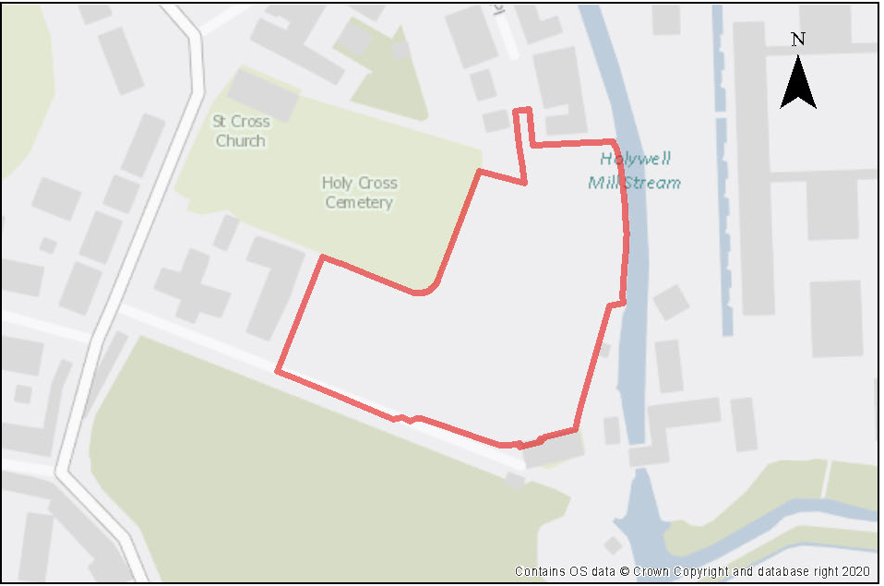

This site consists of a mix of disused hard and grass tennis courts, abandoned private allotments and an orchard. It is a sensitive location falling within the Central Conservation Area, and forms part of the setting of several listed buildings and the Holywell Cemetery. The site is in line with the Elsfield, Doris Field and Headington Hill Allotments view cones but may also appear in others as it is located in the Historical Core Area.

The area is characterised by hedged boundaries and several mature/semi mature trees established on the site, particularly at the northern and southern corners. The site itself contains various types of natural ground cover including grass, scrub and scattered trees. These contribute to the green, semi-rural character of the setting which includes Holywell Cemetery, St Cross Annex and the Magdalene College Deer Park and likely have high biodiversity value.

Preliminary analysis suggests that the presence of various green infrastructure features on the site at present means it is likely to score above the minimum thresholds for green surface cover as required by Policy G3; as such proposals will need to ensure that this score is retained (no net loss), demonstrated through submission of the Urban Greening Factor assessment. New development on the site will need to consider how existing green features, particularly higher scoring elements, can be retained including the features highlighted above such as mature trees and hedged boundary features. Sufficient replacements will need to be incorporated into the new design, or enhancement of existing green infrastructure that is being retained, to preserve the baseline UGF score as a minimum.

The site lies in close proximity to the New Marston Meadows SSSI which is sensitive to changes in the flows and quality of water in the River Cherwell due to its floodplain. As such this site faces several hydrological challenges that would need to be addressed in any development proposals. The site adjoins the River Cherwell and a small portion of the site is active floodplain. It is expected development be directed away from affected areas subject to flood risk and a site-specific flood risk assessment will be required.

The majority of the site is at low risk of flooding, but a small part of the site is in Flood Zone 2, and a very small part in Flood Zone 3b. Residential development at this site, a small part of which is in Flood Zone 3a, has been justified through the sequential test. A Level 2 Strategic Flood Risk Assessment was carried out for this site to examine part b) of the Exception Test (which relates to whether the development is safe). The Level 2 SFRA considered the proposed development was appropriate and additional mitigation and/ or analysis may be required to demonstrate compliance with the Exception Test at the planning application stage. This is to be undertaken through a site-specific FRA supporting the planning application. The site-specific flood risk assessment must demonstrate how the development will be safe otherwise planning permission will not be granted.

The site is of archaeological interest with Civil War defences having been excavated previously.

Access to the site may prove to be challenging, due to physical constraints and potential routes being outside of the control of the landowner. To minimise the impact of vehicular traffic, the most appropriate uses for the site are either student accommodation, or low car residential development. The loss of the former sports facility is considered justified only due to the need for and benefits of new housing or student accommodation.

Policy SPCW3: Manor Place

Planning permission will be granted for student accommodation or car free residential development or a mix of both uses. The minimum number of dwellings to be delivered on the site is 43 (or, if delivered as student rooms, the number of rooms that equate to this when the relevant ratio is applied).

Other complementary uses will be considered on their merits.

Open space, nature and flood risk

Policies G1 and G3 require protection of existing green infrastructure features and enhancement of greening on site through the urban greening factor. Policy G5 requires onsite biodiversity enhancement, and Policy G2 requires new Green Infrastructure features and enhancement of existing features. It is expected that those requirements will be met in the following ways. Planning permission will only be granted if it can be proven that there would be no adverse impact on the New Marston Meadows SSSI. Development proposals should reduce surface water runoff in the area and should be accompanied by an assessment of groundwater and surface water flows. Development proposals must incorporate sustainable drainage with an acceptable management plan.

Development proposals should reduce surface water runoff in the area and should be accompanied by an assessment of groundwater and surface water flows, as well as a site-specific flood risk assessment, and development should incorporate any necessary mitigation measures. Development proposals should also incorporate sustainable drainage with an acceptable management plan.

A site-specific FRA will be required. A sequential approach should be taken to locating development on the site, with more vulnerable uses away from the highest flood risk. A drainage strategy will be required to manage run-off and may need a raised floor level for some of the site, to be informed by the FRA.

Urban design and heritage
Policy HD7 requires high quality design and the following sets out key considerations for achieving that on this site. Development proposals must be designed with consideration of their impacts on the setting of the Central Conservation Area, the setting of the nearby listed buildings and views, and demonstrate compliance with policies HD1, HD2 and HD9.

Development must be based upon a clear understanding of the significance of the site and its surrounding context. Development should seek to preserve the secluded character of the Magdalen College Deer Park and the Victorian cemetery and maintain spatial separation of the historic western suburb and the suburb of Holywell and views from the elevated cemetery towards the tree lined Cherwell and the 15th century Magdalen College wall, for example by employing separated buildings in a green landscape. The size, alignment and design of any proposed development should take account of the importance of preserving the visual and physical connections between important, surviving, historic elements.

Development should demonstrate compliance with Policy HD5 and must preserve the Royalist Civil War rampart and ditch line, previously located by archaeological evaluation, in situ.

Materials and construction details used for new development schemes should be of high quality, appropriate for the setting and sympathetic to the local context.

Movement and access
The most appropriate vehicular access would be to widen and extend the existing pedestrian and cycle access from Manor Place to the north of the site, incorporating land in Merton College’s ownership. Access via Holywell Mill Lane to the south is unlikely to be deliverable as it is not under the control of Merton College and the visibility at the junction with St Cross Road is substandard. Applicants will be expected to demonstrate how the development enables access by alternative means of transport including improving connectivity to support active travel such as walking and cycling.

Natural resources
Site investigations will be required as part of the development proposals to ensure that any land contamination is fully identified and mitigated (Policy R5).

Canalside Land, Jericho

Site area: 0.49 hectares
Ward: Jericho and Osney
Landowner: Canal and River Trust, Oxford City Council, The Church of England
Current use: Boat hire facility, open space and derelict workshops
Flood Zone: FZ3b but FZ2 for sequential test

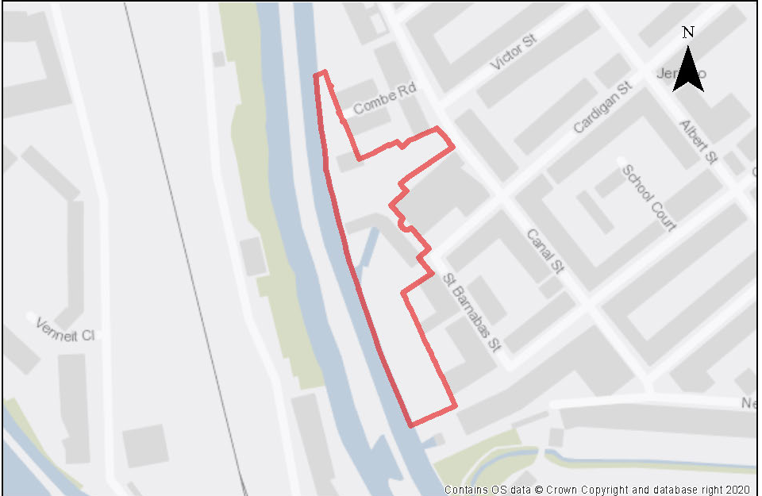

This former boatyard and workshop site has been vacant and derelict since 2006. Part of the site to the north is still used by a boat hire facility while garages and open space occupy the land owned by the City Council. The site is in a sensitive area with the Jericho Conservation Area and adjacent to the Grade 1 listed St Barnabas Church.

As a former boatyard it is considered that this use should remain and there is capacity for it to do so. The operating boatyard should include the provision of a wet and/or a dry dock and allow craneage for narrowboats with possible supporting chandlery and associated workshop facilities. Other uses that should be provided on the site are residential units, a sustainably sized community centre, a public open space or square. The canal hire base at the northern part of the site should be retained. The development proposal needs to incorporate electric charging infrastructure for boaters to reduce carbon emissions from diesel engines and improve air quality.

It is expected that the any development on the site would make a financial contribution towards the upgrading of or reprovision of the existing bridge in the area. There is also a need for the proposal to support the upgrading of the tow path.

The site is at moderate risk of fluvial flooding, with most of the site in Flood Zone 2 and parts in Flood Zone 3a and 3b. The residential development at this site has been justified through the sequential test. A Level 2 SFRA was carried out for this site to examine part b) of the Exception Test (which establishes whether the development is safe). The Level 2 SFRA considered the proposed development was appropriate and additional mitigation and/or analysis maybe required to demonstrate compliance with the Exception Test at the planning application stage. This is to be undertaken through a site-specific FRA supporting the planning application. The site-specific flood risk assessment must demonstrate how the development will be safe otherwise planning permission will not be granted. Early warning methods should be considered as part of the SFRA given the high speed of onset values associated with the proximity to the Oxford Canal.

The site is adjacent to Oxford Canal which is an Oxford City Wildlife Site. The site supports a small number of common bat roosts. Key to any development is avoiding potential impacts on the Canal and Castle Mill Stream and the wildlife that utilise them, including foraging and commuting bats, otter and (potentially) water vole. Any planning application should incorporate a robust lighting assessment that demonstrates no additional artificial light spill on the canal – from either exterior or interior lighting – or otherwise demonstrate that the light spill will avoid any significant impacts on the faunal interest. It should also include an appropriate assessment of the Canal and Castle Mill Stream. The Oxford Meadows SAC is a short distance away from the site.

Preliminary analysis suggests that the limited presence of green infrastructure features on the site currently means it is likely to score below the minimum thresholds for green surface cover as required by Policy G3. As such, proposals will need to ensure that an appropriate proportion of green features are incorporated into the design of development to meet the minimum targets set out in the policy, demonstrated through submission of the Urban Greening Factor assessment.

Policy SPCW4: Canalside Land, Jericho

Planning permission will be granted for a mixed-use development at the Canalside Land that includes all the following:

- Residential dwellings;
- A sustainably-sized community centre;
- Public open space/square;
- Replacement operating boatyard;
- To provide electric charging points for mooring boats;
- A contribution towards the upgrade of the tow path between the site and Hythe Bridge Street; and
- A contribution towards the upgrading of the existing bridge over the canal.

Other complementary uses will be considered on their merits

Open space, nature and flood risk
Policies G1 and G3 require protection of existing green infrastructure features and enhancement of greening on site through the urban greening factor. Policy G5 requires onsite biodiversity enhancement, and Policy G2 requires new Green Infrastructure features and enhancement of existing features. These requirements should be met through sufficient provision of a range of green infrastructure features that allow the site to meet minimum requirements for the UGF assessment. Planting that enhances the waterside and promotes connections between it and the wider area are encouraged, as well as habitat features that can support the foraging and shelter of wildlife of the adjacent ecological designated sites.

Development proposals should be accompanied by an assessment of potential recreational pressure on the immediate setting including the canal towpath and the Oxford Meadows SAC that may arise from increased numbers of visitors, along with plans to mitigate this impact as necessary. Development proposals should also be accompanied by ecological and lighting assessments of the potential impact on ecology and protected species on site and adjacent Canal and Castle Mill Stream, along with plans to mitigate this impact as necessary.

A lighting strategy should be submitted in support of any planning application setting out the internal and external lighting associated with the proposed development. This is because the Canal is likely to be an important foraging and commuting resource for bats and should not be subject to any artificial illumination as a result of the proposed development.

Planning applications must be accompanied by a site-specific flood risk assessment and development should incorporate any mitigation measures. The FRA should look at options for early warning. A sequential approach should be taken to locating development on the site, with more vulnerable uses away from higher risk areas where possible. A drainage strategy will be required to manage run-off and may need a raised floor level for some of the site, to be informed by the FRA.

Urban design and heritage
Policy HD7 requires high quality design and the following sets out key considerations for achieving that on this site. Building heights should reflect the form and scale of surrounding development, particularly around the area of public open space, and should not exceed three storeys. Finished design should respect the waterfront heritage of the site, the conservation area and Grade 1 listed St Barnabas Church. A new public square should be created and to open up views of St Barnabas Church from the canal, the wall separating the church and the proposed new square could be demolished. The wall is curtilage listed and as it relates to an active place of worship, separate Faculty approval is required from the Diocese. Listed building consent is not required for such demolition.

Movement and access
A contribution towards the upgrading of the existing bridge over the canal and the towpath should be provided as part of the development proposals. Applicants will be expected to demonstrate how the development enables access by alternative means of transport including improving connectivity to support active travel such as walking and cycling.

Natural resources
All proposals should minimise impact on air quality during the construction phase and a Contruction Traffic Management Plan must be followed in accordance with the requirements of Policy C6.

The on-site boatyard may need some sealed storage areas if fuels, paints and chemicals are being used.

Development proposals will be required to include an appropriate site contamination investigation and applications will be required to demonstrate how contamination issues will be resolved (Policy R5).

Development proposals must include an acoustic design statement to be submitted in compliance with Policy R7 as this site is part of an area which is subject to significant environmental noise from the railway line.

West End and Botley Road Area of Focus
Oxford’s West End
Oxford’s West End is located in the south-west corner of the city centre and includes Oxford Railway Station. For many years it has been an under-performing area of the city centre. There is potential for the West End of Oxford to be transformed into a vibrant city quarter through the successful development of a number of key sites in the area. However, there is a risk that with so much development proposed for the area during the Plan period that Oxford’s historic character could be impacted. Care needs to be taken to ensure that Oxford’s historic character is not lost or harmed through development in this sensitive part of the city. The West End Area of Focus has a rich depth of history with a number of buildings from different time periods located within it. However, it also includes some poorly integrated incremental development which could be enhanced or improved through redevelopment.
Development opportunities should seek to improve connectivity through the area and where appropriate, to improve the contrasting qualities of old and new built form. Opportunities should also be taken to improve the legibility of the area and to improve connectivity with the watercourses that run through it.
The West End and Botley Road Area of Focus is an appropriate location for employment-related development opportunities which seek to build on Oxford’s key economic strengths that link research, education and social enterprise in areas such as life sciences and energy. Given the high demand for commercial research and development space and specific developer interest, it is likely that this sector will be the main driver of development across the area. However, there are also opportunities to accommodate a range of other sectors and uses, such as the creative and digital industries, as well as affordable workspaces for start-ups, co-working spaces, or even community uses where feasible across the wider area that this area of focus covers.
Redevelopment opportunities should aim to provide a mix of uses including employment, residential, leisure and other city centre uses including appropriate levels of retail where it supports the creation of new communities and helps to activate street frontages.
The heights of new buildings will be an important consideration in this area of focus and there is likely to be a degree of conflict between delivering development that protects and enhances Oxford’s iconic dreaming spires and the ambitions of delivering certain development types. Wherever high buildings are proposed (over 15 metres) they should be accompanied by a visual impact assessment which clearly shows how the proposal relates to Oxford’s historic skyline.
If a heritage asset is currently appreciated as a prominent feature in views, the introduction of a high building that distracts the attention of a viewer, could harm the heritage significance of the asset. The High Buildings Technical Advice Note (TAN) provides further information, and all visual analysis in support of proposals should be carried out based on the advice in this document.
West End and Osney Mead SPD
The West End and Osney Mead Supplementary Planning Document (SPD) is an area-based SPD that was produced to support the delivery of sites in this part of the city centre following the adoption of the previous Local Plan 2036. It underwent extensive consultation with stakeholders including landowners, amenity groups, and the public during its production. The West End and Osney Mead SPD is retained to supplement and facilitate the delivery of the site allocations in the Local Plan 2040.
The West End and Osney Mead SPD provides guidance about infrastructure interventions including green and blue infrastructure, public realm and walking and cycling improvements that would enhance and improve the area. Infrastructure improvements should be made in line with the SPD.
Oxford Railway Station
Oxford Railway Station is situated within the West End and has the potential to be transformed within the Plan period. This is due to the delivery of strategic rail infrastructure to support the Oxford to Cambridge Pan Regional Partnership – namely East West Rail. East West Rail would connect both people and businesses in the towns and villages between Oxford, Milton Keynes, Bedford and Cambridge. It would open up new journeys, cutting travel times, easing congestion on local roads and would bring more jobs within the reach of local people.
Work is already being undertaken to the western entrance to Oxford Station to help deliver track capacity upgrades to support East West Rail, and more future services, including the proposed re-opening of the Cowley Branch Line to passengers. Additional works would also be required to create further track and platform capacity to the Eastern side, which would require a replacement main entrance. Work is on-going between partners to develop a scheme which enables a transformed station building and interchange which meets the needs of the 21st century and growing passenger numbers. The central location and strategic importance of the station should be capitalised upon and enable good onward connections by public transport, walking and cycling within the West End and towards the core of the city centre.
The City Council will support proposals for the redevelopment of the eastern entrance to the railway station and associated infrastructure (i.e., Becket Street car park) to deliver a mixed-use scheme including enhancements to the public realm which helps to fund the transformation of Oxford's Railway Station.
Osney Mead and Botley Road
Osney Mead Industrial Estate and Botley Road Retail Park are characterised as 20th Century Fringe Business, Industry and Retail areas in the updated Oxford Landscape Character Assessment. They sit outside of the city’s historic core and have a different character to it. However, given their close proximity to the city’s dreaming spires, some similarities exist within this Area of Focus, for instance, the relationship between historic views of the city’s iconic skyline and the potential conflict with the scale of redevelopment ambitions in this area.
Osney Mead Industrial Estate is a Category 2 employment site. It is in a central location that offers one of the few opportunities for a range of employment uses in the city. It is in an accessible location close to the railway station and has some existing connections via walking and cycling to the wider area. The site is not intensively used at present. Changes in technology, how space is used, and the type of employment provided mean that the employment function could be provided in a smaller space, as well as being enhanced. It is important that this site maintains its role in creating a diverse employment base as it makes an important contribution to Oxford’s employment land supply.
A transformation of the Osney Mead site has the potential to be delivered within the plan period. Planned infrastructure improvements including a pedestrian and cycle bridge linking Osney Mead directly to the West End via the Oxpens site are programmed to be delivered within the early part of the plan period which would provide better accessibility from Osney Mead and help create a natural extension of the city centre into this location.
Botley Road Retail Park is a large retail park within the western edge of the city boundary. Built from the 1980s, it features many large single storey retail stores with associated parking, belonging to familiar brands in homewares, consumer electronics and DIY. The current urban environment is considered poor quality as it is dominated by cars and hard surfacing.
The retail park borders small scale residential properties to the east on Earl Street, Lamarsh Road and Brock Grove and to the opposite (to the north) on Botley Road. The fields to the south form an important part of the historic landscape setting for the city and the site is adjacent to the historic City and Liberty Boundary.
Osney Mead Industrial Estate and Botley Road Retail Park are both at risk from flooding. Flood mapping produced as part of the Strategic Flood Risk Assessment shows that both sites contain land within flood zones 3a and 3b. The mapping also shows that both sites are surrounded by land in flood zone 3. This level of flood risk would have significant implications on the type and nature of development that would be permissible on the site, and where it can be located. A comprehensive flood risk management strategy needs to be developed in order to make ensure that any uses here are delivered in way which enables safe access and egress in times of flood. A Strategic Flood Risk Assessment Level 2 has been carried out.
Redevelopment at Botley Road has the potential to impact views into and out of the city. The Botley Road Retail Park Design Brief TAN should be consulted in relation to design principles, building heights and the assessment of views along with the High Buildings TAN. The Botley Road Development Brief TAN sets out an initial officer assessment of the impact of the site using the Vu.City model and suggest some heights which would be likely to be acceptable in terms of redevelopment proposals at the retail park. This initial assessment should be used to inform further testing and analysis to support individual development proposals that may come forward.

Policy WEAOF: West End and Botley Area of Focus

Planning permission will be granted for new development within this area of focus where it would ensure that opportunities are taken to deliver the following (where applicable):

- Pedestrian and cycling infrastructure improvements must be delivered in accordance with the requirements of the Oxfordshire Local Cycling and Walking Infrastructure Plan. All opportunities to optimise connectivity and permeability for people wishing to walk or cycle in the area to other parts of the city should be taken;
- Positive contributions and enhancements to the character and setting of conservation areas and other heritage assets;
- Making the best use of good urban design and place making opportunities with the redevelopment of Oxford Station and Becket Street Car Park to deliver a strong sense of arrival to Oxford and an improved environment for passengers;
- Development proposals are expected to enhance Frideswide Square to facilitate the creation of a western gateway;
- Building heights that are appropriate for their setting and that do not negatively impact on key views or historic skylines;
- A reduction in car parking across the area;
- Integration of servicing and plant infrastructure into the built form;
- Mitigation of potential negative air quality impacts that arise during the construction and operational phases;
- Enhanced landscaping, including tree planting and enhanced biodiversity and green corridors and SuDs;
- Improved demarcation and legibility of public routes through the area, using urban design and wayfinding;
- Public realm improvements should be undertaken in line with the infrastructure interventions set out in the West End and Osney Mead SPD; and
- Development opportunities at the Botley Road Retail Park should follow the guidance set out in the Botley Road Retail Park Development Brief TAN.

Site allocation policies within West End and Botley Area of Focus
- Oxpens
- Osney Mead
- Nuffield Sites
- Botley Road Retail Park
Oxpens

Site Area: 6.29 hectares
Ward: Osney & St Thomas
Landowner: OXWED and several other ownerships
Current Use: Surface level car parking, green space and a variety of different buildings including the ice rink, sorting office and sheltered housing.
Flood Zone: FZ3b but FZ2 for sequential test

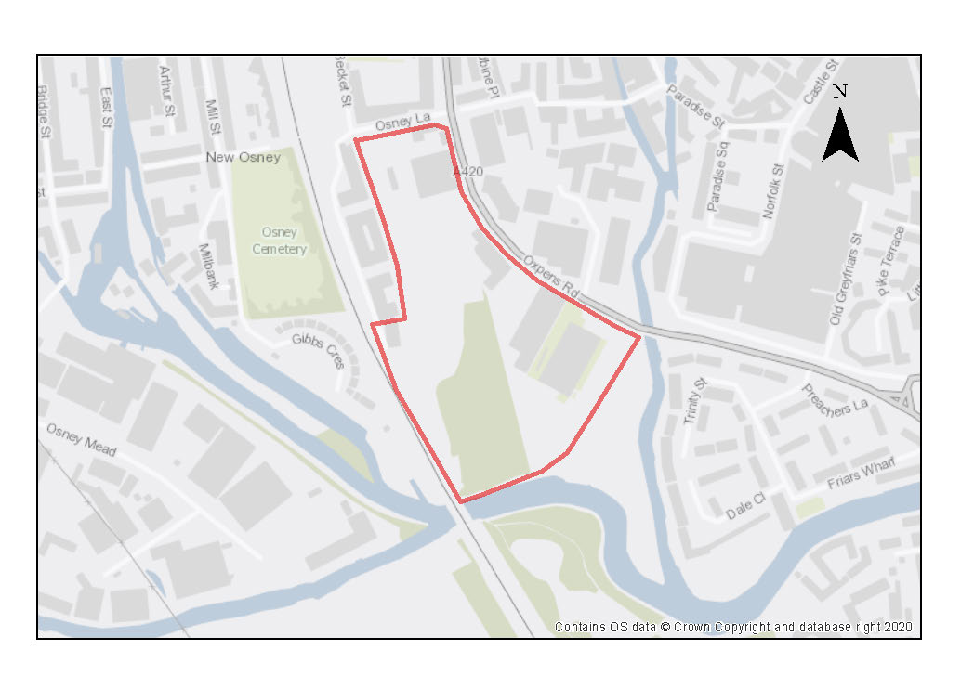

The Oxpens site is bounded by the River Thames to the south and the railway line and Student Castle development form the western boundary. Oxpens Road forms the curved eastern boundary of the site and Osney Lane provides the boundary to the north. The Oxpens site includes a large amount of hard standing which is mainly used for either public or private car parking. The site also contains a number of buildings including the Ice Rink (a regional sports facility), the Royal Mail Sorting Office, some sheltered housing accommodation blocks and several other low-rise buildings along the frontage of Oxpens Road in fairly poor condition. The site also includes some green space and is adjacent to Oxpens Meadow which benefits from Fields In Trust status. The site has poor legibility and permeability, and it is not currently possible to navigate through the site.

Oxpens Road is a main vehicular route through the West End of the city. It acts as a barrier to movement, limiting pedestrian and cycle connections into and out of the Oxpens site and on into the city centre core beyond. Although the site is in close proximity to the railway station and the existing bus network at Frideswide Square, there are no local bus connections along Oxpens Road itself, which also lacks good quality pedestrian crossings and cycleways.

Much of Oxford’s West End is sensitive to change given its location within the western historic fringe and pastoral flood plains located mainly to the west of the railway. The Oxpens site lies within the Raleigh Park view cone and the city’s High Buildings Area. The site forms a part of other important views out of the city (for instance, from St. George’s Tower and the University Church of St. Mary’s Tower) and from further views (such as the potential for visibility within other view cones e.g., Elsfield and Doris Field). This means that a visual impact assessment will be needed to ensure that development proposals do not harm these important historic views into and out of the city. The High Buildings Technical Advice Note (TAN) sets out that development proposals over 15m have the potential to create competition with existing built form in views out from the city’s historic core. The placement of any taller buildings needs to be carefully considered to avoid causing harm to the heritage significance of views into and out from Oxford’s iconic skyline.

This site has the potential to be transformed into a vibrant mixed-use quarter of the city centre supporting a range of different uses including residential and student accommodation, employment and other complementary uses including hotel, retail and other appropriate town centre uses. There is also the opportunity to provide infrastructure improvements to the area which include:
- High-quality public space at the heart of the Oxpens site;
- A safer pedestrian crossing over Oxpens Road along Castle Mill Stream to access Oxpens Meadow and associated public realm improvements
- Creation of the Oxpens Bridge northern landing point;
- Public realm improvements along Oxpens Road which could include tree-planting, cycle lanes, and the narrowing of vehicular carriageways;

Infrastructure interventions and improvements should be delivered in accordance with the West End and Osney Mead SPD.

An outline planning application has been submitted covering a large portion of the site controlled by the OXWED consortium. At the time of writing, this application (22/02954/OUT) was being considered by the Council alongside an application for detailed enabling works (22/02955/FUL).

The remainder of the Oxpens Site (outside the redline boundary of the current planning application) falls into a number of different ownerships and includes the Ice Rink, Kingsmead House (which includes the Royal Mail Sorting Office and a teaching college), some surface level car parking associated with the Sorting Office, the site of the former Esso Petrol Station, Richard Gray Court (18 units of sheltered housing), and Unit 16 of the Osney Business Centre.

Any redevelopment proposals for the Ice Rink will need to ensure that this regional sports facility is re-provided in line with Policy C3.

Redevelopment proposals involving the sheltered housing accommodation at Richard Gray Court will need to ensure that it is re-provided in line with Policy H7.

It is important that any development opportunities afforded by the redevelopment of this site demonstrate how the minimum number of homes are likely to be delivered across the whole site. It should be set out in a clear and transparent way that ensures the remainder of the homes can be brought forward as part of a well-designed development that fosters good place-making given the sensitive nature of this location.

Preliminary analysis suggests that the limited presence of green infrastructure features on the site currently means it is likely to score below the minimum thresholds for green surface cover as required by Policy G3. As such, proposals will need to ensure that an appropriate proportion of green features are incorporated into the design of development to meet the minimum targets set out in the policy, demonstrated through submission of the Urban Greening Factor assessment.

The uses on this site, part of which is in Flood Zone 3b, have been justified through the sequential test. A Level 2 Strategic Flood Risk Assessment was carried out for this site to examine part b) of the Exception Test (which relates to whether the development is safe). The Level 2 SFRA considered the proposed development was appropriate and additional mitigation and/ or analysis may be required to demonstrate compliance with the Exception Test at the planning application stage. This is to be undertaken through a site-specific FRA supporting the planning application. The site-specific flood risk assessment must demonstrate how the development will be safe otherwise planning permission will not be granted.

Policy SPCW5: Oxpens

Planning permission will be granted for a mixed-use development that delivers residential and/ or student accommodation, employment uses, and complementary town centre, leisure and community uses including retail, cafés and evening economy uses, which activate ground floor frontages and help create a vibrant city quarter.

The development is expected to deliver a minimum of 450 dwellings (or, if delivered as student rooms, the number of rooms that equate to this when the relevant ratio is applied).

Open space, nature and flood risk
Policies G1 and G3 require protection of existing green infrastructure features and enhancement of greening on site through the urban greening factor. Policy G5 requires onsite biodiversity enhancement, and Policy G2 requires new Green Infrastructure features and enhancement of existing features. It is expected that those requirements will be met in the following ways. Planning permission will only be granted for development on Oxpens where it enhances Oxpens Meadow to create a high quality public open space.

Development proposals should demonstrate how green and blue infrastructure will be integrated across the site in particular opportunities should be taken to create links between the river with the city centre. Oxpens Meadow should be expanded into the heart of the site and development proposals should respond appropriately to the riverside setting.

A sequential approach should be taken to locating development on the site. More vulnerable development will be expected to be located away from the areas at highest risk of flooding. A drainage strategy will be required to manage run-off and may need a raised floor level for some of the site, to be informed by the FRA. Some of the access route is at risk of flooding (with low hazard) so an evacuation strategy should be considered as part of the FRA.

A undeveloped buffer zone of at least 10m width should be left alongside the River Thames watercourse in accordance with Policy G2.

Urban design and heritage
Policy HD7 requires high quality design and the following sets out key considerations for achieving that on this site. New high quality and well-located public space should be provided at the heart of the site. Development should be designed to create an attractive public realm and the buildings to form active frontages in particular along Oxpens Road. Development proposals should have regard to the design principles set out in the West End and Osney Mead SPD

Development should be designed to enhance the relationship and connection between the site and the river and to enhance physical and visual permeability of the site.

Development proposals must be designed with consideration of their impact on views, particularly from Hinksey Hill to the historic core, from views out of the historic core and from further views of the site.

Development proposals that exceed the height that the High Buildings TAN states may have an impact on the historic core (which says competition impacts may be possible from 15m and above) will be required to provide extensive information so that the full impacts can be understood and assessed as listed in Policy HD9.

New development must take into consideration the potential presence of archaeological remains. Due to this potential, development should demonstrate compliance with Policy HD5.

Movement and access
The development should provide for the landing of the new Oxpens Bridge across the Thames in order to facilitate pedestrian and cycle access from south of the city, Grandpont and Osney Mead to the Station and city centre. Routes within the site should be designed to strengthen the link to Castle Mill Stream and the Westgate and to enable clear and direct access towards the station. The development should contribute towards the cost of new infrastructure improvements to the public realm along Oxpens Road, including better pedestrian and cycle crossing links as well as new cycle lanes.
Natural resources
Development proposals must include an acoustic design statement to be submitted in compliance with Policy R7 as this site is part of an area which is subject to significant environmental noise from both Oxpens Road and the railway line.
Development proposals will be required to include an appropriate site contamination investigation and applications will be required to demonstrate how any contamination issues will be resolved (Policy R5).
Nuffield Sites (Island / Worcester St Car Park/ South of Frideswide Square)

Site area: 1.41 hectares
Ward: Osney and St Thomas (Land South of Frideswide Square and Island Site) and Carfax & Jericho (Worcester St. Car Park)
Landowner: Nuffield College
Current use: Mix of uses across the sites including surface level car park, ground floor retail, residential and other town centre uses on upper floors.
Flood Zone: FZ3b but FZ2 for sequential test

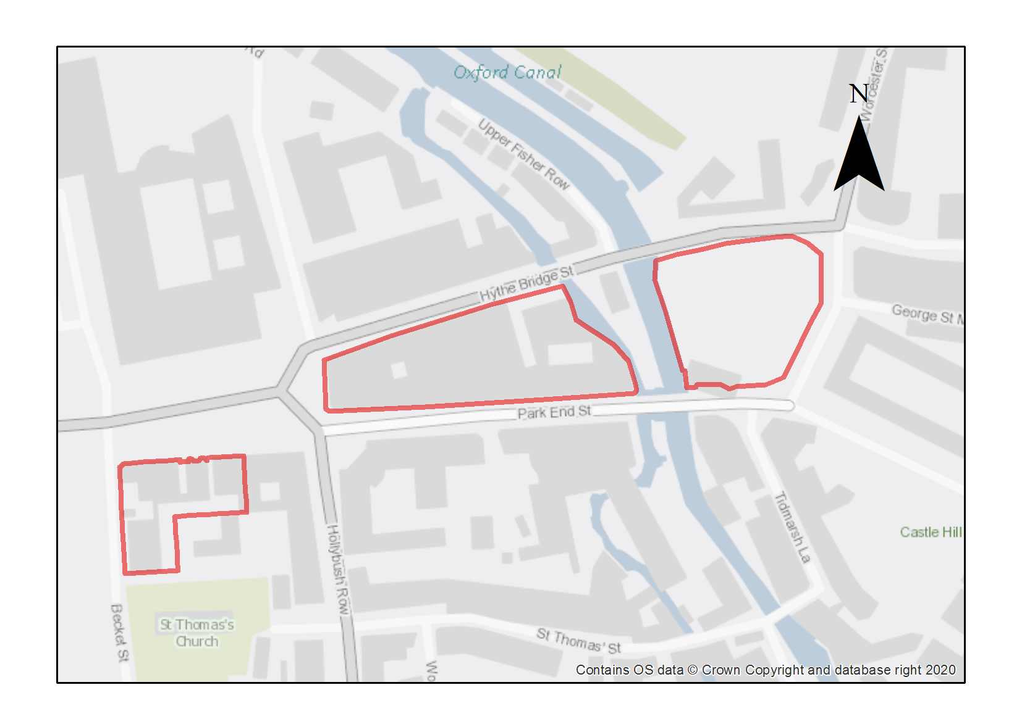

The Nuffield Sites consist of the Island Site (0.63ha), Worcester Street Car Park (0.52ha) and land south of Frideswide Square (0.26ha).

The Island Site runs between Park End Street and Hythe Bridge Street. The western edge of the site fronts on to Frideswide Square as the Royal Oxford Hotel. The eastern edge of the site is bounded by Fisher Row with Middle Fisher Row Gardens adjacent to Castle Mill Stream. The Island site contains a range of different uses including ground floor retail, hotel, cafés and bars with other uses (including office accommodation and a back-packers hostel) on the upper floors. Park End Street has a continuous frontage of mainly three storeys and with the distinctive former Hartwell’s garage which runs through to Hythe Bridge Street, with an early 20th century brick former warehouse (also vacant) set back from the street frontage.

Worcester Street Car Park is a surface level car park on the site of a former 18th-19th century canal basin. Brick walls and Mature trees line the western edge of the car park along Castle Mill Stream. At the northern extent of the car park a retaining wall supports the raised causeway of the Hythe Bridge Crossing. The southern end of the car park retains an entrance pier from the Canal Basin with a 19th century Pub fronting onto Park End Street.

Land South of Frideswide Square comprises a well preserved late-Victorian group of commercial buildings along the southern edge of the Square with retail uses on the ground floor (but excluding the listed Coopers Marmalade Factory on the corner with Hollybush Row) and a further coherent group of early 20th century town houses along the Becket Street frontage.

Both Worcester Street Car Park and land south of Frideswide Square are within the boundary of the Central (City and University) Conservation Area. The Island site is just adjacent to the boundary. The redevelopment of Worcester Street Car Park presents an opportunity to enhance the setting of the adjacent listed buildings at Nuffield College and must consider local views towards the Castle motte. The car park also contains fragments of industrial archaeology of significant interest which should be sought to be preserved or incorporated within development proposals.

Some of the Nuffield Sites lie directly within the Raleigh Park View Cone and they are all within the city’s High Buildings Area. These sites also form part of other important views out of the city (e.g., from St. George’s Tower or the University Church of St. Mary The Virgin’s Tower) and from further views (e.g., the potential for visibility from the South Park and Doris Field view cones). This means that a visual impact assessment will be needed to ensure that redevelopment proposals do not harm these important historic views into and out of the city. The High Buildings Technical Advice Note (TAN) sets out that development proposals over 15m in this area have the potential to create competition with existing built form in views out from the historic city core in this area. The placement of any taller buildings needs to be carefully considered to avoid causing harm to the heritage significance of views into and out from Oxford’s iconic skyline.

The Nuffield sites are suitable for a mix of uses including residential and town centre uses and should include uses that will activate ground floor frontages such as retail, cafes, restaurants and appropriate employment generating uses. Located within the western approach to the city centre, the redevelopment of these sites represents an opportunity to improve the urban fabric of the area. Their redevelopment provides an opportunity to enhance this area with high quality development, public realm and improved legibility and wayfinding to the historic city core.

Infrastructure interventions for the Nuffield Sites are considered within the West End and Osney Mead SPD. This SPD sets out a number of public realm, movement and green infrastructure improvements which could be incorporated as part of forthcoming development proposals including:
- Improvements to Hythe Bridge Street and Park End Street to create a better environment for walking and cycling;
- Creation of a new active public space to help pedestrian and cycle movement;
- Appropriate tree planting;
- Introduction of safe, legible pedestrian crossings;
- Improvements to the location of bus stops.

Infrastructure interventions and improvements should be delivered in accordance with the West End and Osney Mead SPD.

Preliminary analysis suggests that the limited presence of green infrastructure features on these sites currently means it is likely to score below the minimum thresholds for green surface cover as required by Policy G3. As such, proposals will need to ensure that an appropriate proportion of green features are incorporated into the design of development to meet the minimum targets set out in the policy, demonstrated through submission of the Urban Greening Factor assessment. Whilst the overall proportion of green infrastructure across the site does not currently meet the policy target set in G3, the site contains a number of existing trees located within Middle Fisher Row Gardens and along the boundary of the Worcester Street Car Park with the Castle Mill Stream. These trees perform an important public amenity function and provide valuable ecosystem services. The loss of existing trees should be resisted in line with Policy G1 and opportunities to plant new trees and improve connectivity within the Green Infrastructure network should be taken both on-site and in the wider public realm where appropriate. Development at this location would provide an opportunity to deliver significant enhancements along the stream corridor, which could include the provision of a natural buffer to the adjacent development.

The uses on this site, part of which is in Flood Zone 3b, have been justified through the sequential test. A Level 2 Strategic Flood Risk Assessment was carried out for this site to examine part b) of the Exception Test (which relates to whether the development is safe). The Level 2 SFRA considered the proposed development was appropriate and additional mitigation and/ or analysis may be required to demonstrate compliance with the Exception Test at the planning application stage. This is to be undertaken through a site-specific FRA supporting the planning application. The site-specific flood risk assessment must demonstrate how the development will be safe otherwise planning permission will not be granted. Some of the access routes are at risk of flooding, with high hazard in some places, so a flood warning strategy should be explored as part of the FRA.

A Masterplan for the Nuffield Sites should be developed in order to demonstrate how all the uses can be brought forward (including the minimum number of homes) in a way which addresses challenges (e.g., relationship with the historic city core, views and flood risk) and to ensure proposals make a positive contribution to the heritage significance of the area. Where a phased delivery strategy is proposed, this should ensure that all the residential development can be delivered across the whole development.

The site lies partially within the Central Conservation Area, and is in the setting of a number of listed buildings, including the Jam Factory, so development proposals need to ensure they do not detrimentally impact upon these.

Adjustments and considerations at design stage may be helpful in reducing the ongoing impact of poor air quality. Potential options may include considering layout options that place habitable spaces and openings away from pollution sources such as busy roads, landscape buffers, and designing in walking and cycling options as integral part of schemes.

Policy SPCW6: Nuffield Sites

Planning permission will be granted for a mix of uses across the three sites which delivers residential and/ or student accommodation, employment uses, and complementary town centre uses including retail, cafés and evening economy, which activate ground floor frontages. Active frontages should be delivered at ground floor level.

The minimum number of dwellings to be delivered is 59 (or if delivered as student rooms, the number of rooms that equate to this when the relevant ratio is applied).

Development proposals should have regard to the principles set out in the West End and Osney Mead SPD.

Open space, nature and flood risk
Policies G1 and G3 require protection of existing green infrastructure features and enhancement of greening on site through the urban greening factor. Policy G5 requires onsite biodiversity enhancement, and Policy G2 requires new Green Infrastructure features and enhancement of existing features. It is expected that those requirements will be met in the following ways. The Castle Mill Stream runs through the site and opportunities should be taken to improve access to it.

Opportunities should be investigated to demonstrate how access can be improved to Castle Mill Stream from the Worcester Street Car Park site.
Development Proposals should seek to enhance Middle Fisher Row. Such endeavours should be secured via financial contributions due to land ownership considerations.
A sequential approach should be taken to locating development on the site. More vulnerable development will be expected to be located away from the areas at highest risk of flooding. A drainage strategy will be required to manage run-off and may need a raised floor level for some of the site, to be informed by the FRA. A flood warning strategy should be considered as part of the FRA.

Urban design and heritage
Policy HD7 requires high quality design and the following sets out key considerations for achieving that on this site. Development proposals must also be designed with consideration of their impact on views, particularly from Hinksey Hill to the historic core, from views out of the historic core and from further views of the site.
Development proposals that exceed the height that the High Buildings TAN states may have an impact on the historic core (which says competition impacts may be possible from 15m and above) will be required to provide extensive information so that the full impacts can be understood and assessed as listed in Policy HD9.

Development must be designed with consideration of its impact on the Central Conservation Area and nearby listed buildings (Policy HD1 and HD2)

New development must take into consideration the potential presence of archaeological remains. Due to this potential, development should demonstrate compliance with Policy HD5.
Movement and access
A new active public space should be created on the Worcester Street Car Park site. The development should contribute to the cost of public realm improvements to Hythe Bridge Street and Park End Street which could include new and improved pedestrian crossings, and other environmental improvements to create a safe and legible environment for pedestrians and cyclists.
Natural resources
Because of uses on the site some areas of potential contamination are present on the site, so site investigation will be required, and remedial works are likely to be necessary (Policy R5).
The site is located in an air quality hot spot area. Development proposals must demonstrate compliance with policy R4 by ensuring that all necessary mitigation measures against poor air quality have been incorporated during the construction and operational phases and ensuring that any potential negative air quality impacts are adequately mitigated on an ongoing basis, within and surrounding the site.
Development proposals must include an acoustic design statement as this site is part of an area which is subject to significant environmental noise from both the road and railway line.
Osney Mead

Site area: 17.4 hectares
Ward: Osney and St Thomas
Landowner: A number of landowners own various plots. The University of Oxford is the largest landowner
Current use: Industrial Estate
Flood Zone: FZ3b

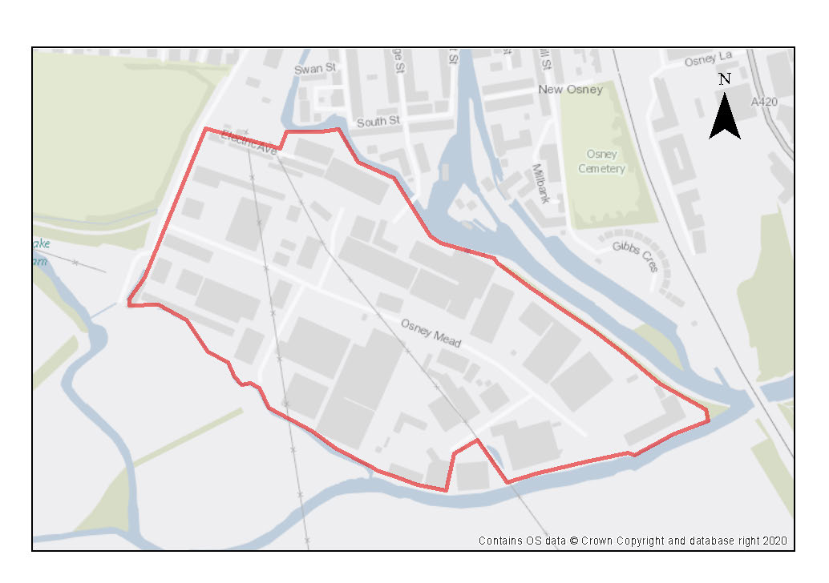

Osney Mead Industrial Estate is located on an island between an arm of the River Thames, Botley Stream and Bulstake Stream, to the south of the Victorian terraces of New Osney. It comprises a number of large commercial and light industrial units of various sizes, styles and materials. Buildings are generally one- to two storeys with some taller units enclosed by a belt of trees along the southern boundary. Access is from Ferry Hinksey Road and Osney Mead. The boundary of the Osney Town Conservation Area extends across the River Thames and encapsulates the trees and the footpath to the north of the Osney Mead site.

Osney Mead is a Category 2 employment site that contributes to the local and wider economy and as such it is important that the jobs located here remain in the city. It is in a central location that offers one of the few opportunities for a range of employment uses in the city. It is in an accessible location close to the railway station and has some existing walking and cycling connections to the wider area. There is scope to use the site more intensively. It is important that this site maintains its role in creating a diverse employment base as it makes an important contribution to Oxford’s employment land supply. There is significant potential to intensify existing uses at the site and to introduce new uses. There should be no loss in the number of jobs at the site.

The site is at high risk of fluvial flooding, the majority being in Food Zone 2 and 3a and a significant proportion being in Flood Zone 3b. This level of flood risk would have significant implications on the type and nature of development that would be permissible on the site, and where it can be located. A comprehensive flood risk management strategy needs to be developed in order to make ensure that any uses here are delivered in way which enables safe access and egress in times of flood. The hazard rating is mostly low in the east of the site, but moving westwards the hazard rating increases to ‘danger to most’ in many areas. Early warning at the site is essential to ensure access routes can be utilised before they become flooded.

The largest landowner at the site is the University of Oxford. The site presents an excellent opportunity to create an innovation area in a central location close to the core of the university that will contribute to Oxford’s role in the knowledge and high-tech economy. Academic uses linked to this could also be located at the site to maximise the benefit of linkages between academic research and innovation.

Osney Mead lies within the city centre boundary which means a wide range of town centre uses may be appropriate as part of the comprehensive redevelopment of the site. It will be important to activate the ground floor street frontage of existing and newly planned streets. Part of the site lies directly within the Raleigh Park view cone and part of the site lies within the city’s High Buildings Area. The site also forms part of other important views out of the city (e.g., from St. George’s Tower or the University Church of St. Mary the Virgin’s Tower) and from further views (e.g., the potential for visibility from the Elsfield and Doris Field view cones). This means that a visual impact assessment will be needed to ensure that redevelopment proposals do not harm these important historic views into and out of the city. The High Buildings Technical Advice Note (TAN) sets out that development proposals over 15m in this area have the potential to create competition with existing built form in views out from the historic city core in this area. The placement of any taller buildings needs to be carefully considered to avoid causing harm to the heritage significance of views into and out from Oxford’s iconic skyline.

Planned infrastructure improvements include a pedestrian and cycle bridge linking Osney Mead directly to the West End via the towpath (which itself needs improvements from Osney Mead, particularly for cyclists) and the Oxpens site which is programmed to be delivered within the early part of the plan period. This would provide better accessibility from Osney Mead and help create a natural extension of the city centre into this location.

A transformation of Osney Mead has the potential to be delivered within the plan period. The West End and Osney Mead SPD set out some infrastructure interventions to support this transformation. Suggested improvements to the Osney Mead site and surrounding area include:
- Improved pedestrian crossings at Botley Road/ Ferry Hinksey Road;
- Public realm improvements to Ferry Hinksey Road (e.g., improved paving/ improved signage at Botley Road; tree planting etc.)
- Improvements to the Osney Mead road to create more welcoming environment including improved cycleways, widening of footpaths and green infrastructure
- Improvements to the public realm including the creation of a public space
- Potential for improved access to the river

Infrastructure interventions and improvements should be delivered in accordance with the West End and Osney Mead SPD.

There are key opportunities to unlock the site around access, place-making and sustainable infrastructure. These measures make the most efficient use of land to fully achieve development goals and to unlock the full potential of Osney Mead as a world leading innovation and sustainable urban quarter. Some of these opportunities may only be achieved by comprehensive development across the site, the potential benefits of which may in future justify a Compulsory Purchase Order.

Preliminary analysis suggests that the limited presence of green infrastructure features on the site currently means it is likely to score below the minimum thresholds for green surface cover as required by Policy G3. As such, proposals will need to ensure that an appropriate proportion of green features are incorporated into the design of development to meet the minimum targets set out in the policy, demonstrated through submission of the Urban Greening Factor assessment.

Osney Mead Industrial Estate contains a number of existing trees both individually and in groups. These on-site trees provide a public amenity function and make a valuable contribution to ecosystem services in this location. Groups of mature trees are present along the boundaries of the site which run along the River Thames, Bulstake Stream and the site’s southern edge. The trees along the northern boundary are protected within the Osney Town Conservation Area. These trees (and the Thames) act as a visual (and sonic) buffer between the busy industrial estate and more tranquil residential streets of the Victorian suburbs on Osney Island.

The retention of trees within the site should be considered in accordance with Policy G1 and G3. The redevelopment of this site presents an opportunity to plant new trees to benefit the public amenity of the area and improve the quality of the urban landscape and public realm.

Opportunities to improve the Green and Blue Infrastructure of the site (e.g., tree planting to benefit public amenity and improve the quality of the urban landscape and flood mitigation / sustainable urban drainage schemes) should be developed in accordance with guidance in the West End and Osney Mead SPD.

There are a number of mature trees within the site boundary and development proposals seek to minimise tree removal and seek to incorporate and introduce new semi-mature trees where possible within front gardens. All planting proposals should form part of a submitted landscape plan which demonstrates how trees will be retained and an appropriate proportion of green features are incorporated into the design of development to meet the minimum green infrastructure targets set out in the Policy G3, demonstrated through submission of the Urban Greening Factor assessment.

The mix of uses on this site, which is at high risk of fluvial flooding, has been justified through the sequential test. A Level 2 Strategic Flood Risk Assessment was carried out for this site to examine part b) of the Exception Test (which relates to whether the development is safe). The Level 2 SFRA considered the proposed development was appropriate and additional mitigation and/ or analysis may be required to demonstrate compliance with the Exception Test at the planning application stage. This is to be undertaken through a site-specific FRA supporting the planning application. The site-specific flood risk assessment must demonstrate how the development will be safe otherwise planning permission will not be granted. The start of the proposed access route to/from the site is at significant flood risk. Approximately 1.2km from the site the route becomes flood free and onward travel is at minimal flood risk. For these reasons early warning will be essential to ensuring that the route can be utilised before floodwater inundates the site and wider area. A site-specific FRA should look into this in more detail and consider provision of a flood evacuation plan.

Policy SPCW7: Osney Mead

Planning permission will be granted for a mixed-use development that includes employment, academic and research and development uses, student accommodation, employer-linked affordable housing and market housing. The development of an innovation quarter is encouraged. The development is expected to deliver a minimum of 247 dwellings (or, if delivered as student rooms, the number of rooms that equate to this when the relevant ratio is applied) (unless further flood risk work undertaken cannot find a solution to ensure the safety of residents).

Other complementary uses will be considered on their merits, including uses which help activate appropriate ground floor street frontages. Such uses could include culture, arts and leisure uses.

The site would only be suitable for new academic institutional uses provided that the requirements of Policy H10 are met.

In order to maximise the full potential of Osney Mead, a comprehensive approach to future planning and development is required, in particular to ensure that site constraints, new infrastructure provision and land-use considerations are resolved on a site-wide basis.

A masterplan approved by the City Council should be developed prior to any development, and development should comply with the masterplan. This would ensure a comprehensive approach to development, which will maximise its potential, helping ensure site constraints, new infrastructure provision and land use considerations are resolved on a site-wide strategic basis. The masterplan and any subsequent development proposals should be delivered in accordance with the West End and Osney Mead SPD.

Any development proposals coming forward should not prejudice the comprehensive redevelopment of the site and should be delivered in accordance with an Oxford City Council approved masterplan.
Short-term incremental opportunities for development will be assessed on their merits and will need to have regard to the delivery of any agreed wider masterplanning ambitions for the site.
Open space, nature and flood risk
A 10-metre buffer to the watercourse should be maintained or re-instated where possible. Planning applications must be accompanied by a site-specific flood risk assessment and development should incorporate any mitigation measures. The FRA should look at options for early warning and consider a flood evacuation plan. A sequential approach should be taken to locating development on the site, with car parks and other ancillary uses in higher risk areas where possible. A drainage strategy will be required to manage run-off and may need a raised floor level for some of the site, to be informed by the FRA.

A sequential approach should be taken to locating development on the site. More vulnerable development will be expected to be located away from the areas at highest risk of flooding. A drainage strategy will be required to manage run-off and may need a raised floor level for some of the site, to be informed by the FRA. The access route is at risk of flooding so an evacuation strategy should be considered as part of the FRA.

Urban design and heritage
Development proposals should have regard to the design principles set out in the West End and Osney Mead SPD. Policy HD7 requires high quality design and the following sets out key considerations for achieving that on this site.
Development should be designed to enhance the relationship and connection between the site and the river and to enhance the physical and visual permeability of the site.
Development proposals must also be designed with consideration of their impact on views, particularly from Hinksey Hill to the historic core, from views out of the historic core and from further views of the site, as well as consideration of impact on the Osney Town Conservation Area (Policy HD1).

Development proposals that exceed the height that the High Buildings TAN states may have an impact on the historic core (which says competition impacts may be possible from 15m and above) will be required to provide extensive information so that the full impacts can be understood and assessed as listed in Policy HD9.

Movement and access
New high quality public open space should be created on site. Footpaths and cycleways to and through the site should be provided and existing routes enhanced to increase accessibility and promote permeability. A masterplan should comprehensively address how new and enhanced pedestrian and cycle connections will be provided into the wider area, including connectivity across the river with a future bridge link from Grandpont to Oxpens.
Natural resources
Because of uses on the site there are areas of potential contamination, so site investigation is required, and remedial works are likely to be necessary (Policy R5).
Development proposals must include an acoustic design statement as this site is part of an area which is subject to significant environmental noise from a number of sources.
Botley Road Retail Park

Site area: 8.85 hectares
Ward: Osney & St Thomas
Landowner: Various
Current use: Retail Park with associated car parking
Flood Zone: FZ3b

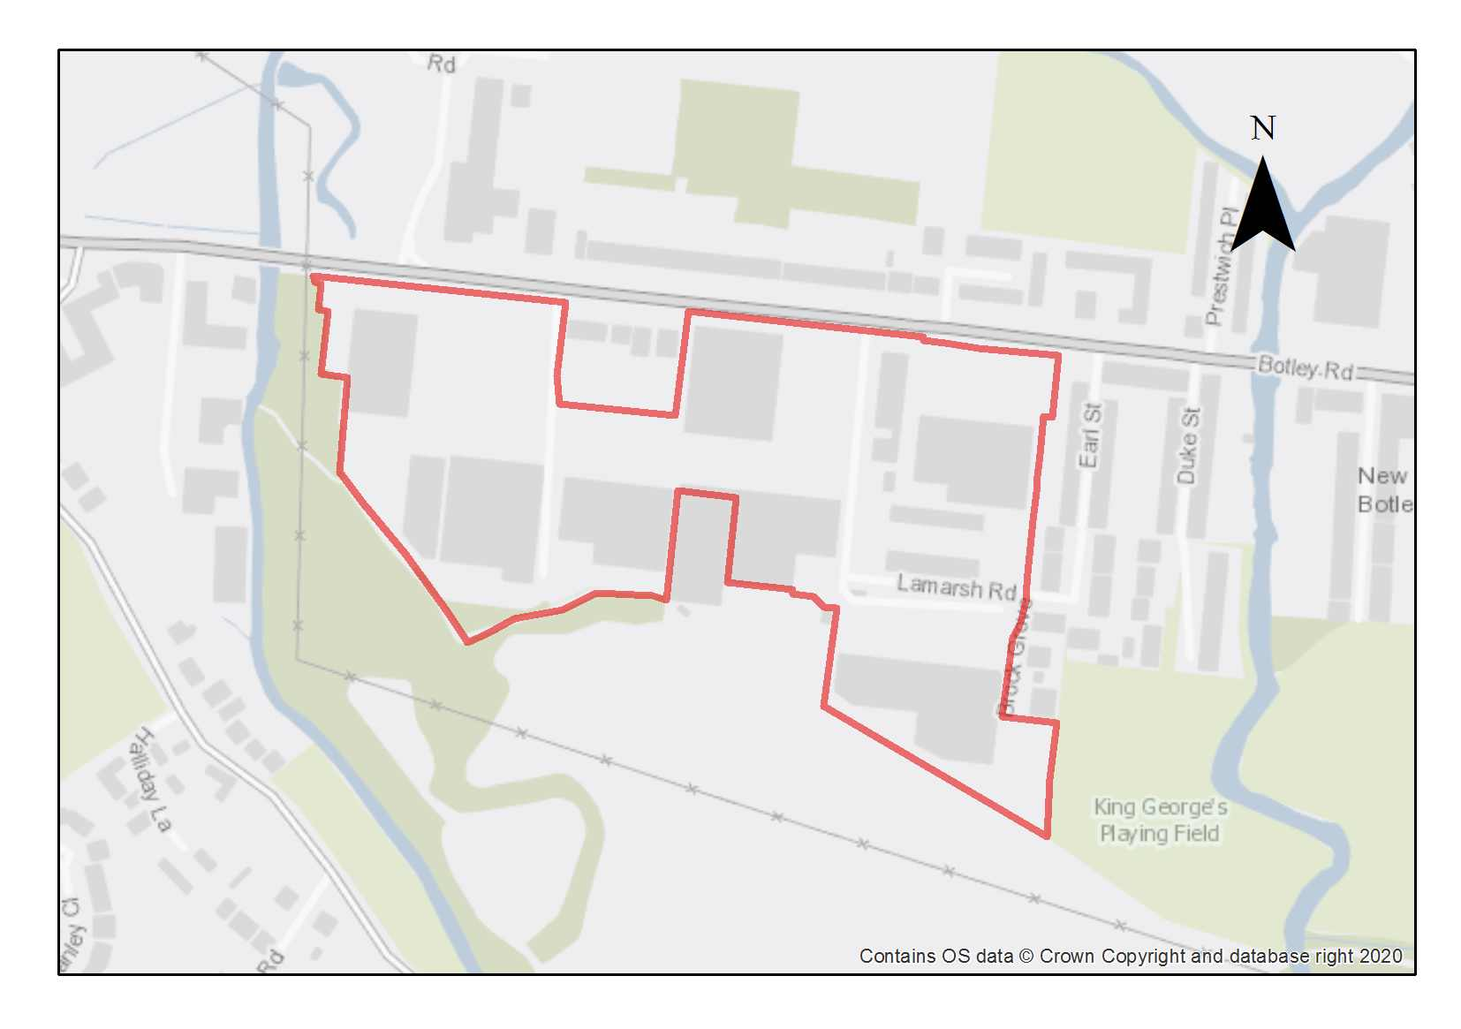

Botley Road Retail Park comprises single storey retail units with large areas of associated car parking. The site is made up of several subdivided plots of varying sizes with multiple landownerships and interests. To the rear of the site there are building suppliers yards and service yards for the retail units. These yards largely obscure views out to the landscape. The retail park is bounded by Botley Road to the North, open meadow to the South, with domestic scale residential properties to the East on Earl Street, Lamarsh Road, Brock Grove and opposite on the Botley Road.

There are few natural features of note. However green fields adjoin the site along the southern boundary, with ditches and trees screening the activities of the retail park. Today these fields form a local wildlife site and part of the Green Belt. There are two areas of Tree Preservation Order along this boundary. The Green Belt extends along the site’s western boundary and includes the Seacourt Nature Park which connects into the site via a pedestrian/ cycle path. Seacourt Stream lies just beyond the north-west boundary of the site. To the east the site borders King George’s Field. From here there are footpaths and cycleways providing connections towards Oatlands Road Recreation Ground and to Osney Mead Industrial Estate via Willow Walk which connects Ferry Hinksey Road with North Hinksey Lane to the west.

The fields to the south form an important part of the historic landscape setting for the city and the site is adjacent to the historic City and Liberty Boundary. There is the potential for several protected views to be impacted by development proposals on this site. These include views out from Castle Mound, St. George’s Tower, St. Michaels Tower, the Sheldonian Cupola, St. Mary the Virgin, and the Carfax Tower. Further views which may be impacted by proposals include the Crescent Hill and Rose Hill Viewcones, the view from Hinksey Meadow, views from Binsey Lane and the Road to Hinksey Heights Golf Course.

Preliminary analysis suggests that the limited presence of green infrastructure features on the site currently means it is likely to score below the minimum thresholds for green surface cover as required by Policy G3. As such, proposals will need to ensure that an appropriate proportion of green features are incorporated into the design of development to meet the minimum targets set out in the policy, demonstrated through submission of the Urban Greening Factor assessment.

The site is at high risk of fluvial flooding. Nearly 50% of the site area is within FZ3a, particularly towards the eastern side of the site and a central section (a section on the eastern side of Lamarsh Road comes within FZ3b). The rest of site lies within FZ2, with some patches showing low flood risk. Most of the surrounding area is within FZ3. The hazard rating is mostly low in the west but in the eastern part of the site towards Bulstake Stream the hazard rating is ‘danger to most’. The access is also at high risk with some high hazard, so early warning of flood events it essential. The level of flood risk would have significant implications on the type and nature of development that would be permissible on the site, and where it can be located. In practice this will preclude the development of residential schemes on any part of the site.

The site is well served by various travel modes via Botley Road, including several bus routes to and from the city centre, dedicated cycle paths and footways. Vehicles access the site from Botley Road via three access points with right turn lanes, with a fourth access point from Lamarsh Road at the southeastern part of the site. The Seacourt Park & Ride is located directly opposite the site.

Cyclists can access the site via the cycle path on Botley Road which links to Oxford Station and the city centre. A cycle path (Oxford Cycle Route 24) goes east-west through the middle of the site in front of the retail units linking into Seacourt Nature Park for onward connections towards North Hinksey Lane to the west and to Lamarsh Road to the east. Other than this path, cyclists do not have a separated path once inside the site cyclists are compelled to share with cars and HGVs. Pedestrians can access the site via the footways on Botley Road or Lamarsh Road or via the Seacourt Nature Park. Footpaths and zebra crossings allow pedestrians to cross the car parks within the site.

Policy SPCW8: Botley Road Retail Park

Planning permission will be granted for employment uses that directly relate to key sectors of research led employment, and other economic and employment uses suitable for the location. Other complementary uses, including community and learning uses (Class F) will be considered on their merits.

Developers are encouraged to follow a coordinated masterplan approach for the site to encourage holistic development and avoid a situation where proposals coming forward in a piecemeal way.

Development proposals should have consideration for the policy and spatial guidance contained in the Botley Road Retail Park Development Brief (TAN 17).

Open space, nature and flood risk
Policies G1 and G3 require protection of existing green infrastructure features and enhancement of greening on site through the urban greening factor. Policy G5 requires onsite biodiversity enhancement, and Policy G2 requires new Green Infrastructure features and enhancement of existing features. It is expected that those requirements will be met in the following ways. Opportunities should be sought to enhance the spatial quality and environmental amenity of the site by reducing areas of hard surfacing, introducing natural features and other green infrastructure to improve landscaping and onsite biodiversity and environmental management, improving the quality of space between buildings, and making the most of the adjoining green setting with respect to views and direct connections.

Planning applications must be accompanied by a site-specific flood risk assessment and development should incorporate any mitigation measures. The FRA should look at options for early warning and consider a flood evacuation plan. A sequential approach should be taken to locating development on the site, with car parks and other ancillary uses in higher risk areas where possible. A drainage strategy will be required to manage run-off and may need a raised floor level for some of the site, to be informed by the FRA.

This site is adjacent to the proposed site of the Oxford Flood Alleviation Scheme (OFAS) therefore any future master planning of these sites should have consideration about the potential impact from the OFAS.

Urban design and heritage
Development proposals must be designed with consideration of their impact on views across the city and from the fields to the south which form an important part of the historic landscape setting for the city and demonstrate compliance with policy HD9. Dynamic views of the site should be tested along the Botley Road including from Osney Bridge, St. Frideswide’s Church, Botley Road junction with Binsey Lane, Botley Road junction with Prestwich Place and the Westway.

Policy HD7 requires high quality design and the following sets out key considerations for achieving that on this site. The retail sheds sit a long way back from the Botley Road to accommodate parking. Development proposals should aim to bring the buildings closer to Botley Road and creating an active frontage at ground floor level to give the development a presence on the Botley Road.

The site is bordered to the east and has a block of residential houses in the central edge of the site which must be treated sensitively to avoid overlooking or overbearing from new development. Massing should be tested in views identified and must not detract from the Osney Town Conservation Area. The roofscape should contribute to the rich and varied roofscape of Oxford and avoid long uninterrupted expanses at height.

Movement and access
Opportunities should be sought to enhance and promote more sustainable travel modes to the site, including significantly reducing the area of car parking, providing charging points to support low emission vehicles and providing dedicated segregated cycle/pedestrian routes through the site. The access and egress for cyclists and pedestrians to the site needs to be addressed in development proposals.

Natural resources
Any planning applications near the Seacourt Stream will also need to assess the potential for additional indirect impacts on the flora and fauna of those areas, including (but not limited to) potential impacts from lighting, noise, and dust, and provide adequate buffers and deliver ecological enhancements as required.

Additional protective and enhancement measures for river and wetland restoration as required around the watercourse and ecological buffers zones (minimum 10metres from bank top) should form part of development proposals.

There are areas of potential contamination, so a site investigation will be required, and remedial works undertaken as required in compliance with Policy R5.

Development proposals must include an acoustic design statement in compliance with Policy R7 as this site is part of an area which is subject to significant environmental noise from the traffic on the Botley Road.

Infrastructure includes schools, hospitals, utilities, digital communications, transport provision, and community facilities
Homes England Housing Infrastructure Funding
Beyond the Oxford North permission 18/02065/OUTFUL
South Oxfordshire Local Plan 2035
including the Spatial Framework and Design Guide
East West Rail, Route Report Update May 2023 https://eastwestrail-production.s3.eu-west-2.amazonaws.com/public/Route-Update-Announcement/4c8cb5ea3b/Route-update-report.pdf

